Prometheus + grafana + loki

EKS Anywhere
|
Kubernetes
|
+-----------+-----------+
| |
Grafana Loki
| |
PVC PVC
| |
v v
StorageClass StorageClass
|
v
CSI Driver
|
v
vSphere
|
Datastore

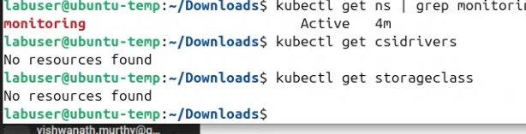
.

Case 1 — vSphere CSI was never installed

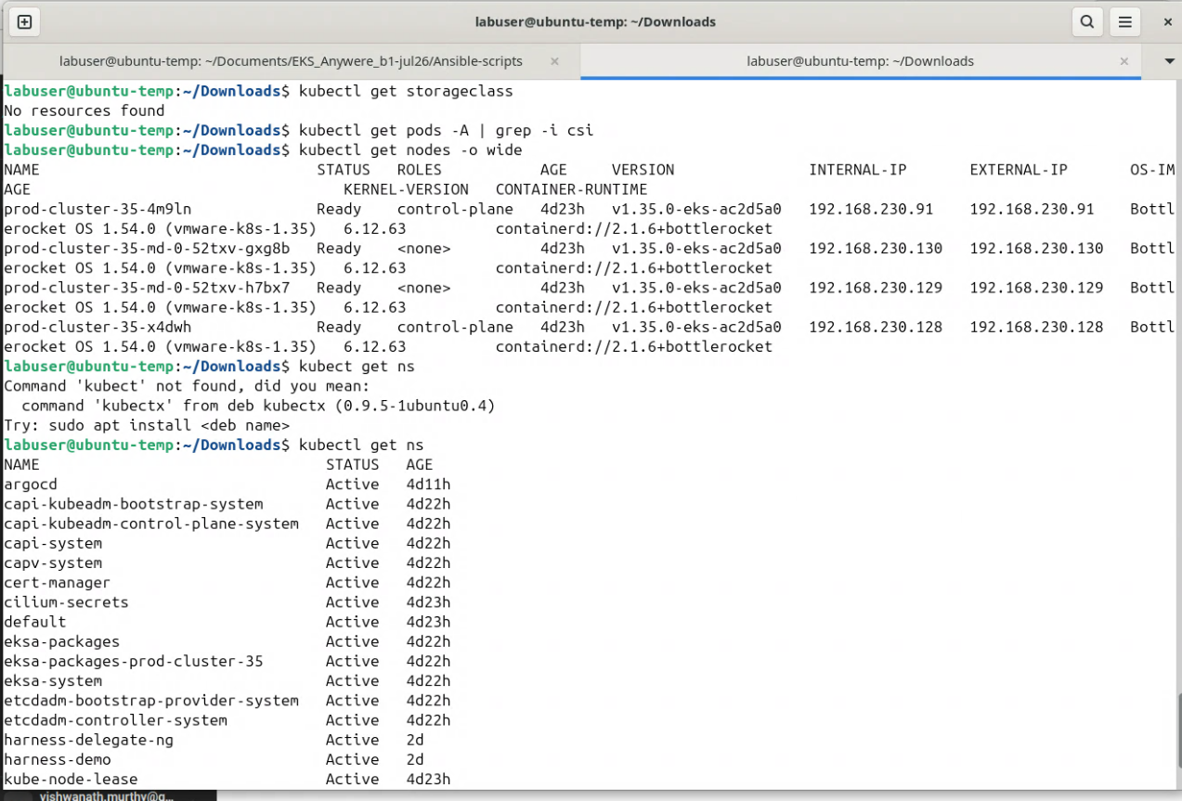
.
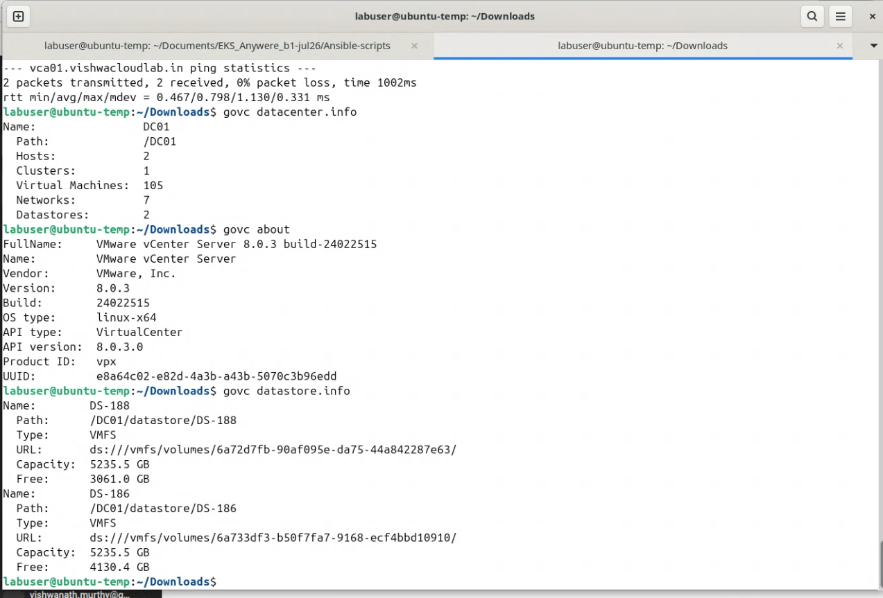
.

The architecture we should build

Rafay SaaS
|
|
EKS-A Blueprint
|
+---------------+---------------+
| |
v v
Storage Add-on Observability Add-on
| |
vSphere CSI kube-prometheus-stack
| / \
| Prometheus Grafana
|
StorageClass
|
v
PVCs
|
v
vSphere CNS / VMFS
|
+-----+------+
| |
DS-188 DS-186

What I want you to do now
Don't install anything yet.
First run these commands:

1. Confirm EKS-A version

eksctl anywhere version

2. Check whether vSphere CPI exists

kubectl get pods -A | grep -i vsphere

3. Check for vSphere-related secrets

kubectl get secrets -A | grep -i vsphere

4. Check the EKS-A cluster object

kubectl get cluster -A

5. Check whether the cluster has a vSphere cloud-provider configuration

kubectl get cm -A | grep -i vsphere

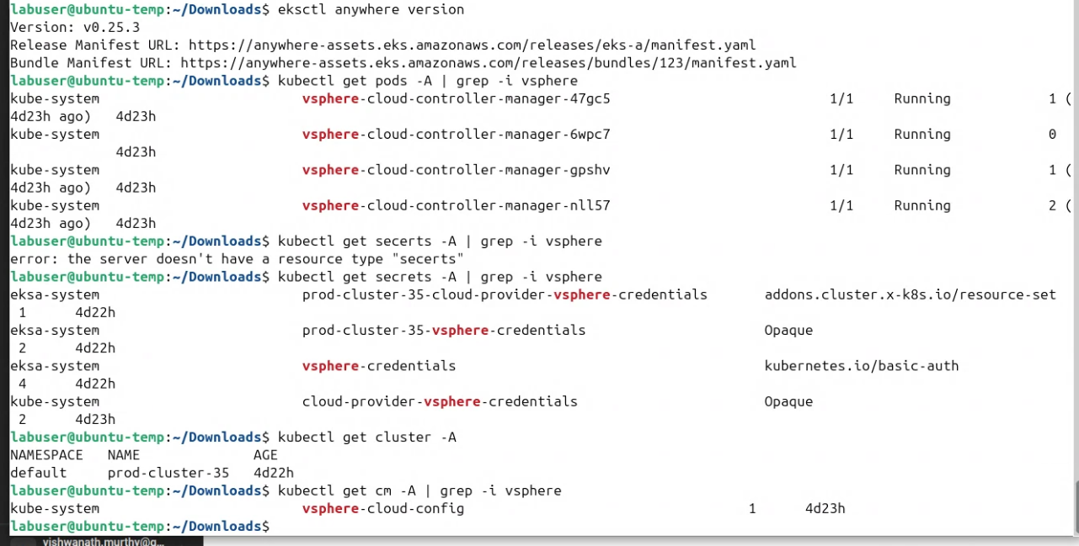
.

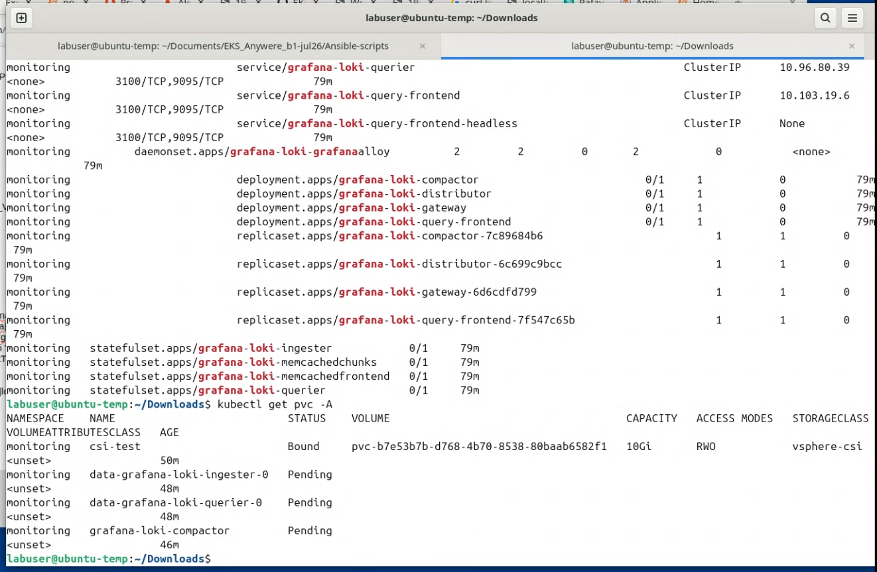
..

Rafay “grafana-loki” add on values are suppose to be

------------------------------------

ingester:
persistence:
enabled: true
storageClass: vsphere-csi
size: 10Gi

querier:
persistence:
enabled: true
storageClass: vsphere-csi
size: 10Gi

compactor:
persistence:
enabled: true
storageClass: vsphere-csi
size: 10Gi
------------------------------------

Then
Updated the grafana-loki addon with custom values3.yaml ( with above values
Updated the blueprint with the new version of the addon

updated the cluster with new version of the blueprint

But there's an even easier fix for your lab
Because you already have a working StorageClass, you could make vsphere-csi the default StorageClass.
Then the existing Loki PVCs, which have:

storageClassName: <empty>

would be eligible to use the default provisioner.
Check whether it is currently default:

kubectl get sc

You might have:

NAME PROVISIONER
vsphere-csi csi.vsphere.vmware.com

with no (default).
You can make it default:

kubectl patch storageclass vsphere-csi \
-p '{"metadata":{"annotations":{"storageclass.kubernetes.io/is-default-class":"true"}}}'

Then:

kubectl get sc

should show:

NAME PROVISIONER
vsphere-csi (default) csi.vsphere.vmware.com

