**Lab manual – VPC-Peering**

**Topics**

1. **VPC-Peering - Diagram**
2. **Configure EC2 instance with public IP in the N.Virginia**
3. **Configure EC2 instance with only private IP in the Canada**
4. **Configure VPC Peering**
5. **Update Routing table of N.Virginia**
6. **Update Routing Table of Oregon**
7. **Check the Connectivity Between EC2 instance in both the Regions.**
8. **VPC-Peering - Diagram**

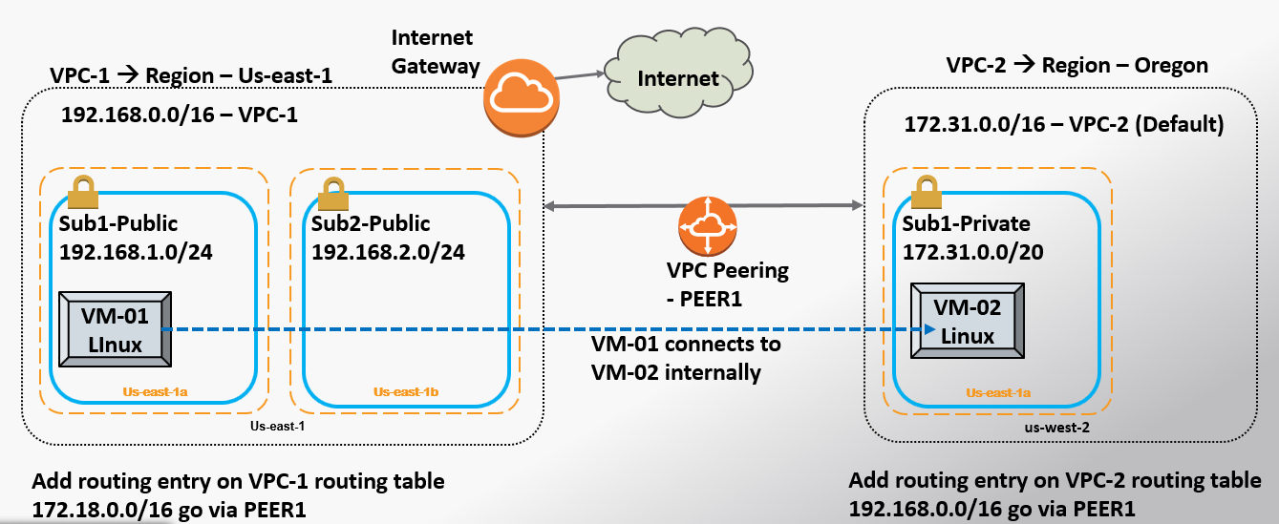

1. **Configure EC2 instance with public IP in the N.Virginia**

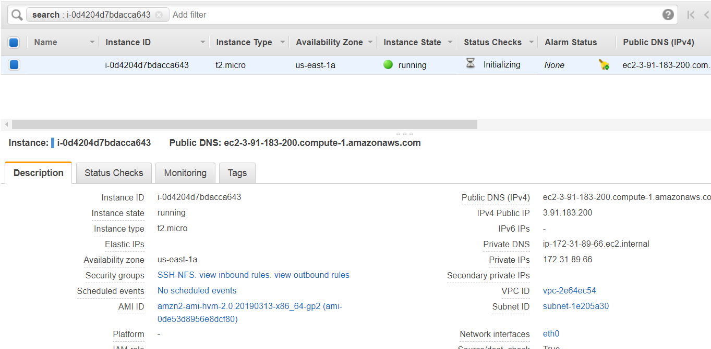

1. **Configure EC2 instance with only private IP in the Canada**

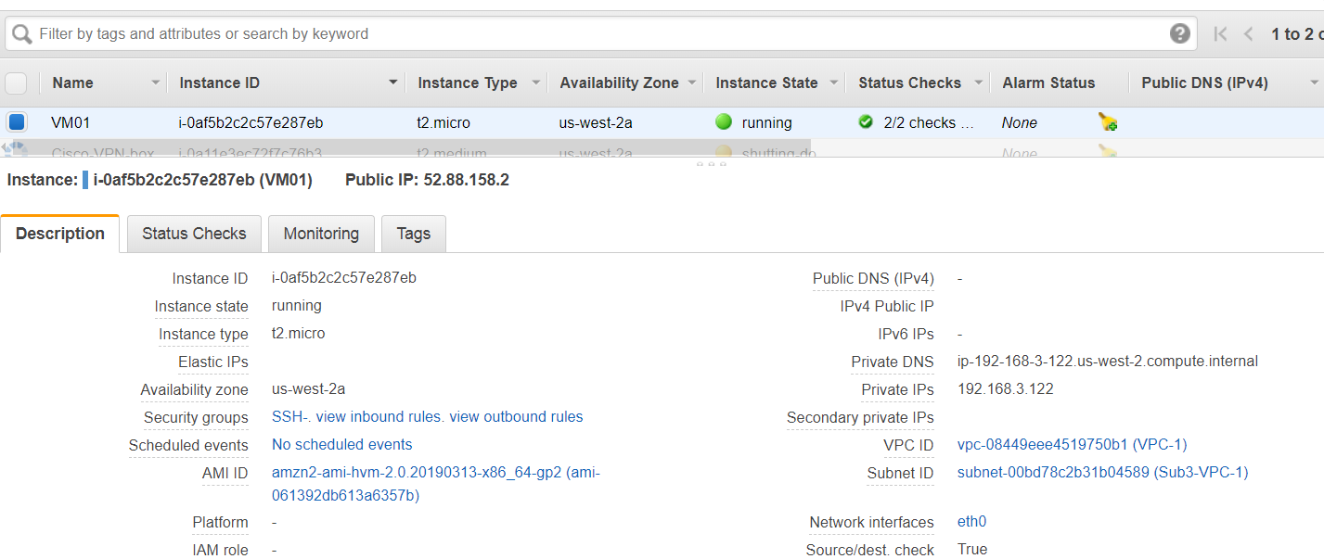

This has only **“Private IP”.**

1. **Configure VPC-Peering**
   1. **Click on the “Peering” under the VPC option.**

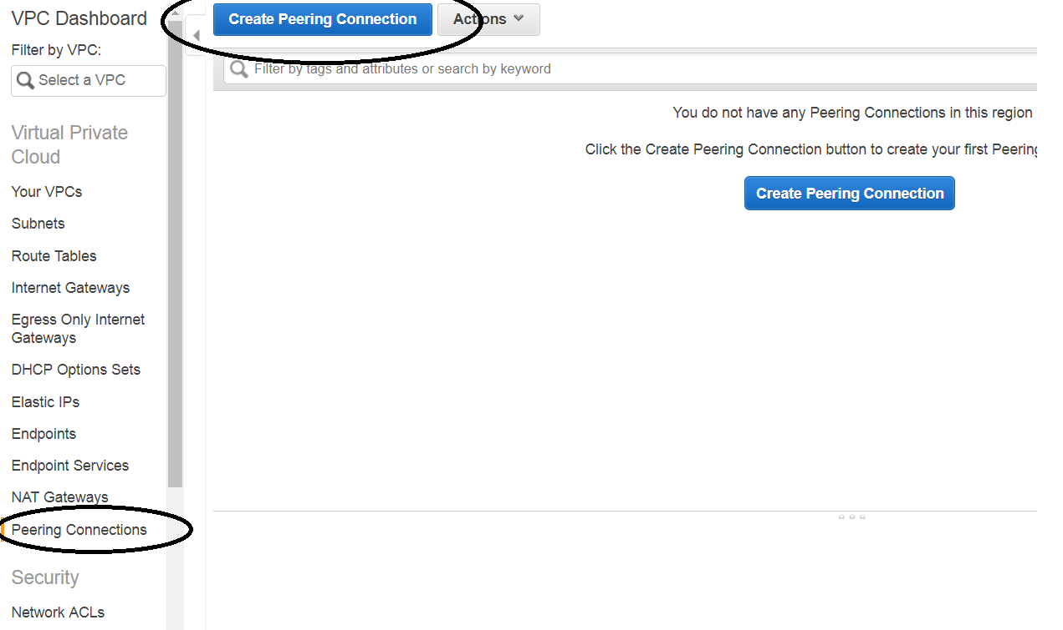

* 1. **Configure the VPC details of both side.**

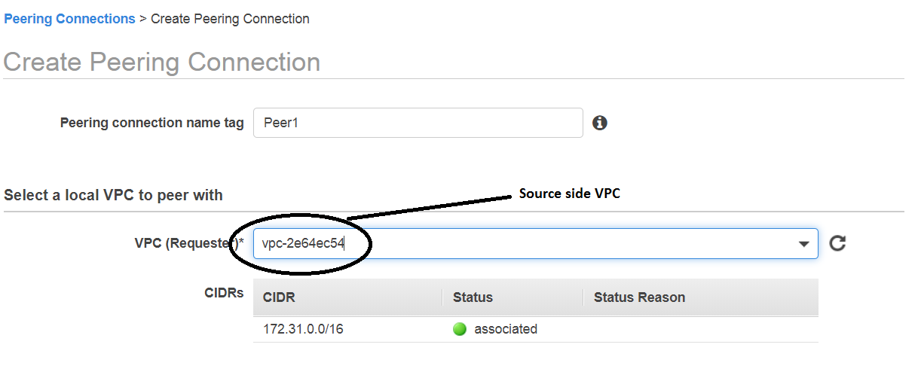

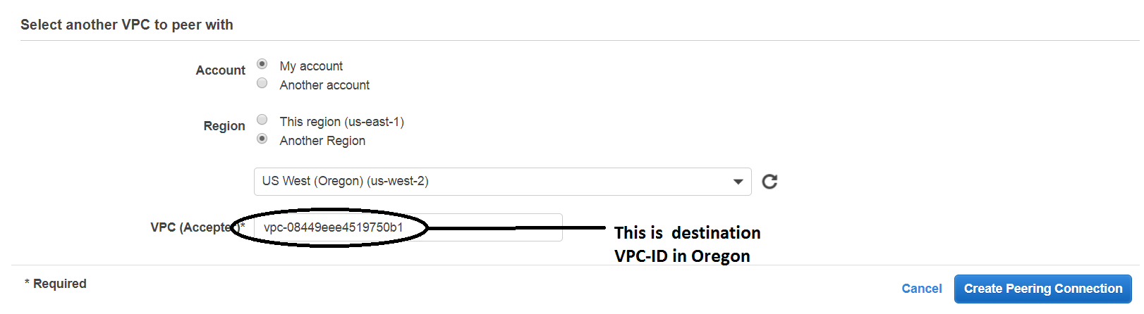

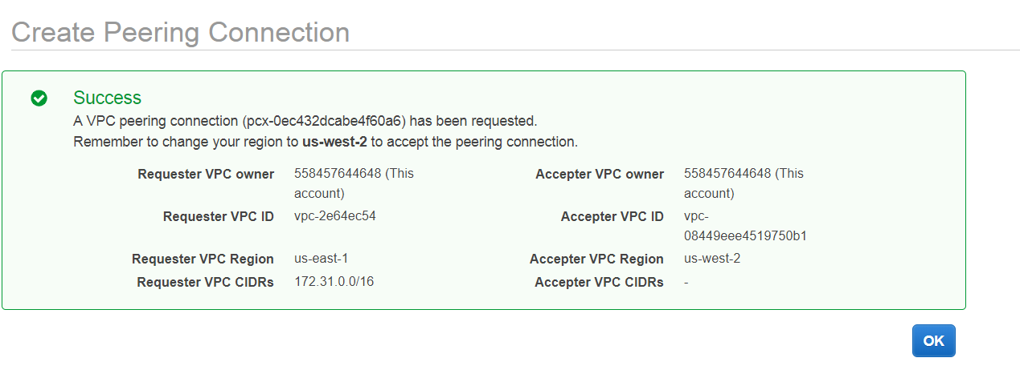

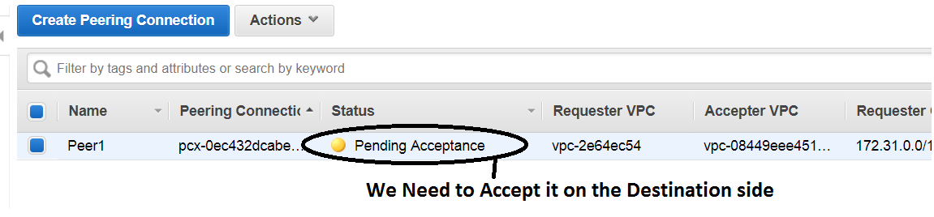

* 1. **Accept it on the “Oregon Side”.**

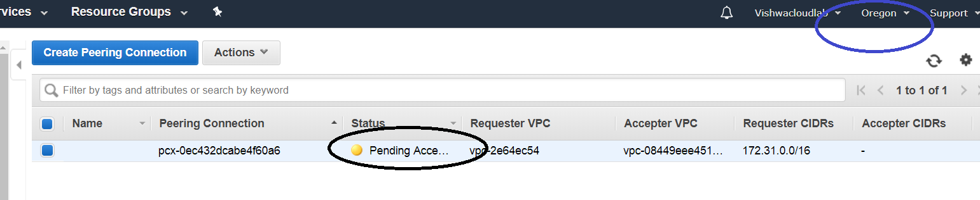

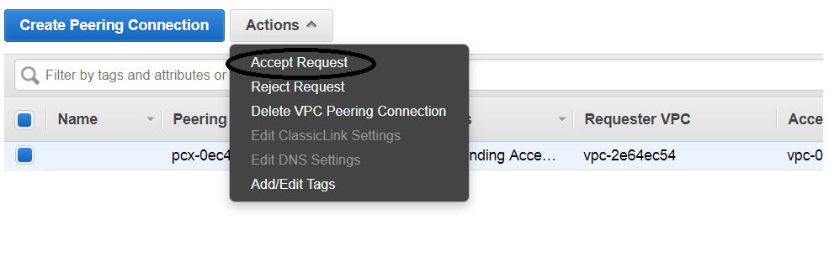

* 1. Output of both side VPC peering

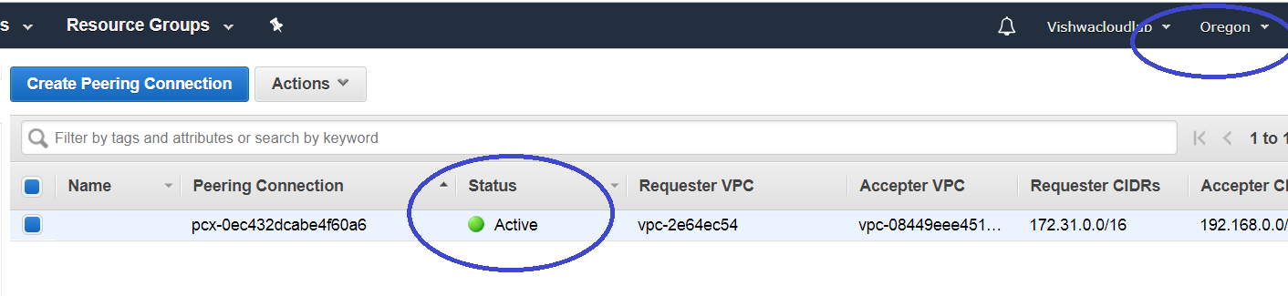

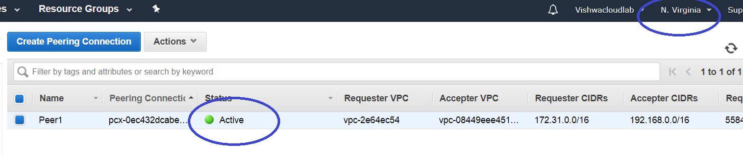

1. **Update Routing table of N.Virginia**

**Update the route Table with the Oregon VPC CIDR in the Destination.**

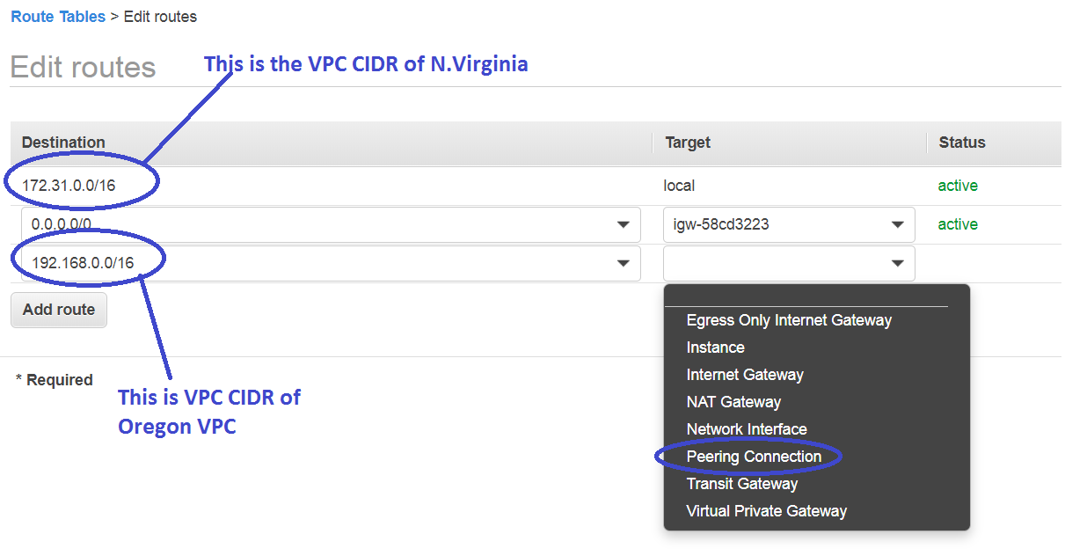

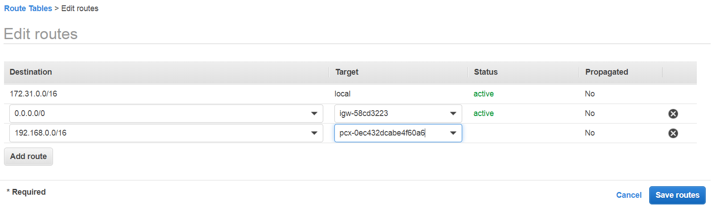

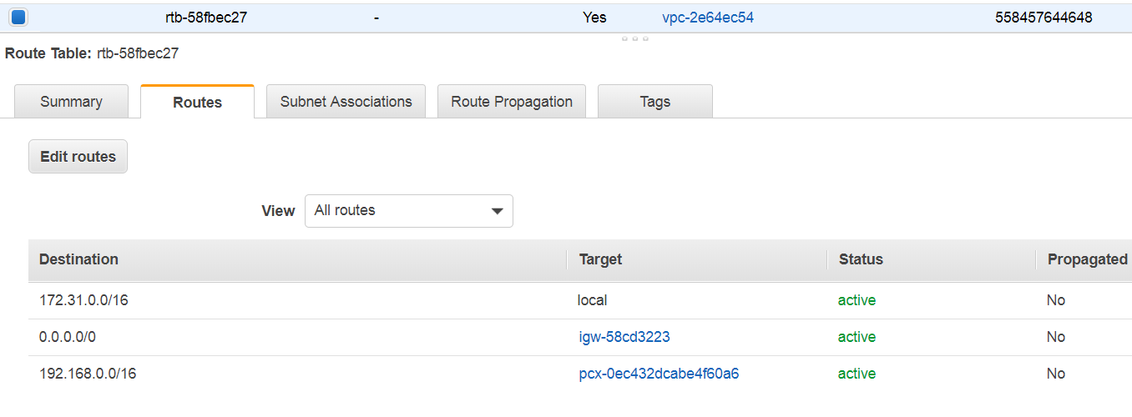

1. **Update Routing table of Oregon**

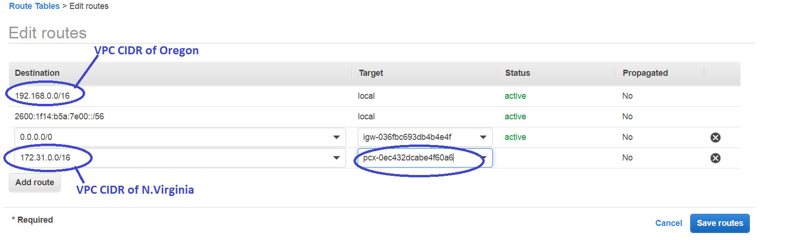

Input the CIDR of the N.Virginia VPC and select the Peering connection ID that was just created in the above.

1. **Check the Connectivity Between EC2 instance in both the Regions.**

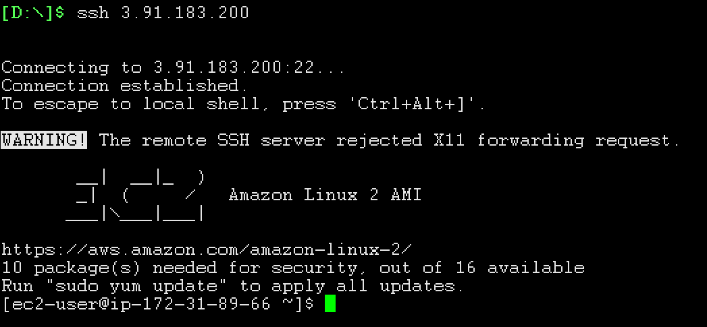

**Login to the EC2 in the N.Virginia,**

**Source IP 🡪 172.31.89.66**

**Destination IP 🡪 192.168.3.122**

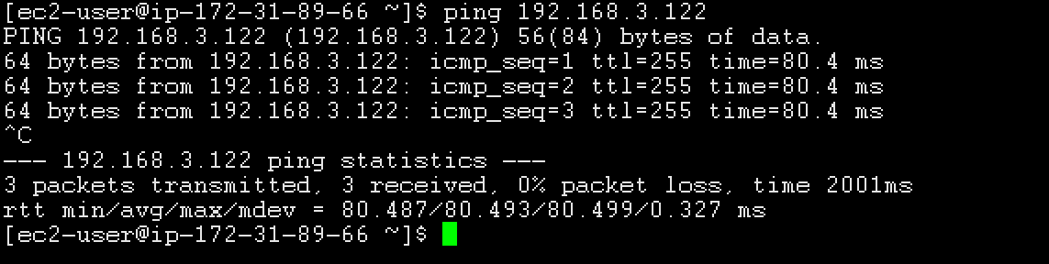

We, are able to ping the destination.

Which means, **VPC PEERING IS WORKING FINE.**