Lab manual – S3 – Simple Storage Service

Steps

1. Create log bucket
2. Create data bucket
3. Upload the File
4. Create log bucket

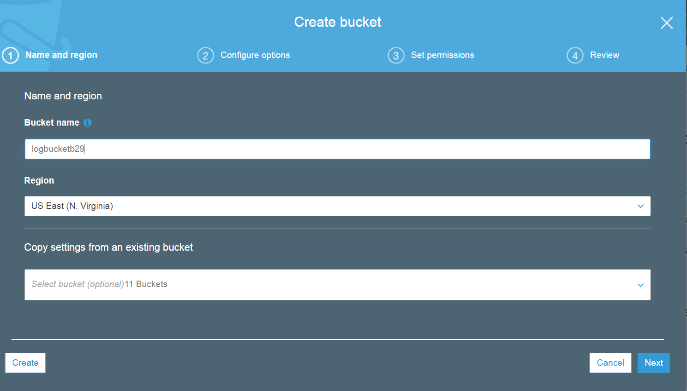

Click "NEXT".

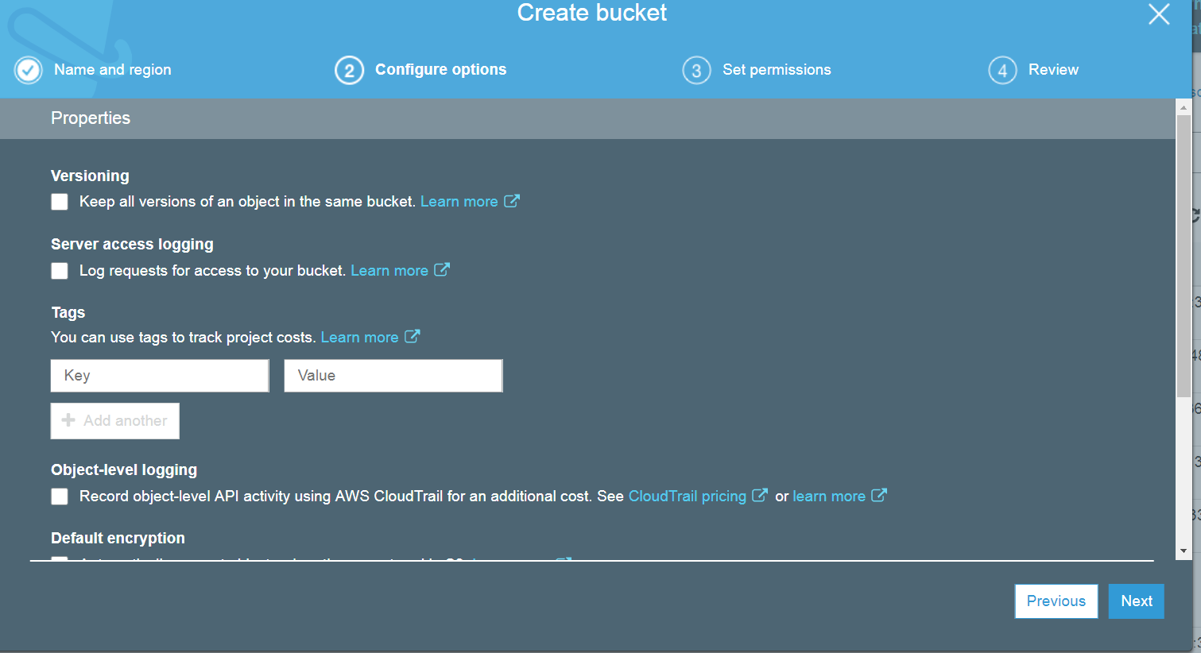

Click "NEXT"

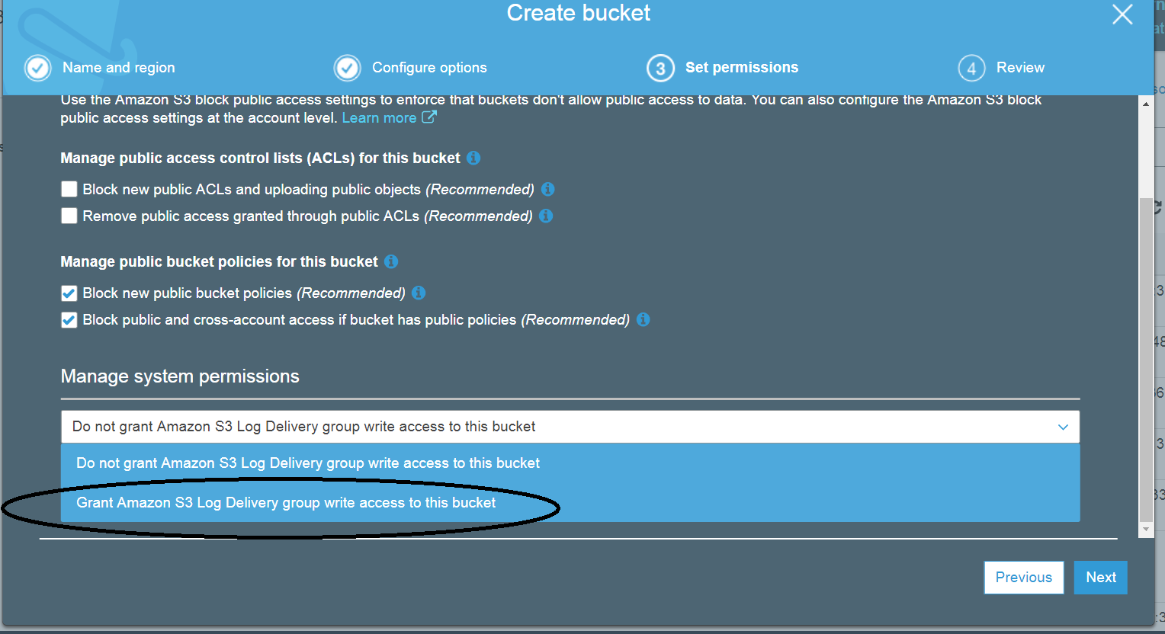

Select "Grant Amazon S3 log" for this bucket.

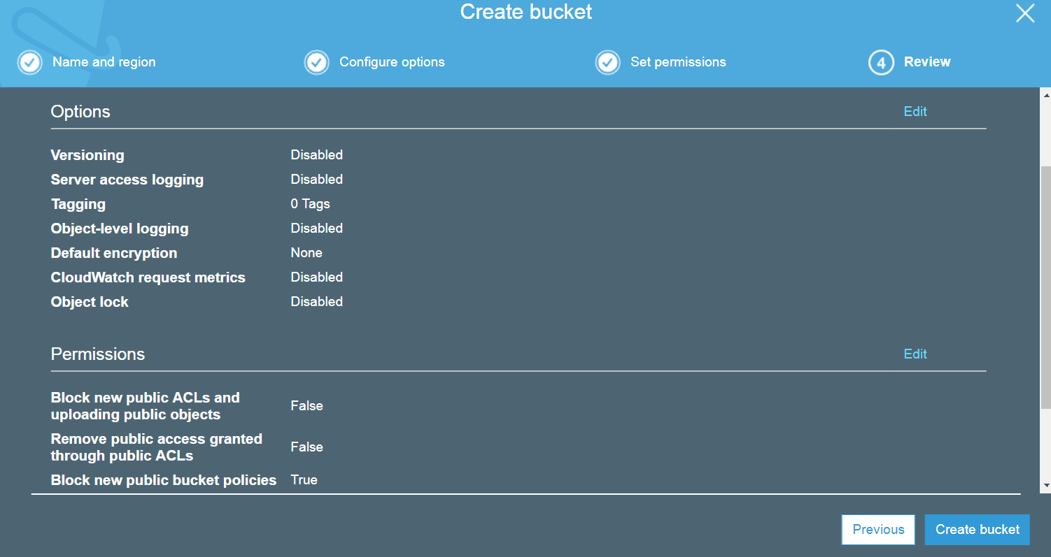

Click on 'create Bucket.

1. Create data bucket

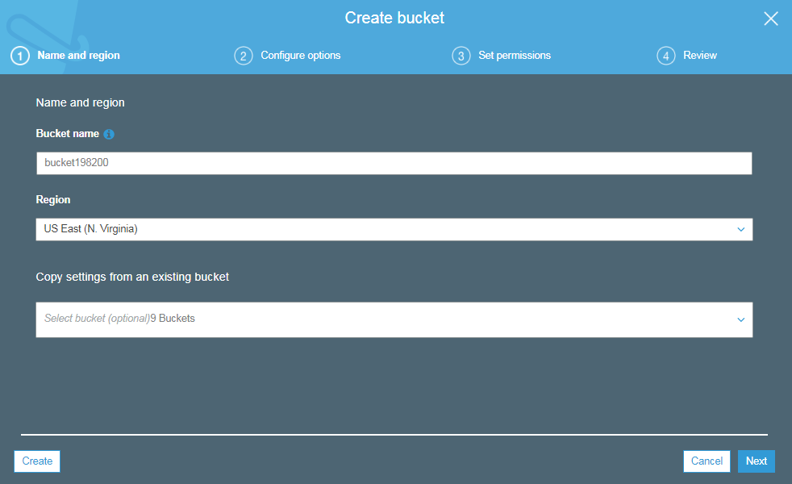

Note:- The Data Bucket and Log Bucket should be in the same Region

Click **“NEXT”**

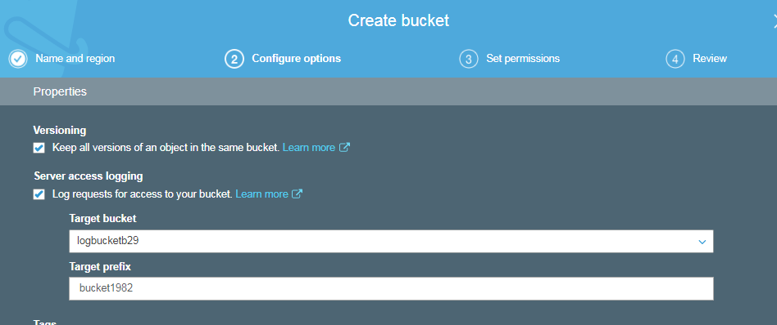

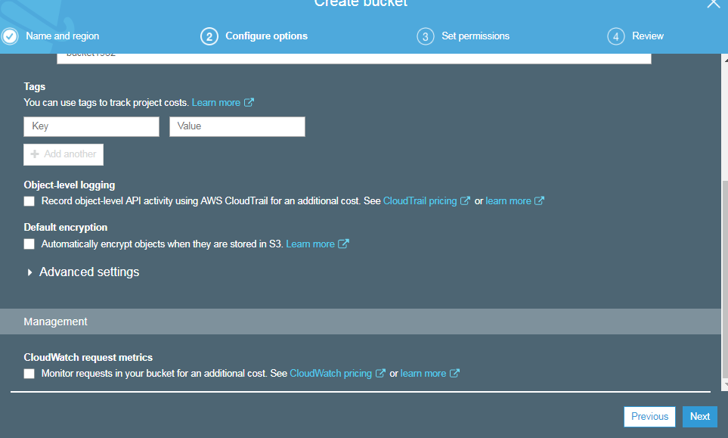

Click **“NEXT”**

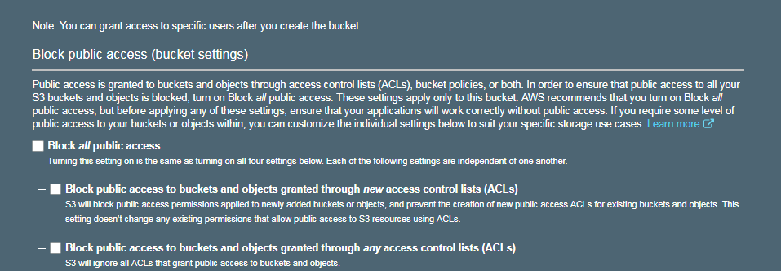

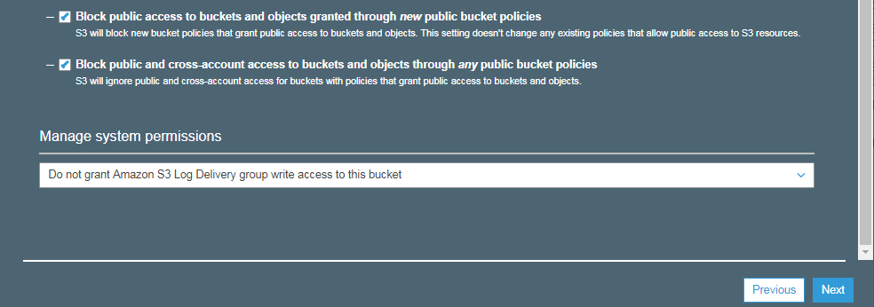

Click **“NEXT”**

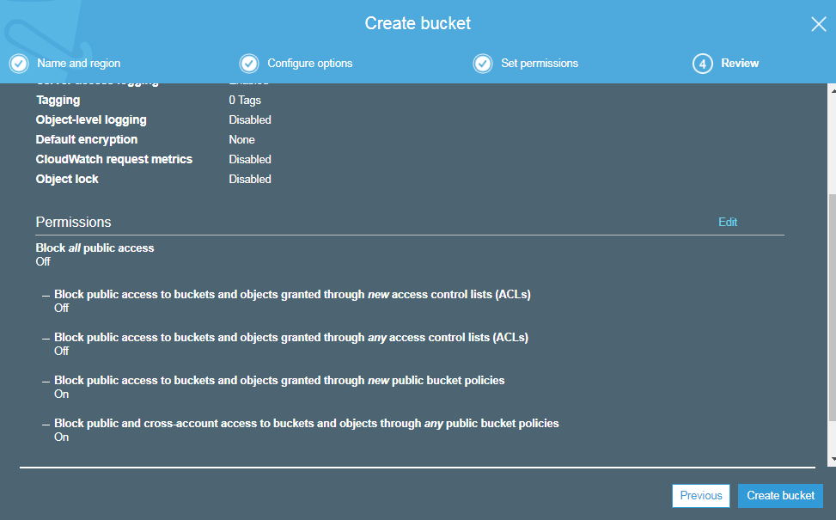

Click “**Create bucket**”

**Output**:

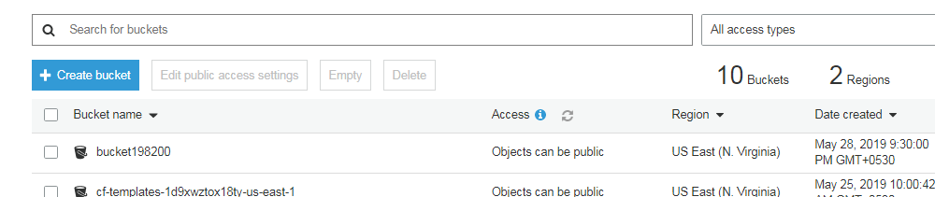

1. Upload the File

Click on the Bucket name

You should be able to see the below screen

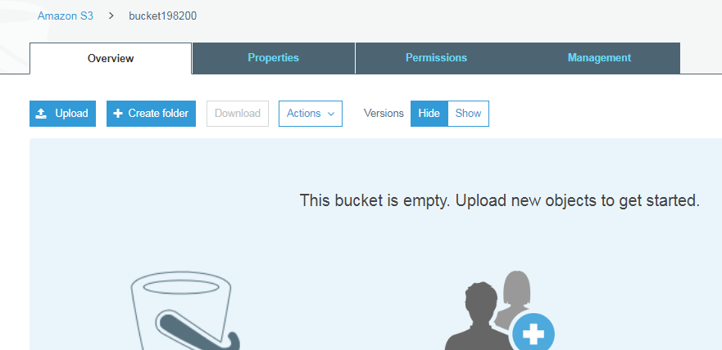

Click “**upload”**

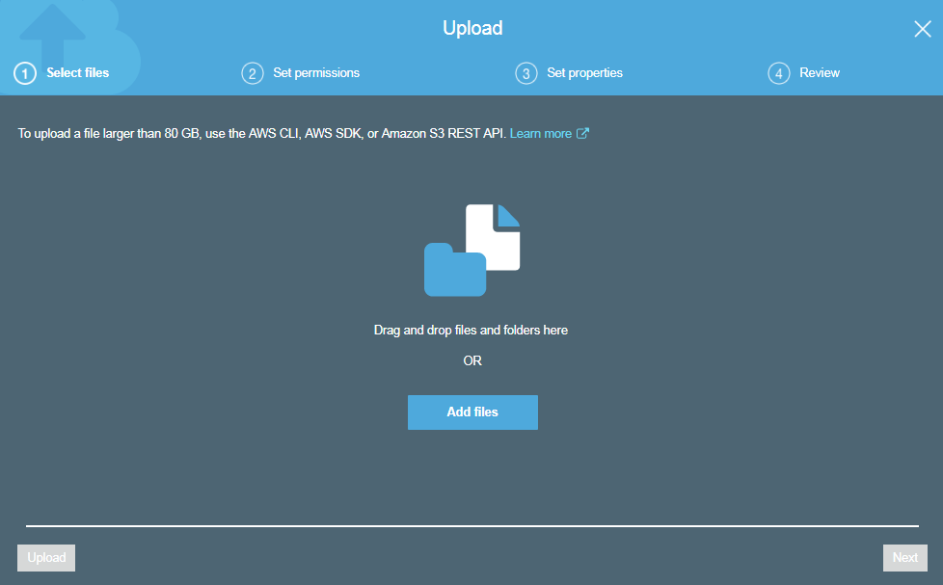

Click on **“Add Files”**

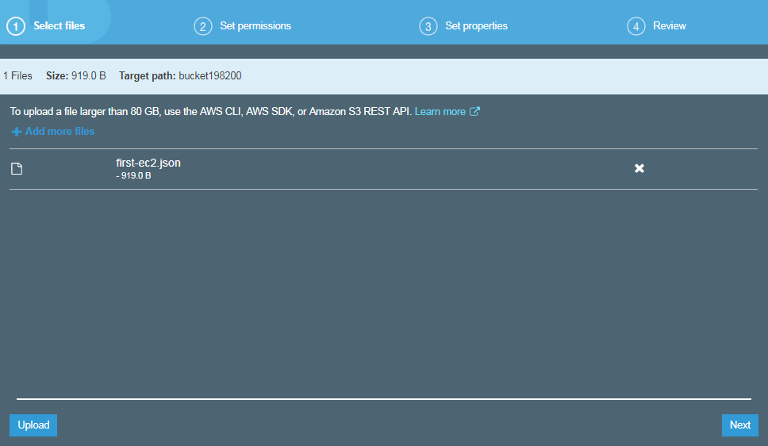

Click on **“NEXT”**

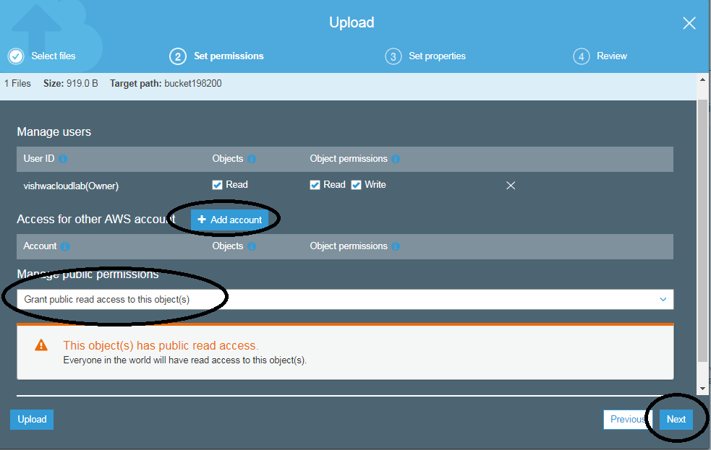

Select “**Grant public read access to this object”**

Then Click “**NEXT”**

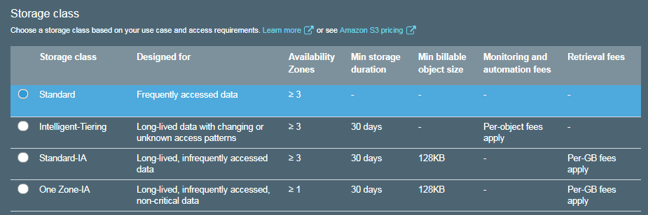

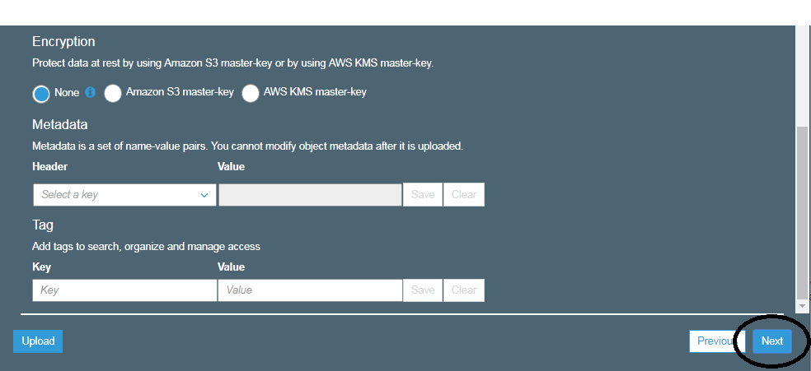

Note:-- If required we can enable “Encryption” on file/object level

Click on “**NEXT”**

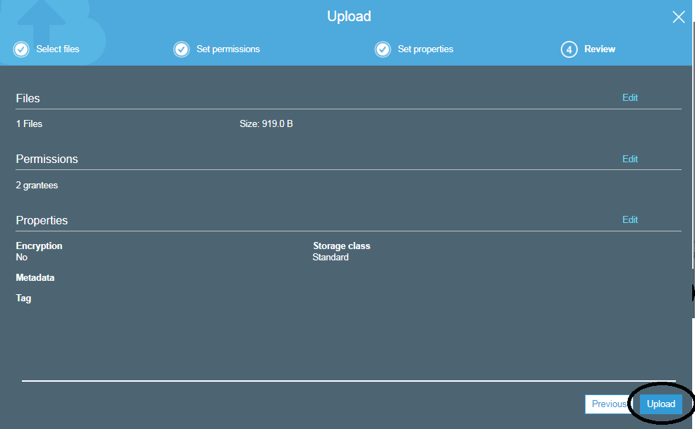

Click on “**UPLOAD”**

**OUTPUT:**

