🚀 ADVANCED AWS LAB: Build Python Web App on EC2 + S3 Upload + API Gateway + Lambda + RDS Logging

📌 Architecture Overview (Combined Scenario)
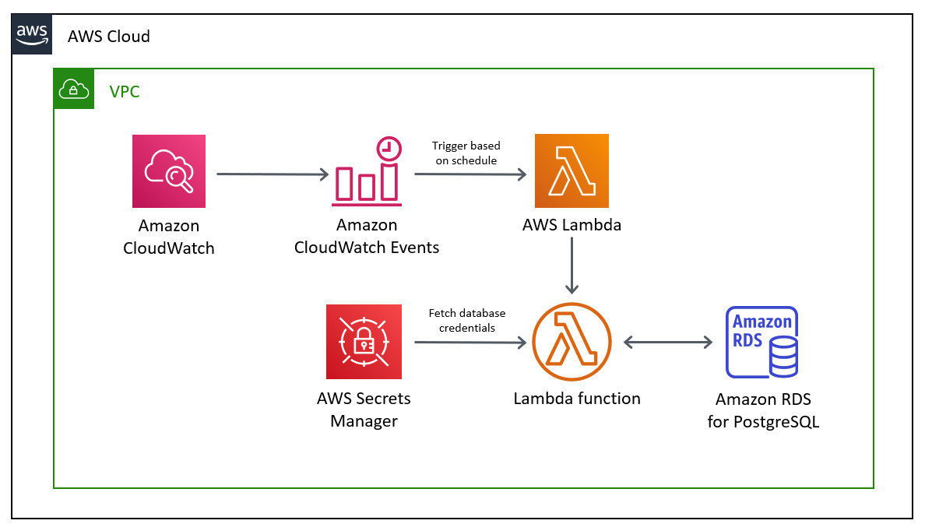
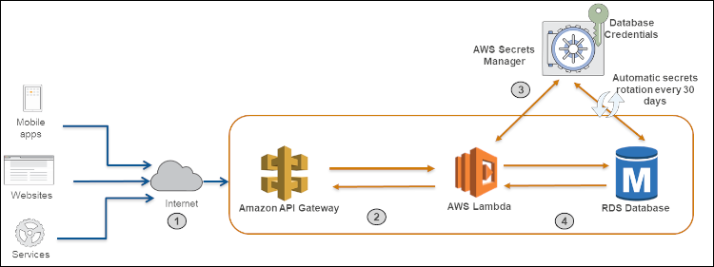
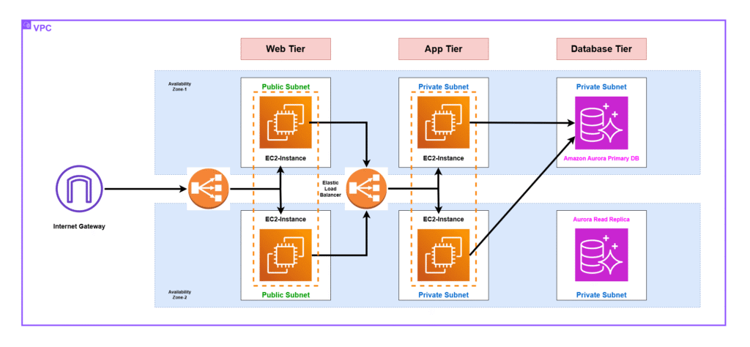
Flow Summary
- User accesses Flask web app on EC2 (Amazon Linux 2023).
- Website provides:
  - Upload file → S3 bucket
  - Click button → Calls API Gateway → triggers Lambda
  - Shows API response on UI
- Button click count is logged into RDS PostgreSQL.
- Webpage reads hit count from RDS and displays it.

SECTION 1 — EC2 SERVER SETUP (Amazon Linux 2023)
Step 1: Launch EC2 Instance
- OS: Amazon Linux 2023 AMI
- Instance type: t2.micro
- Security group:
  - Allow HTTP 80
  - Allow SSH 22
  - Allow outbound to:
    - S3
    - Secrets Manager
    - RDS Endpoint Port (default: 5432)
- IAM Role (VERY IMPORTANT): Attach the following policies:
  - AmazonS3FullAccess (or restricted bucket access)
  - AmazonRDSFullAccess (or new IAM policy for DB connection)
  - SecretsManagerReadWrite (read DB password)
  - CloudWatchFullAccess (optional for logs)

Step 2: Install Dependencies on EC2
SSH into EC2:
sudo dnf update -y
sudo dnf install python3 python3-pip git -y
=====Install Flask + AWS SDK + PostgreSQL Library:
pip3 install flask boto3 psycopg2-binary
====Create a working folder:
mkdir /home/ec2-user/myapp
cd /home/ec2-user/myapp

SECTION 2 — PREPARE THE WEB APPLICATION (Python + Flask)
Step 1: Create Flask App
Create file:
nano app.py
Paste the FULL Flask app: -- Filename : “web-python.code” from the github repo

Step 2: Create Data Table in PostgreSQL
SSH into EC2 → Use psql (optional: connect from pgAdmin).
CREATE TABLE apihits (
id SERIAL PRIMARY KEY,
action VARCHAR(50),
created_at TIMESTAMP DEFAULT CURRENT_TIMESTAMP
);

Step 3: Start Flask App
sudo python3 app.py
Or run as a service:

SECTION 3 — ENABLE SECRET READING FROM IAM ROLE
Ensure EC2 role has:
- secretsmanager:GetSecretValue
Example IAM inline policy:
{
"Version": "2012-10-17",
"Statement": [
{
"Effect": "Allow",
"Action": "secretsmanager:GetSecretValue",
"Resource": "*"
}
]
}

SECTION 4 — WEBSITE FEATURES YOU NOW HAVE
✔ Upload File → Stored in S3
✔ Button → Calls API Gateway → Lambda responds
✔ API Response output shown on webpage
✔ Button click stored in RDS PostgreSQL
✔ Total hits shown dynamically on webpage

SECTION 5 — FINAL VALIDATION
Open this in a browser:
http://<EC2-Public-IP>
Test:
- Upload S3 file → ✔ should succeed
- Click “Call API” → Lambda message should appear
- Refresh → hit count should increase
- RDS table apihits should show new rows

SECTION 6 — CLEANUP (OPTIONAL)
- Terminate EC2 instance
- Delete S3 objects
- Delete API Gateway
- Delete Lambda
- Remove Secrets Manager secrets
- Delete RDS instance

