Pre-requisite
Private VM (VM02) should be able to access the Amazon Web Services Amazon RDS MySQL database,

Make sure the “ec2-rds-x” security group is assigned to the VM02, as mentioned in the below screenshot
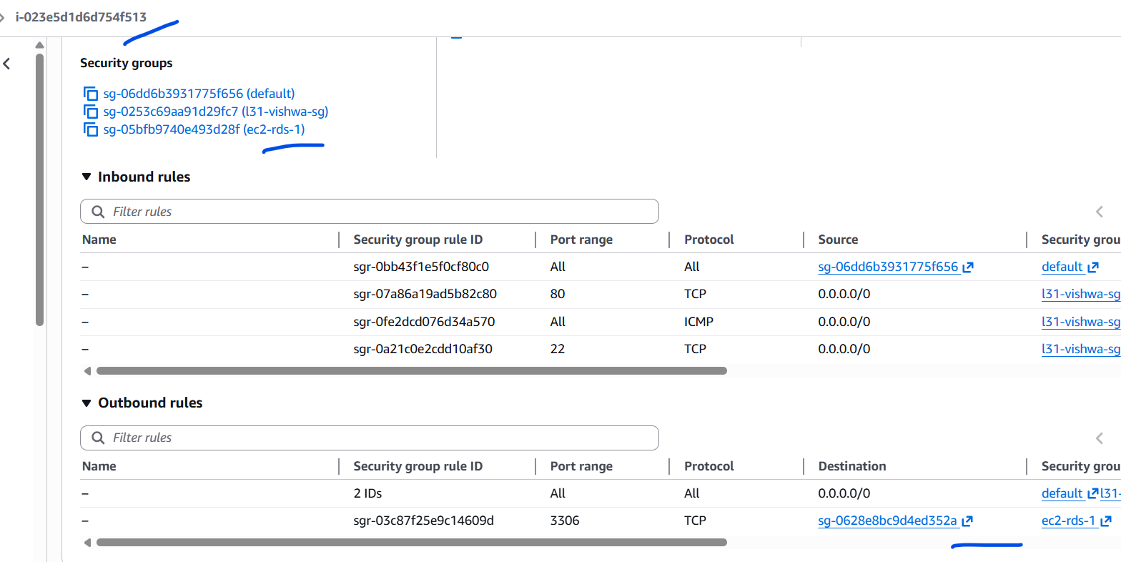

Confirm the connect to the DB from the VM02
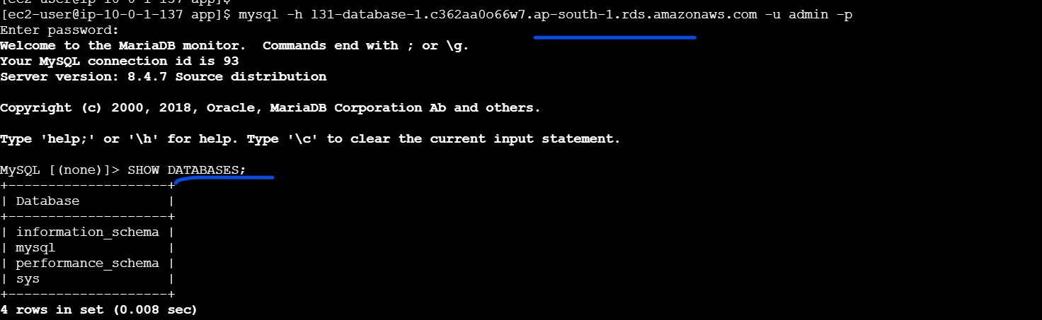
mysql -h l31-database-1.c362aa0o66w7.ap-south-1.rds.amazonaws.com -u admin -p

Now we can modify the Python app to:
- Connect to the MySQL database.
- Execute a simple query.
- Display the result in the browser through port 8000, which NGINX will proxy.

Below is a simple working example.

1️⃣ Install Required Python Library
On VM02 (Private instance)
pip3 install pymysql
If pip3 is not installed:
sudo dnf install python3-pip -y
Then install again:
pip3 install pymysql

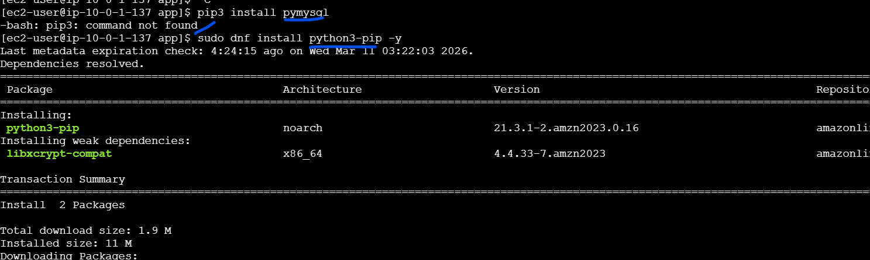
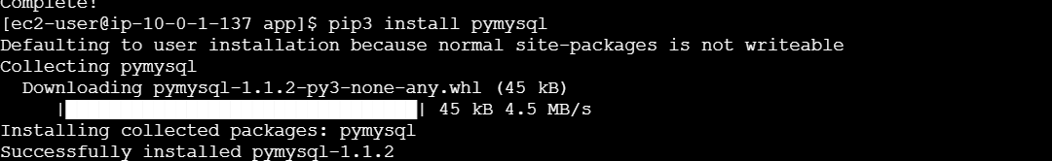

2️⃣ Python Application Code
Create the file:
nano app-db.py
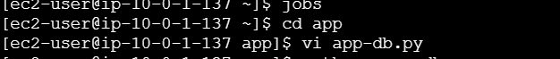
from http.server import BaseHTTPRequestHandler, HTTPServer
import pymysql

# RDS Configuration
DB_HOST = "your-rds-endpoint.rds.amazonaws.com"
DB_USER = "admin"
DB_PASS = "password"
DB_NAME = "testdb"
DB_PORT = 3306

def get_db_data():
try:
conn = pymysql.connect(
host=DB_HOST,
user=DB_USER,
password=DB_PASS,
database=DB_NAME,
port=DB_PORT
)

cursor = conn.cursor()
cursor.execute("SELECT NOW();")
result = cursor.fetchone()

conn.close()

return f"Database Connected Successfully.<br>DB Time: {result[0]}"

except Exception as e:
return f"Database Connection Failed: {str(e)}"

class handler(BaseHTTPRequestHandler):

def do_GET(self):

db_result = get_db_data()

self.send_response(200)
self.send_header('Content-type', 'text/html')
self.end_headers()

message = f"""
<html>
<head>
<title>Python App + RDS</title>
</head>

<body>
<h2>Hello from Private Python Server</h2>

<h3>Database Status</h3>
<p>{db_result}</p>

</body>
</html>
"""

self.wfile.write(message.encode())

server = HTTPServer(('0.0.0.0',8000), handler)
print("Server running on port 8000...")
server.serve_forever()

Edit the 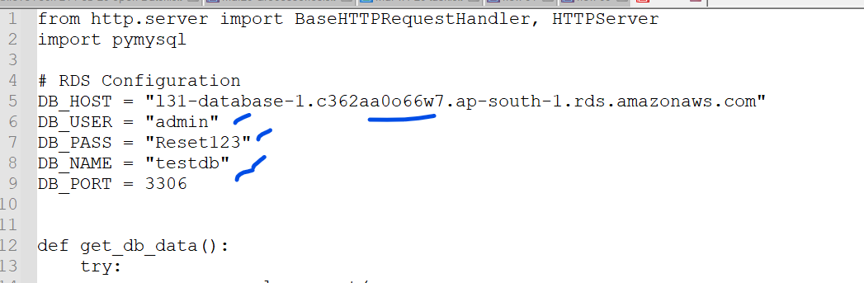

3️⃣ Create the table on the DB
First connect to the DB
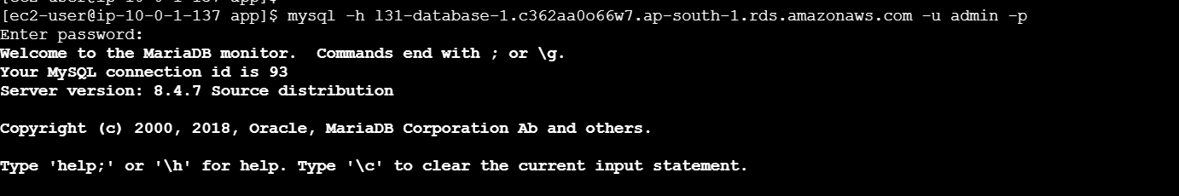
mysql -h l31-database-1.c362aa0o66w7.ap-south-1.rds.amazonaws.com -u admin -p

CREATE DATABASE testdb;
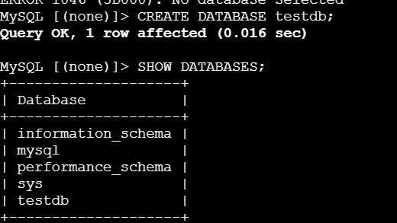
Verify:
SHOW DATABASES;
You should see:
testdb

4️⃣ Run the Application
python3 app-db.py &
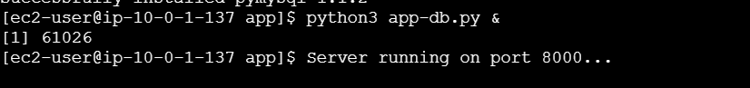

5️⃣ Test From Public Server
Your NGINX reverse proxy should already forward requests.
Open:
http://PUBLIC-EC2-IP
Expected output:
Hello from Private Python Server

Database Status
Database Connected Successfully
DB Time: 2026-03-11 10:32:00

Optional (Better Demo)
Create a sample table in your MySQL database:
CREATE TABLE students (
id INT AUTO_INCREMENT PRIMARY KEY,
name VARCHAR(50)
);

INSERT INTO students(name) VALUES
('Alice'),
('Bob'),
('Charlie');
Modify the query:
cursor.execute("SELECT * FROM students")
Then display the rows in HTML.

7. DB Output

Select the Database
USE testdb;
Show All Tables in the Database
SHOW TABLES;

