Below is an updated version of your 3-tier architecture where the database credentials are stored in AWS Secrets Manager instead of hardcoding them in the Python code.
This is the recommended security practice on Amazon Web Services when connecting applications to Amazon RDS using MySQL.

3-Tier Architecture (Secure Version)
Internet
|
Public EC2
(NGINX Reverse Proxy :80)
|
Private EC2 (VM02)
(Python App :8000)
|
AWS Secrets Manager
|
Amazon RDS MySQL
Public tier uses NGINX and the application tier retrieves database credentials securely.

1. Store Database Credentials in AWS Secrets Manager
Go to AWS Console → Secrets Manager
Create a new secret.
Secret Type
Credentials for RDS database
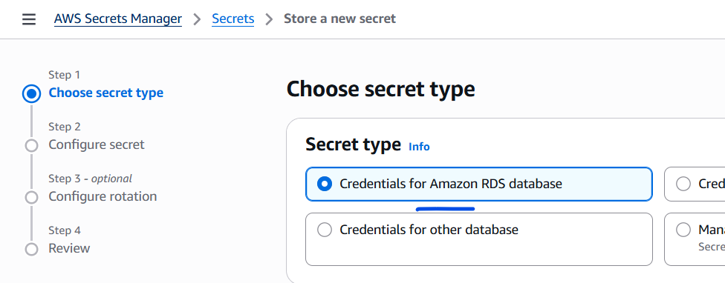
Key Value Pairs
Example:
username : admin
password : MyDBPassword123
host : mydb.xxxxxx.ap-south-1.rds.amazonaws.com
dbname : testdb
port : 3306
Secret name example:
rds-mysql-secret
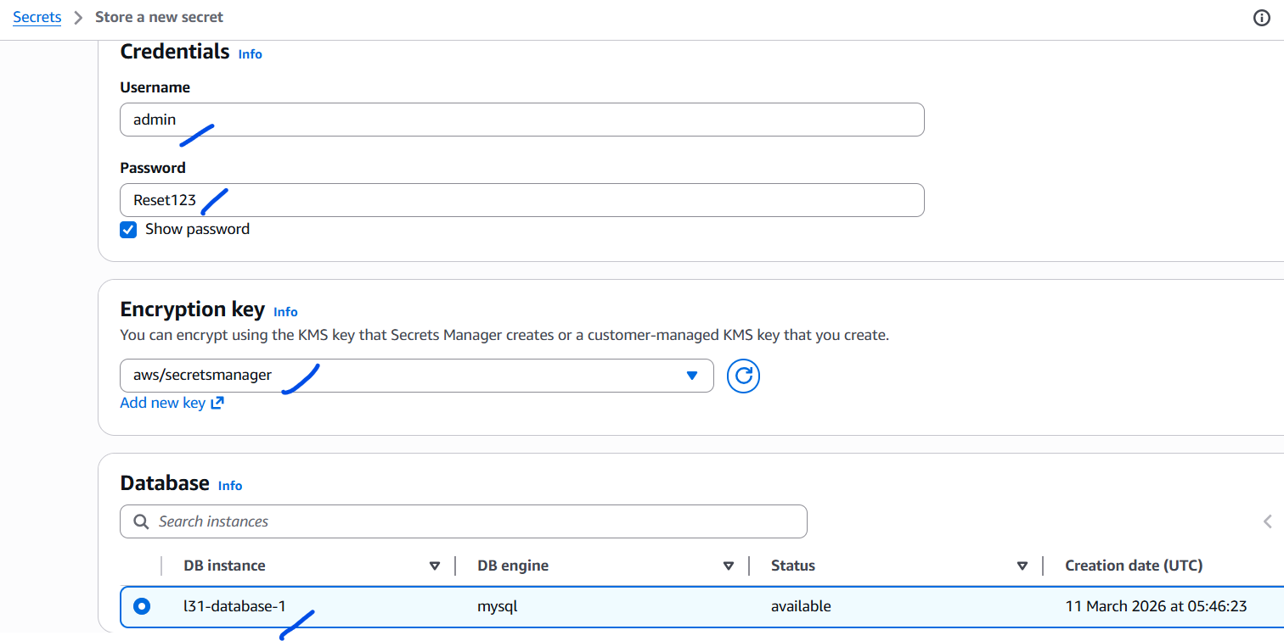
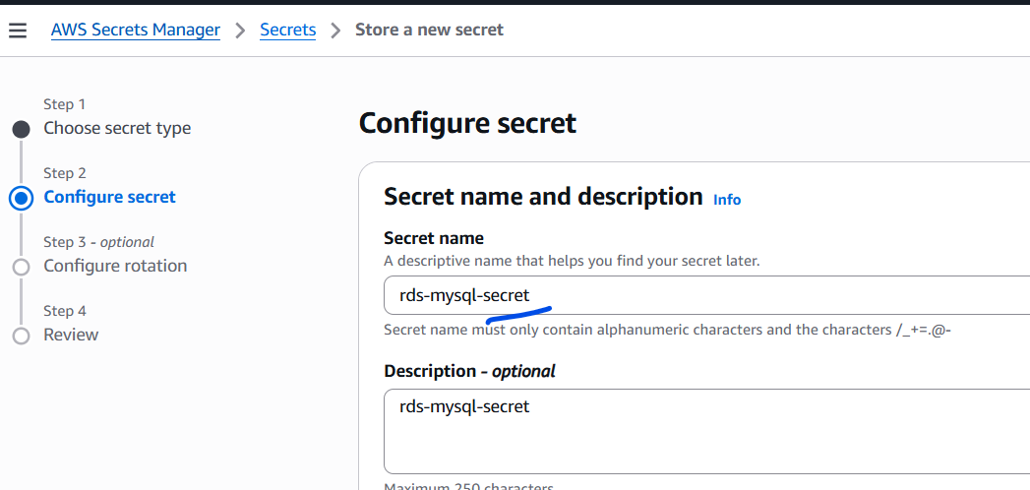
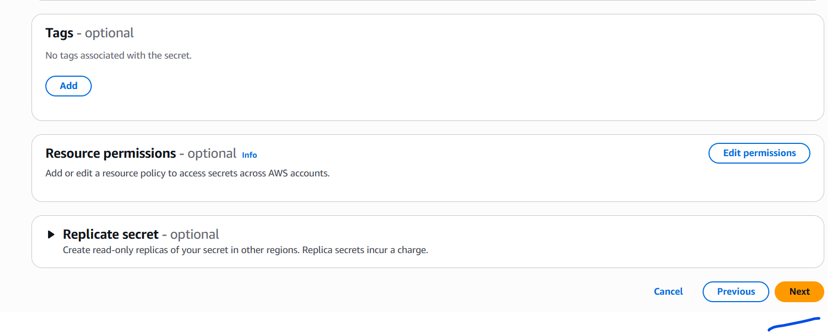
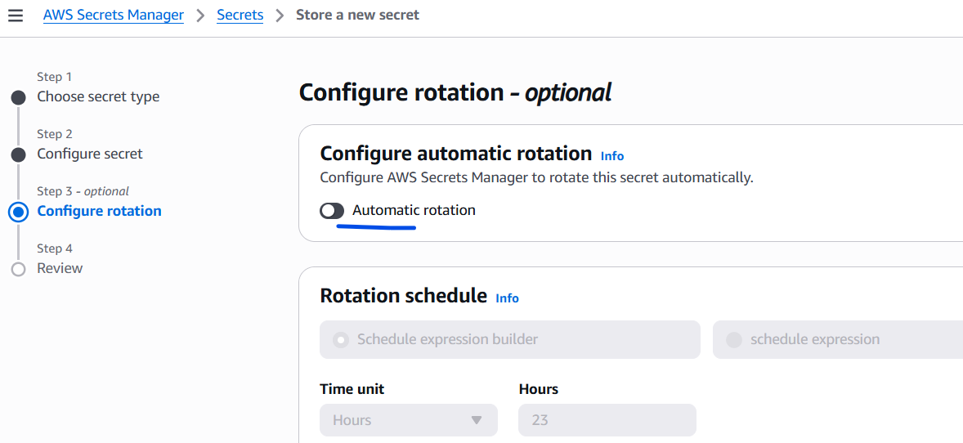For this lab, we will keep the “auto rotation” off.
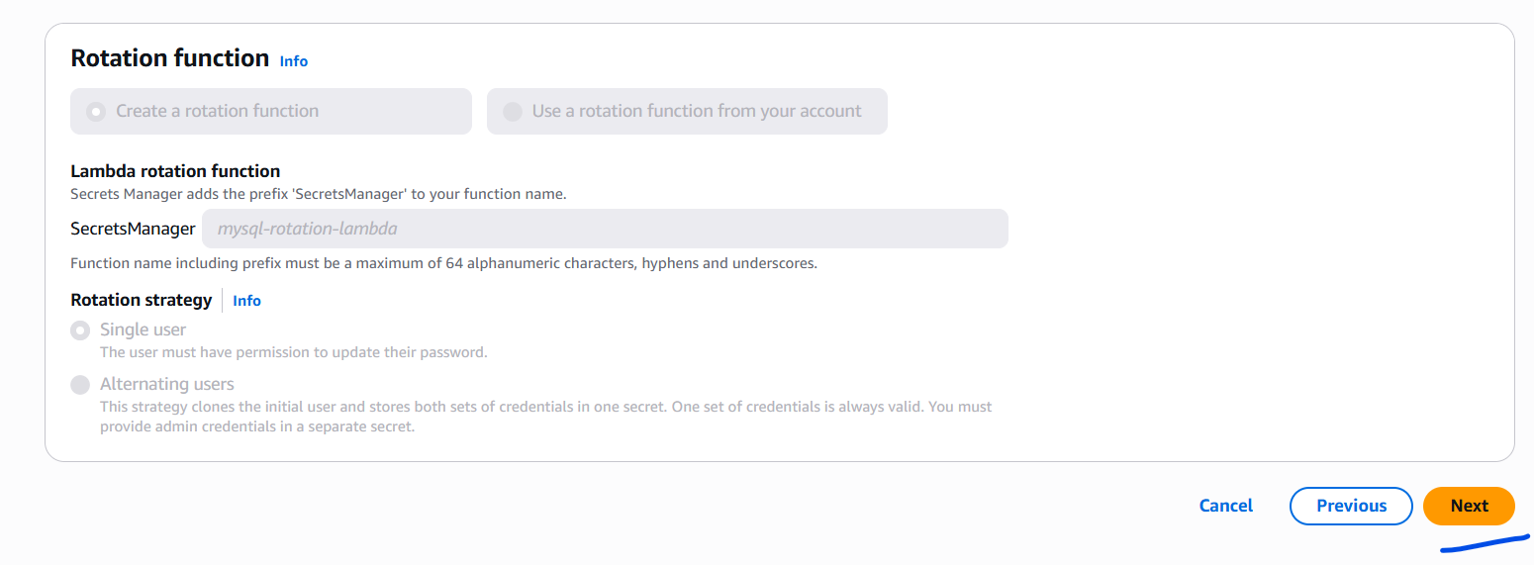
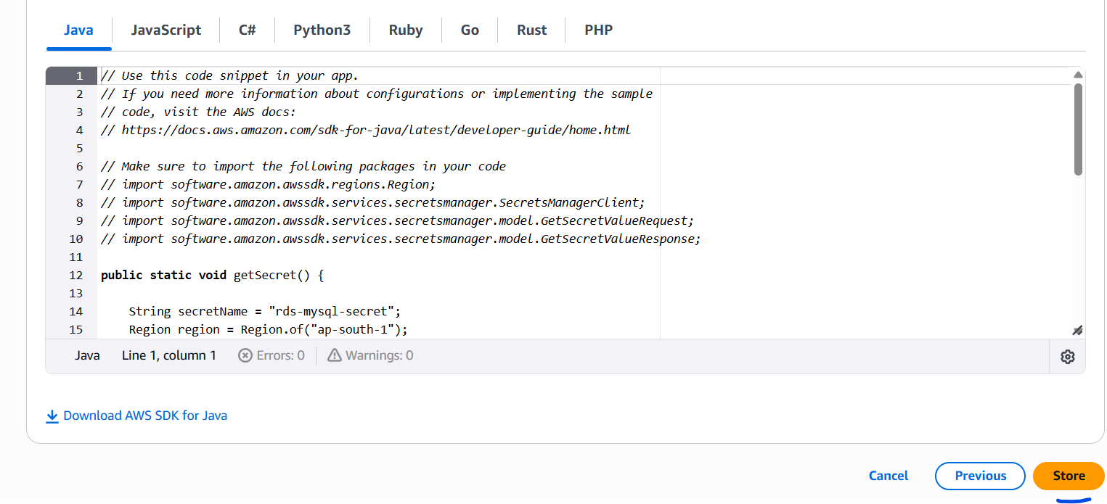
Click on “store”
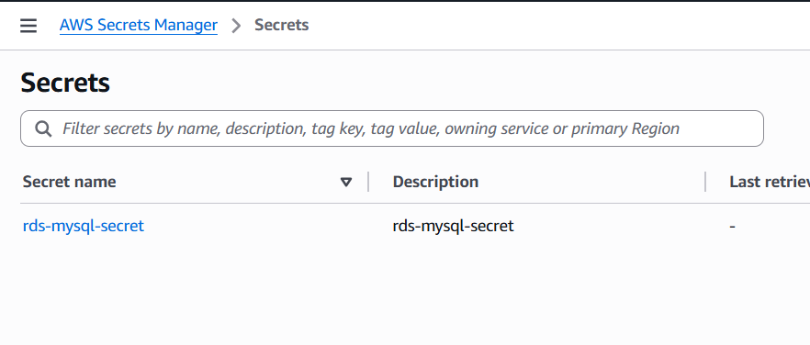

2. Attach IAM Role to VM02
Your private EC2 instance must have permission to read the secret.
Create an IAM Role with policy:
SecretsManagerReadRole
Policy example:
{
"Version": "2012-10-17",
"Statement": [
{
"Effect": "Allow",
"Action": [
"secretsmanager:GetSecretValue"
],
"Resource": "*"
}
]
}
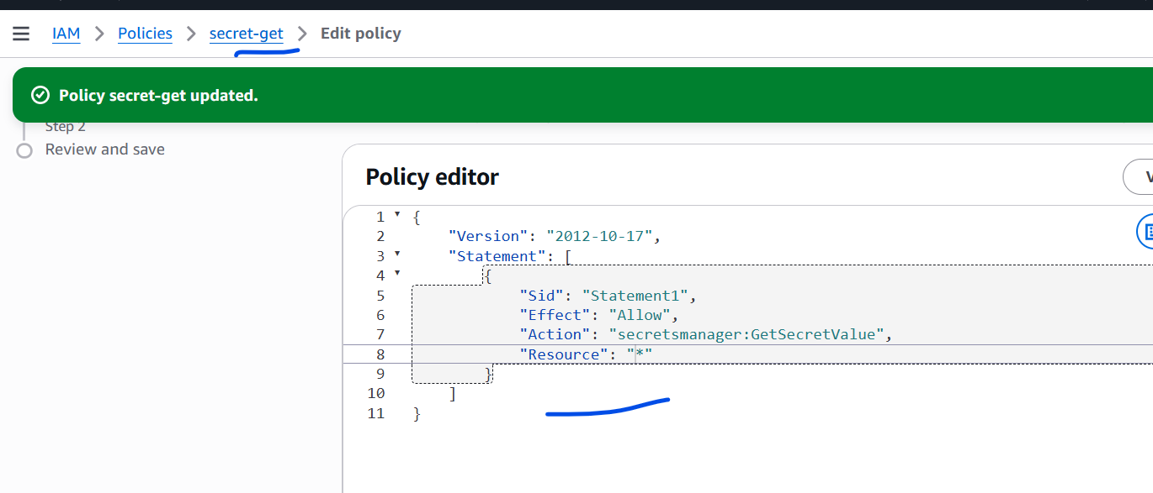
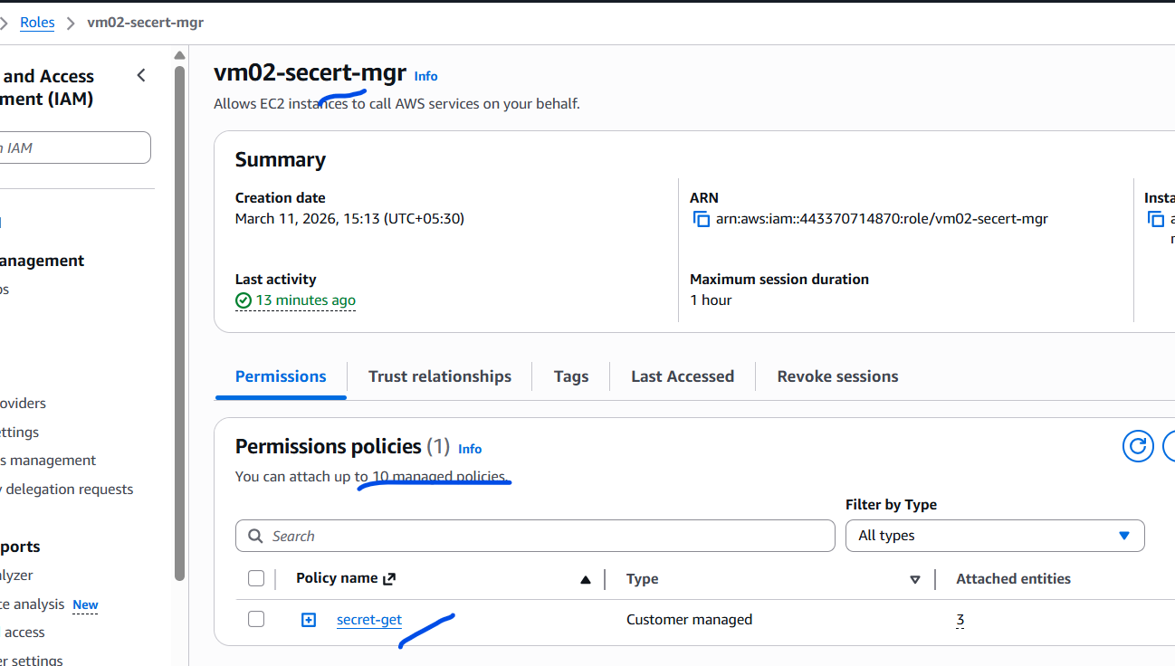
Attach this role to VM02 EC2 instance.
This allows the instance to access AWS Secrets Manager securely without storing credentials locally.

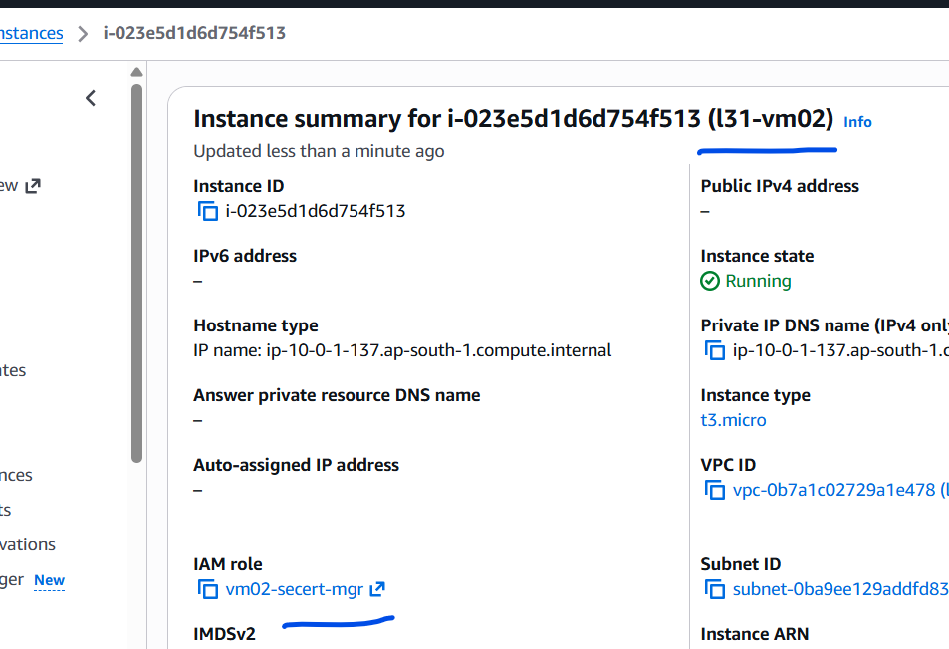
The role is assigned to the VM02

3. Install Required Python Libraries
On VM02
pip3 install pymysql boto3
Libraries used:
- PyMySQL → MySQL connectivity
- boto3 → AWS SDK for Python

4. Create the Hit Counter Table
Select the Database
USE testdb;
Verify:
SHOW TABLES;
Create the Hit Counter Table
CREATE TABLE page_hits (
id INT PRIMARY KEY,
hits INT
);
Insert Initial Row
INSERT INTO page_hits VALUES (1,0);
Verify
SELECT * FROM page_hits;
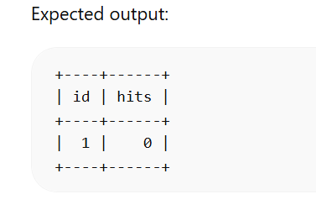

5. Updated Python Application
Filename --- app-db-secret.py
from http.server import BaseHTTPRequestHandler, HTTPServer
import pymysql
import boto3
import json

SECRET_NAME = "rds-mysql-secret"
REGION = "ap-south-1"

def get_secret():

session = boto3.session.Session()
client = session.client(
service_name='secretsmanager',
region_name=REGION
)

response = client.get_secret_value(
SecretId=SECRET_NAME
)

secret = json.loads(response['SecretString'])

return secret

def get_db_data():

try:

secret = get_secret()

connection = pymysql.connect(
host=secret['host'],
user=secret['username'],
password=secret['password'],
database=secret['dbname'],
port=int(secret['port'])
)

cursor = connection.cursor()
cursor.execute("SELECT NOW();")

result = cursor.fetchone()

connection.close()

return f"Database Connected Successfully<br>DB Time: {result[0]}"

except Exception as e:

return f"Database Connection Failed: {str(e)}"

class handler(BaseHTTPRequestHandler):

def do_GET(self):

db_status = get_db_data()

self.send_response(200)
self.send_header('Content-type', 'text/html')
self.end_headers()

message = f"""
<html>
<body>
<h2>3 Tier Architecture Demo</h2>

<h3>Application Server : VM02</h3>

<h3>Database Status</h3>
{db_status}

</body>
</html>
"""

self.wfile.write(message.encode())

server = HTTPServer(('0.0.0.0',8000), handler)

print("Server running on port 8000")

server.serve_forever()

5. Run the Application
python3 app-db-secret.py

Run in background:
nohup python3 app-db-secret.py &

6. Test the Complete Flow
Open browser:
http://PUBLIC-EC2-IP

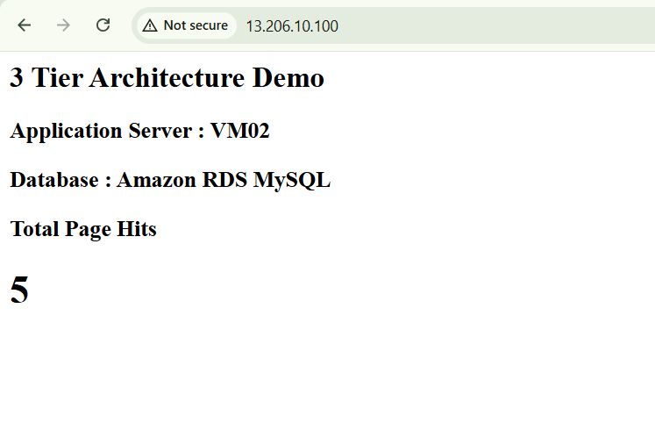

Request flow:
User Browser
|
v
Public EC2 (NGINX)
|
v
Private EC2 Python App
|
v
AWS Secrets Manager
|
v
Amazon RDS MySQL
Expected output:
3 Tier Architecture Demo

Application Server : VM02

Database Connected Successfully
DB Time : 2026-03-11 14:10:00

7. Verify Connectivity (Troubleshooting)
Test Secrets Access
aws secretsmanager get-secret-value \
--secret-id rds-mysql-secret \
--region ap-south-1
Test RDS Connection
mysql -h <rds-endpoint> -u admin -p
Test Python Server
curl localhost:8000

8. Security Best Practices Implemented
✔ No DB credentials in code
✔ IAM Role authentication
✔ Secrets stored in AWS Secrets Manager
✔ Private subnet database access
✔ Reverse proxy via NGINX

✅ This is now a proper cloud production pattern used in real deployments on Amazon Web Services.

