You can configure NGINX as a reverse proxy so that requests coming to the public EC2 instance are forwarded to the private EC2 instance running a Python app on port 8000.
Below is a simple architecture and step-by-step setup.

1️⃣ Architecture
Internet
|
v
Public EC2 (Nginx) --- Private VPC Network ---> Private EC2 (Python App :8000)
| |
Port 80 Port 8000
- Public VM → Has public IP
- Private VM → Only private IP
- Nginx forwards requests to Python app

Step 1 — Security Group Configuration
Public EC2 (NGINX)
Allow:
Port | Source
80 | 0.0.0.0/0
22 | Your IP
8000 | Private EC2 SG (optional)

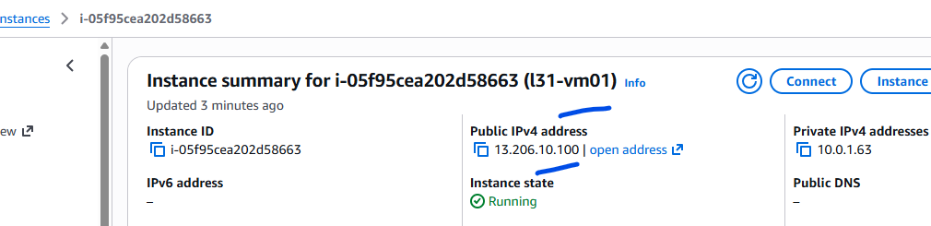
This is the public vm
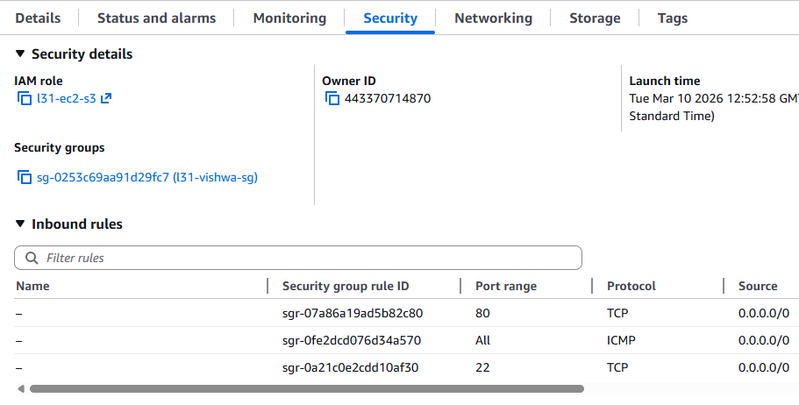
All the required ports opened

Also assign “Default Security group on both the VM , so that it can communicate on any port.
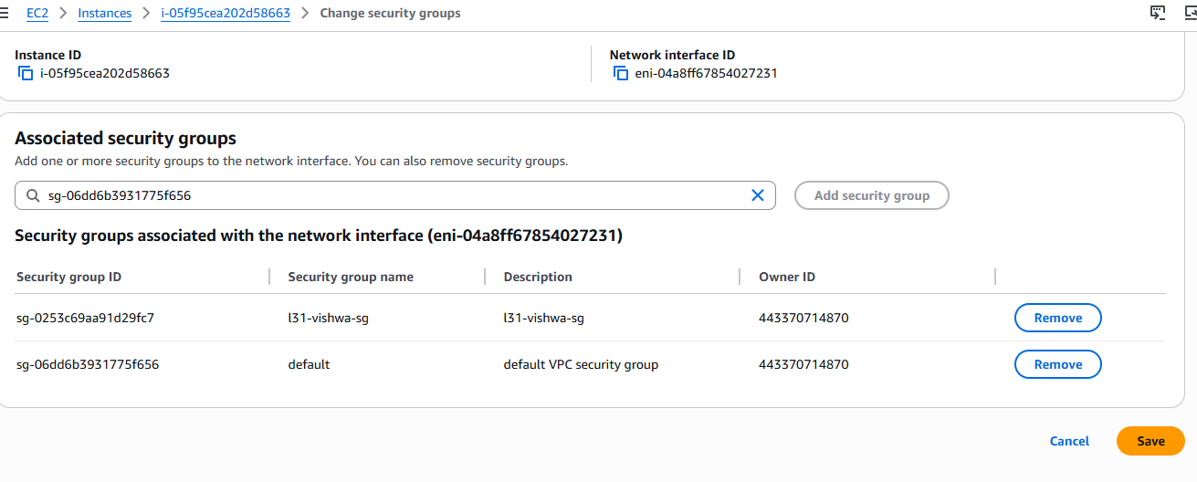
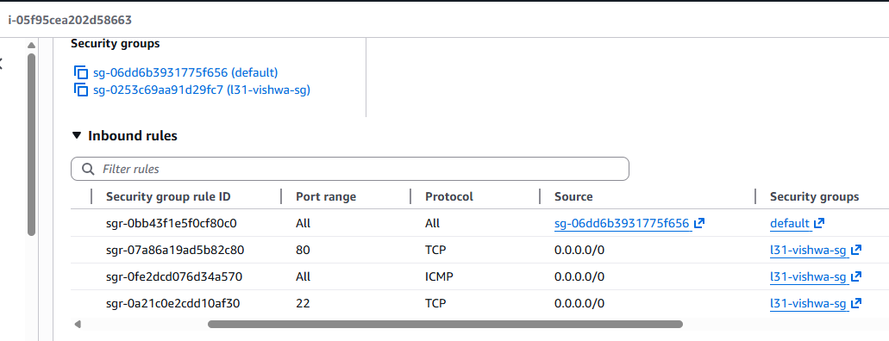

Private EC2 (Python App)
Allow:
Port | Source
8000 | Public EC2 Security Group
22 | Public EC2
This ensures only Nginx server can access the app.

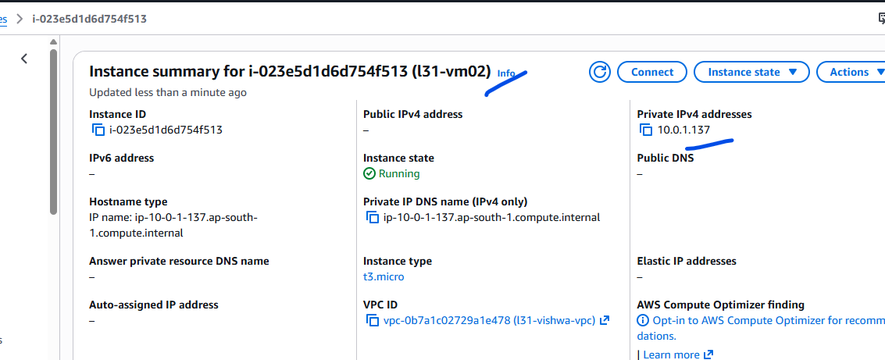
This is private VM for running python with internet access.
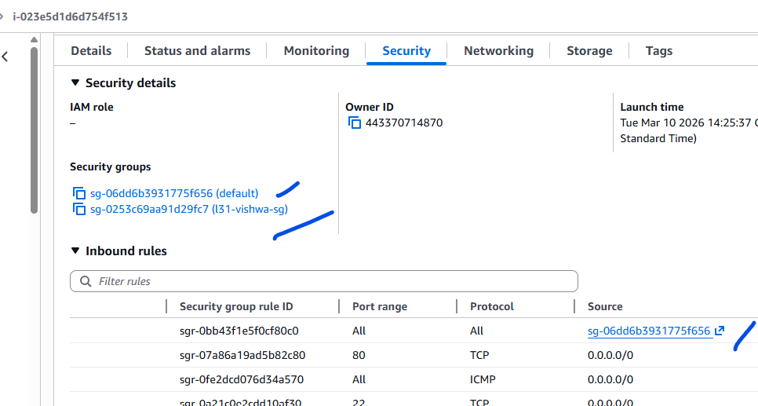

Step 2 — Install Python on Private VM
SSH to the private instance.
sudo dnf install python3 -y
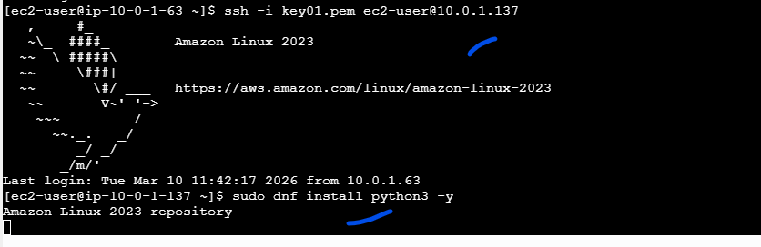
Create a simple Python app.
mkdir app
cd app
vi app.py
from http.server import BaseHTTPRequestHandler, HTTPServer

class handler(BaseHTTPRequestHandler):
def do_GET(self):
self.send_response(200)
self.send_header('Content-type','text/html')
self.end_headers()
self.wfile.write(b"Hello from Private Python Server")

server = HTTPServer(('0.0.0.0',8000), handler)
server.serve_forever()
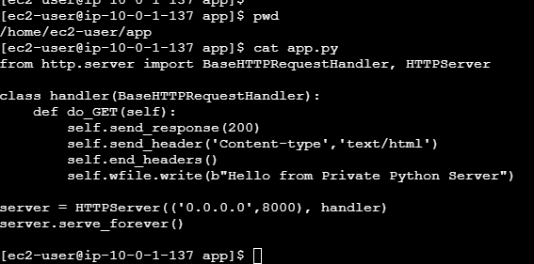
Run it:
python3 app.py &
Check locally:
curl localhost:8000
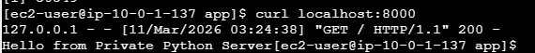

Step 3 — Get Private IP of Python Server
Example:
10.0.1.137

Step 4 — Configure Nginx Reverse Proxy (Public VM) ( create another session on aws to run the below commands)
Edit nginx config:
sudo vi /etc/nginx/conf.d/python.conf
server {
listen 80;

location / {
proxy_pass http://10.0.1.137:8000;
proxy_set_header Host $host;
proxy_set_header X-Real-IP $remote_addr;
}
}
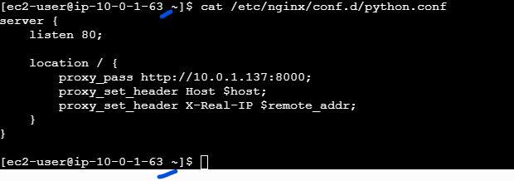

Step 5 — Restart Nginx
sudo nginx -t
sudo systemctl restart nginx
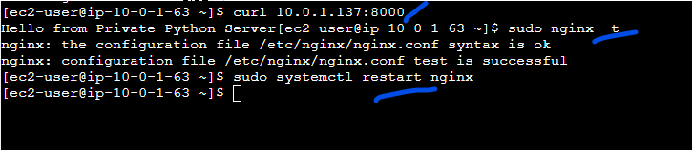

Step 6 — Test
Open browser:
http://PUBLIC_EC2_IP
Expected output:
Hello from Private Python Server


7️⃣ Optional (Better Python App Server)
Instead of simple Python HTTP server, use Gunicorn with Flask.
Example:
pip3 install flask gunicorn
Run:
gunicorn -b 0.0.0.0:8000 app:app
This is production ready.

8️⃣ Real Production Architecture
Internet
|
Route53 / DNS
|
ALB
|
Public EC2 (NGINX Reverse Proxy)
|
Private EC2 (Flask/Gunicorn App)

