EC2 LAB Scenarios

- Create and login to the EC2 instance for the below mentioned with putty ad xshell.
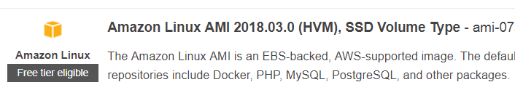
Note:-- If you are not able to login to the EC2 instance.
Check the below point
- Use the public ip on the EC2 instance to login
- Do you have an internet Gateway and is it attached to an VPC.
- Does your Route Table (Default Route table) has the “0.0.0.0/0” pointing towards the Internet Gateway

- Create and login to the EC2 instance for the below mentioned with putty ad xshell.

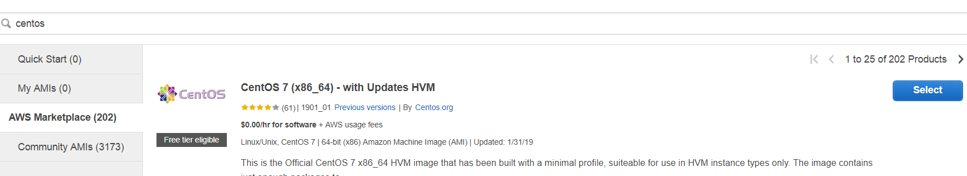

- Create and login to the EC2 instance for the below mentioned with putty ad xshell.
