Steps:

- Create a repo on the github
- Add a file and commit
- Update the file & Check the commit

- Create a repo on the github

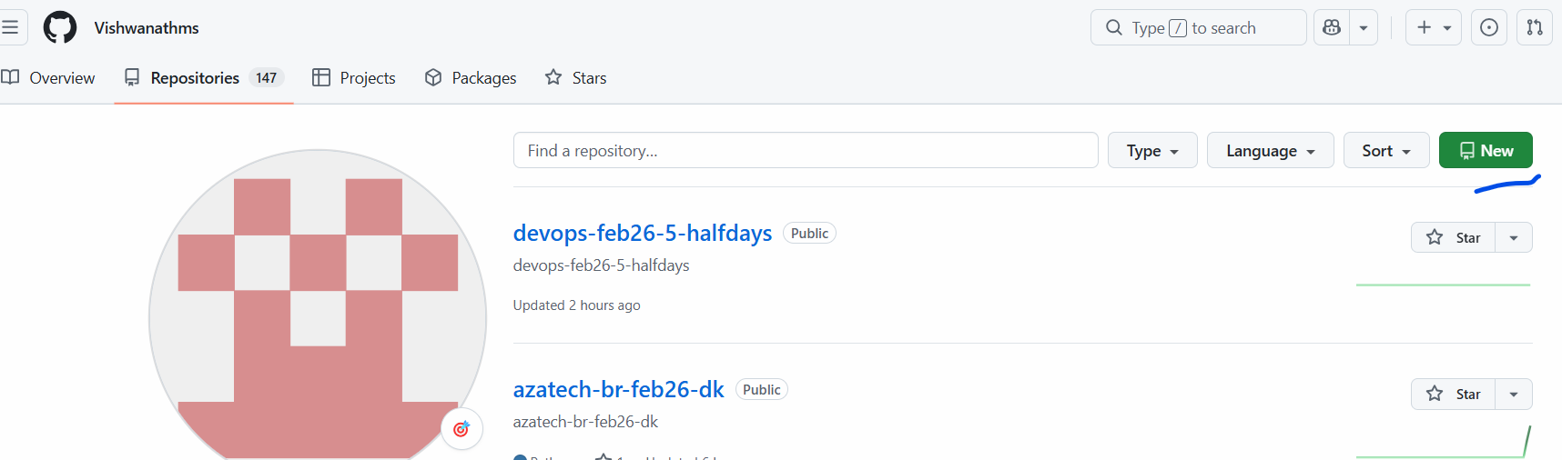

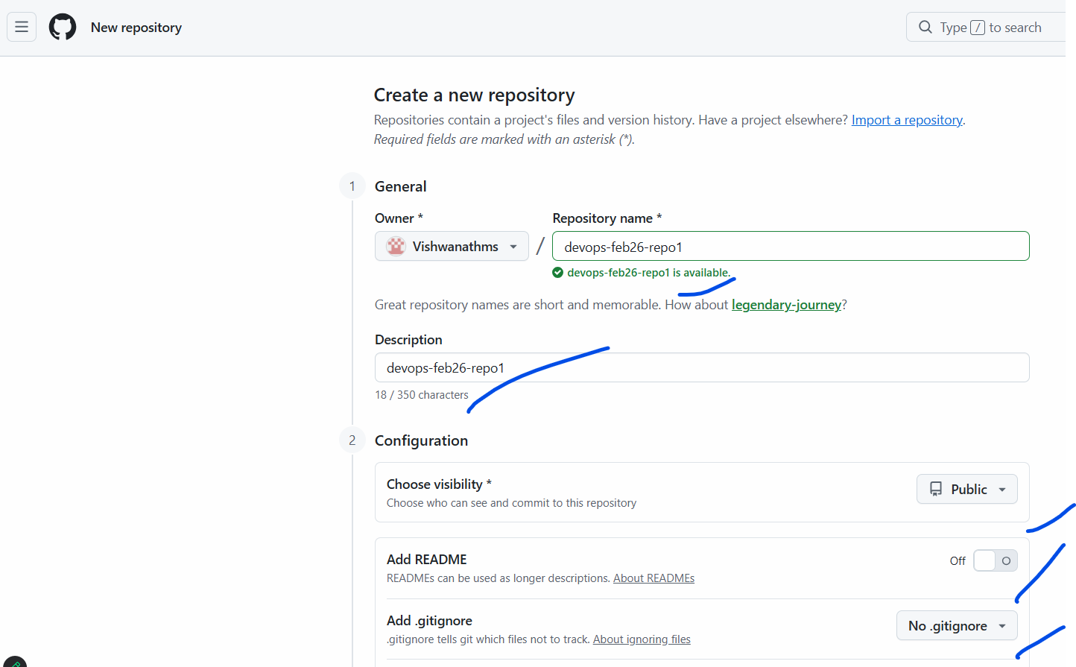
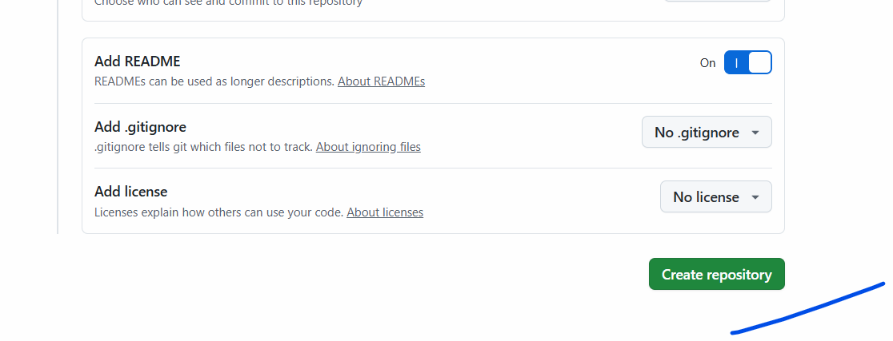
Click on create repository.
This repo can be accessed by anyone.

- Add a file and commit
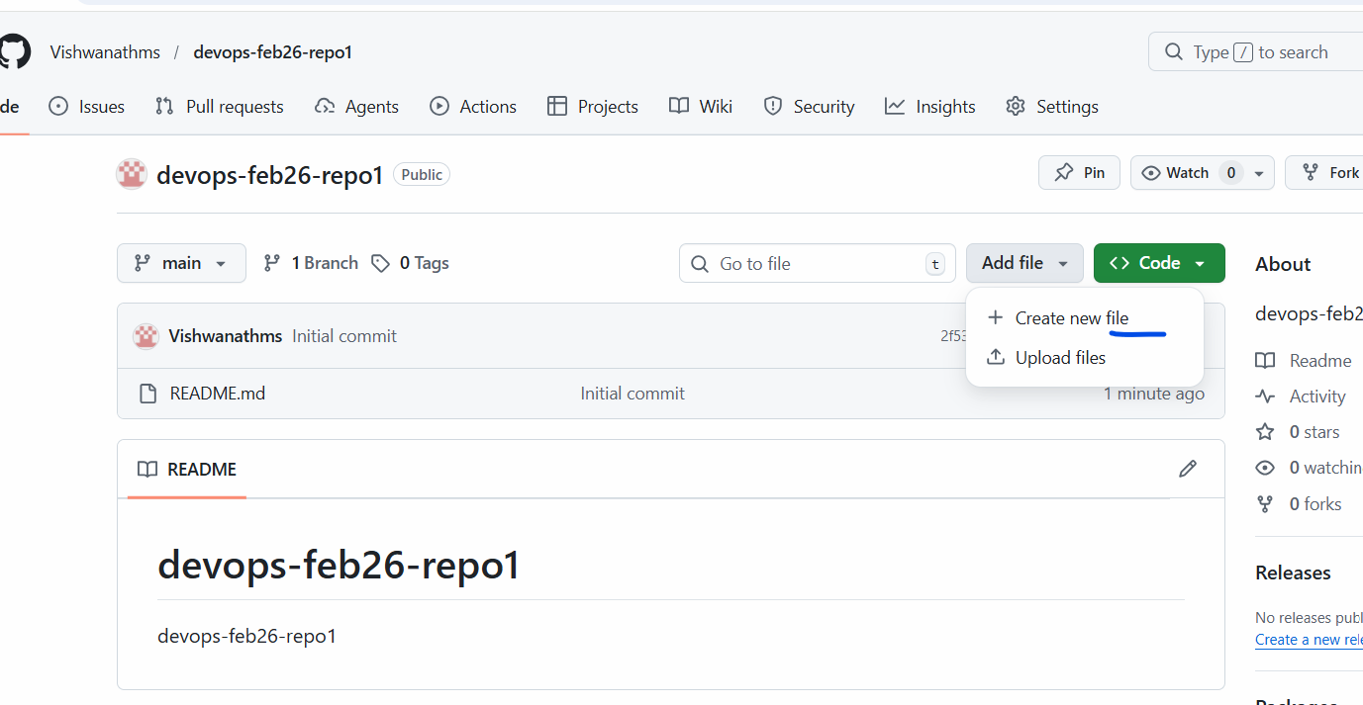
Click on “Create file”
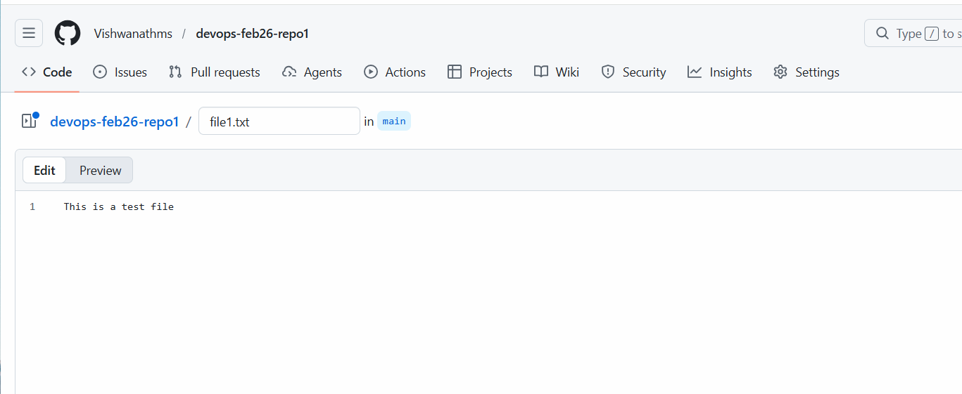
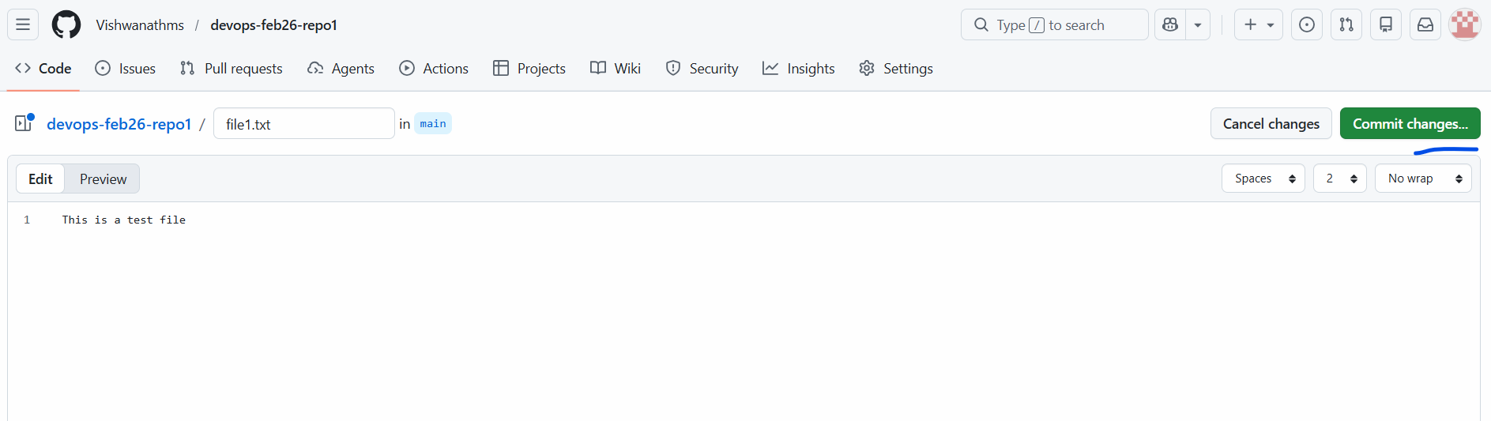
Click on “Commit Changes”.
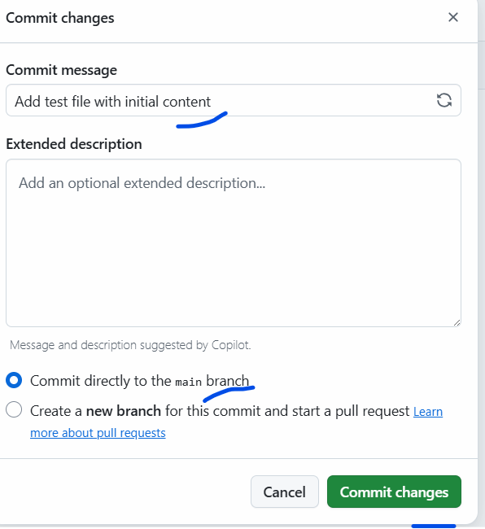

There is an new file created
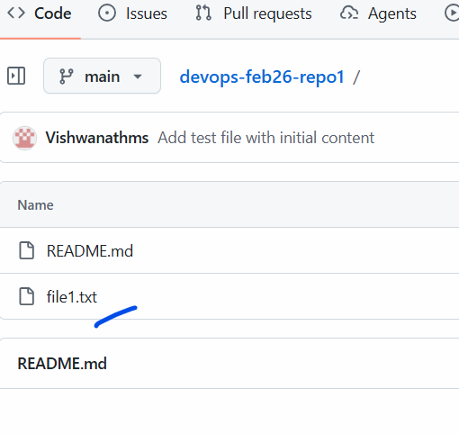
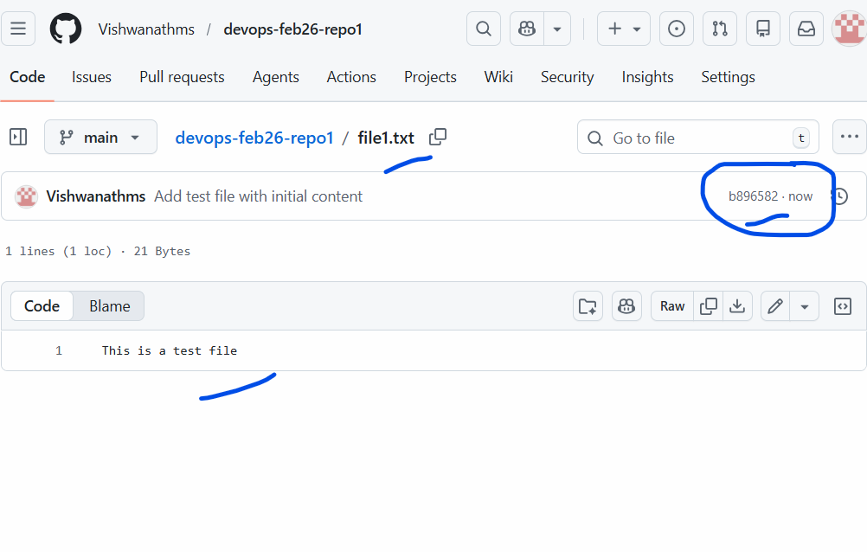
There is also an commit ID created , marked in circle.
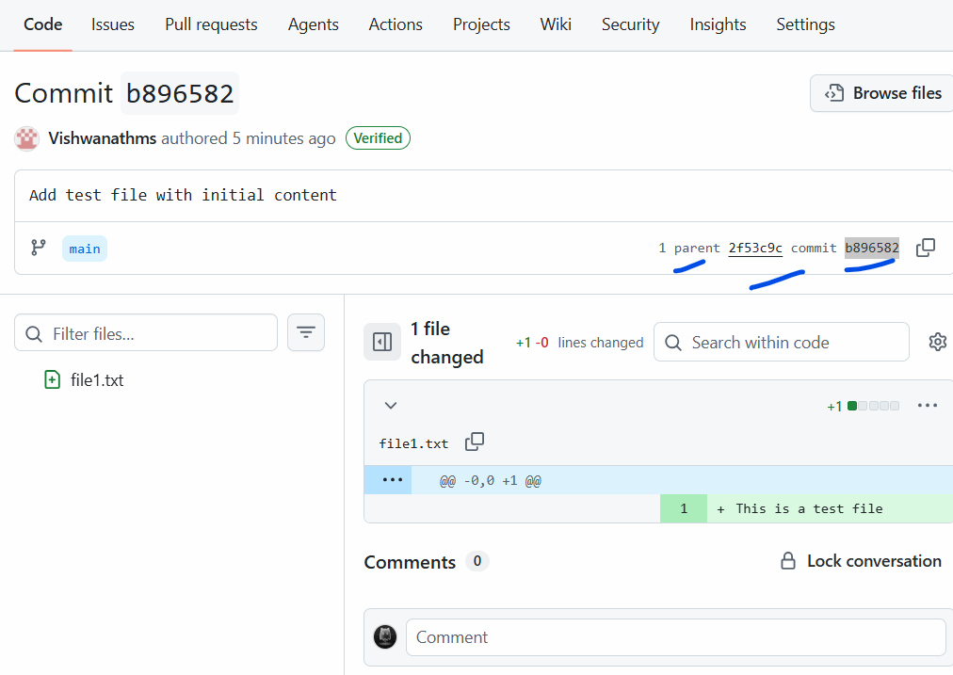

- Update the file

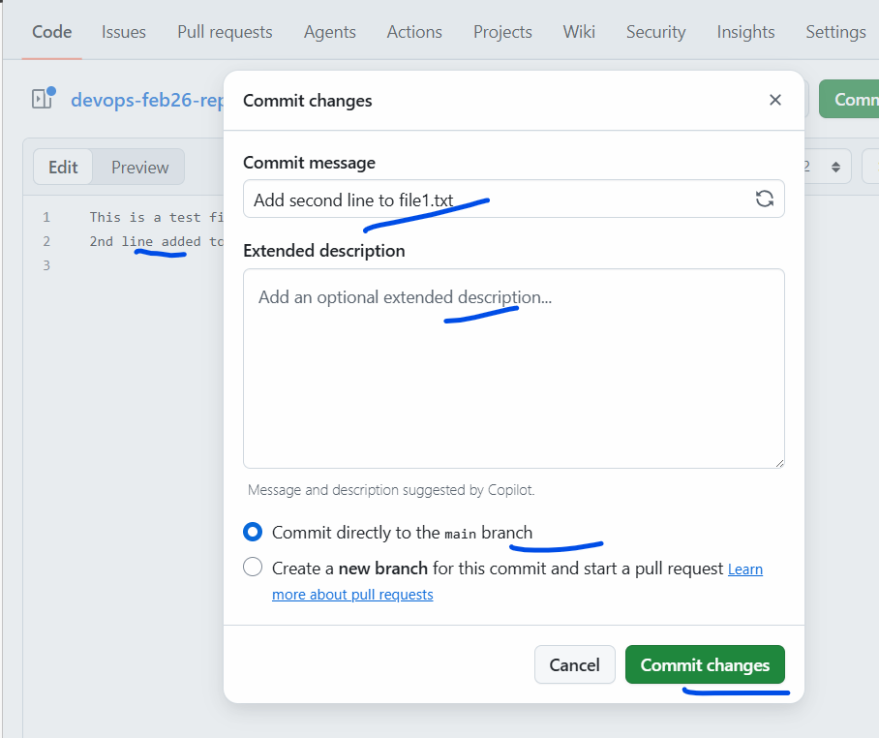
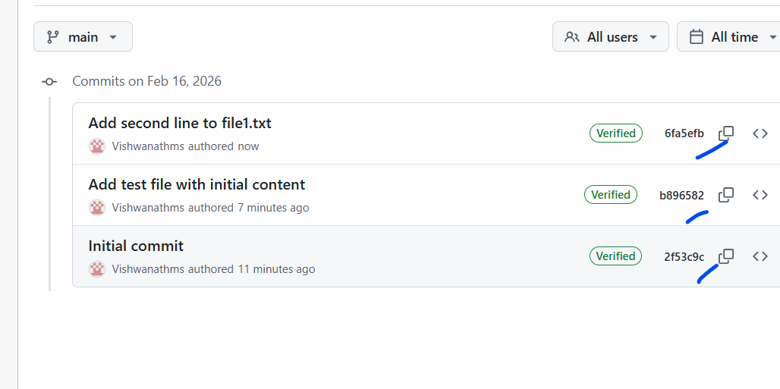
Now there are 3 commits.
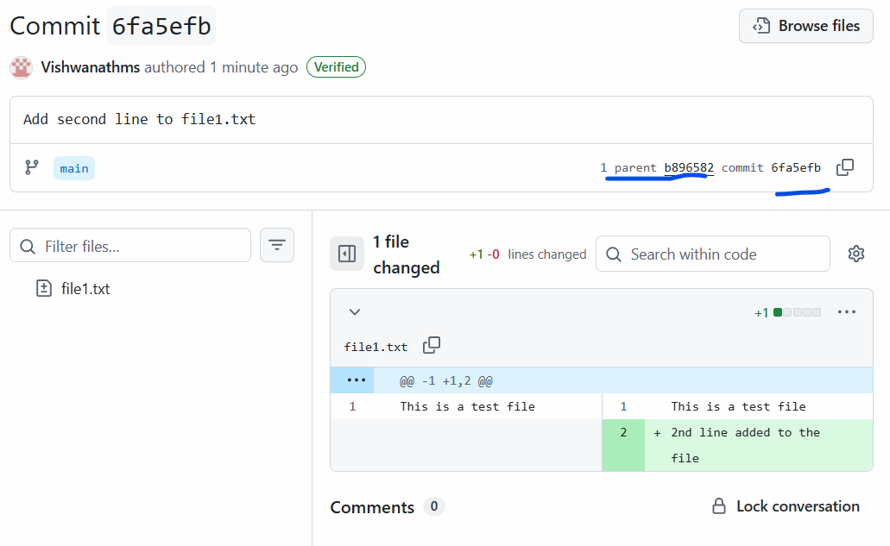
Now previously which was the commit ID , has become the parent commit ID for the new ONE.

