Key-based-Authentication-github

Steps:

- Create the key on the local VM
- Copy the key to the github

- Create the key on the local VM

$ ssh-keygen -t rsa

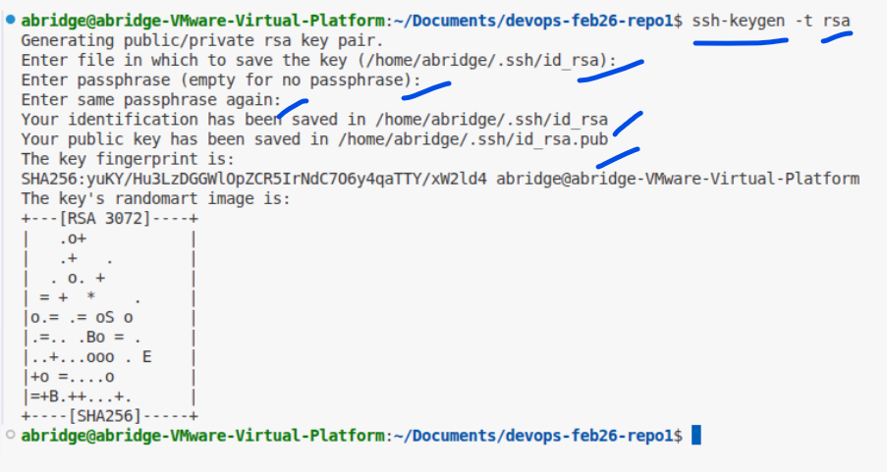
This would create public key and a private key
For github authorization, we need to copy the public key to the github
$ cat /home/abridge/.ssh/id_rsa.pub

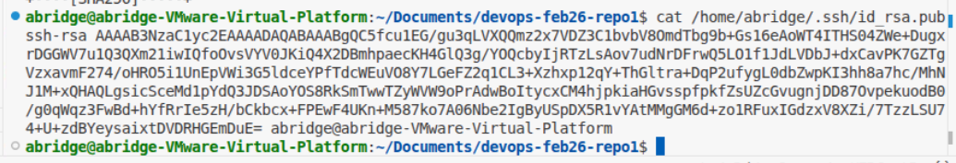

Copy the public key , end to end
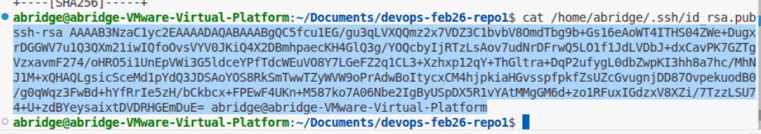

- Copy the key to the github

Now go to github , click on top right corner on the icon
And click on “settings”
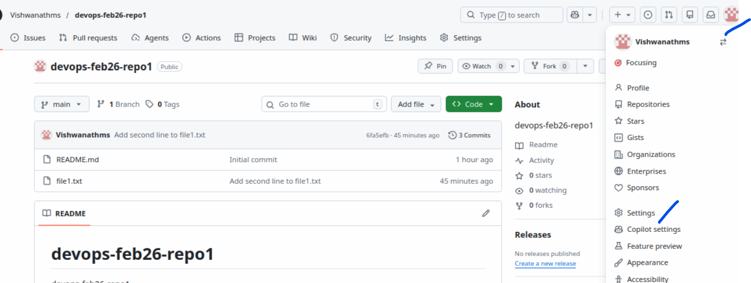
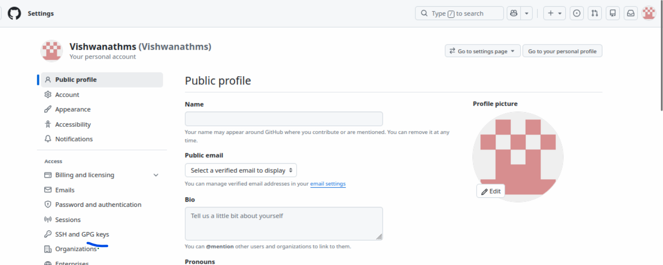
Click on the “SSH and GPG keys”

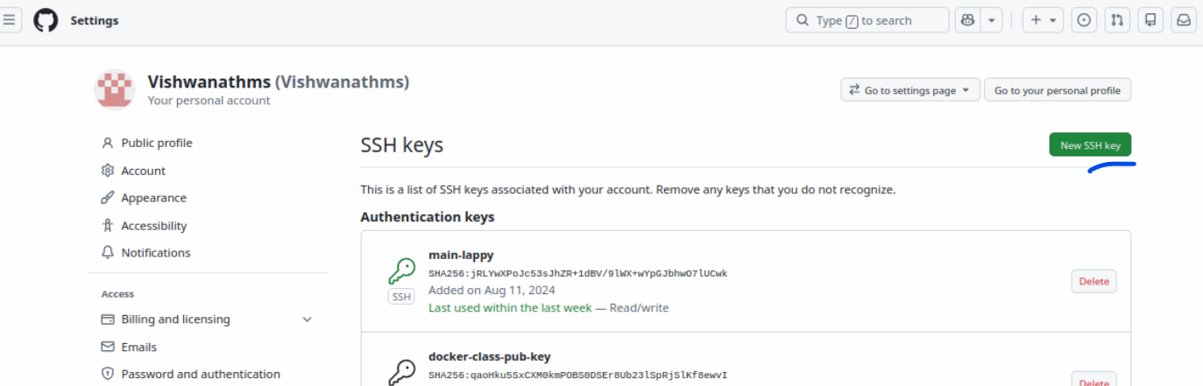
Click on “new ssh key”

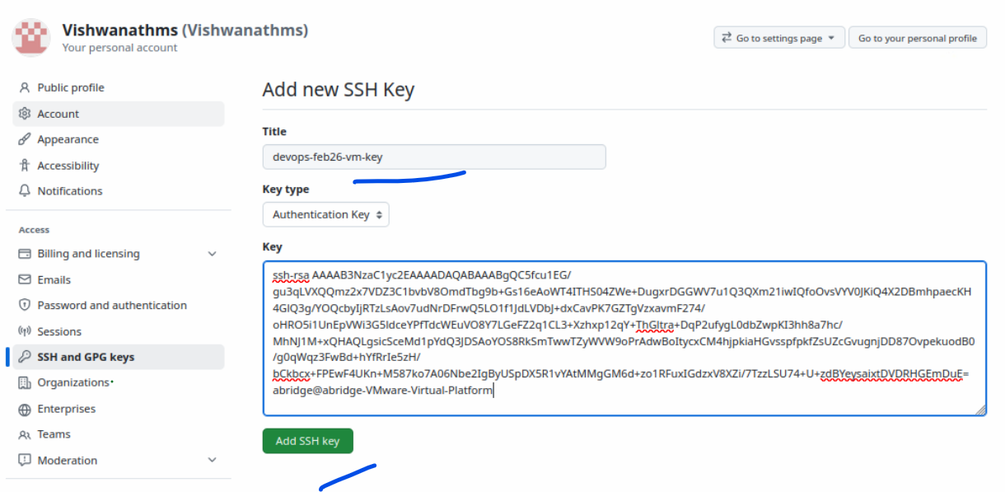
Click on “Add ssh key”
The key should be added
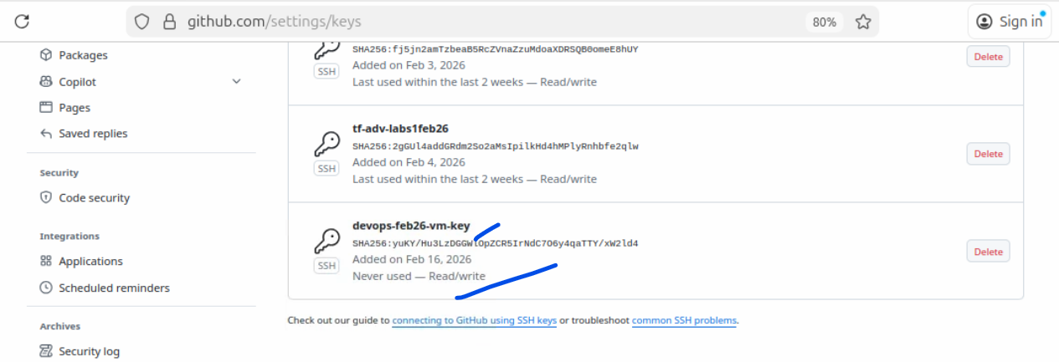

- Change the authen method on the local

Current authentication method is visible using this command
$ git remote -v
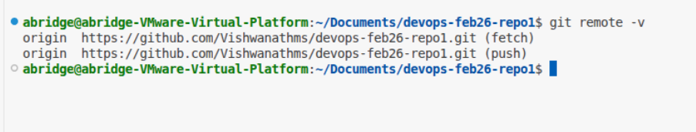

Now lets delete this config
$ git remote delete origin
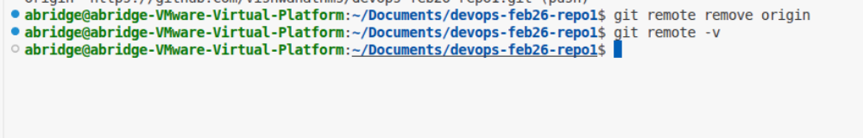
Configure the SSH origin
$ git remote add origin <url>
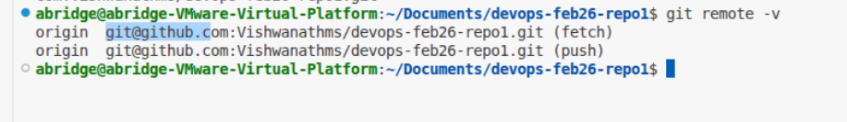

- Git push
$ git push
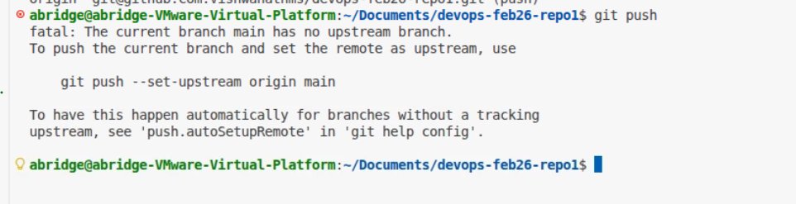
Run the command mentioned above
