15. Azure Virtual WAN – Conceptual Overview
Azure Virtual WAN is a managed global networking service that unifies:
- Site-to-Site VPN
- Point-to-Site VPN
- ExpressRoute
- Azure Firewall
- Routing & monitoring
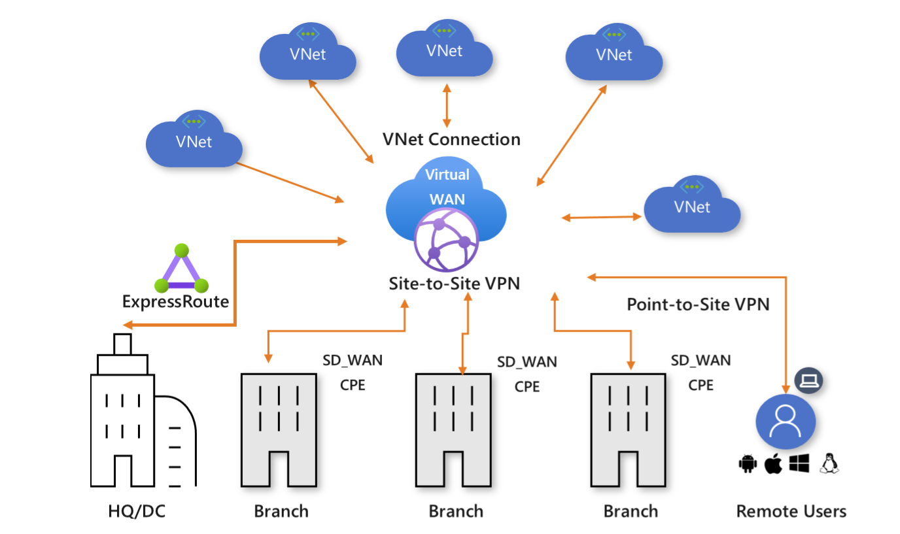

16. Virtual WAN Architecture
Key Components
- Virtual WAN
- Virtual Hub (Microsoft-managed)
- Hub-spoke connectivity
- Integrated security & routing
Advantages
- No subnet planning inside hub
- Built-in scale & resilience
- Centralized control plane

17. Virtual WAN SKUs
SKU | Features
Basic | Limited functionality
Standard | Full routing, firewall, automation

18. Virtual Hub Address Space
- Minimum /24
- Azure automatically creates:
  - Gateway subnets
  - Firewall subnets
  - Routing infrastructure

19. Virtual Hub Routing – Deep Dive
Routing Components
- Route Tables
- Associations
- Propagations
- Labels
- Static routes
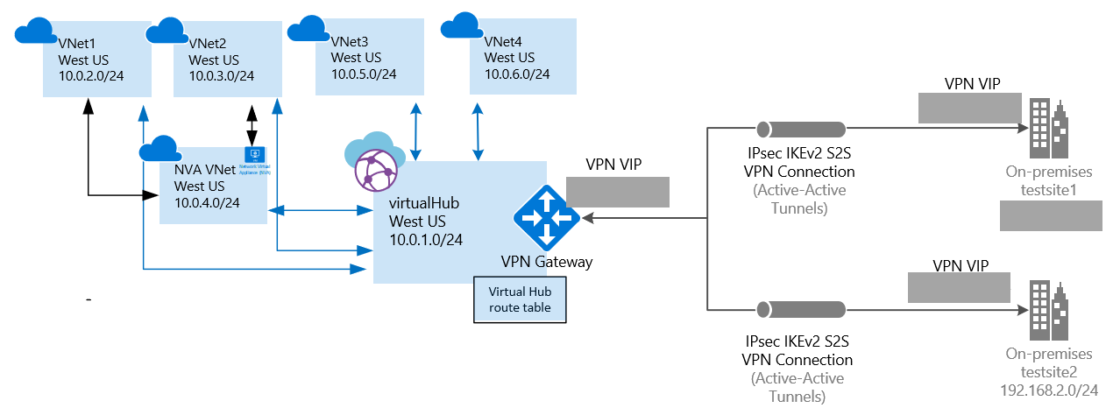

20. Cross-Tenant Connectivity with Virtual WAN
Virtual WAN supports:
- Multi-tenant VNets
- Cross-subscription connectivity
- Centralized global hubs
Requirement:
- Non-overlapping IP spaces

21. Network Virtual Appliance (NVA) in Virtual WAN
Virtual WAN allows third-party firewalls directly inside the hub.
Supported Use Cases
- Advanced inspection
- Custom security policies
- Vendor-specific features
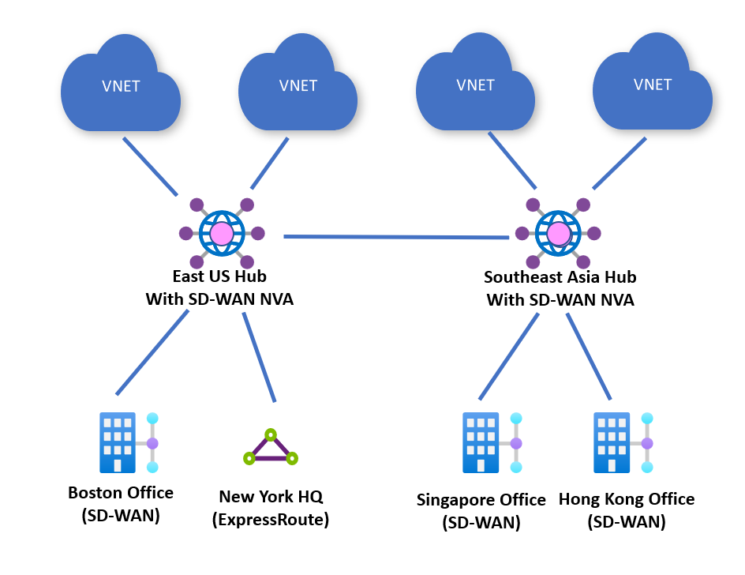
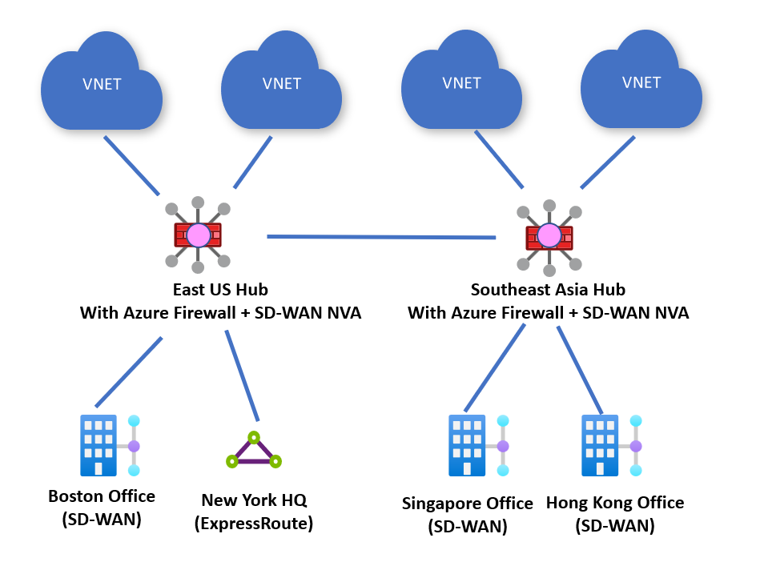

22. Secured Virtual Hub
A Secured Hub integrates:
- Azure Firewall
- Routing
- Logging
- Traffic inspection
Benefits:
- Centralized security
- Zero-trust networking
- Simplified governance

23. When to Use What (Design Decision Table)
Scenario | Recommended Solution
Single datacenter | S2S VPN
Remote users | P2S VPN
Multiple branches | Virtual WAN
Global enterprise | Virtual WAN + Firewall
Encrypted VNet connectivity | VNet-to-VNet VPN

