Lab-Scenario

🧪 Azure Networking Lab – VNet Peering, Endpoints, NSG & ASG

🎯 Lab Objectives
By the end of this lab, you will be able to:
- Configure VNet Peering (Same Region & Global)
- Understand and test Service Endpoints vs Private Endpoints
- Deploy VMs
- Secure traffic using NSG (Network Security Groups) and ASG (Application Security Groups)
- Validate connectivity using real tests (ping, curl, nslookup)

VNets Used
VNet | Region | Address Space
VNet-A | East US | 10.1.0.0/16
VNet-B | East US | 10.2.0.0/16
VNet-C | West Europe | 10.3.0.0/16

🧪 LAB 1 – VNet Peering (Same Region)
Step 1: Create VNets
Create VNet-A and VNet-B in East US.
Subnets:
- VNet-A: subnet-a (10.1.1.0/24)
- VNet-B: subnet-b (10.2.1.0/24)
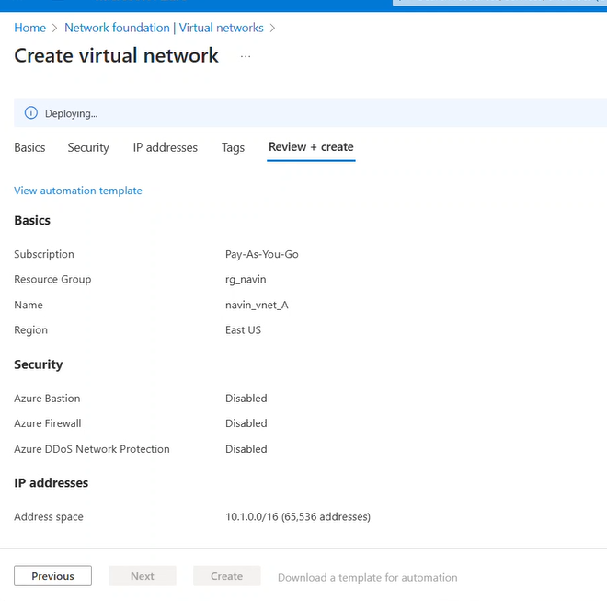
2nd vnet and subnet
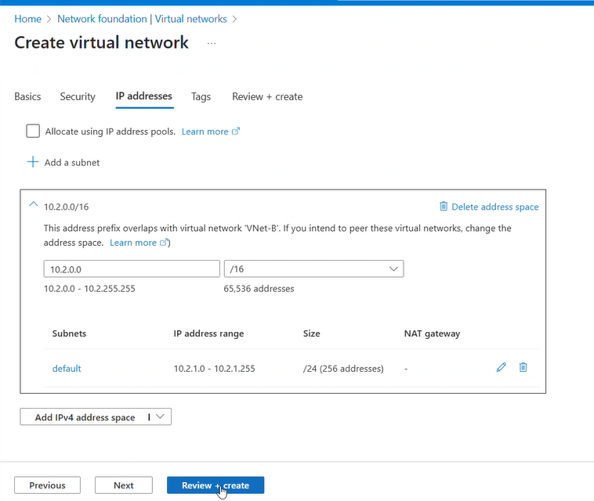

Step2: Create a VM in each vnet.
Vm01 on vnet01

VM | VNet | Subnet
VM-A | VNet-A | subnet-a
• OS: Ubuntu 22.04
• Public IP: Enabled (for initial access)

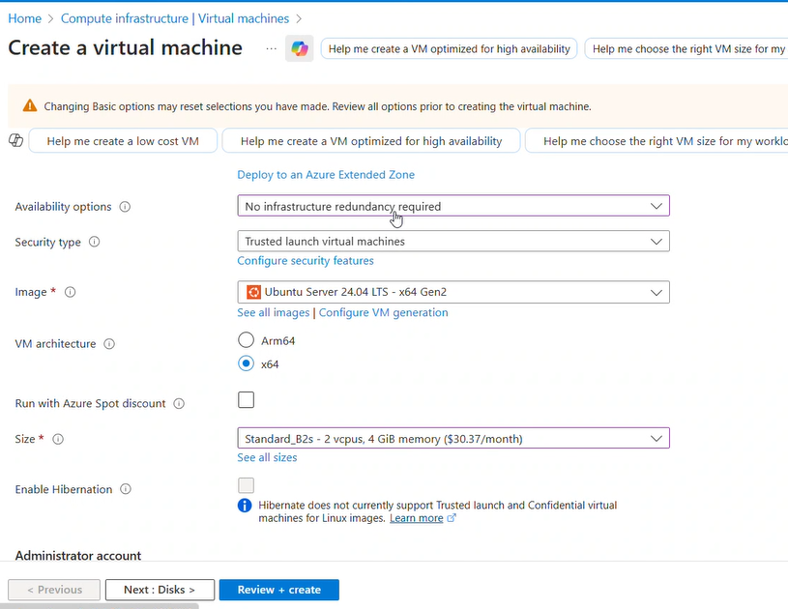
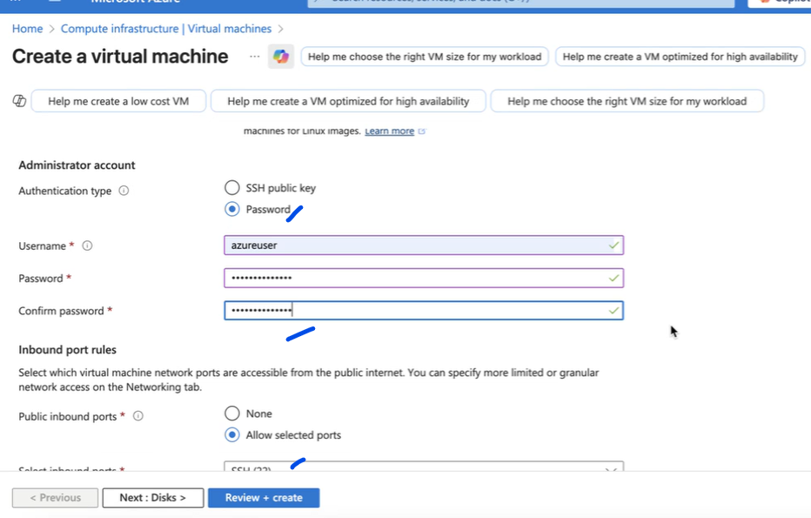
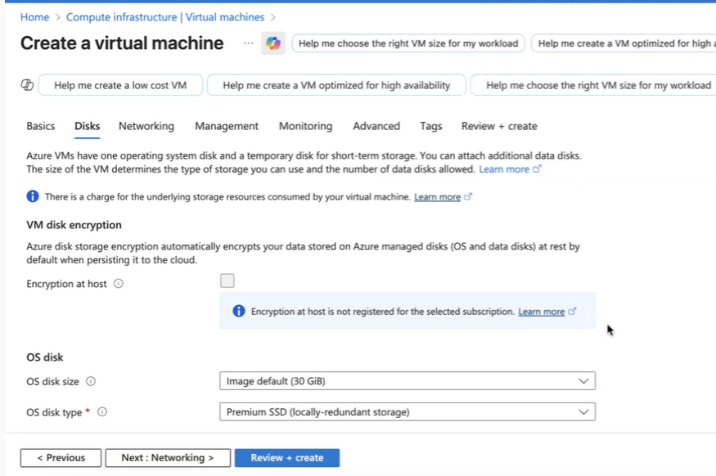
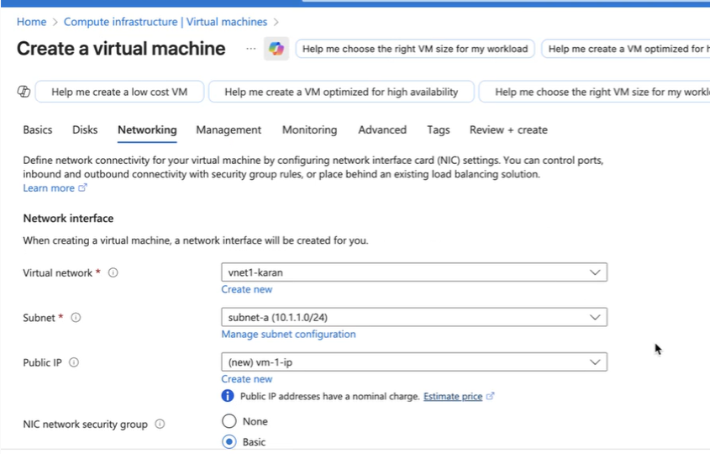
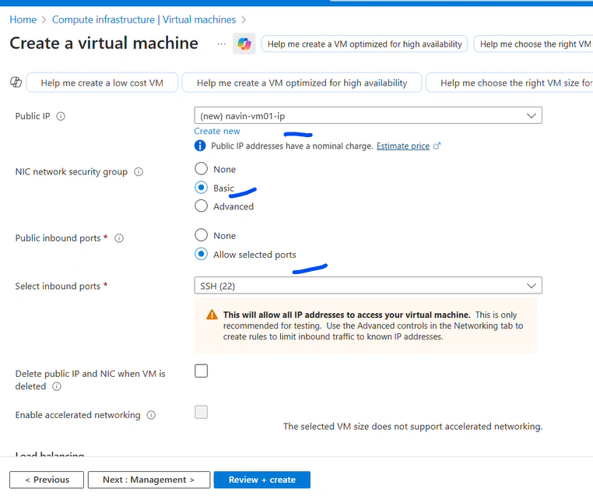

Vm02- Vnet-B
VM | VNet | Subnet
VM-B | VNet-B | subnet-b
• OS: Ubuntu 22.04
• Public IP: Disabled

Step 3: Peer VNet-A ↔ VNet-B
From VNet-A:
- Go to Peerings → Add
- Name: A-to-B
- Allow:
  - ✔ Virtual network access
  - ✔ Forwarded traffic
Repeat from VNet-B to VNet-A.
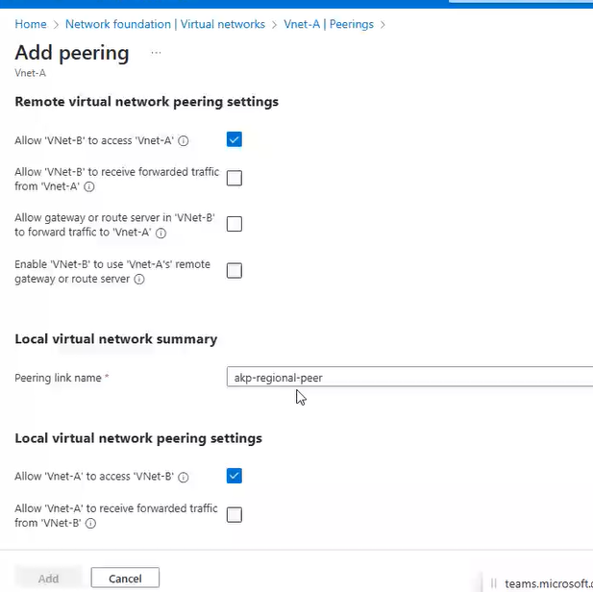

Step4:
Change the NSG on Vm2 to accept only Vm01 subnet on ssh
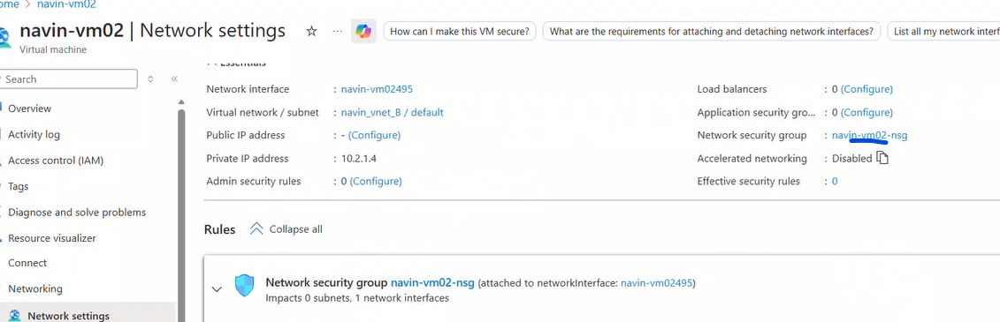
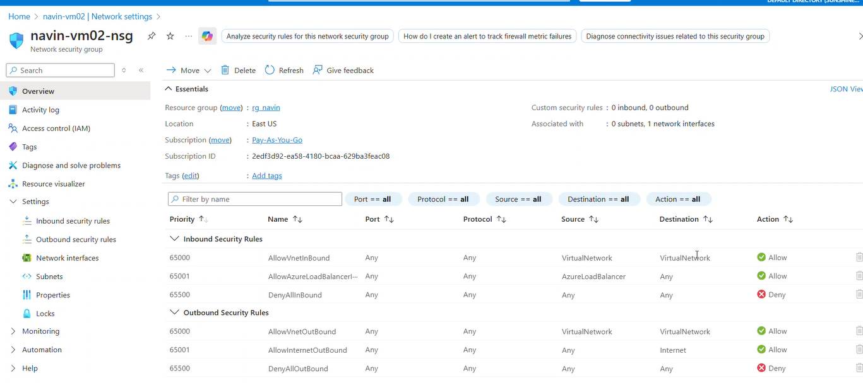
So Add All block
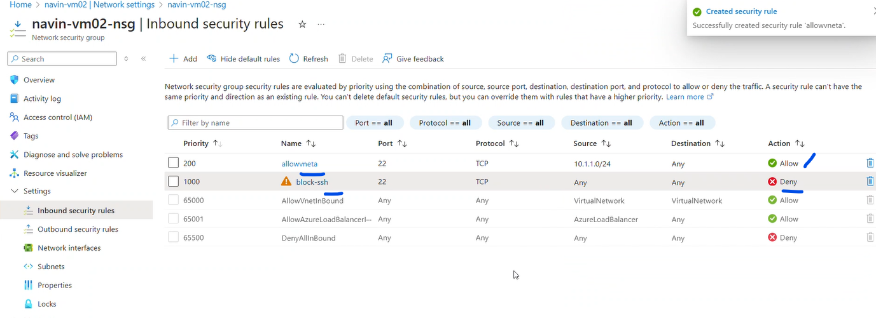
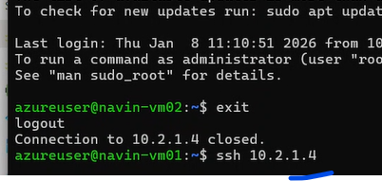
Deny is in effect
The rule 200 will take few minutes to get effected.

Step5:
Create UDR

