Lab Objective
You will:
- Create a Hub VNet with a GatewaySubnet
- Deploy a VPN Gateway (Route-based)
- Configure Point-to-Site using Azure Certificate Authentication
- Generate & upload certificates
- Download and install the VPN client
- Connect from your laptop and RDP/SSH to a VM using private IP
- Validate routing and troubleshoot common failures

Prerequisites
- Azure subscription + Owner/Contributor permissions
- Windows 10/11 (recommended for easiest P2S client steps)
- Azure CLI or Portal access
- Basic networking knowledge (subnets, private IP, routes)

Recommended Lab Topology
Hub VNet: 10.10.0.0/16
- Hub-Workload-Subnet: 10.10.1.0/24 (VM subnet)
- GatewaySubnet: 10.10.255.0/27 (must be named exactly GatewaySubnet)
P2S Client Address Pool: 172.16.10.0/24
(This must NOT overlap with any VNet/on-prem ranges.)

Part 1 — Create Hub VNet + Subnets
Step 1. Create a Resource Group
- Azure Portal → Resource groups → Create
- Name: rg-p2s-lab
- Region: Central India (or your preferred region)
- Create
Step 2. Create Hub VNet
- Portal → Virtual networks → Create
- Resource group: rg-p2s-lab
- VNet name: vnet-hub-p2s
- Address space: 10.10.0.0/16
- Subnets:
  - Hub-Workload-Subnet = 10.10.1.0/24
  - GatewaySubnet = 10.10.255.0/27
- Create
✅ Checkpoint
- VNet created with both subnets
- GatewaySubnet exists and named correctly

Part 2 — Create a Test VM in Hub
Step 3. Create Windows VM (or Linux)
- Portal → Virtual Machines → Create
- Name: vm-hub-01
- Image: Windows Server 2022 (or Ubuntu)
- Size: any small size (B2s/B1ms)
- Networking:
  - VNet: vnet-hub-p2s
  - Subnet: Hub-Workload-Subnet
  - Public IP: None (important for private-only testing)
  - NIC NSG: create new nsg-vm-hub-01
- Create
Step 4. Allow RDP/SSH only from P2S Pool (Recommended)
Go to NSG → Inbound rules → Add:
For Windows VM:
- Source: IP Addresses
- Source IP: 172.16.10.0/24
- Destination: Any
- Service: RDP (3389)
- Action: Allow
For Linux VM:
- Source: 172.16.10.0/24
- Service: SSH (22)
- Action: Allow
✅ Checkpoint
- VM has private IP only, like 10.10.1.4
- NSG allows management access only from P2S clients

Part 3 — Deploy Azure VPN Gateway
Step 5. Create Public IP for VPN Gateway
- Portal → Public IP addresses → Create
- Name: pip-vpngw-hub
- SKU: Standard
- Assignment: Static
- Create
Step 6. Create Virtual Network Gateway
- Portal → Virtual network gateways → Create
- Name: vpngw-hub-p2s
- Region: same as VNet
- Gateway type: VPN
- VPN type: Route-based
- SKU: VpnGw1 (or smaller if available in your region)
- Virtual network: vnet-hub-p2s
- Public IP: pip-vpngw-hub
- Create
⏳ This can take time, but continue once it shows Succeeded.
✅ Checkpoint
- Virtual network gateway exists and status is Succeeded

Part 4 — Configure P2S (Certificate Authentication)
Option A (Recommended Lab): Azure Certificate Authentication
Step 7. Generate Root Certificate (Windows)
On your Windows laptop, open PowerShell as Administrator:
# Create Root Certificate (self-signed)
$rootCert = New-SelfSignedCertificate `
-Type Custom `
-KeySpec Signature `
-Subject "CN=P2SRootCert-Lab" `
-KeyExportPolicy Exportable `
-HashAlgorithm sha256 `
-KeyLength 2048 `
-CertStoreLocation "Cert:\CurrentUser\My" `
-KeyUsageProperty Sign `
-KeyUsage CertSign

# Export Root Cert public key (.cer) - required for Azure upload
Export-Certificate `
-Cert $rootCert `
-FilePath "$env:USERPROFILE\Desktop\P2SRootCert-Lab.cer"
✅ This creates:
- Root cert in your cert store
- P2SRootCert-Lab.cer on Desktop
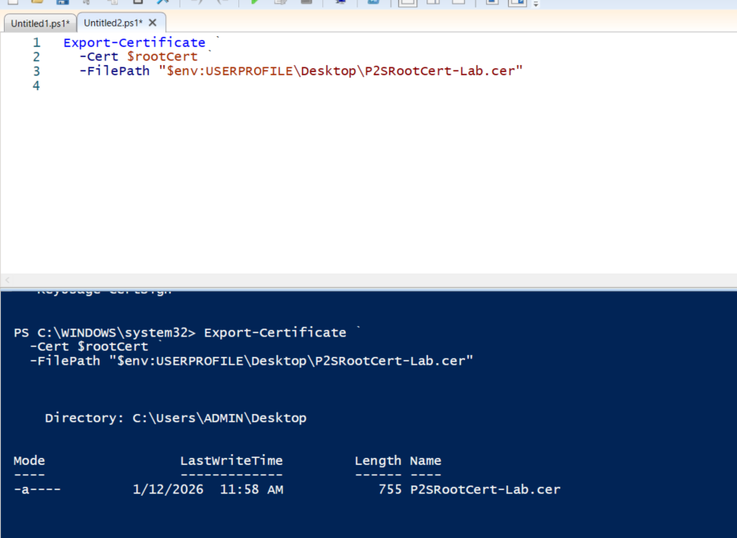
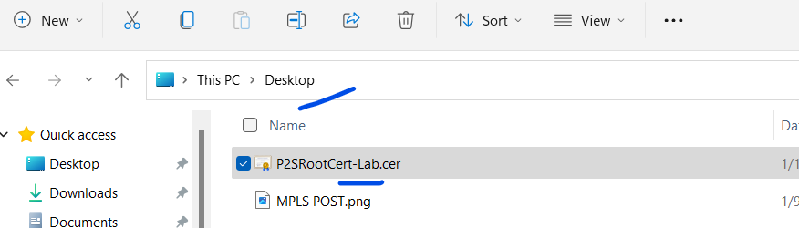
Step 8. Generate Client Certificate (Signed by Root)
$clientCert = New-SelfSignedCertificate `
-Type Custom `
-DnsName "P2SClientCert-Lab" `
-KeySpec Signature `
-Subject "CN=P2SClientCert-Lab" `
-KeyExportPolicy Exportable `
-HashAlgorithm sha256 `
-KeyLength 2048 `
-CertStoreLocation "Cert:\CurrentUser\My" `
-Signer $rootCert
✅ Client cert is installed on your laptop (CurrentUser\My)
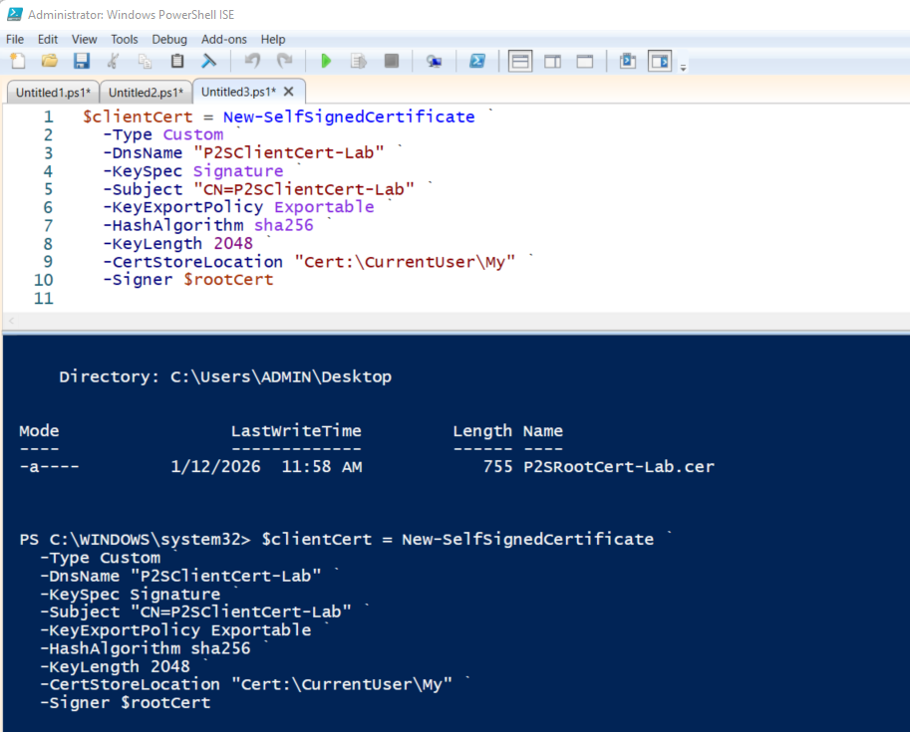

Part 5 — Configure P2S on VPN Gateway
Step 9. Open P2S Configuration
- Portal → Virtual network gateways → vpngw-hub-p2s
- Left menu → Point-to-site configuration
- Click Configure now (or Edit)
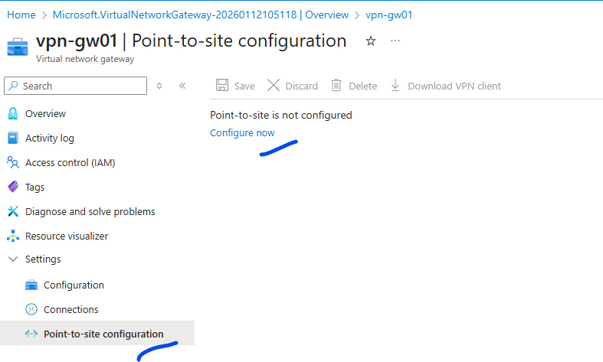
Step 10. Enter P2S Settings
- Address pool: 172.16.10.0/24
- Tunnel type: select OpenVPN (SSL) (recommended)
- Authentication type: Azure certificate
- Root certificates:
  - Name: P2SRootCert-Lab
  - Public Certificate Data: upload/copy from the .cer
Step 11. Upload Root Certificate Data
Open P2SRootCert-Lab.cer in Notepad:
- Copy content including:
  - -----BEGIN CERTIFICATE-----
  - -----END CERTIFICATE-----
Paste into Public Certificate Data.
Click Save.
Note: If the certificate is still in binary format , follow the below steps to create it manually.
The Configuration save will take around 5 – 10 min
OPTION 1 — Convert Binary .cer Using PowerShell
If you already have the binary .cer, convert it:
Step 1: PowerShell
$cert = Get-PfxCertificate -FilePath "C:\Users\Vishwa\Desktop\P2SRootCert-Lab.cer"
[System.Convert]::ToBase64String($cert.RawData)
❗ This prints Base-64 without headers
Azure prefers PEM with headers, so Option 1 is cleaner.
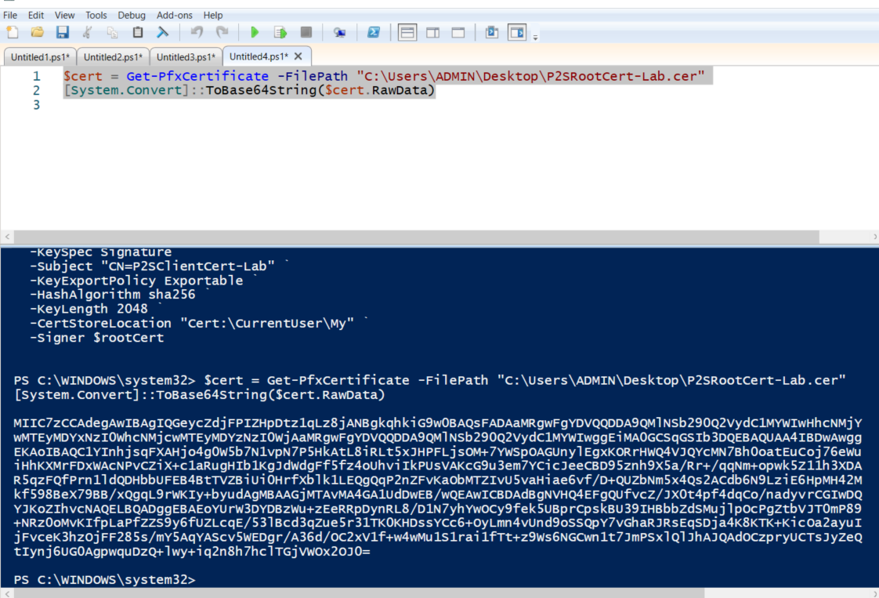
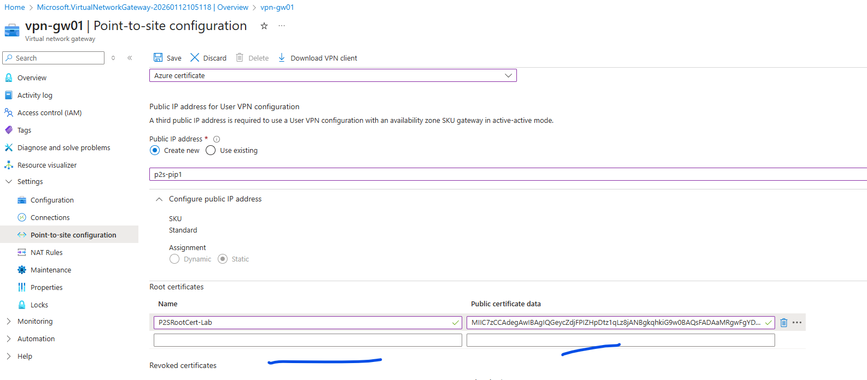
✅ Checkpoint
- P2S config saved successfully
- Root cert listed under Root certificates

OPTION 2 — Export the Root Cert as Base-64 (RECOMMENDED)
Step 1: Open Certificate Manager
Press Win + R → type:
certmgr.msc

Step 2: Locate Root Certificate
Go to:
Certificates – Current User
└── Personal
└── Certificates
Find:
P2SRootCert-Lab

Step 3: Export Certificate
- Right-click P2SRootCert-Lab
- All Tasks → Export
- Certificate Export Wizard:
  - ❌ Do NOT export private key
  - ✔ Base-64 encoded X.509 (.CER) ← IMPORTANT
- Save as:
P2SRootCert-Lab-Base64.cer

Step 4: Open in Notepad
Now open P2SRootCert-Lab-Base64.cer in Notepad
You will see:
-----BEGIN CERTIFICATE-----
MIIC5DCCAcwCCQDhfG...
...
-----END CERTIFICATE-----
✅ This is what Azure expects

Step 5: Upload to Azure
Azure Portal →
Virtual network gateway → Point-to-site configuration
- Root certificate name: P2SRootCert-Lab
- Public certificate data: Paste entire Base-64 block
Click Save

The Download link would be ready

Part 6 — Download VPN Client and Connect
Step 12. Download VPN Client
- In P2S configuration page
- Click Download VPN client
- Extract the downloaded zip
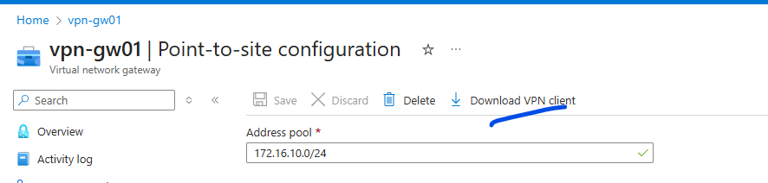
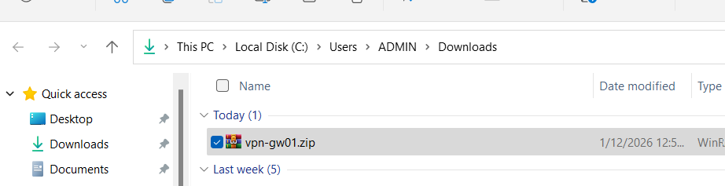
- Run the installer:
  - Usually VpnClientSetupAmd64.exe
Note: is the above exe file is not present the we have to install it separately
Option1:
STEP 1 — Install OpenVPN Client (Once)
Download and install OpenVPN GUI:
🔹 https://openvpn.net/community-downloads/
Install:
- ✔ OpenVPN GUI
- ✔ TAP driver (default)
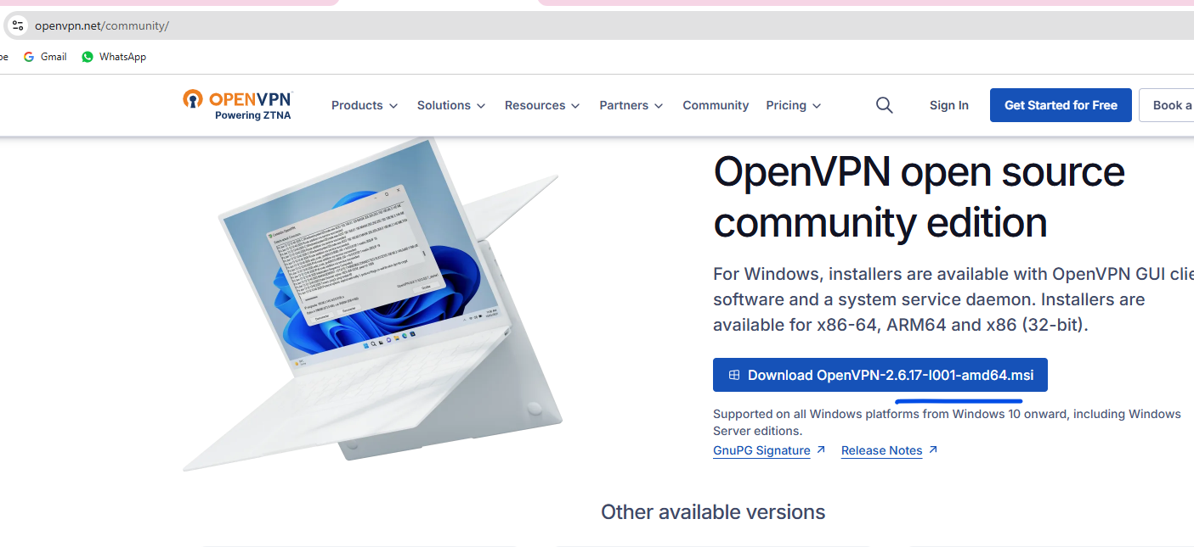

Option2:
https://apps.microsoft.com/detail/9np355qt2sqb?hl=en-US&gl=US
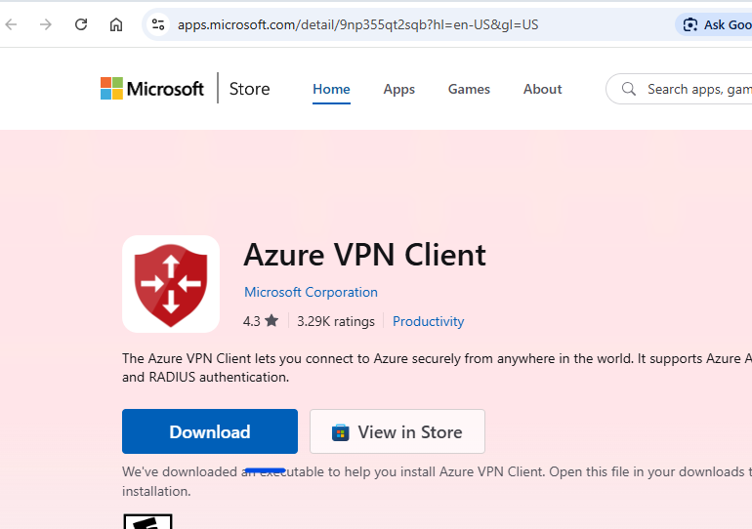
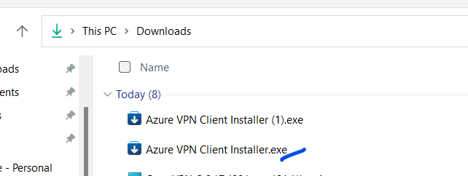
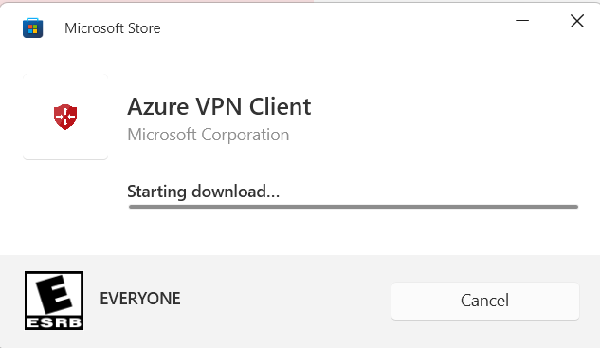

Step 13. Connect
- Windows → Start → VPN
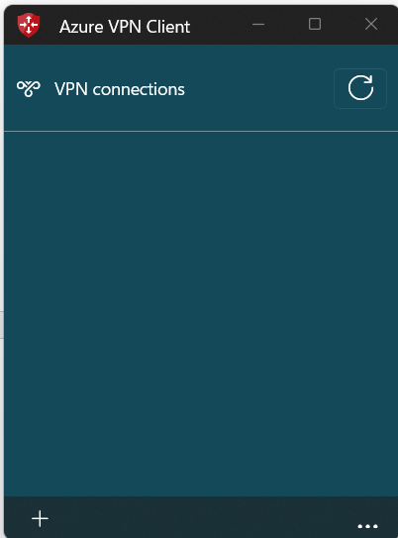

- You will see a VPN profile like: vpngw-hub-p2s
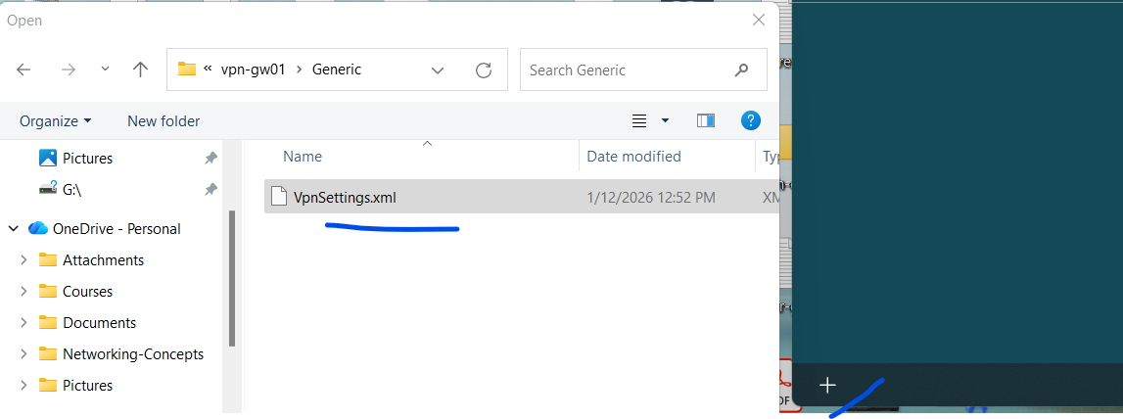
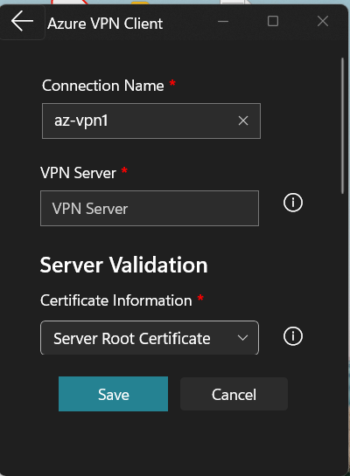
- Click Connect
✅ Checkpoint
- VPN shows Connected
- You get a client IP from 172.16.10.0/24

Part 7 — Validation Tests
Step 14. Confirm VPN Adapter IP
PowerShell:
ipconfig
Look for adapter with IP like 172.16.10.x.
Step 15. Check Routes
route print
You should see routes for 10.10.0.0/16 via VPN interface.
Step 16. Ping Hub VM Private IP
ping 10.10.1.4
Note: Windows VM may block ICMP by default. Ping failure doesn’t always mean VPN failure.
Step 17. RDP to VM (Private IP)
- Run: mstsc
- Computer: 10.10.1.4
- Login with VM credentials
✅ If RDP works through private IP, your P2S is successful.

Part 8 — Common Issues & Fixes
1) VPN connects but can’t reach VM
Fix checklist:
- VM NSG allows RDP/SSH from 172.16.10.0/24
- Windows firewall allows RDP (usually yes) and ICMP (if you want ping)
- VM has no UDR forcing traffic elsewhere
2) Address pool overlaps
If 172.16.10.0/24 overlaps with your home network or other VPNs, routing breaks.
Fix: choose something like 172.20.10.0/24 or 10.250.10.0/24 (non-overlapping).
3) GatewaySubnet too small / wrong name
- Must be named exactly GatewaySubnet
- Use at least /27 (recommended)
4) Using IKEv2 only causes client issues
Use OpenVPN (SSL) for easiest lab success.

Optional Enhancements (For Advanced Lab)
- Add Spoke VNet + peering to hub; verify P2S client can reach spoke VM
- Force spoke-to-spoke via hub firewall; test UDR + firewall rules
- Use Azure AD authentication for P2S (enterprise scenario)
- Enable VPN diagnostics logs to Log Analytics

