Point-to-Site (IPsec) Configuration -- this takes around 25-40 min
a. Create the user vpn config profile

Step1:
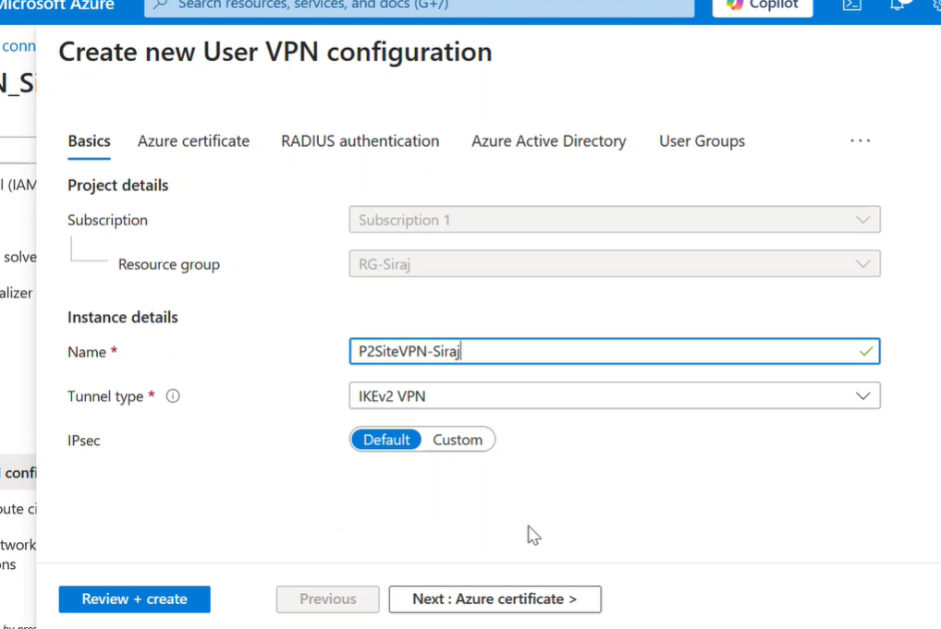
We are selecting IKEv2 VPN for certificate based auth

Step2:

Create the certificate
