Load Balancing HTTP(S) Traffic in Azure
Azure Application Gateway & Azure Front Door
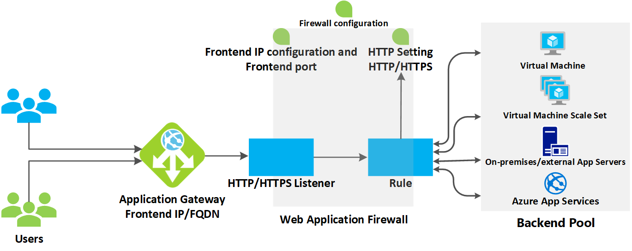
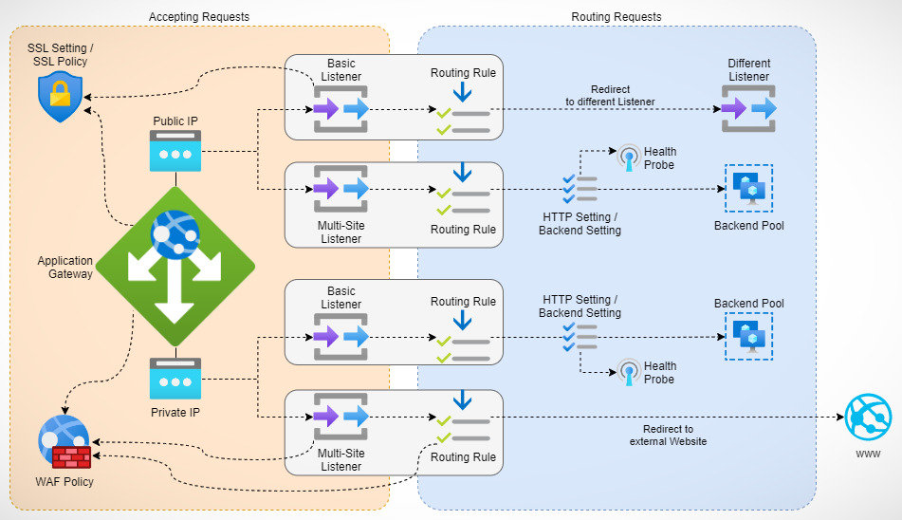
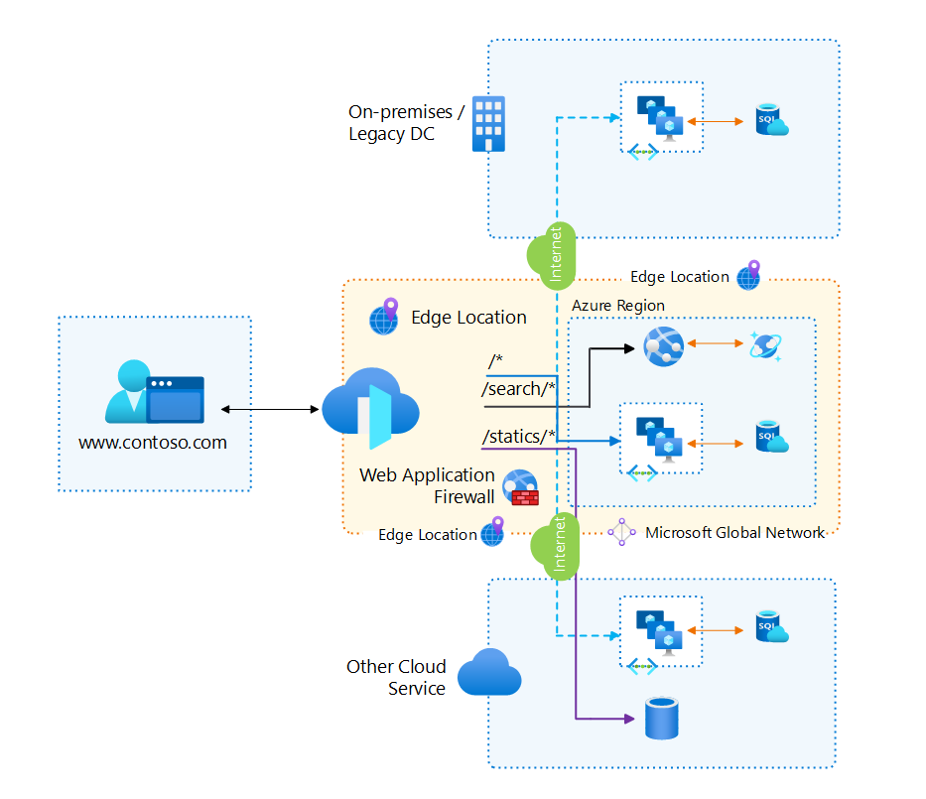
4

1. Design Azure Application Gateway

1.1 What is Azure Application Gateway (Deep Explanation)
Azure Application Gateway is a Layer 7 (application-layer) load balancer specifically designed to manage HTTP and HTTPS traffic.
Unlike Layer 4 load balancers (which only understand IP and port), Application Gateway understands web traffic semantics, such as URLs, headers, cookies, and SSL certificates.
Why Layer 7 Matters
At Layer 7, Application Gateway can:
- Inspect URLs (/login, /api, /images)
- Read HTTP headers
- Terminate SSL connections
- Apply security rules (WAF)
- Route traffic intelligently based on application logic
This makes Application Gateway ideal for modern web and microservices architectures.

1.2 Manages Web App Requests
Application Gateway acts as a single entry point for all incoming web requests.
Instead of exposing backend servers directly:
- Clients connect to Application Gateway
- Application Gateway evaluates the request
- Traffic is forwarded to the correct backend
Benefits
- Backends remain private
- Centralized traffic management
- Simplified certificate handling
- Easier scaling and security enforcement

1.3 Routes Traffic to Backend Pools Based on URL
Application Gateway can examine the URL path and route traffic accordingly.
Example
URL | Routed To
/api/users | API backend
/images/logo.png | Image server
/cart/checkout | E-commerce backend
This capability is critical for:
- Microservices
- Multi-tier applications
- Legacy + modern hybrid apps

1.4 Supported Backend Targets
Application Gateway supports heterogeneous backends, meaning different compute types can exist in the same backend pool.
Supported Backends
- Azure Virtual Machines
- VM Scale Sets (autoscaling)
- Azure App Service (PaaS)
- On-premises servers (via VPN / ExpressRoute)
This flexibility allows gradual cloud migration without redesigning routing logic.

2. Application Gateway Features (Expanded)

2.1 URL Path-Based Routing
URL Path-Based Routing enables routing decisions inside the same domain.
How it Works
- A listener receives the request
- Path map evaluates the URL
- Matching backend pool is selected
Why It’s Important
- Avoids multiple load balancers
- Reduces infrastructure cost
- Enables clean application separation

2.2 Multiple-Site Routing
Multiple-site routing allows hosting multiple websites on a single Application Gateway.
How
- Uses host headers
- Each site has its own listener and rule
Example
Host Header | Backend
www.contoso.com | Contoso pool
www.fabrikam.com | Fabrikam pool
Use Case
- Hosting multiple customer apps
- SaaS platforms
- Dev/Test environments

2.3 Web Application Firewall (WAF)
WAF protects applications from common web attacks.
What WAF Protects Against
- SQL Injection
- Cross-Site Scripting (XSS)
- Command Injection
- OWASP Top 10 vulnerabilities
Modes
- Detection → Logs attacks (safe for testing)
- Prevention → Blocks malicious requests (production)
WAF rules are continuously updated by Microsoft.

3. Determine Application Gateway Routing

3.1 Listeners (Deep Dive)
A listener defines how traffic enters the Application Gateway.
Listener Components
- Frontend IP (Public / Private)
- Frontend Port (80 / 443)
- Protocol (HTTP / HTTPS)
- Optional hostname
Without a listener, traffic cannot enter the gateway.

3.2 Routing Rules
Routing rules define what happens after traffic is received.
Rule Types
- Basic Rule
  - All traffic → one backend pool
- Path-Based Rule
  - Traffic routed by URL path
Rules are evaluated in order, which is important when paths overlap.

3.3 Backend Pools
Backend pools define where traffic is sent.
Backend Pool Can Contain
- IP addresses
- FQDNs
- Azure services
A backend pool can be reused across multiple rules.

3.4 Health Probes
Health probes determine backend availability.
Why Probes Matter
If a backend fails health probes:
- Traffic is automatically stopped
- Users are not affected
- High availability is maintained
Probe Types
- Default probe (simple)
- Custom probe (advanced)

4. Choosing an Azure Application Gateway SKU

4.1 Application Gateway v2 SKU
The v2 SKU is production-recommended.
Key Advantages
- Autoscaling
- Zone redundancy
- Faster provisioning
- Lower operational overhead
You don’t manage instance sizes — Azure handles it.

4.2 Application Gateway v1 SKU
The v1 SKU requires:
- Manual scaling
- Instance size selection
Primarily used for:
- Legacy deployments
- Exam understanding
- Small test environments

5. Application Gateway Configuration Planning

5.1 Subnet Requirements
Application Gateway must be deployed in a dedicated subnet.
Why
- Ensures predictable routing
- Prevents IP conflicts
- Required for platform stability
No other resources are allowed in this subnet.

5.2 Frontend Design
Frontend configuration decides:
- Public vs private access
- Protocol (HTTP/HTTPS)
- Security exposure
Best practice:
- Use HTTPS only
- Redirect HTTP to HTTPS

5.3 Security Planning
Security is layered:
- SSL certificates
- WAF policies
- NSGs
- Backend isolation
Application Gateway often sits behind Azure Firewall in hub-spoke designs.

6. Configure Azure Application Gateway

6.1 Frontend IP
Defines how clients reach the gateway.
- Public IP → Internet-facing
- Private IP → Internal apps

6.2 Listeners – Order of Processing
Listeners are matched based on:
- Port
- Protocol
- Hostname
If no hostname is specified, it acts as a catch-all listener.

6.3 Redirection (Expanded)
Redirection improves:
- Security
- SEO
- User experience
Common Pattern
HTTP → HTTPS using global redirection.

6.4 Rewrite Policies
Rewrite policies allow modifying traffic without touching the app.
Use Cases
- Add security headers
- Hide backend server info
- Rewrite URLs

