🧪 LAB: Azure Application Gateway with WAF (Web Application Firewall)
🎯 Lab Objectives
By the end of this lab, you will:
- Deploy Azure Application Gateway (v2) with WAF
- Host a vulnerable web app on backend VMs
- Configure WAF rules (Detection & Prevention modes)
- Simulate OWASP Top-10 attacks
- Validate WAF blocking behavior using logs

🧱 Lab Architecture Overview
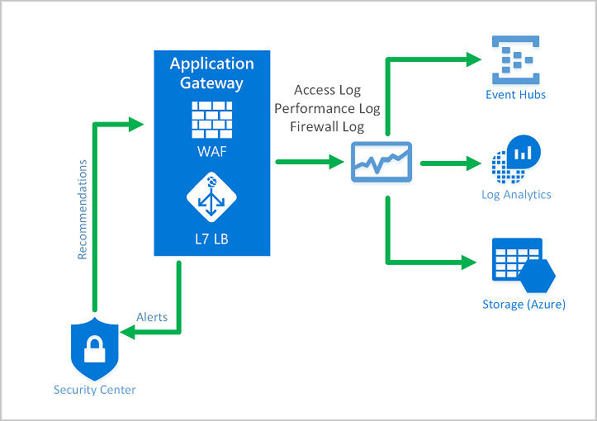
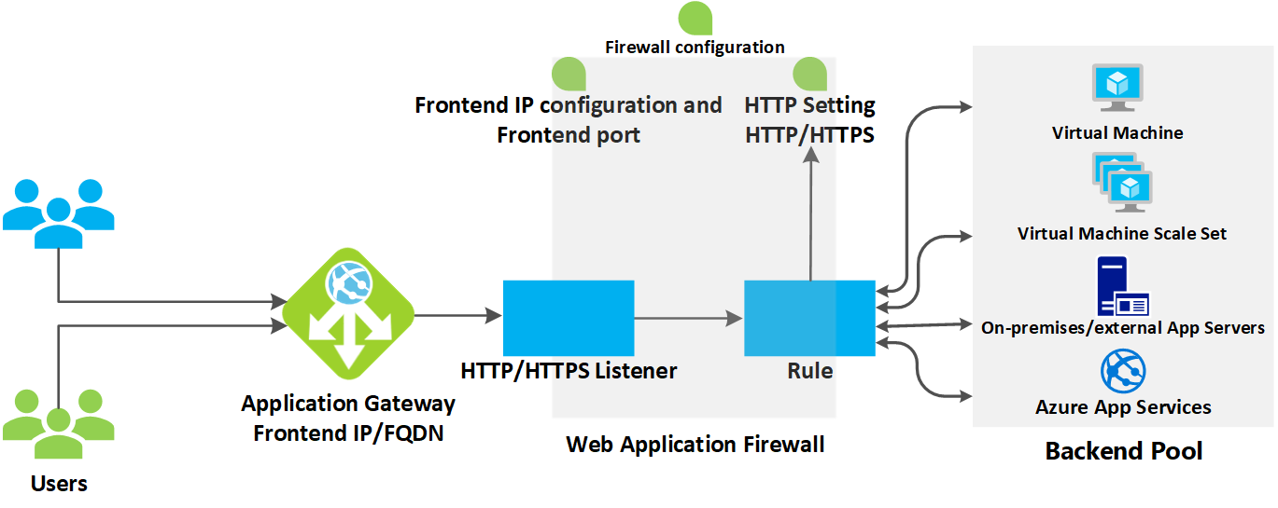
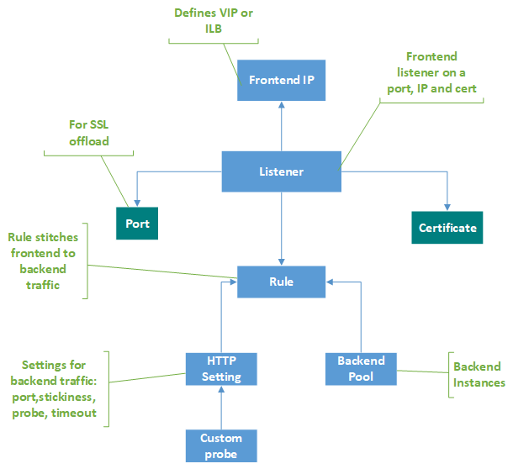
Architecture Components
- VNet with 2 subnets
  - appgw-subnet → Application Gateway
  - backend-subnet → Web VMs
- 2 Linux VMs (NGINX / Apache)
- Azure Application Gateway v2
- WAF Policy (OWASP CRS 3.2)
- Log Analytics Workspace

🔹 Lab 1: Create Resource Group & Network
Step 1: Create Resource Group
Resource Group: rg-appgw-waf-lab
Region: East US

Step 2: Create Virtual Network
VNet Name: vnet-appgw-lab
Address Space: 10.0.0.0/16
Subnets
Subnet Name | CIDR
appgw-subnet | 10.0.1.0/24
backend-subnet | 10.0.2.0/24
⚠️ Important Rule
Application Gateway must be in a dedicated subnet.

🔹 Lab 2: Deploy Backend Web Servers

Step 3: Create Linux VM – Web01
Name: webvm01
Image: Ubuntu 22.04
Subnet: backend-subnet
Public IP: Optional (for troubleshooting)
Step 4: Install Web Server
SSH into VM:
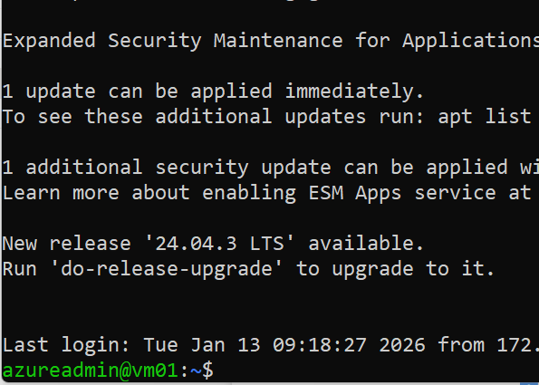
sudo apt update
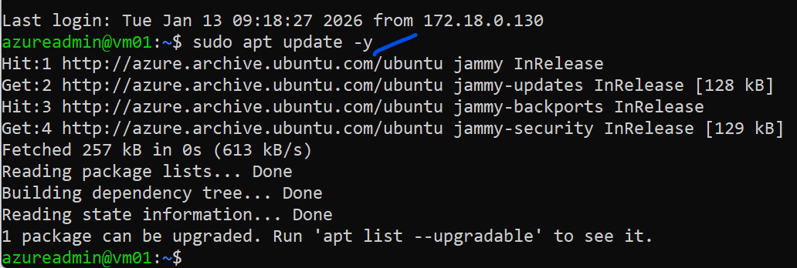
$ sudo apt install -y nginx
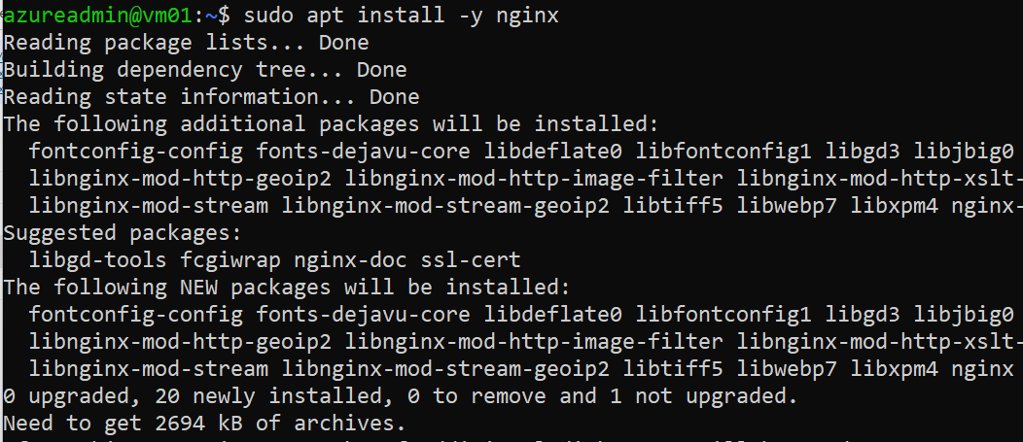
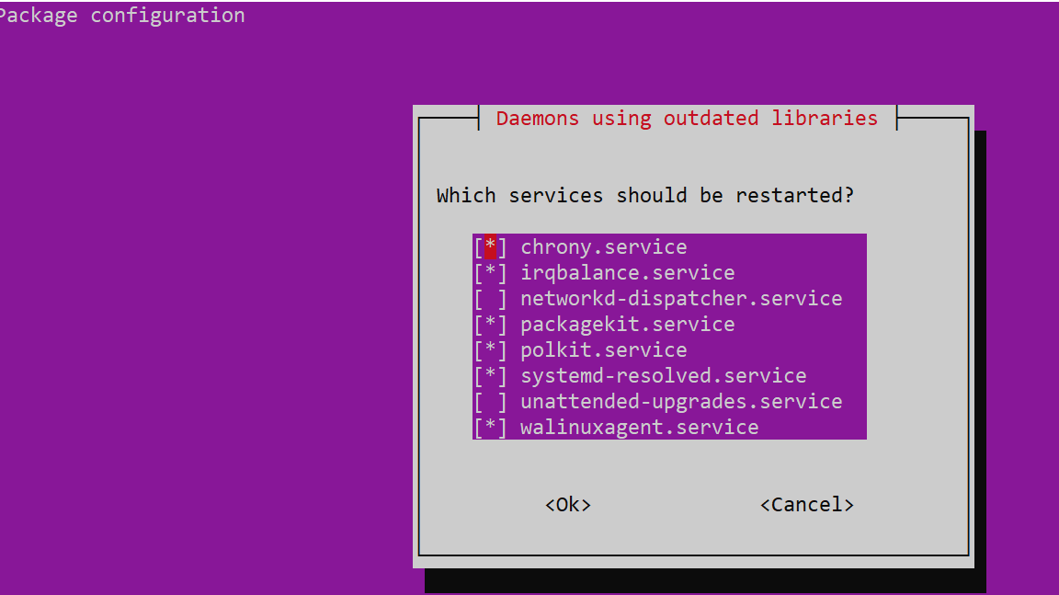
Create a vulnerable test page:
sudo nano /var/www/html/index.html
<h1>Backend Server - WebVM01</h1>
<form method="GET">
<input name="q">
<input type="submit">
</form>
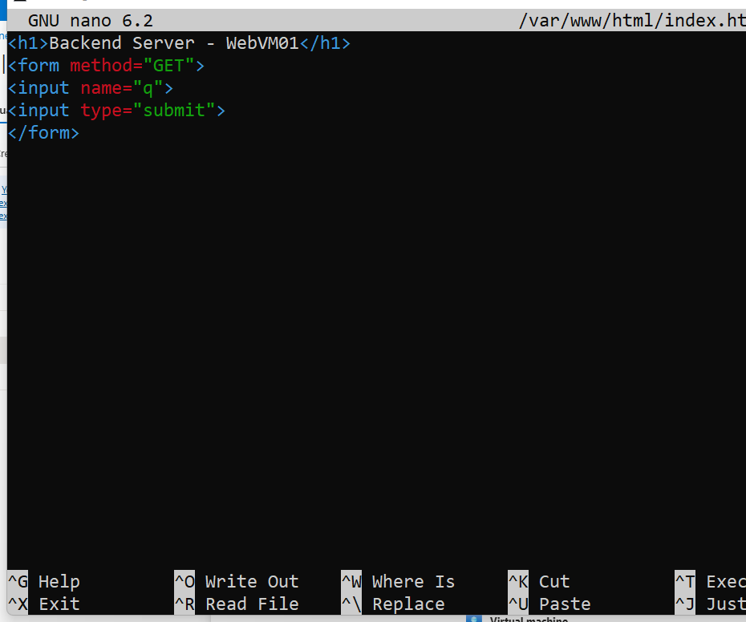

Repeat for WebVM02 (optional for load balancing).

🔹 Lab 3: Create Azure Application Gateway (WAF v2)
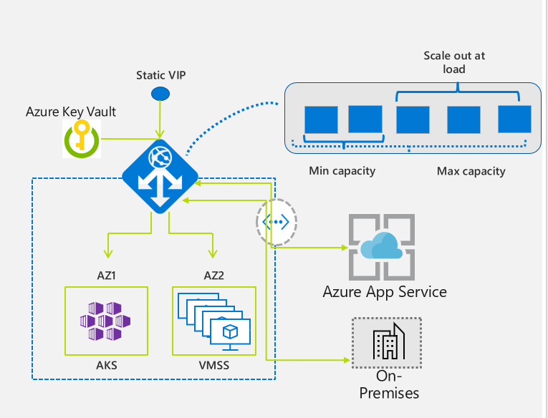
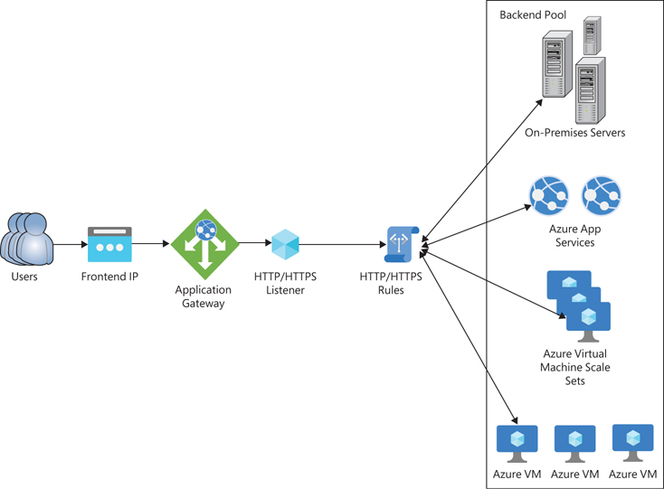
Step 5: Create Application Gateway
- Name: appgw-waf-lab
- Tier: WAF v2
- VNet: vnet-appgw-lab
- Subnet: appgw-subnet
- Public IP: New → appgw-pip

Step 6: Backend Pool Configuration
Add backend targets:
- Private IPs of webvm01 / webvm02

Step 7: HTTP Settings
Protocol: HTTP
Port: 80
Health Probe: Enabled

Step 8: Listener & Rule
- Listener Type: Basic
- Frontend IP: Public
- Port: 80
- Rule: Route to backend pool

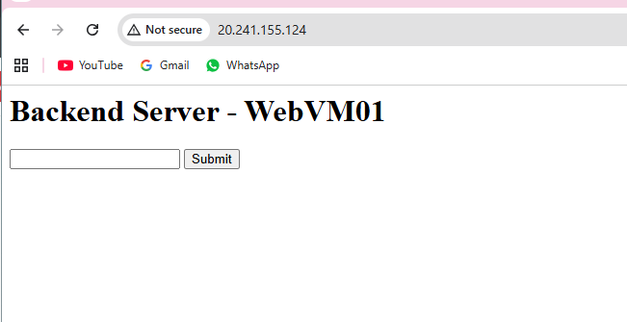

🔹 Lab 4: Create & Attach WAF Policy
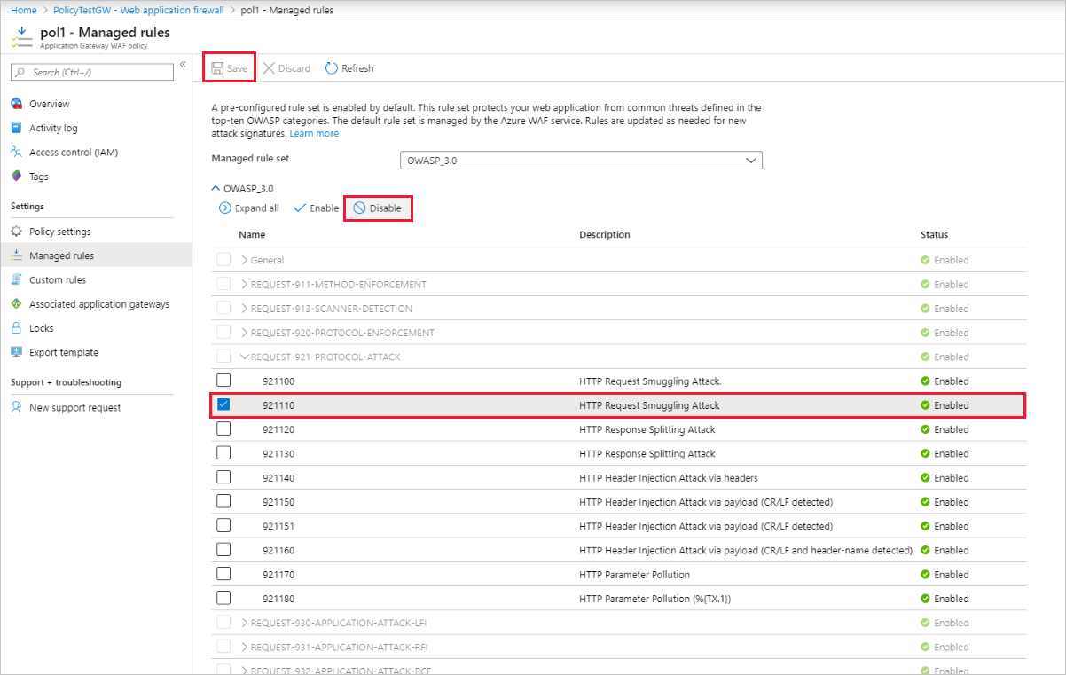
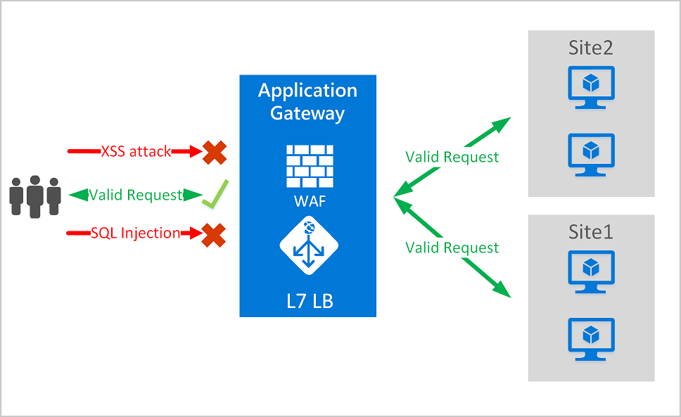
Step 9: Create WAF Policy
Name: waf-policy-lab
Policy Type: Application Gateway
Step 10: WAF Configuration
Setting | Value
Mode | Detection
Rule Set | OWASP CRS 3.2
Request Body Inspection | Enabled
Max Request Body | 128 KB
Attach policy to Application Gateway.

🔹 Lab 5: Baseline Testing (Before Attack)
Step 11: Test Normal Traffic
Open browser:
http://<Application-Gateway-Public-IP>
✅ Expected Result:
- Page loads successfully
- Backend page displayed

🔹 Lab 6: Simulate Web Attacks (Detection Mode)

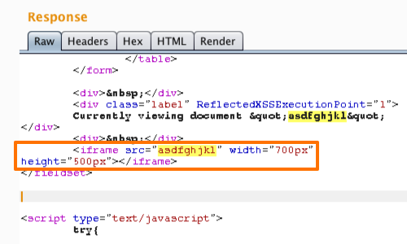
Attack 1: SQL Injection
http://<appgw-ip>/?q=' OR 1=1 --
Expected:
- Page loads
- Attack not blocked
- Logged by WAF

Attack 2: Cross-Site Scripting (XSS)
http://<appgw-ip>/?q=<script>alert(1)</script>
Expected:
- Page loads
- Attack detected
- Logged in WAF logs

🔹 Lab 7: View WAF Logs
Step 12: Enable Diagnostics
Application Gateway → Diagnostic settings
- Send logs to Log Analytics Workspace
Note: if the workspace not present create one.
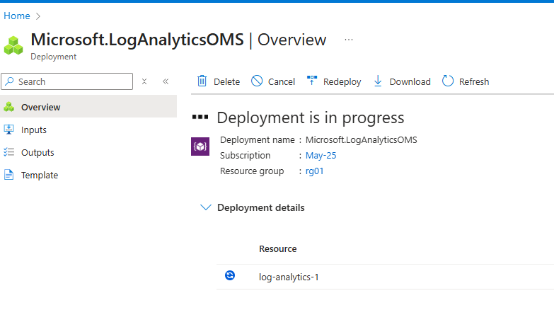

- Enable:
  - ApplicationGatewayFirewallLog
  - ApplicationGatewayAccessLog

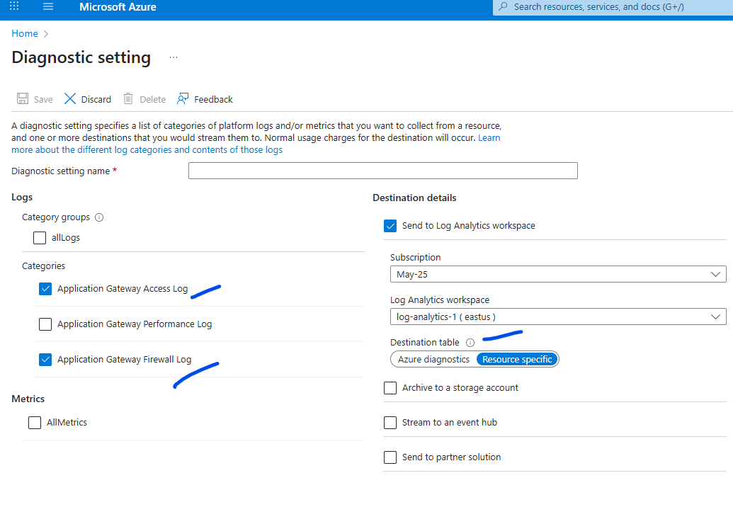

Step 13: Query Logs
Log Analytics → Queries:
AzureDiagnostics
| where Category == "ApplicationGatewayFirewallLog"
| project TimeGenerated, clientIp_s, requestUri_s, ruleId_s, action_s, message_s
✅ You should see:
- Rule ID
- Attack type
- Action = Detected

🔹 Lab 8: Switch to Prevention Mode
Step 14: Update WAF Policy
Mode: Prevention
Save & wait 2–3 minutes.

🔹 Lab 9: Re-Test Attacks (Prevention Mode)
SQL Injection Again
http://<appgw-ip>/?q=' OR 1=1 --
❌ Expected Result:
- 403 Forbidden
- Request blocked

XSS Again
http://<appgw-ip>/?q=<script>alert(1)</script>
❌ Expected Result:
- 403 Forbidden
- Attack blocked

🔹 Lab 10: Validate Blocked Logs
AzureDiagnostics
| where action_s == "Blocked"
| project TimeGenerated, clientIp_s, requestUri_s, ruleId_s, message_s
✅ Confirms WAF is actively protecting the app

📌 Lab Summary
Feature | Result
Application Gateway | Deployed
WAF Policy | OWASP CRS 3.2
Detection Mode | Logged attacks
Prevention Mode | Blocked attacks
OWASP Attacks | SQLi, XSS

