Below is deep-dive, PPT-ready content you can directly use for AZ-700 / Azure Networking slides.
It is structured slide-by-slide, with architect-level explanations, decision guidance, and real-world scenarios.

Slide 1 — Why Multiple Network Security Controls Exist in Azure
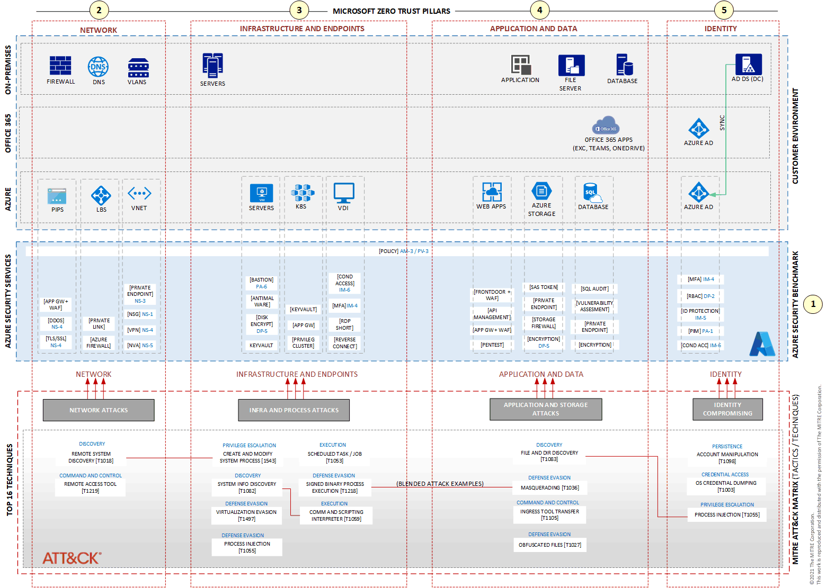
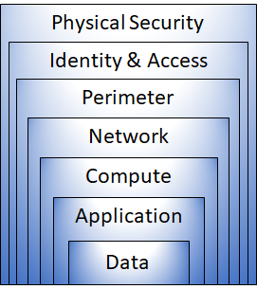
Core Idea
Azure provides multiple security controls because no single control can protect all traffic types.
Azure follows Defense-in-Depth, where security is applied at multiple layers:
- Subnet / NIC level → Network Security Groups (NSG)
- Network perimeter / transit → Azure Firewall
- Application edge (HTTP/S) → Web Application Firewall (WAF)
Key Reason
Different traffic types require different inspection depth:
- L3/L4 traffic (IP, Port, Protocol)
- Stateful network flows
- L7 application payload inspection (HTTP requests)

Slide 2 — Network Security Groups (NSG): The First Line of Defense
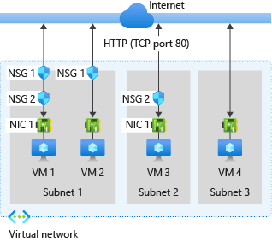
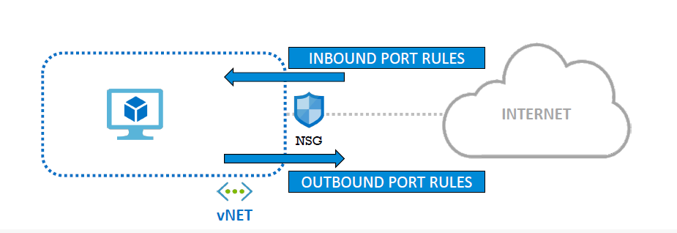
What is an NSG?
A Network Security Group (NSG) is a stateful packet filter that controls traffic:
- To and from
  - Subnets
  - Network Interfaces (NICs)
Inspection Level
- Layer 3 & Layer 4
  - Source IP
  - Destination IP
  - Port
  - Protocol (TCP/UDP/ICMP)
How NSG Works
- Rules are evaluated by priority (100–4096)
- First match wins
- Default rules:
  - Allow VNet traffic
  - Allow Azure Load Balancer
  - Deny all inbound
NSG Rule Example
Priority | Source | Destination | Port | Action
100 | Internet | WebSubnet | 80 | Allow
200 | Any | Any | Any | Deny

Slide 3 — NSG Strengths and Limitations
Strengths ✅
- Simple and cost-free
- Very fast (no appliance involved)
- Perfect for:
  - East-West traffic control
  - Subnet isolation
  - Basic micro-segmentation
Limitations ❌
- No application awareness
- No URL or payload inspection
- Cannot detect:
  - SQL Injection
  - XSS
  - OWASP attacks
- No centralized logging for advanced analytics
Best Use Case
“Who can talk to whom, on which port?”

Slide 4 — Azure Firewall: Centralized Network Perimeter Security
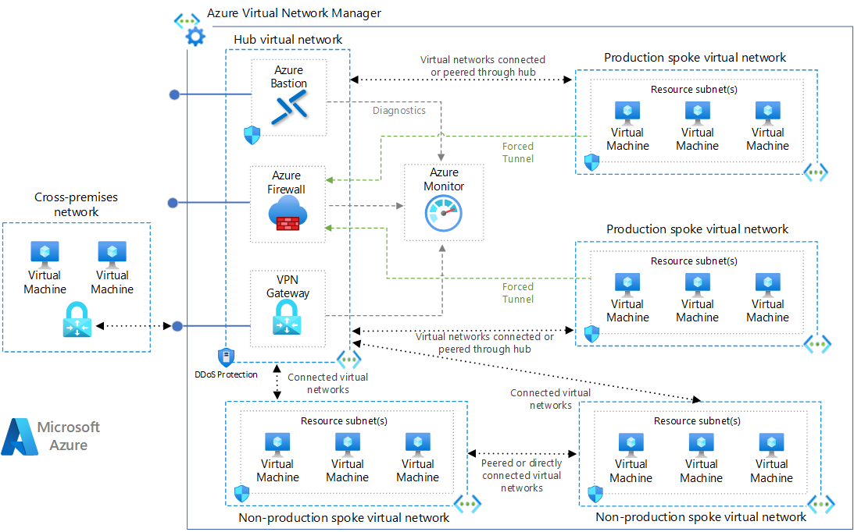
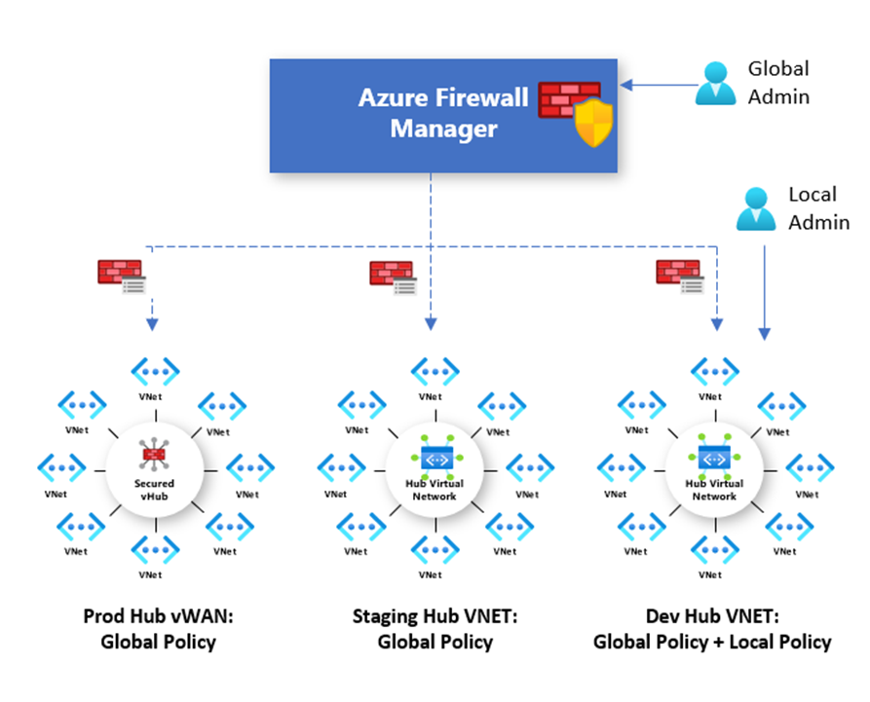
What is Azure Firewall?
A managed, cloud-native, stateful firewall deployed at the hub VNet level.
Inspection Level
- Layer 3, 4, and limited Layer 7
  - IP, Port, Protocol
  - FQDN filtering
  - Application rules (HTTP/S, SQL, etc.)
Key Capabilities
- Centralized control
- Stateful inspection
- Built-in High Availability
- Auto-scaling
Traffic Patterns
- Spoke → Spoke
- Spoke → Internet
- On-prem → Azure
- Forced tunneling via UDRs

Slide 5 — Azure Firewall Rule Types (Very Important Slide)
1️⃣ Network Rules (L3/L4)
Used for non-HTTP protocols
- RDP (3389)
- SSH (22)
- SMB
- Custom TCP/UDP ports
Example
Allow TCP 3389 from 10.1.0.0/16 to 10.2.1.4

2️⃣ Application Rules (L7)
Used for HTTP/S traffic
- Domain-based filtering
- FQDN tags (Windows Update, Azure services)
Example
Allow https://*.microsoft.com
Deny https://facebook.com

3️⃣ DNAT Rules
Inbound access from Internet → Private IP
- Public IP → Private VM
- Controlled and logged

Slide 6 — Azure Firewall Strengths and Trade-offs
Strengths ✅
- Centralized security enforcement
- Full traffic logging
- Works with:
  - Hub-Spoke
  - Virtual WAN
- Integrates with:
  - Azure Monitor
  - Log Analytics
  - Sentinel
Limitations ❌
- Not designed for application attack detection
- Cannot inspect:
  - SQL injection
  - Cross-site scripting
- Higher cost than NSG
- Requires routing (UDR dependency)
Best Use Case
“All traffic must pass through a single security checkpoint”

Slide 7 — Web Application Firewall (WAF): Application-Layer Protection
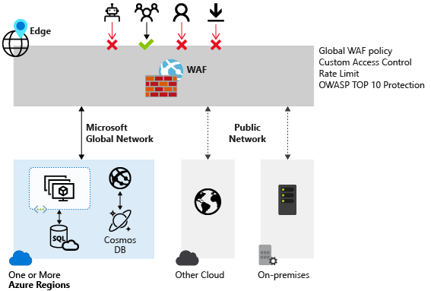
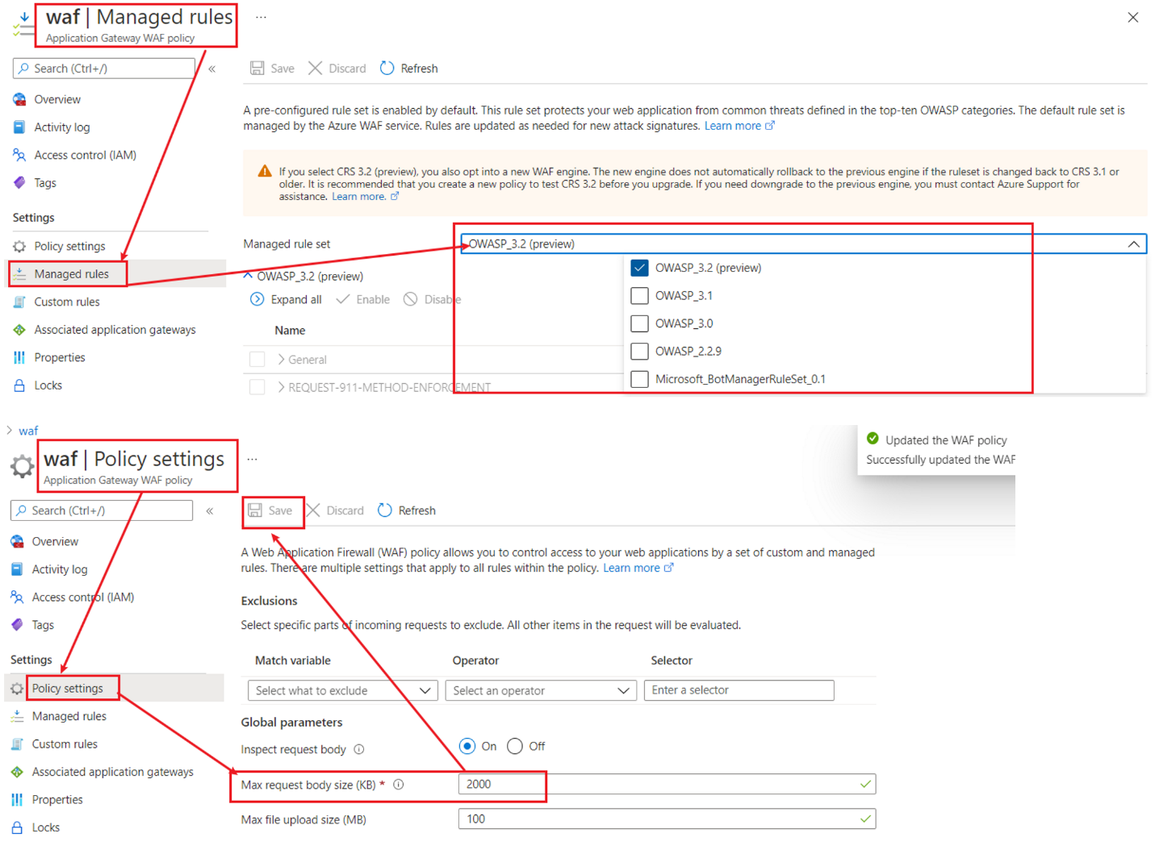
What is WAF?
A Layer-7 security service designed specifically for web applications.
Where WAF Lives
- Azure Application Gateway
- Azure Front Door
- Azure CDN (Premium)
Inspection Level
- Layer 7 (HTTP/S)
- Inspects:
  - Headers
  - URLs
  - Cookies
  - Request body

Slide 8 — WAF Protection Capabilities
Based on OWASP Top 10
WAF protects against:
- SQL Injection
- Cross-Site Scripting (XSS)
- Remote File Inclusion
- Command Injection
- Malformed requests
Operating Modes
- Detection
  - Logs attacks
  - Does not block
- Prevention
  - Blocks malicious requests
Custom Rules
- Geo-blocking
- Rate limiting
- Bot protection
- IP allow/deny lists

Slide 9 — WAF Strengths and Limitations
Strengths ✅
- Deep application inspection
- Protects web apps from real attacks
- Required for internet-facing apps
- Zero trust for HTTP traffic
Limitations ❌
- Only works for HTTP/S
- Cannot secure:
  - RDP
  - SSH
  - Database traffic
- Must be paired with:
  - NSG
  - Firewall
Best Use Case
“Protect my web application from hackers”

Slide 10 — Side-by-Side Comparison (Exam Favorite)
Feature | NSG | Azure Firewall | WAF
Layer | L3/L4 | L3–L7 | L7
Stateful | Yes | Yes | Yes
Application awareness | ❌ | Partial | ✅
OWASP protection | ❌ | ❌ | ✅
Centralized control | ❌ | ✅ | ❌
Cost | Free | Paid | Paid
Placement | Subnet/NIC | Hub VNet | App Edge

Slide 11 — When to Use What (Decision Logic)
Use NSG when:
- You need basic traffic filtering
- Micro-segmentation
- Internal workloads
Use Azure Firewall when:
- You need centralized security
- Hub-and-spoke architecture
- Internet and on-prem traffic control
Use WAF when:
- Application is internet-facing
- Security against OWASP attacks is mandatory
- Compliance requirements exist

Slide 12 — Real-World Enterprise Architecture (Best Practice)
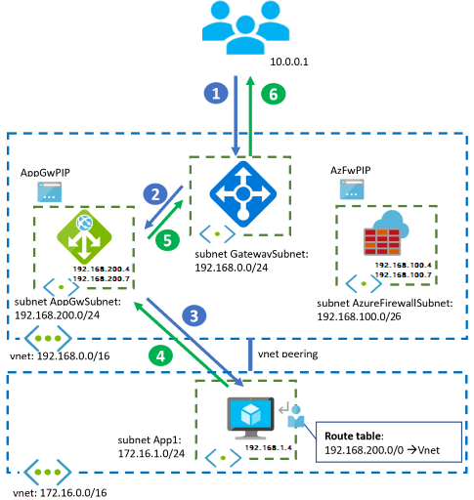

Typical Enterprise Setup
- NSG → Internal subnet control
- Azure Firewall → Network perimeter
- WAF → Application protection
❗ These services are complementary, not replacements

Slide 13 — AZ-700 Exam Tip
❓ “Which service protects against SQL injection?”
✅ WAF
❓ “Which service controls outbound internet traffic centrally?”
✅ Azure Firewall
❓ “Which service filters traffic at subnet level?”
✅ NSG

Slide 14 — One-Line Summary (Perfect for Closing Slide)
- NSG → Who can talk to whom
- Azure Firewall → All traffic goes through me
- WAF → Protect my web app from attacks

