Slide 1 — Just-in-Time (JIT) VM Access: Introduction

What is JIT VM Access?
Just-in-Time (JIT) VM Access is a security feature that locks down management ports on Azure VMs and opens them only when explicitly requested, for a limited time and from approved IPs.
Why JIT Exists
- Management ports (22, 3389) are top attack vectors
- Always-open ports invite:
  - Brute-force attacks
  - Credential stuffing
  - Port scanning
JIT follows the Zero Trust principle: “Never assume access is safe by default.”

Slide 2 — The Core Problem JIT Solves

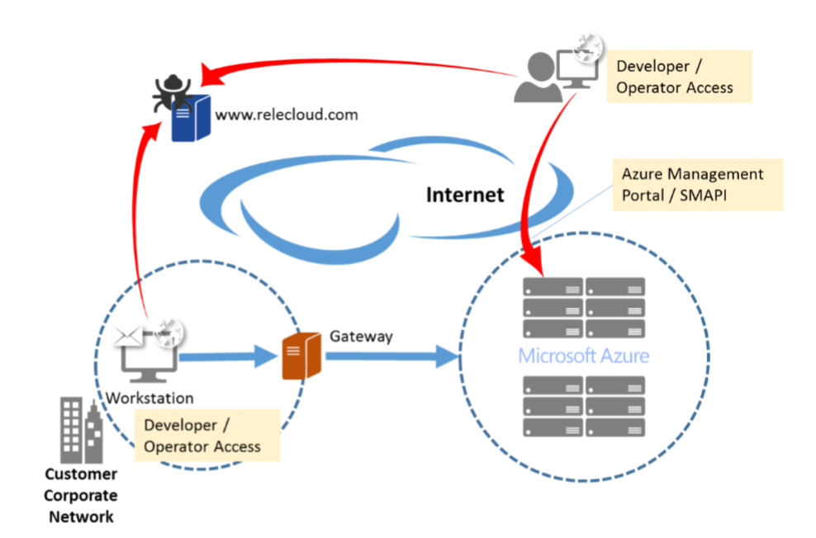
Traditional VM Access Model
- RDP (3389) / SSH (22) open 24×7
- Protected only by:
  - NSG rules
  - Strong passwords / keys
Security Risks
- Continuous exposure to the internet
- Automated attack bots
- Hard to track who accessed what and when
JIT Changes This Model
- Default state: DENY
- Temporary access: ALLOW
- Automatic re-lock after expiry

Slide 3 — What Exactly Does JIT Do?
JIT Enforcement Actions
When JIT is enabled:
- Management ports are blocked by default
- Access is granted:
  - Only on request
  - Only for approved ports
  - Only from specific IP addresses
  - Only for a defined duration
- After expiry → ports automatically closed
Commonly Protected Ports
OS Type | Ports
Windows | 3389 (RDP)
Linux | 22 (SSH)
Custom | Any TCP/UDP port

Slide 4 — Where JIT Fits in Azure Security Architecture
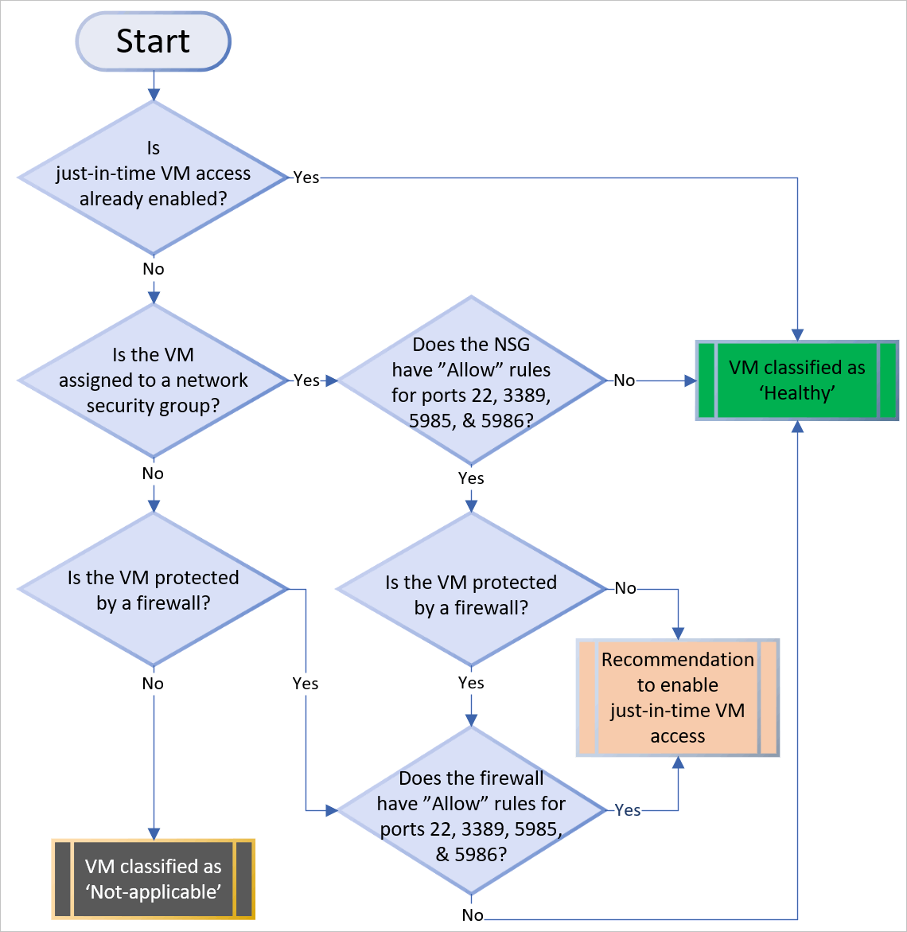

JIT is Part of…
- Microsoft Defender for Cloud
- Works alongside:
  - NSG
  - Azure Firewall
  - Azure Bastion
JIT is NOT
❌ A replacement for:
- NSG
- Firewall
- Bastion
✅ It is an additional control layer specifically for administrative access

Slide 5 — JIT Access Flow (Step-by-Step)
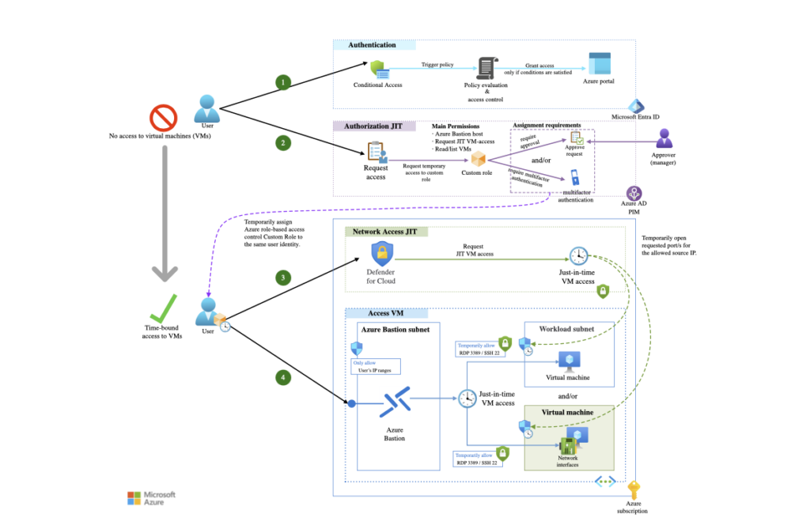
End-to-End Flow
- Admin requests VM access
- Azure validates:
  - User role (RBAC)
  - Requested ports
  - Source IP
  - Requested duration
- NSG rules are temporarily updated
- Admin connects (RDP / SSH)
- Timer expires → NSG rules revert
🔐 No manual cleanup required

Slide 6 — How JIT Works Internally (Important for Exams)
Technical Implementation
- JIT dynamically modifies:
  - Network Security Group rules
- Rules created:
  - High priority
  - Time-bound
  - IP-restricted
Key Point
JIT does not open ports on the VM OS
It controls access at the network layer

Slide 7 — JIT Configuration Options
Configurable Parameters
- Ports to protect
- Maximum access duration (e.g., 1–3 hours)
- Allowed source IP ranges
- Approval requirements (manual / automatic)
Example Configuration
Setting | Value
Port | 3389
Protocol | TCP
Max Duration | 2 hours
Source IP | Admin public IP

Slide 8 — JIT vs Traditional NSG Rules
Feature | Traditional NSG | JIT
Port exposure | Always open | Closed by default
Time-based access | ❌ | ✅
IP restriction | Manual | Automatic
Audit trail | Limited | Full
Zero Trust aligned | ❌ | ✅

Slide 9 — JIT vs Azure Bastion (Common Confusion)
Aspect | JIT | Azure Bastion
Access type | RDP/SSH | Browser-based
Public IP required | Yes | No
Port exposure | Temporary | None
Best for | Admin workflows | Secure jump access
Best Practice
Bastion + JIT = Maximum security

Slide 10 — Logging, Auditing, and Compliance
What Gets Logged
- Who requested access
- When access was granted
- Source IP
- Duration
- Ports opened
Where Logs Go
- Defender for Cloud
- Azure Activity Logs
- Log Analytics
- Microsoft Sentinel
Ideal for SOC, audits, and compliance

Slide 11 — Enterprise Use Cases
Common Scenarios
- Production VM access
- Break-glass troubleshooting
- Regulated environments (PCI, ISO, SOC)
- DevOps admin workflows
Typical Pattern
- No standing access
- Temporary, approved, logged access
- Automatic rollback

Limitations and Considerations
Limitations
- Requires Defender for Cloud plan
- Works only with:
  - Azure VMs
  - Supported OS images
- Not a VPN replacement
Important Consideration
If NSG allows Any-Any, JIT becomes ineffective
Baseline security is mandatory

Best Practices (Architect View)
Recommended Approach
- Enable JIT on all internet-facing VMs
- Use:
  - Short access windows
  - IP-restricted requests
- Combine with:
  - Azure Bastion
  - RBAC least privilege
  - Logging + alerts

Key Takeaways
- JIT protects management ports
- Default state = DENY
- Temporary access via NSG rule injection
- Strongly aligned with Zero Trust
- Complements, not replaces, NSG/Firewall/Bastion

One-Line Summary
JIT VM Access ensures that administrative ports are open only when absolutely required, for the shortest possible time, and with full auditability.

