🔐 Lab 4 — Just-in-Time (JIT) VM Access (Azure)

🎯 Lab Objective
By the end of this lab, you will be able to:
- Understand why JIT VM Access is required
- Enable Just-in-Time VM Access
- Request temporary RDP/SSH access
- Observe dynamic NSG rule creation
- Validate automatic port closure
- Review audit logs and security events

🧱 Lab Architecture Overview

Components Used
- Azure Virtual Machine (Windows or Linux)
- Network Security Group (NSG)
- Microsoft Defender for Cloud
- Public IP (for testing JIT)
- Azure Portal

📌 Lab Prerequisites & Dependencies
🔹 Azure Subscription
- Active Azure subscription
- Contributor or Security Admin role
🔹 VM Requirements
Requirement | Status
Azure VM | ✅ Required
Public IP | ✅ Required
NSG attached | ✅ Required
OS | Windows (RDP) or Linux (SSH)
Defender for Cloud | ✅ Enabled
⚠️ JIT will not work without an NSG attached to the VM subnet or NIC.

🧪 Lab 0 — Environment Preparation (Mandatory)
Step 0.1 — Verify VM Exists
- Azure Portal → Virtual Machines
- Confirm at least one VM is running
  - Windows VM → RDP (3389)
  - Linux VM → SSH (22)

Step 0.2 — Verify NSG Association
- Open Virtual Machine
- Go to Networking
- Confirm:
  - NSG attached to NIC or Subnet
📌 Note: JIT modifies NSG rules, not VM OS firewall.

Step 0.3 — Verify Public IP
- VM → Networking
- Confirm Public IP exists
- Note the Public IP address (used later)

🧪 Lab 1 — Verify Current Security Risk (Before JIT)
Step 1.1 — Check Existing NSG Rules
- Open Network Security Group
- Go to Inbound security rules
- Observe:
  - RDP (3389) or SSH (22) is Allowed
  - Often from Any or Internet
📌 This is the security risk JIT will fix.

Step 1.2 — Test Direct Access (Optional)
- Try connecting using:
  - RDP → Windows VM
  - SSH → Linux VM
- Confirm access works without restriction

🧪 Lab 2 — Enable Microsoft Defender for Cloud
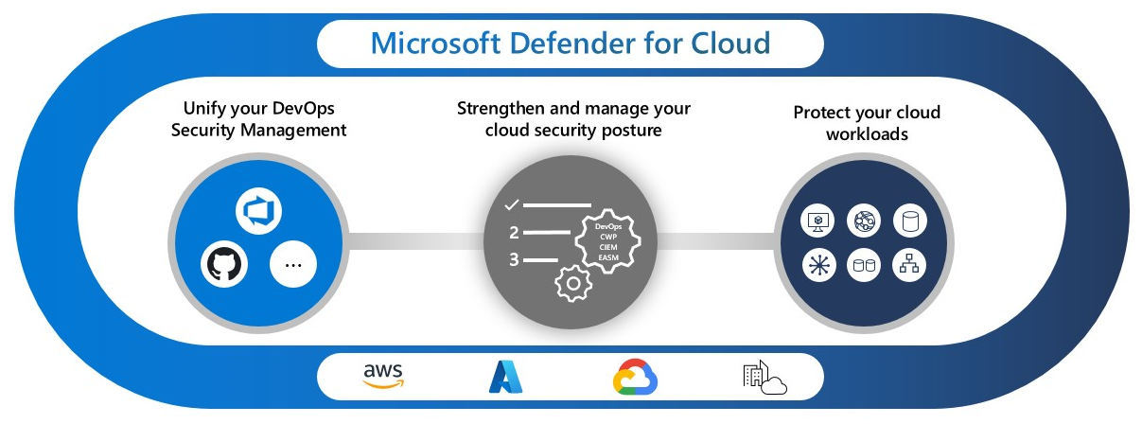
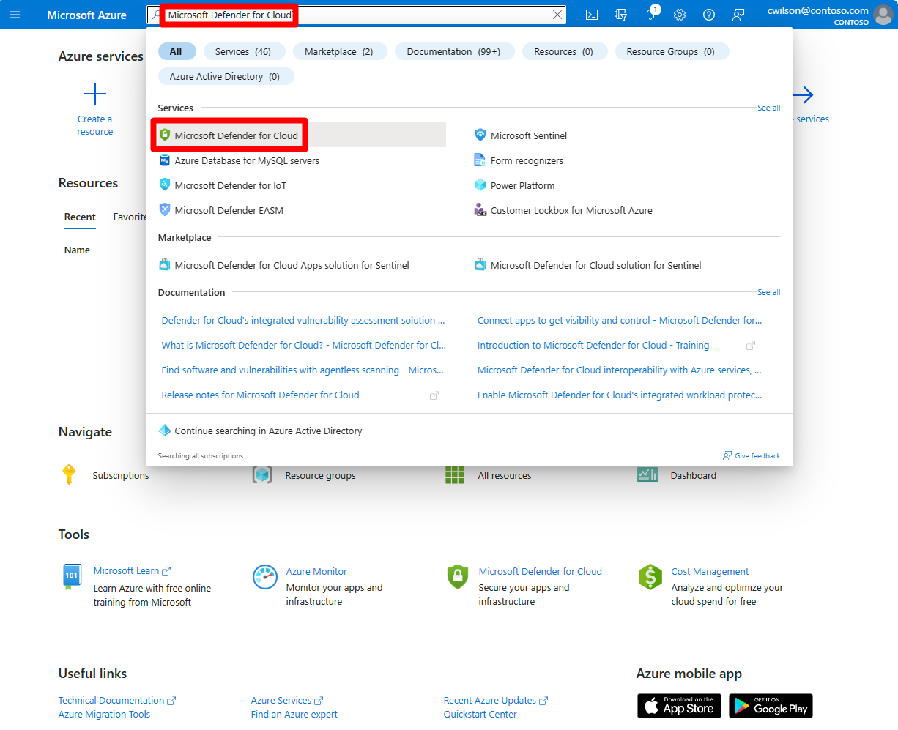
Step 2.1 — Open Defender for Cloud
- Azure Portal → Microsoft Defender for Cloud
- Overview page opens

Step 2.2 — Enable Defender Plans
- Go to Environment settings
- Select your subscription
- Enable:
  - Defender for Servers
- Click Save
⏳ Wait 5–10 minutes for Defender to initialize.

🧪 Lab 3 — Enable Just-in-Time VM Access
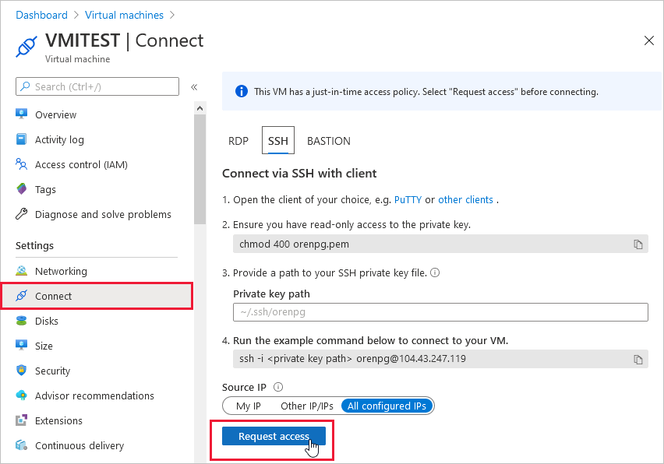
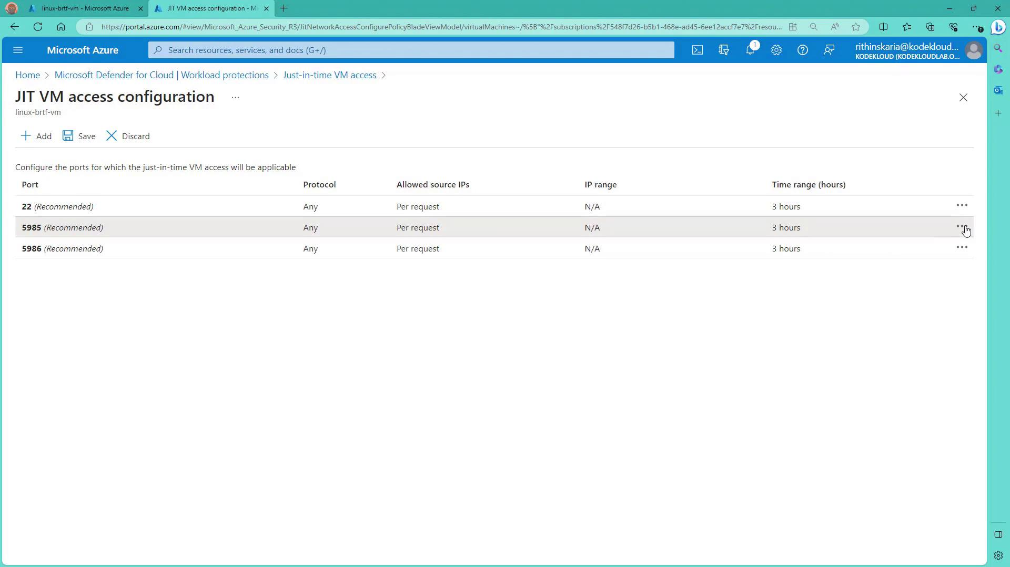
Step 3.1 — Navigate to JIT
- Defender for Cloud → Workload protections
- Click Just-in-time VM access

Step 3.2 — Identify Target VM
- VM appears under:
  - Not configured
  - Or Recommended

Step 3.3 — Enable JIT on VM
- Select VM
- Click Enable JIT on VMs

Step 3.4 — Configure JIT Settings
Setting | Value
Port | 3389 (Windows) / 22 (Linux)
Protocol | TCP
Max Access Duration | 1–3 hours
Allowed Source IP | My IP
Click Save

🧪 Lab 4 — Observe NSG Changes (Critical Learning)
Step 4.1 — Inspect NSG After Enabling JIT
- Go to NSG → Inbound rules
- Observe:
  - New Deny rule for 3389/22
  - High priority rule
📌 This rule blocks access by default

🧪 Lab 5 — Request JIT Access
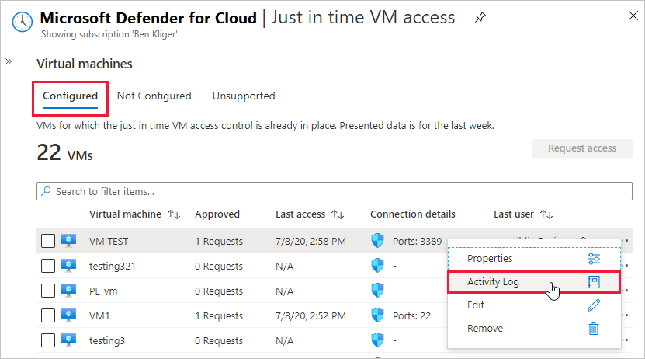
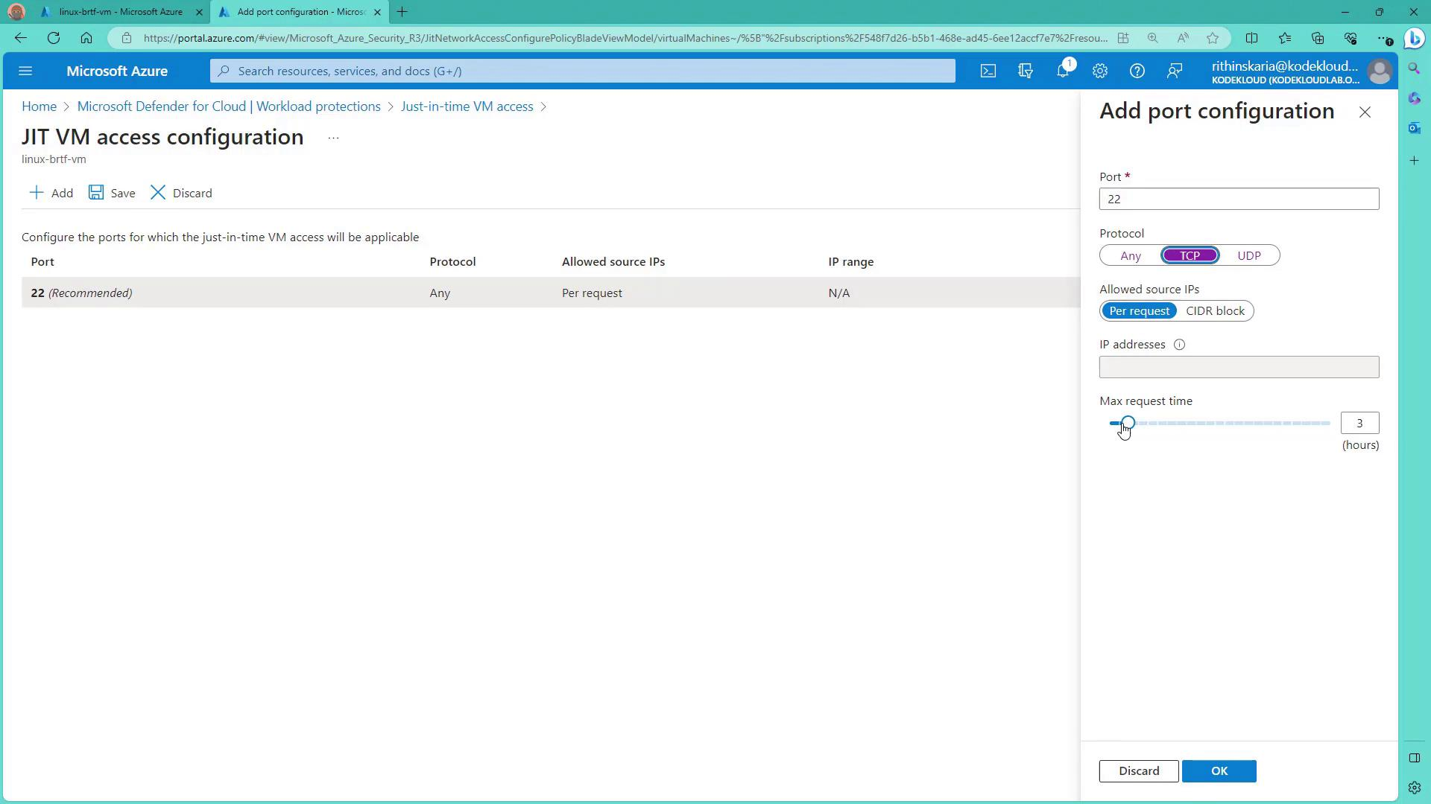
Step 5.1 — Request Access
- Defender for Cloud → Just-in-time VM access
- Select VM
- Click Request access

Step 5.2 — Configure Access Request
Field | Value
Port | 3389 / 22
Source IP | My current public IP
Duration | 30–60 minutes
Click Open ports

Step 5.3 — Verify Access Granted
- Status changes to Active
- Countdown timer visible

🧪 Lab 6 — Verify Dynamic NSG Rule Injection
Step 6.1 — Check NSG Rules
- NSG → Inbound rules
- Observe:
  - Temporary Allow rule
  - Source IP = your public IP
  - High priority
  - Description mentions JIT
📌 This rule is auto-created

🧪 Lab 7 — Connect to VM (Validation)
Step 7.1 — Connect to VM
- Use:
  - RDP client (Windows VM)
  - SSH client (Linux VM)
Expected Result
✅ Connection works only during approved window

🧪 Lab 8 — Verify Automatic Lockdown (Key Outcome)
Step 8.1 — Wait for Timer Expiry
- Wait until JIT timer expires

Step 8.2 — Check NSG Again
- Temporary Allow rule removed
- Only Deny rule remains

Step 8.3 — Attempt Reconnection
- Try RDP/SSH again
❌ Connection fails
📌 This confirms JIT enforcement

🧪 Lab 9 — Logging & Auditing
Step 9.1 — View JIT Logs
- Defender for Cloud → Just-in-time VM access
- Select VM
- View Activity history

Step 9.2 — Azure Activity Logs
- Azure Portal → Monitor
- Activity Log
- Filter:
  - Operation: JIT access request

🧠 Lab Observations & Key Learnings
- JIT modifies NSG rules dynamically
- Ports are closed by default
- Access is:
  - Time-bound
  - IP-restricted
  - Fully logged
- No manual cleanup required

🏗️ Best Practices (Architect View)
- Enable JIT on:
  - All internet-facing VMs
  - Production environments
- Use:
  - Short access windows
  - Bastion + JIT for maximum security
- Monitor via:
  - Defender for Cloud
  - Sentinel alerts

❗ Common Mistakes (Exam + Real World)
Mistake | Impact
NSG allows Any-Any | JIT ineffective
No public IP | Cannot test JIT
Defender disabled | JIT unavailable
Long access duration | Security risk

📝 Lab Cleanup (Optional)
- Disable JIT (optional)
- Stop VM to reduce cost
- Remove public IP if not needed

✅ Final One-Line Summary
Just-in-Time VM Access ensures that administrative ports are never exposed unless explicitly requested, approved, logged, and automatically revoked.

