Detailed Technical Handout (Deep Dive)
Topics Covered
- Azure Virtual Networks (VNet)
- IP Addressing & Address Spaces
- Private IP Address Allocation
- Regions & Subscriptions
- Azure DNS
- VNet Peering
- Gateway Transit & Hub-and-Spoke
- Service Chaining
- Traffic Routing in Azure, Forced Tunneling, Forced Tunneling
- Azure NAT Gateway

1. What is an Azure Virtual Network (VNet)?
An Azure Virtual Network (VNet) is a logically isolated private network within Azure that allows Azure resources (VMs, App Services, AKS, PaaS endpoints) to securely communicate with:
- Each other
- The Internet
- On-premises networks
- Other VNets (same or different regions)
Why VNets Exist
Azure is a multi-tenant cloud. VNets provide:
- Isolation
- IP address control
- Routing boundaries
- Security enforcement
A VNet behaves like a traditional enterprise network, but is:
- Software-defined
- Highly scalable
- Region-scoped

2. Azure Virtual Network – Core Capabilities
Communication Models
Scenario | Description
Internet | Outbound/inbound traffic via public IP, NAT, LB
Azure-to-Azure | Private communication inside or across VNets
Hybrid | VPN / ExpressRoute to on-prem
Filtering | NSG, ASG, Azure Firewall
Routing | System routes, UDRs, Route Server
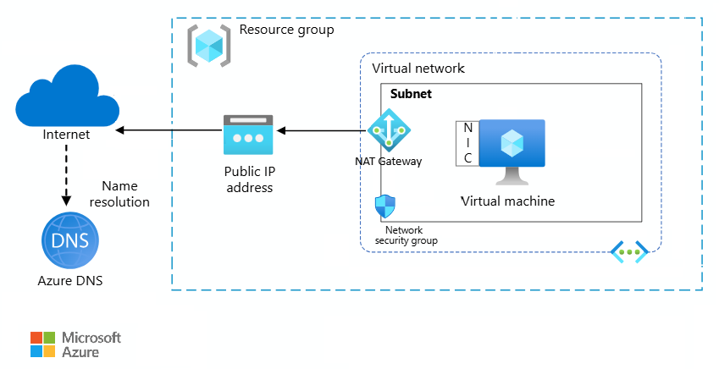
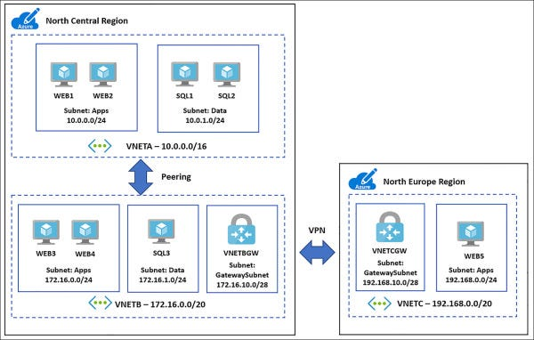

3. Virtual Network Address Space (IP Planning)
RFC 1918 Private IP Ranges
Azure VNets must use private IP ranges:
Range | CIDR
10.0.0.0 – 10.255.255.255 | 10/8
172.16.0.0 – 172.31.255.255 | 172.16/12
192.168.0.0 – 192.168.255.255 | 192.168/16
Azure-Reserved IP Addresses (Critical Exam Topic)
Azure reserves 5 IPs per subnet:
IP | Purpose
x.x.x.0 | Network address
x.x.x.1 | Default gateway
x.x.x.2-3 | Azure DNS mapping
x.x.x.255 | Broadcast
❗ Design Impact
A /29 subnet gives only 3 usable IPs → often too small.

4. Subnets – Logical Segmentation
A subnet is a routing and security boundary inside a VNet.
Why Subnets Matter
- Attach NSGs
- Associate Route Tables
- Deploy service-specific resources (GatewaySubnet, AzureFirewallSubnet)
Key Rules
- Subnet CIDRs must not overlap
- Cannot resize subnet downward once resources exist
- Some services require dedicated subnets
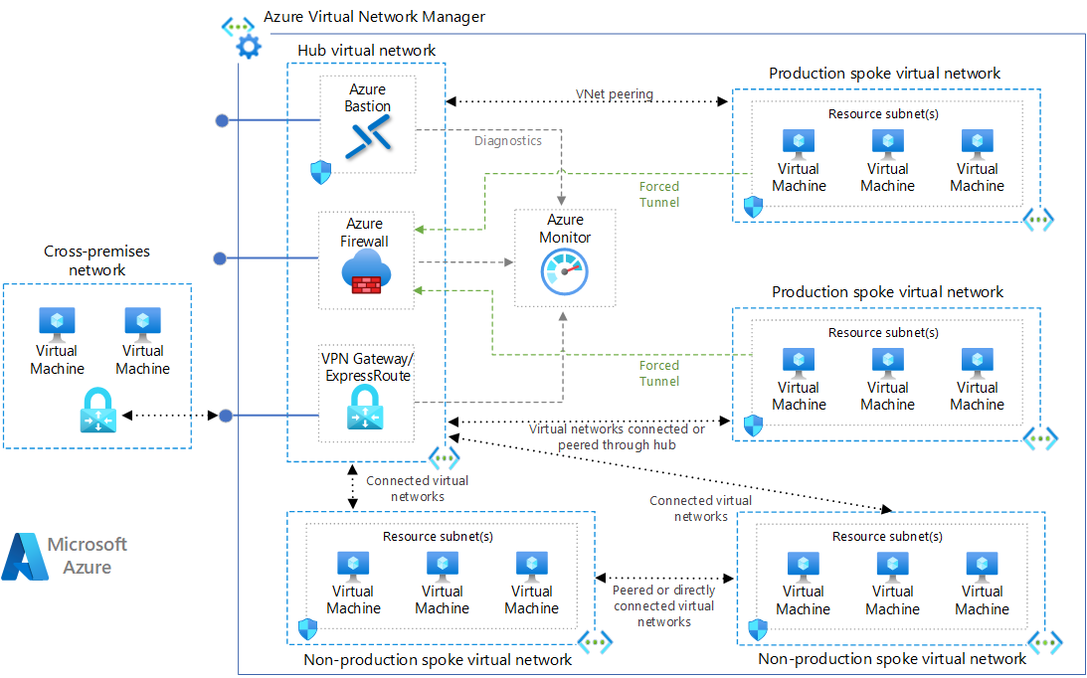

5. Private IP Address Allocation
Allocation Methods
Method | Behavior
Dynamic | Azure assigns next available IP
Static | You choose the IP
Best Practices
- Use static IPs for:
  - Domain controllers
  - DNS servers
  - Firewalls
- Use dynamic IPs for:
  - Application workloads
  - Scale-out services

6. Regions & Subscriptions
- VNets are region-scoped
- VNets cannot span regions
- Connectivity across regions requires:
  - Global VNet Peering
  - VPN / ExpressRoute
Subscription boundaries:
- VNets can peer across subscriptions
- Even across different tenants

7. Public IP Services – Deep Dive
What is a Public IP in Azure?
A Public IP resource represents a routable Internet IP that can be attached to:
- VM NIC
- Load Balancer
- Application Gateway
- VPN Gateway

Public IP SKUs (VERY IMPORTANT)
Feature | Basic | Standard
Allocation | Static / Dynamic | Static only
Security | Open by default | Secure by default
NSG required | Optional | Mandatory
Zone support | ❌ | ✅
Recommended | ❌ | ✅
❗ Production Rule
👉 Always use Standard SKU

8. Bring Your Own IP (BYOIP)
Used by enterprises that:
- Own public IP ranges
- Want to retain email / IP reputation
- Must comply with allowlists
3-Phase Process
- Validation – Prove ownership
- Provision – Upload prefix
- Commission – Advertise via Azure

9. DNS in Azure – Name Resolution Design
Public DNS vs Private DNS
Type | Use Case
Public DNS | Internet-facing services
Private DNS | Internal VMs & PaaS
Azure DNS is authoritative, not recursive.

10. Azure DNS Zones & Delegation
DNS Zone
- Container for records (A, CNAME, MX, TXT…)
- One zone per domain (example: contoso.com)
Delegation Flow
- Register domain at registrar
- Create DNS zone in Azure
- Update registrar NS records → Azure NS
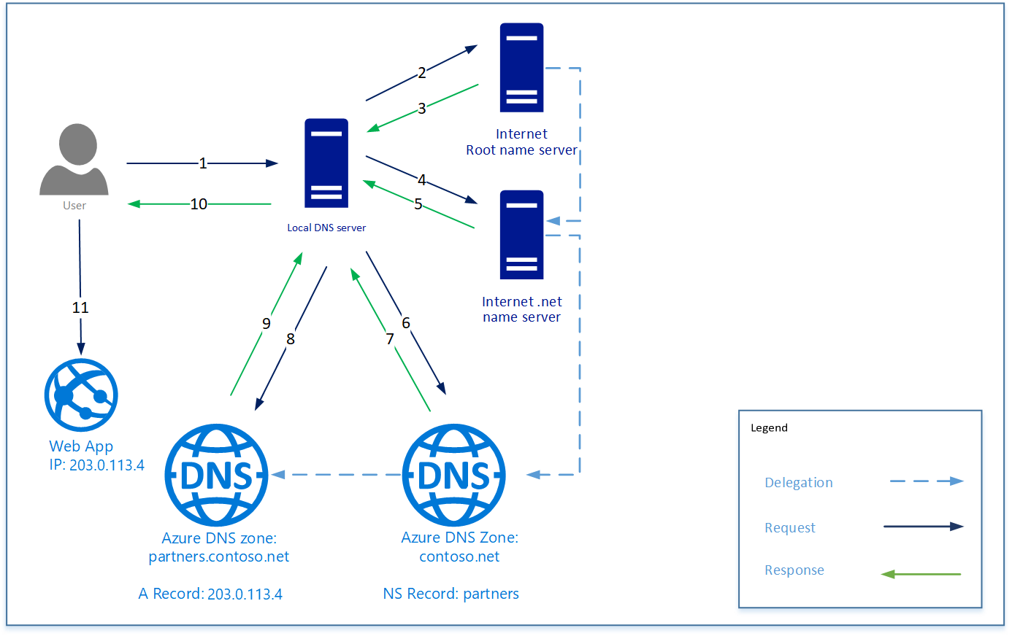

11. Private DNS Zones (Highly Tested Topic)
What They Solve
- Internal DNS without custom DNS servers
- Auto-registration of VM hostnames
- VNet-to-VNet resolution
Key Behavior
- DNS queries resolved only inside linked VNets
- Not reachable from Internet

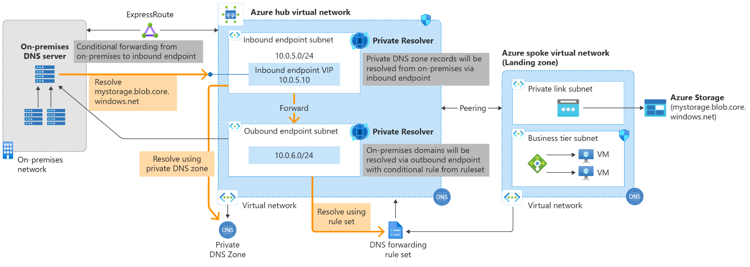

12. Special IP: 168.63.129.16 (VERY IMPORTANT)
This Azure-owned virtual IP enables:
- DHCP
- Azure DNS
- Load balancer health probes
- VM agent communication
- Platform heartbeat
❗ Never block this IP in NSGs or firewalls.

13. VNet Peering – Cross-VNet Connectivity
What VNet Peering Does
- Connects two VNets privately
- Uses Microsoft backbone
- No gateways required
Key Rules
- Non-transitive
- No overlapping IP ranges
- Supports cross-subscription & cross-tenant
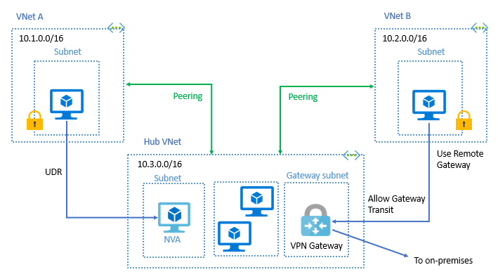

14. Gateway Transit (Hub-and-Spoke)
Allows:
- Spoke VNets to use hub VPN gateway
- Centralized hybrid connectivity
Typical Design
- Hub: VPN / ExpressRoute
- Spokes: Workloads
- UDRs enforce routing

15. Service Chaining
Service chaining forces traffic through:
- Firewall
- NVA
- Inspection appliances
Implemented using:
- User-Defined Routes (UDRs)
- Next hop = Virtual Appliance
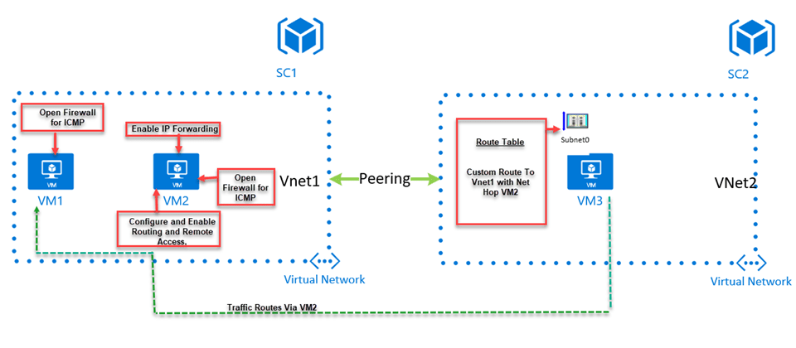

16. Virtual Network Traffic Routing
Route Types
Route Type | Description
System routes | Auto-created by Azure
Default route | 0.0.0.0/0 → Internet
UDRs | Custom routing
Troubleshooting Tool
- Effective Routes (NIC level)
- Network Watcher

17. Forced Tunneling
Forces all Internet traffic via on-prem firewall.
How It Works
- UDR: 0.0.0.0/0 → VPN Gateway
- Requires route-based VPN
- On-prem device must accept default route

18. Azure Route Server
Why It Exists
- Dynamic routing with NVAs
- No manual UDR updates
- Uses BGP
Requirements
- Dedicated RouteServerSubnet
- NVA must support BGP

19. Azure Virtual Network NAT
Problem It Solves
- Outbound Internet access
- Without public IPs on VMs
- Without load balancers
Key Benefits
- Static outbound IP
- Fully managed
- Highly scalable
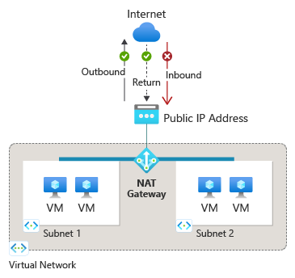

20. NAT vs Load Balancer (Exam Comparison)
Feature | NAT Gateway | Load Balancer
Inbound | ❌ | ✅
Outbound | ✅ | ✅
Static IP | ✅ | ✅
Use case | Egress only | Ingress + Egress

21. Design Summary (Architect View)
✔ Plan IP ranges early
✔ Use Standard SKU everywhere
✔ Centralize security in hub
✔ Prefer Private Endpoints + Private DNS
✔ Use UDRs + Firewall for inspection
✔ NAT Gateway for outbound-only workloads

22. Recommended Lab Flow (Aligned to PPT)
- Create VNets & Subnets
- Add NSGs
- Configure Public IP (Standard)
- Implement Private DNS
- Peer VNets (Global)
- Add UDRs & Forced Tunneling
- Deploy NAT Gateway
- Validate with Network Watcher

