🔹 Slide 1: Title Slide
Hub-and-Spoke Network Architecture in Azure
Design | Security | Routing | Operations
- Centralized networking model
- Enterprise-scale Azure design pattern
- Used for secure multi-application environments

🔹 Slide 2: Why Hub-and-Spoke? (Problem Statement)
Traditional Flat VNet Challenges
- No centralized security
- Duplicate network components
- Difficult governance
- Scaling issues
- Inconsistent routing
Real-World Enterprise Problems
- Multiple teams deploying VNets independently
- Firewall rules duplicated everywhere
- No control over traffic flow
- Hard to integrate on-premises securely

🔹 Slide 3: What is Hub-and-Spoke Design?
Definition
A central Hub VNet that provides shared services, connected to multiple Spoke VNets hosting workloads.
Core Idea
Centralize what should be shared, isolate what should be independent
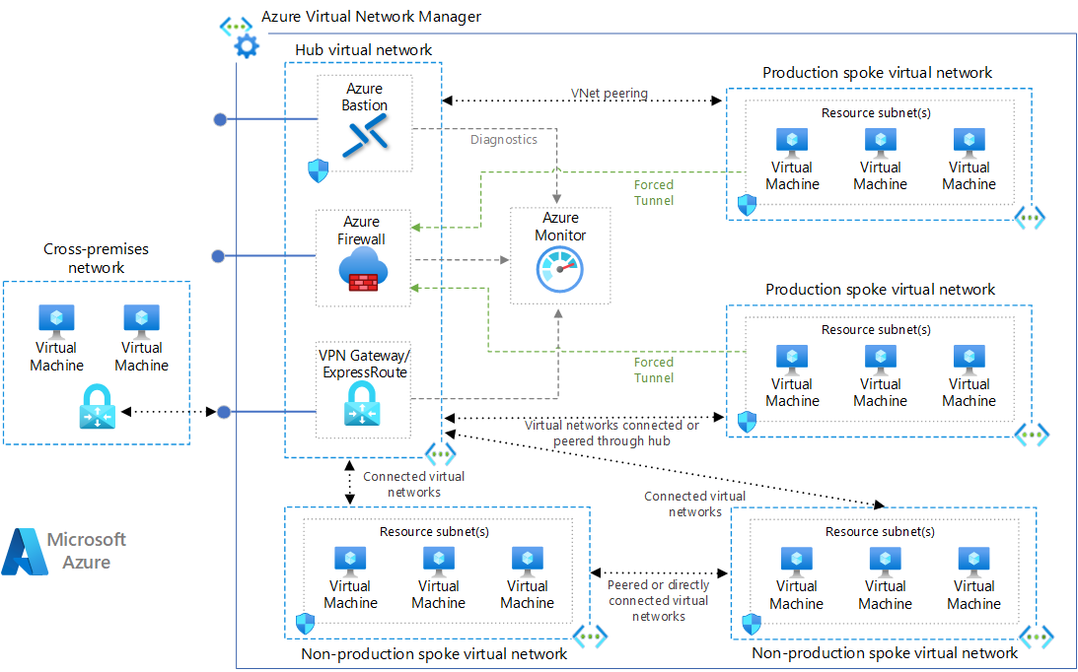

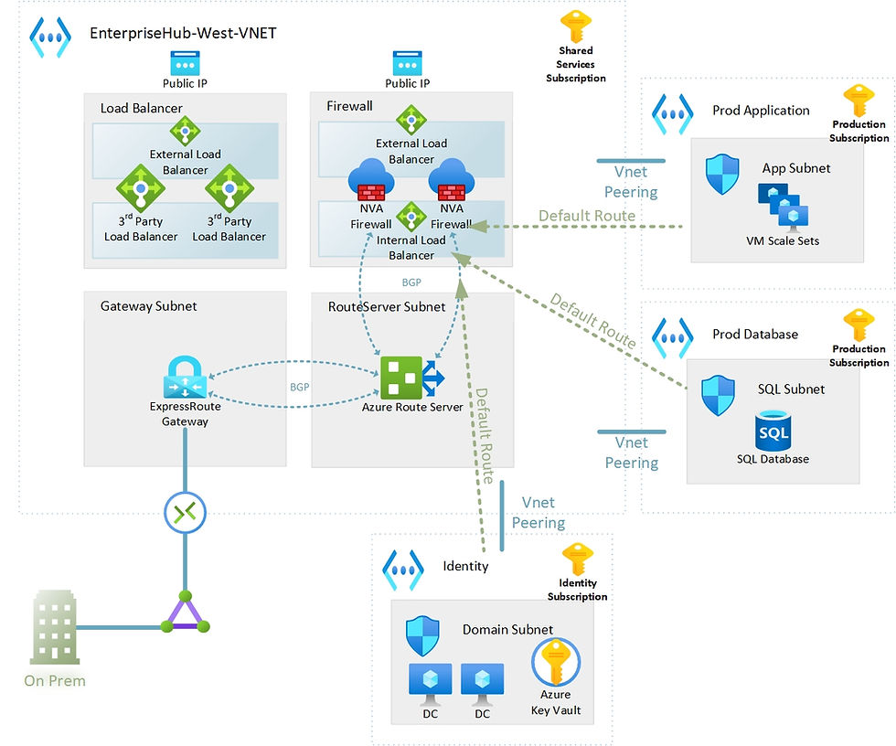

🔹 Slide 4: Hub-and-Spoke – Logical Components
Hub VNet (Central)
- Azure Firewall / NVA
- VPN Gateway / ExpressRoute
- Bastion
- Shared DNS
- Monitoring tools
Spoke VNets (Workloads)
- Application VNets
- Dev / Test / Prod separation
- Isolated teams or projects

🔹 Slide 5: Benefits of Hub-and-Spoke Architecture
Security Benefits
- Single firewall policy point
- Central inspection of traffic
- Reduced attack surface
Operational Benefits
- Easier management
- Reusable network services
- Faster onboarding of new apps
Cost Benefits
- One firewall instead of many
- Shared gateways
- Reduced IP exhaustion

🔹 Slide 6: Typical Use Cases
Enterprise Scenarios
- Multi-subscription architectures
- Shared security & compliance
- Hybrid connectivity (On-Prem → Azure)
- Dev / Test / Prod isolation
- Regulated industries (Banking, Healthcare)

🔹 Slide 7: High-Level Dependency Flow (Very Important Slide)
Dependency Order
- Hub VNet
- Shared Services in Hub
- Spoke VNets
- VNet Peering
- Routing (UDR)
- Security enforcement
- Monitoring & logging
❗ Routing and security depend entirely on correct peering & UDR configuration

🔹 Slide 8: Deploying the Hub Network – Overview
Hub VNet Design
- Large address space (e.g., 10.0.0.0/16)
- Multiple subnets for separation
Typical Hub Subnets
- AzureFirewallSubnet
- GatewaySubnet
- SharedServicesSubnet
- BastionSubnet

🔹 Slide 9: Hub Network – Shared Services
Common Shared Services
- Azure Bastion (secure VM access)
- DNS forwarders
- Jump servers
- Update servers
- Identity services (AD DS)
Why Centralize?
- Avoid duplication
- Enforce standard access
- Reduce admin overhead

🔹 Slide 10: Firewall / NVA in Hub
Options
- Azure Firewall (PaaS)
- NVA (pfSense, FortiGate, Palo Alto)
Firewall Responsibilities
- Internet ingress/egress control
- Spoke-to-Spoke traffic inspection
- On-prem ↔ Azure filtering

🔹 Slide 11: Hub Network – Traffic Control Principle
ALL traffic flows through the Hub
Traffic Type | Path
Spoke → Internet | Via Hub Firewall
Spoke → Spoke | Via Hub Firewall
On-Prem → Spoke | Via Hub Gateway + Firewall

🔹 Slide 12: Deploying Spoke VNets
Spoke Characteristics
- Smaller CIDR blocks
- Dedicated to a workload or team
- No gateways
- No internet exposure
Example
- Spoke-App-Dev: 10.1.0.0/16
- Spoke-App-Prod: 10.2.0.0/16

🔹 Slide 13: Connecting Spokes to Hub – VNet Peering
Peering Properties
- Non-transitive
- Low latency
- Private IP communication
Required Settings
- Hub: Allow gateway transit
- Spoke: Use remote gateway
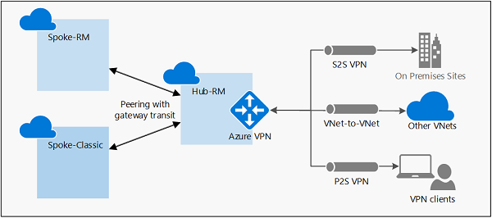
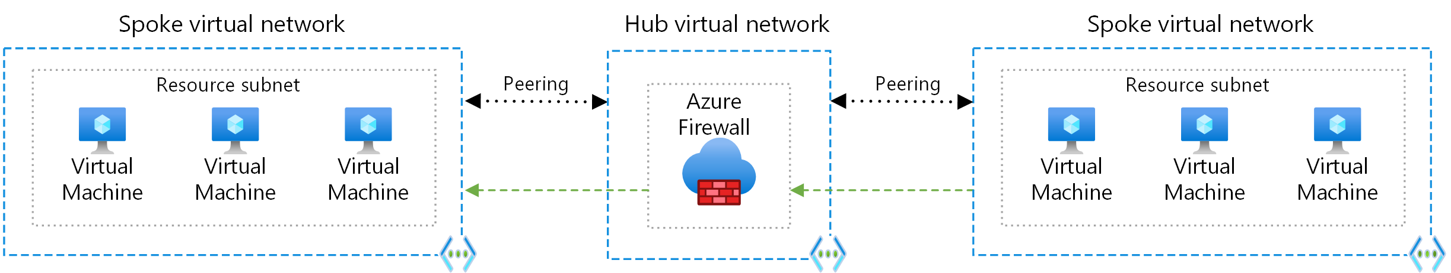

🔹 Slide 14: Peering Dependency Matrix
Configuration | Required
Hub → Spoke Peering | Yes
Spoke → Hub Peering | Yes
Allow Forwarded Traffic | Yes
Gateway Transit | Hub only
Use Remote Gateway | Spoke only

🔹 Slide 15: Route Propagation – Why Default Routes Are Not Enough
Problem
Azure system routes:
- Allow direct Spoke → Internet
- Allow Spoke → Spoke bypassing firewall
Solution
👉 User Defined Routes (UDR)

🔹 Slide 16: User Defined Routes (UDR) – Concept
Goal
Force traffic through the Hub firewall
Example Routes
- 0.0.0.0/0 → Firewall
- 10.0.0.0/8 → Firewall
- 172.16.0.0/12 → Firewall
- 192.168.0.0/16 → Firewall

🔹 Slide 17: Route Table Attachment (Critical Dependency)
Where to Attach UDR?
- Spoke Subnets ONLY
- Never attach to GatewaySubnet
- Never attach to Firewall subnet
Effect
All Spoke traffic is forced to Hub firewall

🔹 Slide 18: Centralized Security Model
Security Enforcement Layers
- NSG (micro-segmentation)
- Firewall / NVA (deep inspection)
- Azure Policy (governance)
- RBAC (access control)

🔹 Slide 19: NSG vs Firewall – Clear Separation
NSG | Firewall
Subnet / NIC level | Network perimeter
Stateless | Stateful
Allow/Deny only | L3-L7 inspection
Cheap | Enterprise security

🔹 Slide 20: Centralized Monitoring & Logging
Hub-Based Monitoring
- Azure Monitor
- Log Analytics Workspace
- Traffic Analytics
- Firewall logs
- NSG flow logs
Benefits
- Single pane of glass
- Faster troubleshooting
- Compliance reporting

🔹 Slide 21: End-to-End Traffic Flow Example
Scenario
VM in Spoke-1 accessing Internet
- VM sends traffic
- UDR sends to Firewall
- Firewall inspects
- Allowed → Internet
- Return traffic via firewall

🔹 Slide 22: Common Design Mistakes (Exam + Real World)
- ❌ No UDR → Firewall bypass
- ❌ Overlapping CIDRs
- ❌ Missing gateway transit
- ❌ NSG blocking firewall traffic
- ❌ Attaching UDR to GatewaySubnet

🔹 Slide 23: When NOT to Use Hub-and-Spoke
- Very small environments
- Single application setups
- Cost-sensitive PoCs
- No centralized security need

🔹 Slide 24: Hub-and-Spoke vs Virtual WAN (Brief)
Hub-Spoke | Virtual WAN
Manual | Managed
More control | Less control
Lower cost | Higher cost
Complex | Simplified

🔹 Slide 25: Summary Slide
Key Takeaways
- Hub-and-Spoke is an enterprise-grade pattern
- Security and routing depend on correct UDR
- Peering alone is not enough
- Centralization improves security, governance, and cost

🔹 Slide 26: Next Steps / Labs (Optional)
- Build Hub VNet with Firewall
- Create 2 Spokes
- Configure peering
- Add UDR
- Validate traffic flow
- Enable logging

