🔧 Progressive Lab Manual
Azure Hub-and-Spoke Architecture (Intermediate Level)

🧩 Lab Structure & Dependency Map
Lab # | Title | Depends On
Lab 0 | Prerequisites & Environment Prep | —
Lab 1 | Design IP Addressing & Architecture | Lab 0
Lab 2 | Deploy Hub VNet & Core Subnets | Lab 1
Lab 3 | Deploy Shared Services & Firewall | Lab 2
Lab 4 | Deploy Spoke VNets & Workloads | Lab 2
Lab 5 | Configure Hub–Spoke VNet Peering | Lab 4
Lab 6 | Implement Route Control (UDR) | Lab 5
Lab 7 | Centralized Security with NSG + Firewall | Lab 6
Lab 8 | Traffic Flow Validation & Troubleshooting | Lab 7
Lab 9 | Centralized Monitoring & Logs | Lab 8

🧪 LAB 0 – Prerequisites & Environment Preparation
Objective
Prepare Azure environment for a multi-VNet enterprise topology.
Prerequisites
- Azure subscription (Owner or Network Contributor)
- Azure Portal access
- Basic Azure networking knowledge
Setup Tasks
- Create Resource Group
  - Name: rg-hub-spoke-lab
  - Region: East US
- Decide naming standard
  - vnet-hub
  - vnet-spoke-app1
  - vnet-spoke-app2

🧪 LAB 1 – IP Addressing & Architecture Design
Objective
Design non-overlapping CIDR ranges (critical dependency).
Architecture CIDR Plan
Component | Address Space
Hub VNet | 10.0.0.0/16
Spoke-App1 | 10.1.0.0/16
Spoke-App2 | 10.2.0.0/16
Why This Matters
- VNet peering fails with overlapping IPs
- Hybrid connectivity breaks with bad planning

🧪 LAB 2 – Deploy Hub VNet & Core Subnets
Objective
Create the central Hub VNet with required subnets.
Steps
- Create VNet
  - Name: vnet-hub
  - Address: 10.0.0.0/16
- Create Subnets
Subnet Name | CIDR
AzureFirewallSubnet | 10.0.1.0/24
GatewaySubnet | 10.0.2.0/24
SharedServicesSubnet | 10.0.3.0/24
AzureBastionSubnet | 10.0.4.0/24
⚠️ Subnet names must be exact for Firewall/Bastion
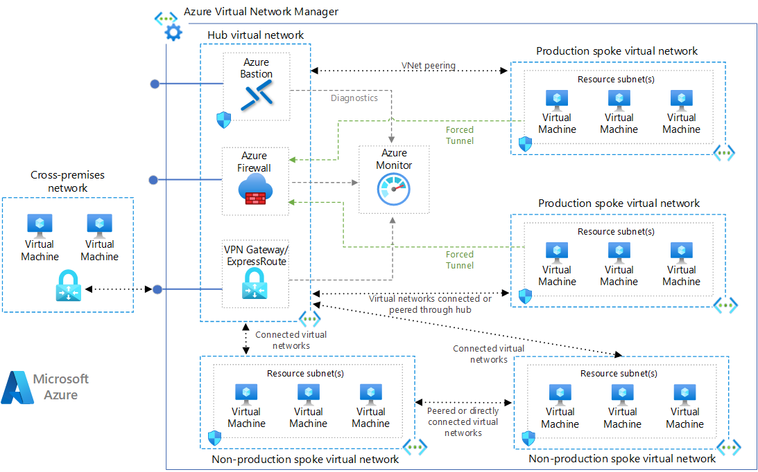
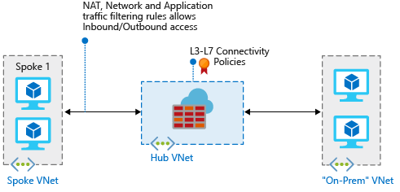

🧪 LAB 3 – Deploy Firewall & Shared Services (Hub)
Objective
Introduce central traffic inspection.
Tasks
- Deploy Azure Firewall
  - Name: azfw-hub
  - VNet: vnet-hub
  - Subnet: AzureFirewallSubnet
  - Assign Public IP
- Create Firewall Policy
  - Allow outbound Internet
  - Allow ICMP
  - Allow HTTP/HTTPS
- (Optional) Deploy Azure Bastion
Validation
- Firewall state: Succeeded
- Firewall has private IP

🧪 LAB 4 – Deploy Spoke VNets & Workloads
Objective
Create isolated workload networks.
Steps
- Create Spoke VNets
VNet | CIDR
vnet-spoke-app1 | 10.1.0.0/16
vnet-spoke-app2 | 10.2.0.0/16
- Create Subnet in each Spoke
- app-subnet → /24
- Deploy Test VM
- OS: Linux
- Public IP: ❌ No
- NSG: Allow ICMP & SSH

🧪 LAB 5 – Hub–Spoke VNet Peering
Objective
Enable private connectivity between Hub and Spokes.
Peering Configuration
Hub → Spoke
- Allow forwarded traffic ✅
- Allow gateway transit ✅
Spoke → Hub
- Allow forwarded traffic ✅
- Use remote gateway ✅
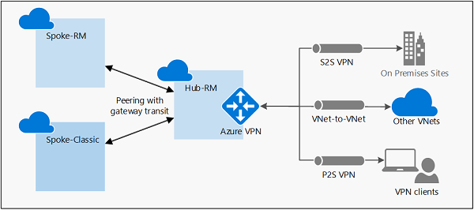
Validation
- VM in Spoke can ping Hub private IP

🧪 LAB 6 – Route Propagation & Control (UDR)
Objective
Force traffic through Firewall (most important lab).
Problem
Without UDR:
- Spoke traffic bypasses firewall
- Direct Internet access allowed
Solution
Create Route Table
Destination | Next Hop
0.0.0.0/0 | Virtual appliance (Firewall IP)
10.0.0.0/8 | Virtual appliance
172.16.0.0/12 | Virtual appliance
192.168.0.0/16 | Virtual appliance
Attach Route Table
- Attach ONLY to Spoke subnets
- ❌ Never attach to GatewaySubnet

🧪 LAB 7 – Centralized Security Enforcement
Objective
Apply layered security model.
Security Layers
- NSG
  - Allow only required ports
  - Deny internet inbound
- Firewall
  - Application rules
  - Network rules
- Azure Policy (Optional)
  - Block public IPs in Spokes

🧪 LAB 8 – Traffic Flow Validation & Troubleshooting
Objective
Prove Hub-controlled traffic flow.
Test Scenarios
- Spoke VM → Internet
- Spoke-1 → Spoke-2
- Spoke → Hub service
Expected Path
Spoke VM → UDR → Firewall → Destination
Common Issues
- Missing UDR
- NSG blocking firewall
- Wrong peering flags

🧪 LAB 9 – Centralized Monitoring & Logs
Objective
Observe traffic centrally.
Steps
- Enable Firewall Diagnostics
- Enable NSG Flow Logs
- Send logs to Log Analytics
Queries
- Blocked traffic
- Allowed outbound flows
- East-West traffic
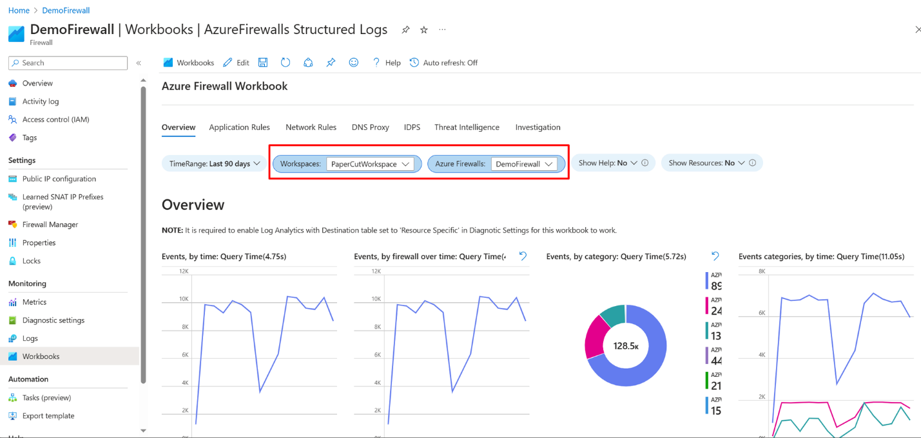
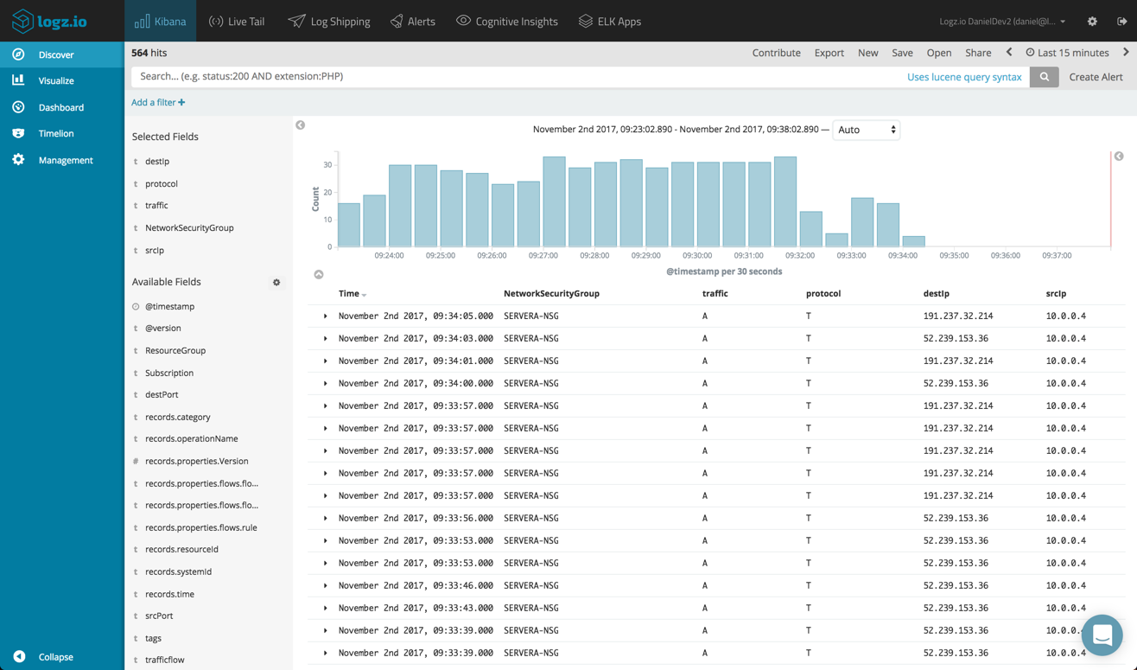

✅ Final Outcomes (What Student Achieves)
✔ Enterprise-grade Hub-Spoke
✔ Central firewall enforcement
✔ Correct routing & UDR usage
✔ Secure workload isolation
✔ Exam-ready troubleshooting skills

