Detailed Deep-Dive Handout (VPN Gateway & Virtual WAN)

1. Hybrid Networking in Azure – Big Picture
Hybrid networking enables secure connectivity between Azure and external networks, including:
- On-premises datacenters
- Branch offices
- Remote users
- Other Azure VNets (same or different regions/tenants)
Azure provides three primary hybrid connectivity models:
Model | Purpose
Site-to-Site (S2S) VPN | Datacenter ↔ Azure
Point-to-Site (P2S) VPN | User device ↔ Azure
Azure Virtual WAN | Large-scale, global hub-and-spoke
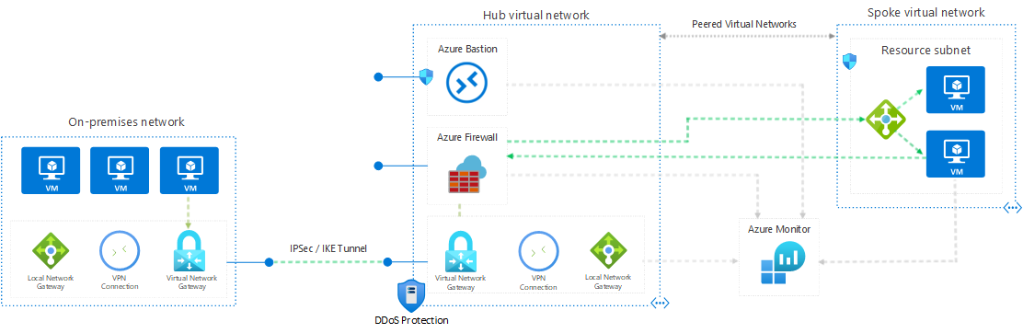
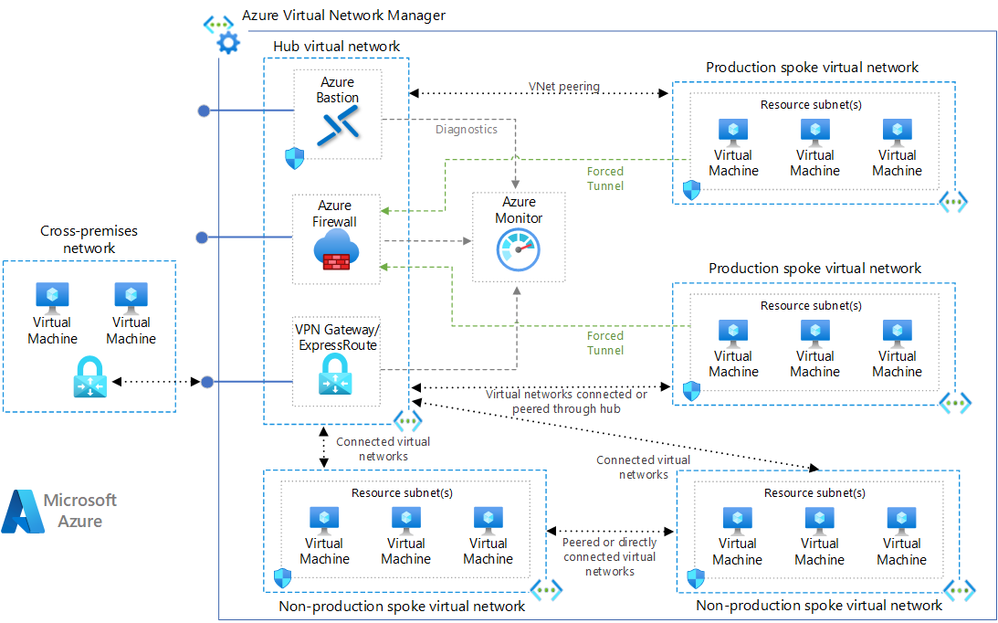

2. Azure VPN Gateway – Core Concept
An Azure VPN Gateway is a managed virtual network gateway that enables encrypted IPsec/IKE tunnels between Azure VNets and external networks.
What VPN Gateway Provides
- Encrypted connectivity (IPsec/IKE)
- High availability (two gateway instances)
- Integration with on-prem VPN devices
- Support for S2S, VNet-to-VNet, and P2S

3. VPN Gateway Deployment Architecture
Mandatory Components
- Virtual Network
- Gateway Subnet
- Public IP address
- Virtual Network Gateway resource
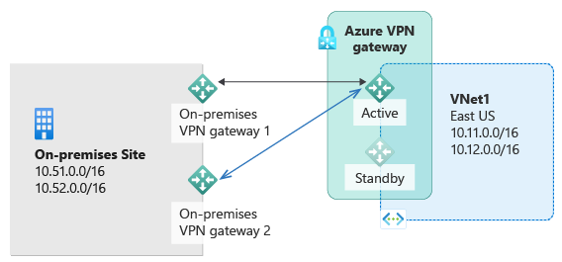
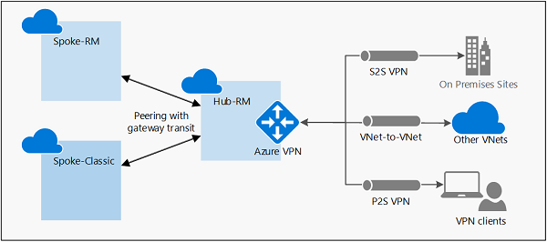

4. Gateway Subnet – Deep Dive (Exam Critical)
The Gateway Subnet is a special-purpose subnet used exclusively by the VPN Gateway.
Key Rules
- Name must be exactly: GatewaySubnet
- Minimum recommended size: /27 or /28
- No other resources allowed
- Azure deploys gateway VMs automatically
❗ Smaller subnets limit:
- Gateway scale
- Future features
- Active/Active mode

5. VPN Gateway Types
Gateway Type | Use Case
VPN | IPsec/IKE tunnels
ExpressRoute | Private MPLS connectivity
VPN Types
- Route-based (Recommended)
- Policy-based (Legacy, limited)

6. Gateway SKU & Generation Selection
Why SKU Matters
- Throughput
- Number of tunnels
- Active/Active support
- Zone redundancy
SKU | Use Case
VpnGw1–5 | Production workloads
Basic | ❌ Legacy (do not use)
Generations
- Gen1 – Older
- Gen2 – Higher performance, scalability

7. High Availability in VPN Gateway
Built-in HA
- Two gateway instances per deployment
- Automatic failover
Active/Active Mode
- Two active tunnels
- Requires:
  - Route-based VPN
  - BGP support
  - Two public IPs
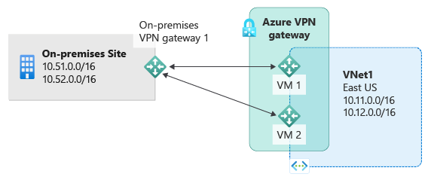

8. Local Network Gateway (On-Prem Representation)
The Local Network Gateway defines the on-premises side of the VPN.
Configuration Includes
- On-prem public IP / FQDN
- On-prem address prefixes
- Used for routing decisions in Azure
Azure uses this object to know where to send traffic.

9. Site-to-Site (S2S) VPN – Deep Dive
What It Solves
- Persistent connectivity
- Datacenter extension to Azure
Traffic Flow
On-prem → IPsec tunnel → Azure VPN Gateway → VNet

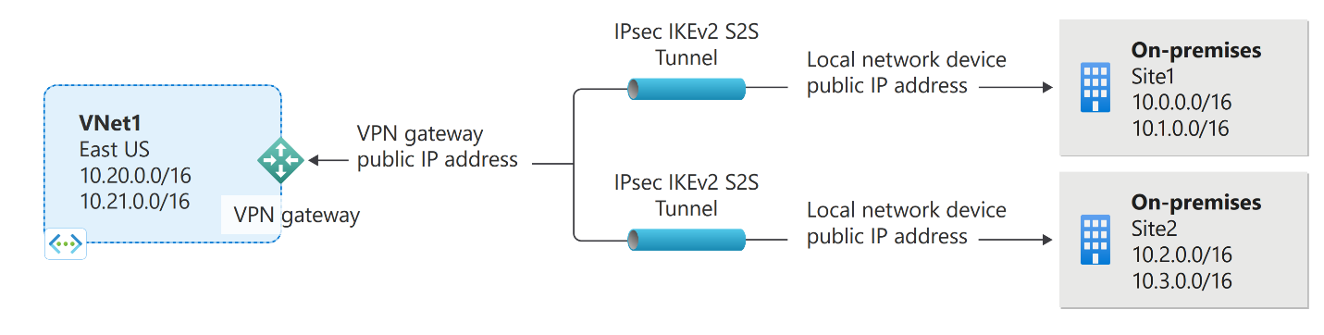
Requirements
- Supported VPN device
- Shared key (PSK)
- Non-overlapping IP ranges

10. VNet-to-VNet VPN Connections
Used when:
- VNets are in different regions
- Peering is not possible
- Encryption is required
Characteristics
- Uses VPN Gateway on both VNets
- Same configuration as S2S

11. Verifying & Troubleshooting VPN Connections
Common Validation Steps
- Connection status = Connected
- Gateway health probe
- Shared key match
- VPN peer IP correctness
Troubleshooting Tools
- Network Watcher
- Diagnostic logs
- Effective routes
- On-prem device logs

12. Point-to-Site (P2S) VPN – User VPN
Purpose
Allows individual user devices to connect securely to Azure VNets.

13. P2S VPN Protocols
Protocol | Platform
OpenVPN® | Cross-platform
SSTP | Windows
IKEv2 | macOS, iOS

14. P2S Authentication Methods
Method | Use Case
Certificate | Small environments
Azure AD | Enterprise, modern auth
AD DS | Legacy integration
Address Pool Rules
- Client IPs dynamically assigned
- Minimum /29 (Active/Passive)
- Minimum /28 (Active/Active)

24. Design Best Practices (Exam + Real-World)
- Always use Route-based VPN
- Avoid Basic SKU
- Plan Gateway Subnet early
- Prefer Virtual WAN for scale
- Use diagnostics & monitoring
- Design for Active/Active gateways

