Handout – Design and Implement Azure ExpressRoute

1. What is Azure ExpressRoute?

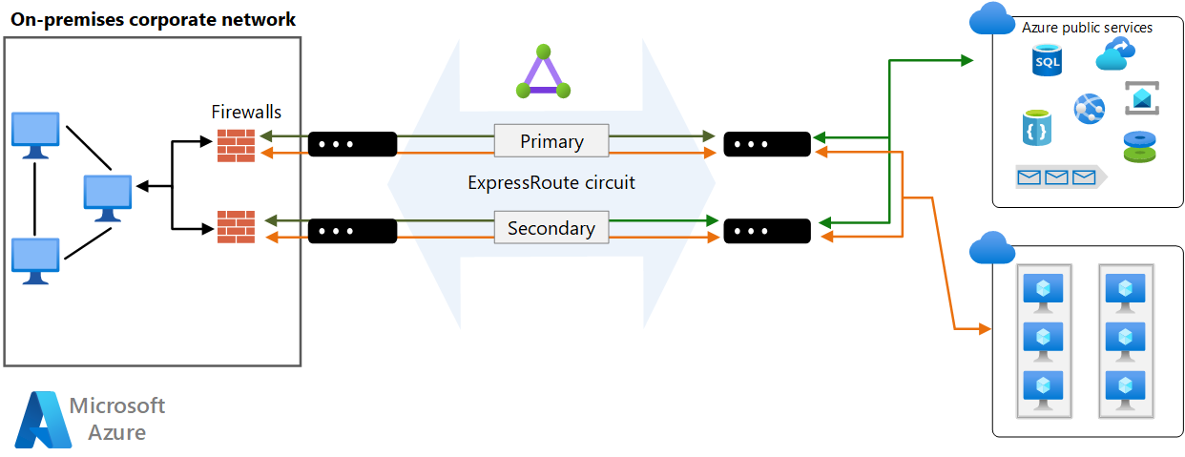
Azure ExpressRoute provides private, dedicated Layer-3 connectivity between your on-premises network and Microsoft’s global network, bypassing the public internet.
Key Characteristics
- Private connectivity (not encrypted by default, but private)
- Uses BGP for dynamic routing
- High availability with dual Microsoft edge routers
- Enterprise-grade SLA-backed connectivity
- Supports 50 Mbps to 100 Gbps
Why ExpressRoute Exists
Internet VPNs are:
- Best-effort
- Subject to congestion
- Less predictable
ExpressRoute solves this by:
- Providing predictable latency
- Ensuring consistent throughput
- Supporting mission-critical workloads

2. ExpressRoute Capabilities (Deep Dive)

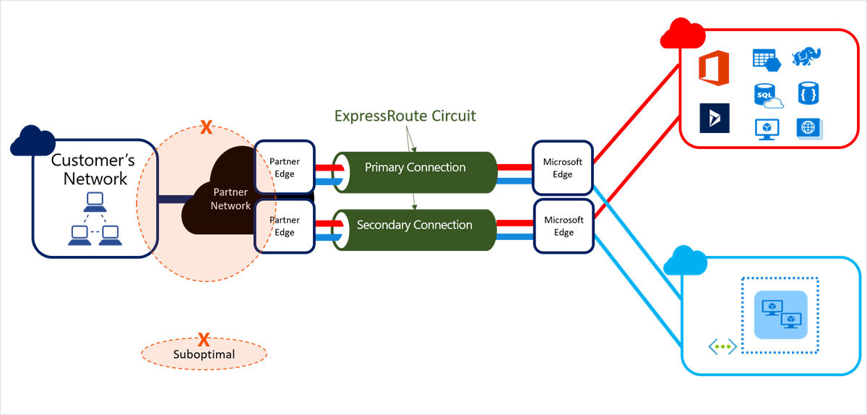
Core Capabilities
Capability | Explanation
Layer-3 Connectivity | BGP-based routing between on-prem and Azure
Built-in Redundancy | Dual Microsoft routers + dual provider links
Global Reach | Connect on-prem sites via Microsoft backbone
Multiple Bandwidths | 50 Mbps → 100 Gbps
SLA | Up to 99.95% availability
Billing Models
- Unlimited Data – flat monthly fee
- Metered Data – outbound charged per GB

3. ExpressRoute Use Cases
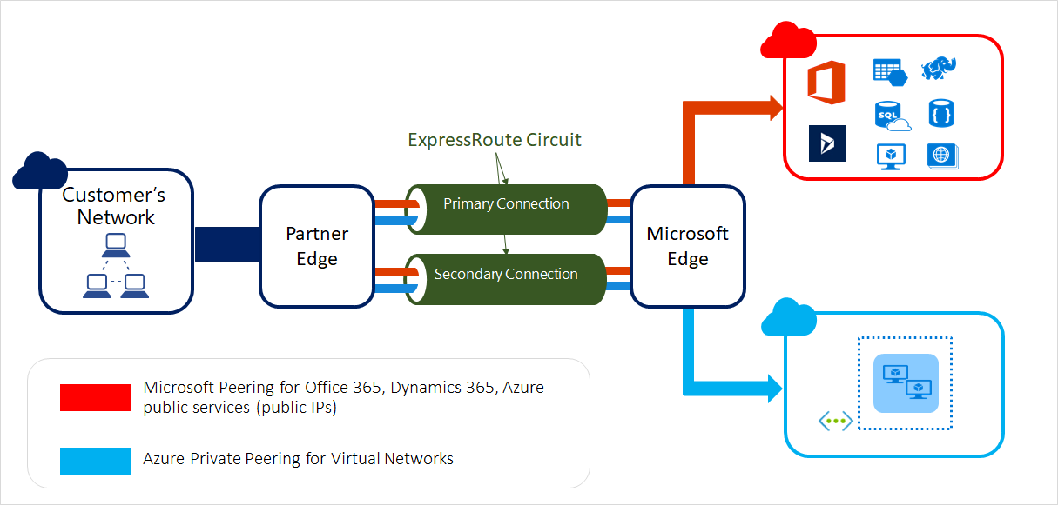
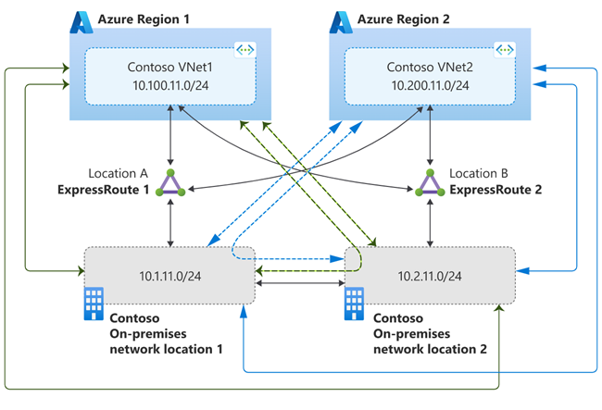
Common Enterprise Scenarios
- Hybrid cloud data centers
- SAP / ERP workloads
- Large-scale backups
- Disaster recovery replication
- High-frequency financial transactions
Why Enterprises Prefer ExpressRoute
- Stable latency
- Predictable performance
- Regulatory compliance (private routing)
- MPLS integration

4. ExpressRoute Connectivity Models
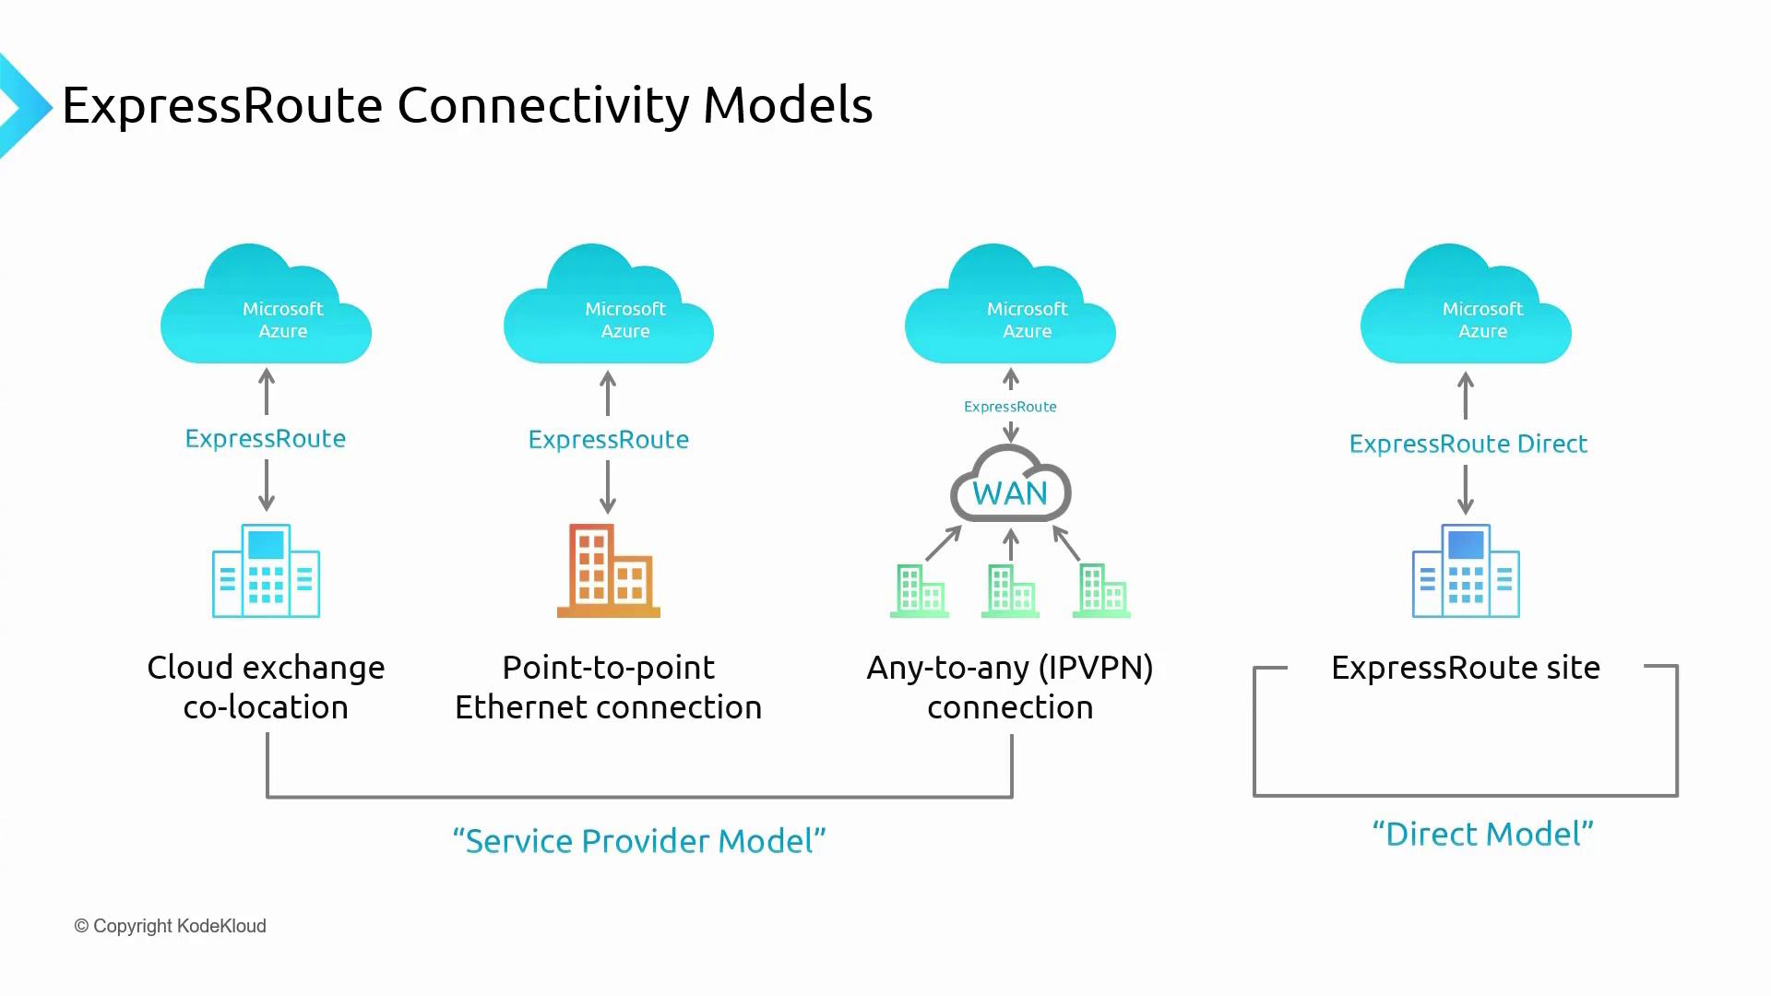
Connectivity Options
- Private Peering
  - On-prem ↔ Azure VNets
  - Most commonly used
- Microsoft Peering
  - On-prem ↔ Microsoft SaaS (M365, Dynamics)
  - Requires public IP ownership
- Global Reach
  - On-prem ↔ On-prem via Microsoft backbone

5. Design Considerations for ExpressRoute

Key Design Decisions
- Single vs dual circuits
- Local vs Standard vs Premium SKU
- Gateway SKU sizing
- BGP ASN planning
- Coexistence with VPN
High Availability Best Practices
- Dual physical circuits (different providers)
- Separate peering locations
- Zone-redundant gateways (AZ SKUs)

6. Bidirectional Forwarding Detection (BFD)
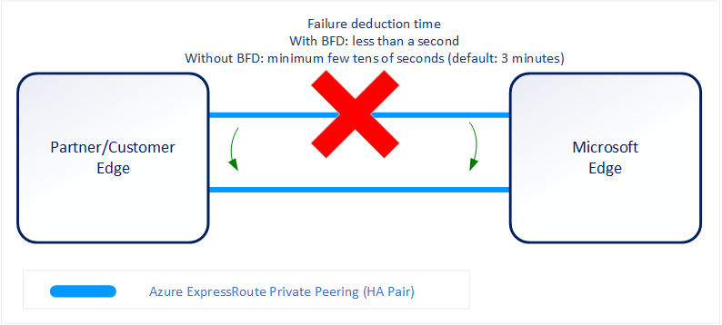
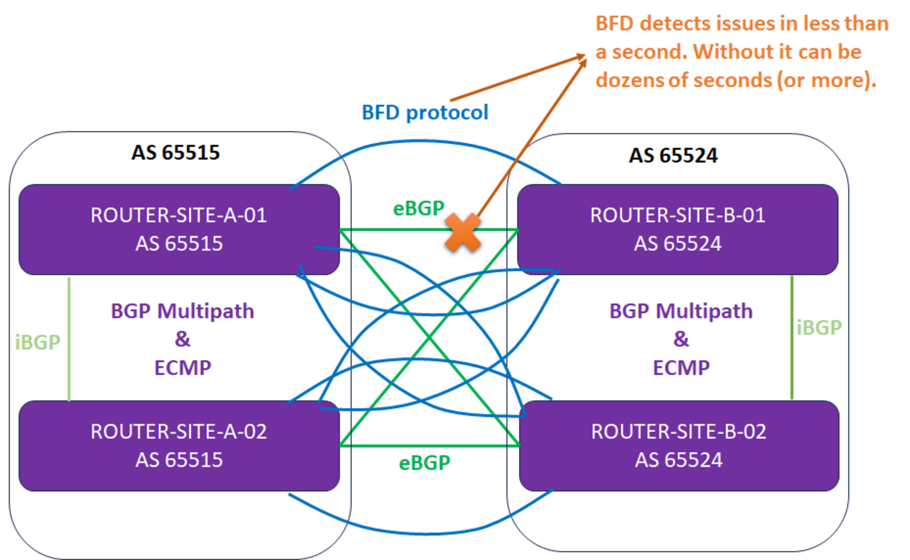
What is BFD?
A fast failure detection protocol that:
- Detects link failure in milliseconds
- Works alongside BGP
- Improves convergence time
Key Points
- Enabled by default on ExpressRoute
- Must be configured on:
  - Primary on-prem router
  - Secondary on-prem router
- Linked to BGP session

7. Encrypting Traffic over ExpressRoute
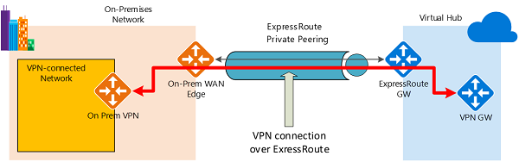
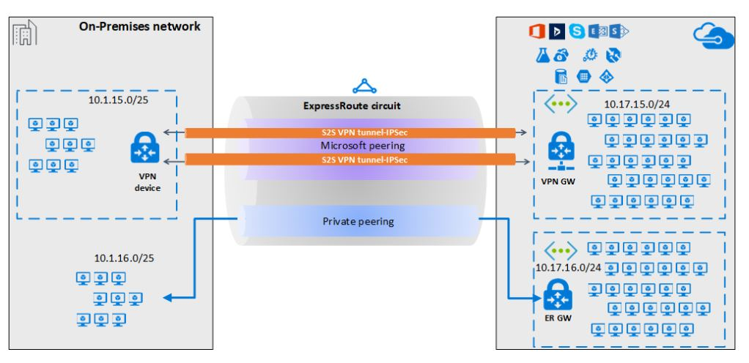
Important Concept
ExpressRoute is private, NOT encrypted by default
Encryption Options
- IPsec VPN over ExpressRoute
- Common in regulated industries
Coexistence Design
- ExpressRoute → Primary path
- Site-to-Site VPN → Failover path

8. ExpressRoute SKUs and Tiers
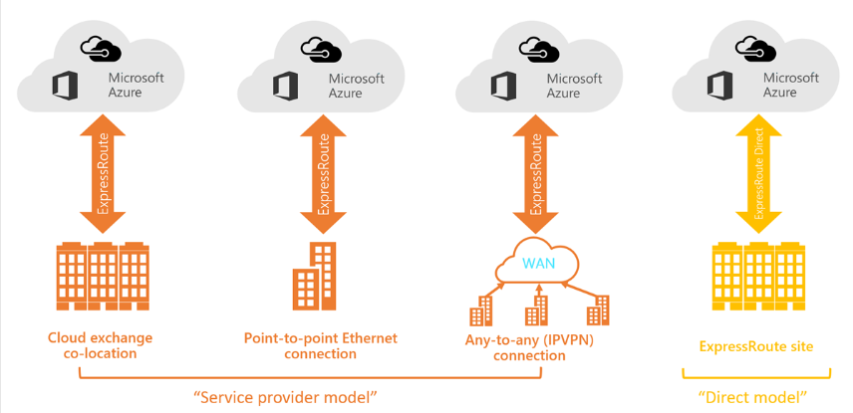
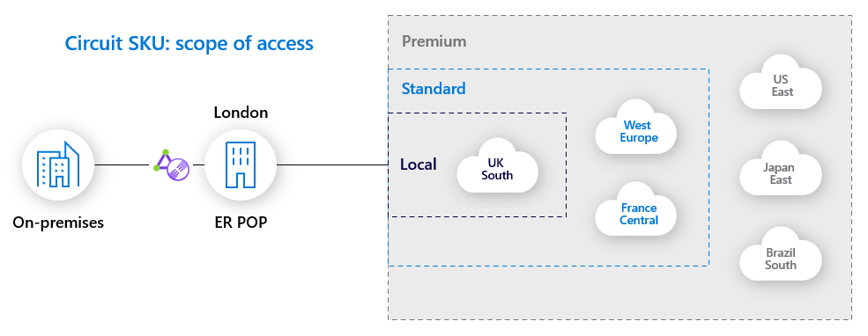
SKU | Scope
Local | 1–2 nearby Azure regions
Standard | All regions in geopolitical area
Premium | Global + >4K routes + >10 VNets
Premium Add-on
- Required for Global Reach
- Required for global VNet connectivity

9. Choosing Peering Location & Circuit
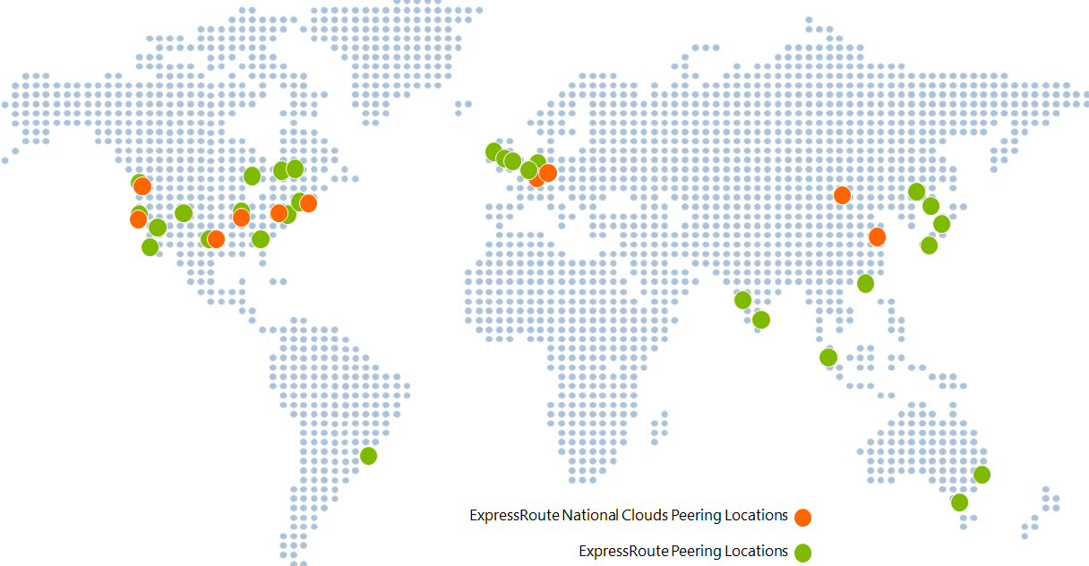
Selection Criteria
- Physical proximity
- Service provider availability
- Latency requirements
- Compliance needs
Circuit Decisions
- Bandwidth (can increase, not decrease)
- Metered vs Unlimited
- Provider redundancy

10. Configuring ExpressRoute Gateway

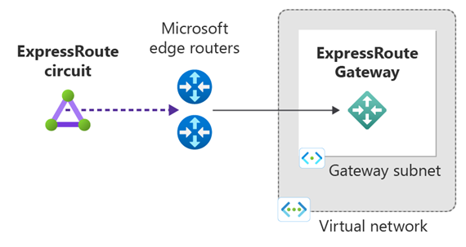
Gateway Requirements
- Dedicated GatewaySubnet
- Cannot share subnet
- SKU matters:
  - UltraPerformance / ErGw3AZ → FastPath eligible

11. Provisioning an ExpressRoute Circuit
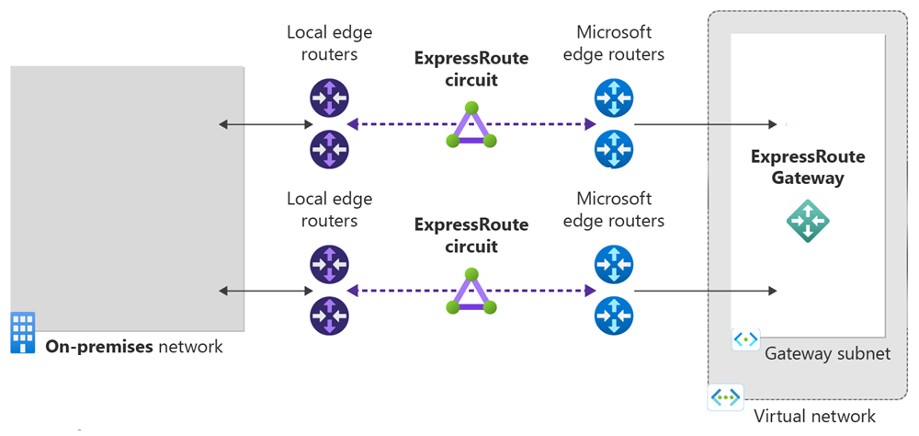
Provisioning Workflow
- Create circuit in Azure
- Obtain Service Key
- Share key with provider
- Provider completes provisioning
- Circuit becomes Enabled

12. ExpressRoute Peering Configuration
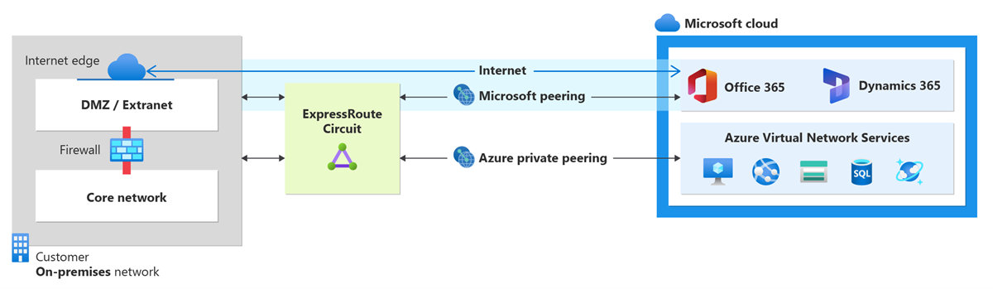
Private Peering Requirements
- Two /30 subnets (primary + secondary)
- VLAN ID
- ASN
- Optional MD5
Microsoft Peering Extras
- Public IP ownership
- Route filters
- Registered prefixes

13. Connecting ExpressRoute to VNets
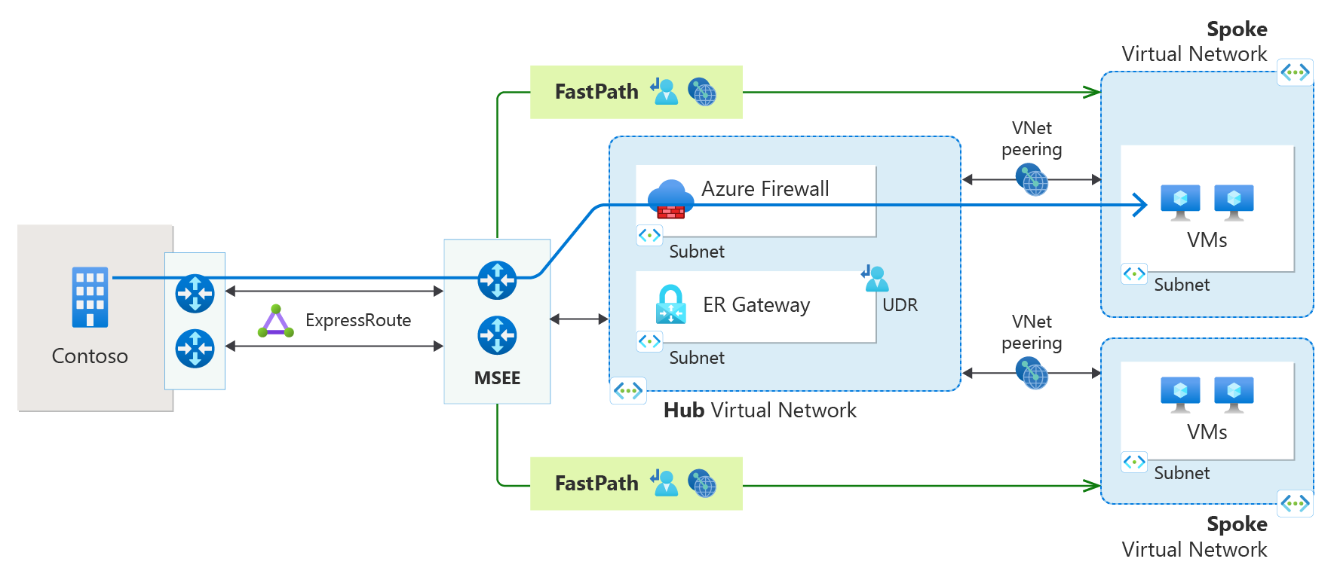
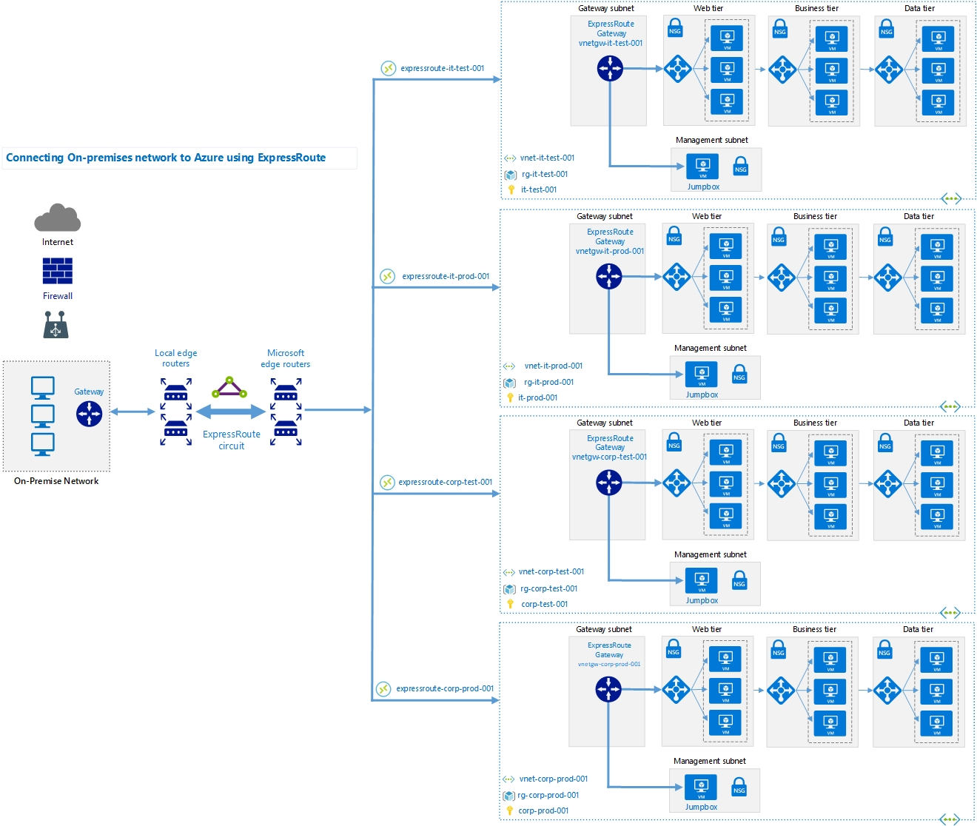
Connection Flow
- ExpressRoute circuit ↔ Gateway
- Gateway ↔ VNet
- Supports multiple VNets (SKU dependent)

14. ExpressRoute Global Reach
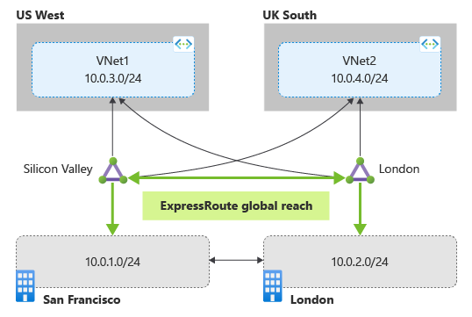
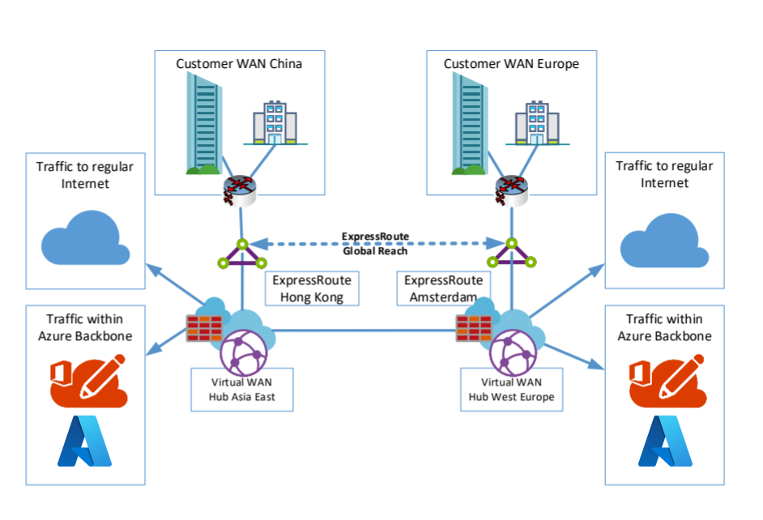
Purpose
- Connect on-premises sites through Microsoft backbone
- Reduces dependency on private WAN
Key Requirement
- ExpressRoute Premium

15. ExpressRoute FastPath
What FastPath Does
- Bypasses VNet gateway
- Traffic flows directly to VM NIC
- Improves:
  - PPS
  - CPS
  - Latency
Requirements
- UltraPerformance or ErGw3AZ gateway
- Enabled via PowerShell

16. Troubleshooting ExpressRoute
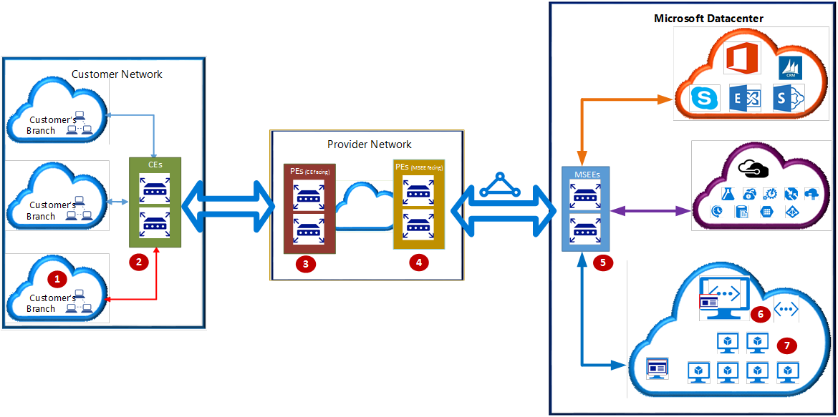
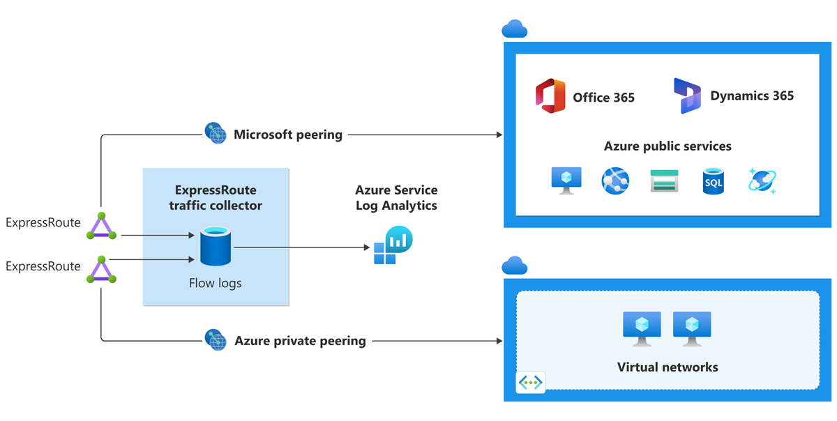
Common Checks
- Circuit provisioning state
- Peering status
- BGP routes
- ARP tables
- Gateway health
Tools
- Azure Portal
- PowerShell / CLI
- Azure Network Watcher
- Azure Connectivity Toolkit (AzureCT)

17. ARP Validation (Layer-2 Checks)
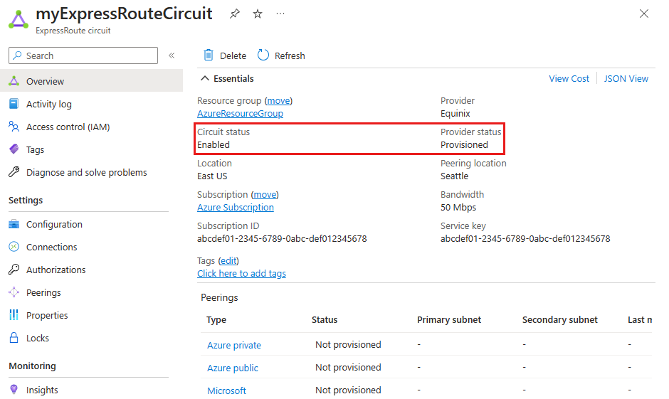
ARP helps validate:
- MAC-IP mapping
- L2 connectivity
- Provider misconfigurations

18. Review & Exam Tips
Exam-Focused Takeaways
- ExpressRoute ≠ encrypted by default
- FastPath bypasses gateway
- Premium SKU enables Global Reach
- BFD improves convergence
- Gateway SKU impacts performance

