**Ansible Lab Manual: From Ad-Hoc Commands to Playbooks**

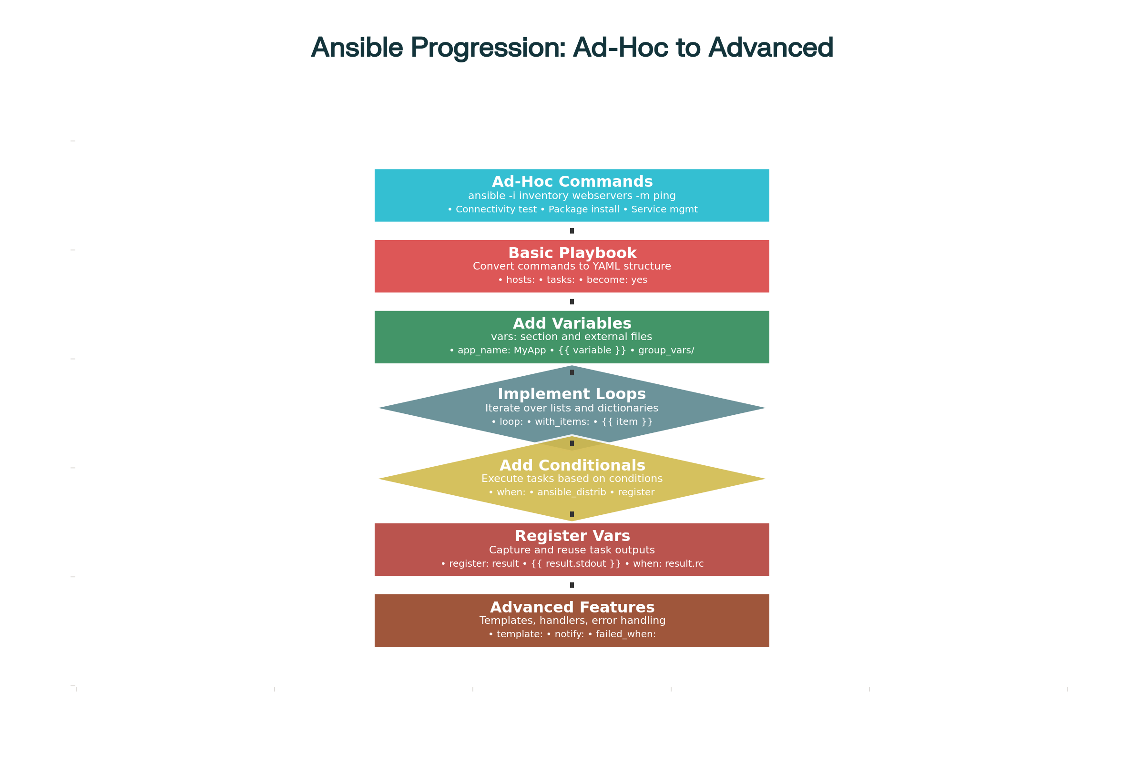

Ansible Lab Progression: From Ad-Hoc Commands to Advanced Playbooks

**Lab Overview**

The lab scenario involves configuring and managing multiple web servers for a new application deployment. Students will:

1. **Start with ad-hoc commands** for immediate tasks like connectivity testing, package installation, and service management
2. **Convert these to basic playbooks** with proper YAML structure
3. **Add variables** for flexibility and reusability
4. **Implement loops** to handle multiple items efficiently
5. **Use conditionals** for OS-specific tasks
6. **Leverage register variables** to capture and reuse task outputs
7. **Apply advanced features** like templates, handlers, and error handling

**Key Learning Objectives**

**Variables Implementation**

* **Playbook-level variables**: Using vars: section for configuration
* **External variable files**: Organizing variables in group_vars/ and host_vars/
* **Variable substitution**: Using {{ variable_name }} syntax
* **OS-specific variables**: Conditional variable assignment based on system facts

**Loops and Iteration**

* **Simple loops**: Using loop: directive for package installation
* **Complex loops**: Iterating over dictionaries for user creation
* **Conditional loops**: Combining loops with when statements
* **Loop variables**: Accessing {{ item }} and nested dictionary values

**Conditionals**

* **Basic conditions**: Using when: with facts like ansible_distribution
* **Complex conditions**: Combining multiple conditions with and, or, not
* **Registered variable conditions**: Making decisions based on task results
* **Variable existence checks**: Using is defined and is undefined

**Practical Examples Included**

The lab manual provides real-world examples including:

* **Multi-OS support**: Handling both Ubuntu and RHEL systems
* **User management**: Creating multiple admin users with different privileges
* **Package installation**: OS-specific package management
* **Service management**: Starting and configuring web servers
* **File operations**: Creating directories and deploying configuration files
* **Error handling**: Managing failures and implementing robust playbooks

**Progressive Learning Structure**

The lab follows a structured progression:

1. **Part 1**: Environment setup and inventory creation
2. **Part 2**: Hands-on ad-hoc commands with practical examples
3. **Part 3**: Converting ad-hoc commands to playbooks step-by-step
4. **Part 4**: Adding advanced features (variables, loops, conditionals)
5. **Part 5**: Best practices and troubleshooting
6. **Part 6**: Practical exercises for reinforcement

**Supporting Materials**

The lab includes supporting files and examples:

* **Inventory file**: Properly structured with groups and variables
* **Basic playbook**: Simple conversion from ad-hoc commands
* **Advanced playbook**: Full-featured with all concepts
* **Comparison table**: Side-by-side ad-hoc vs playbook benefits

This comprehensive lab manual provides a complete learning experience that bridges the gap between simple ad-hoc commands and production-ready Ansible playbooks, making it ideal for DevOps training environments and skill development.

⁂

1. <https://www.middlewareinventory.com/blog/ansible-ad-hoc-commands/>

1. <https://www.redhat.com/en/blog/ansible-ad-hoc-commands>

1. <https://spacelift.io/blog/ansible-when-conditional>

1. <https://docs.ansible.com/ansible/latest/collections/ansible/builtin/ini_inventory.html>

1. <https://www.linkedin.com/pulse/day-56-understanding-ad-hoc-commands-ansible-sayali-shewale>

1. <https://docs.ansible.com/ansible/latest/playbook_guide/playbooks_loops.html>

1. <https://docs.ansible.com/ansible/latest/getting_started/get_started_inventory.html>

1. <https://docs.ansible.com/ansible/latest/command_guide/intro_adhoc.html>

1. <https://docs.ansible.com/ansible/latest/playbook_guide/playbooks_variables.html>

1. <https://www.geeksforgeeks.org/devops/what-is-ansible-inventory/>

1. <https://www.cloudbees.com/blog/getting-started-quickly-with-ansible-ad-hoc-commands>

1. <https://labex.io/tutorials/ansible-ansible-conditionals-and-loops-390455>

1. <https://spacelift.io/blog/ansible-playbooks>

1. <https://www.geeksforgeeks.org/devops/ansible-best-practices/>

1. <https://www.freekb.net/Article?id=2396>

1. <https://www.reddit.com/r/ansible/comments/145lyy1/is_there_a_way_to_convert_this_command_line_to/>

1. <https://4sysops.com/archives/ansible-playbook-examples/>

1. <https://www.syncfusion.com/succinctly-free-ebooks/ansible-succinctly/running-ad-hoc-commands>

1. <https://www.uninets.com/blog/yaml-basics>

1. <https://notes.kodekloud.com/docs/Learn-Ansible-Basics-Beginners-Course/Ansible-Playbooks/Ansible-Loops>

1. <https://stackoverflow.com/questions/66696782/how-to-write-this-ad-hoc-command-as-a-playbook>

1. <https://spacelift.io/blog/ansible-loops>

1. <https://spacelift.io/blog/ansible-inventory>

1. <https://www.tutorialspoint.com/ansible/ansible_yaml_basics.htm>

1. <https://stackoverflow.com/questions/50456997/ansible-with-items-vs-loop>

1. <https://www.youtube.com/watch?v=s4ewXGOsnMM>

1. <https://developers.redhat.com/learning/learn:ansible:yaml-essentials-ansible/resource/resources:ansible-yaml-file-syntax-and-structure>

1. <https://www.youtube.com/watch?v=wfxAt_nNtjE>

1. <https://docs.ansible.com/ansible/latest/reference_appendices/YAMLSyntax.html>

1. <https://www.devopsschool.com/blog/how-to-loop-and-iteration-executations-in-ansible-playbook-with-example/>

1. <https://www.devopsschool.com/blog/example-code-of-ansible-variable-with-playbook/>

1. <https://www.geeksforgeeks.org/devops/conditional-statements-in-ansible/>

1. <https://developers.redhat.com/learning/learn:ansible:get-started-ansible-playbooks/resource/resources:ansible-playbook-variables-and-facts>

1. <https://www.geeksforgeeks.org/devops/ansible-ad-hoc-commands/>

1. <https://www.geeksforgeeks.org/devops/ansible-register/>

1. <https://stackoverflow.com/questions/31310688/conditionally-define-variable-in-ansible>

1. <https://spacelift.io/blog/ansible-variables>

1. <https://spacelift.io/blog/ansible-register>

1. <https://stackoverflow.com/questions/37479605/register-ansible-variable-property>

1. <https://ostechnix.com/ansible-register/>

1. <https://docs.ansible.com/ansible/2.9/user_guide/playbooks_conditionals.html>

1. <https://www.digitalocean.com/community/tutorials/how-to-use-variables-in-ansible-playbooks>

1. <https://www.youtube.com/watch?v=2Du96Y0vCh0>

1. <https://www.cherryservers.com/blog/when-condition-in-ansible>

1. <https://docs.ansible.com/ansible/latest/playbook_guide/playbooks_conditionals.html>

1. <https://docs.ansible.com/ansible/2.9/user_guide/playbooks_variables.html>

1. <https://www.reddit.com/r/sysadmin/comments/pmsu4p/ansible_set_variable_based_on_condition/>

1. <https://www.rogerperkin.co.uk/network-automation/ansible/inventory-file/>

1. <https://ecanarys.com/ansible-ad-hoc-commands-and-playbooks/>

1. <https://www.env0.com/blog/the-ultimate-guide-to-ansible-conditionals-for-smarter-automation>

1. <https://docs.ansible.com/ansible/latest/inventory_guide/intro_inventory.html>