**Lab-Scenario**

**Step1: Gitlab-issues-Creation**

**All the issues are going to specific to the project**

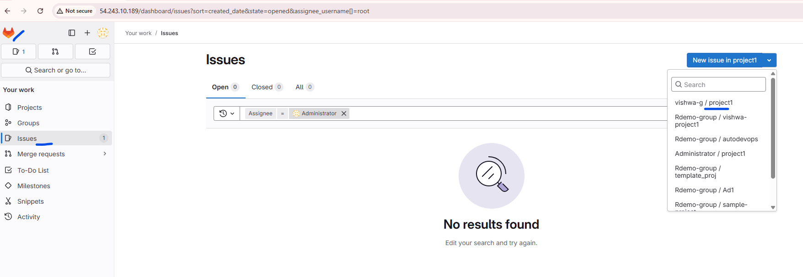

**First click on the gitlab icon,**

**Then on the “issues” 🡪 top right hand corner, select the project.**

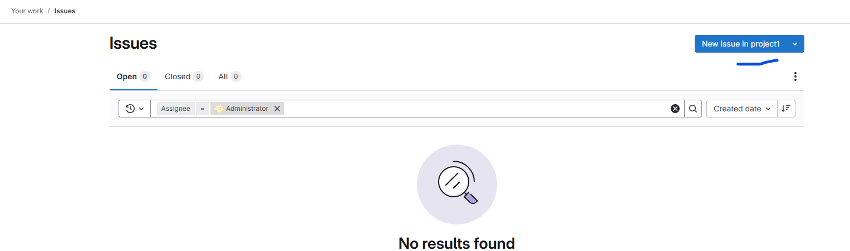

**Click on “New issues”**

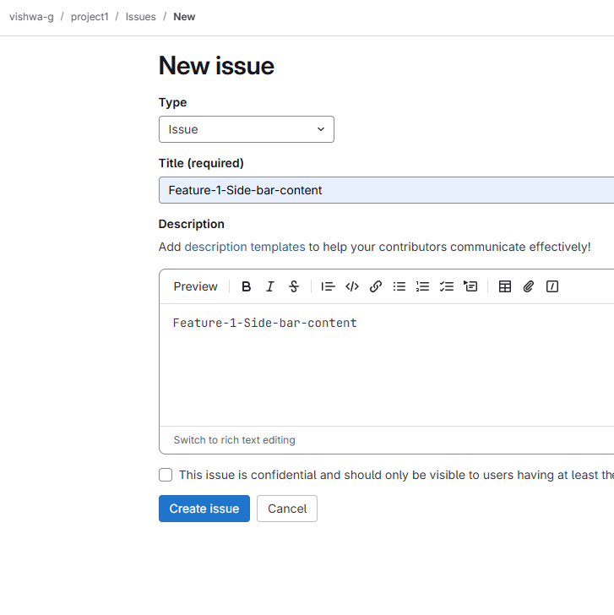

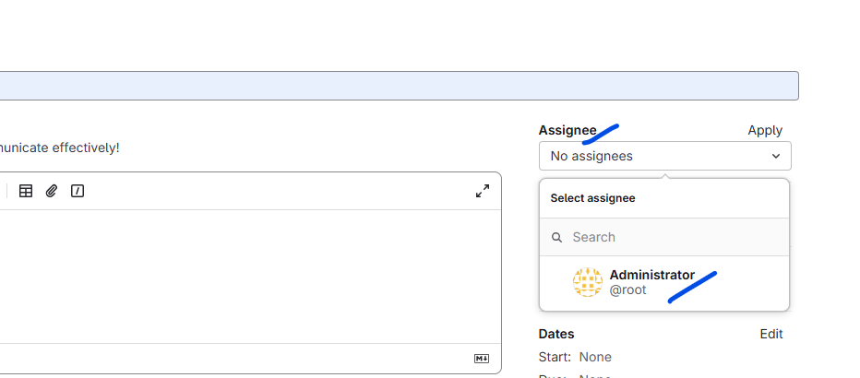

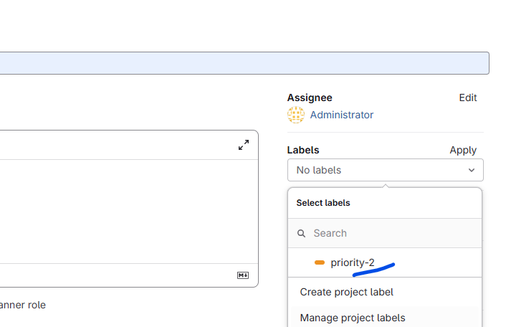

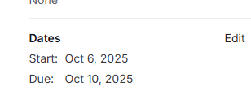

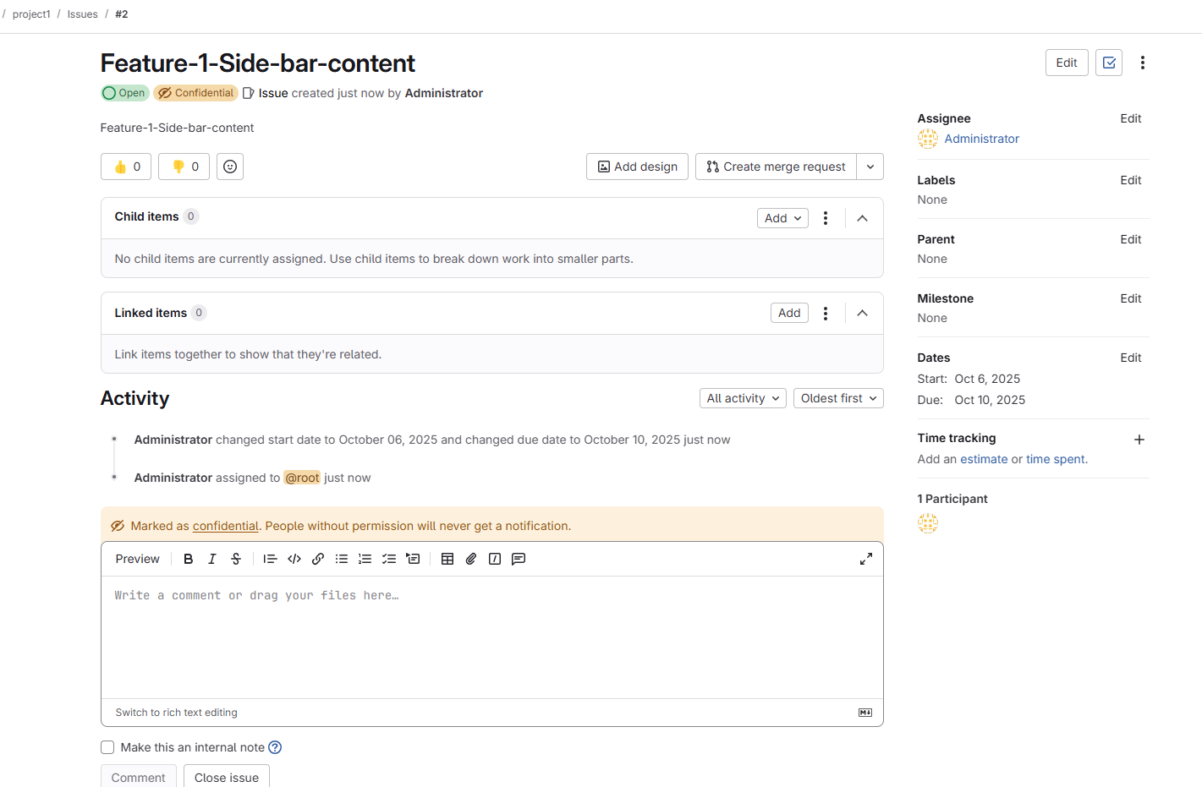

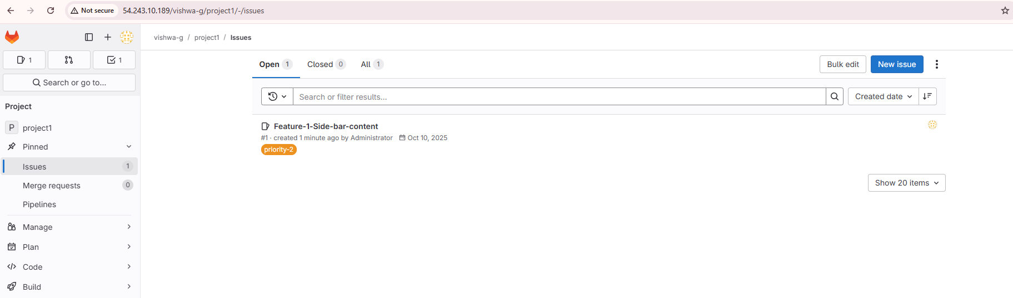

**Step2: Manage label.**

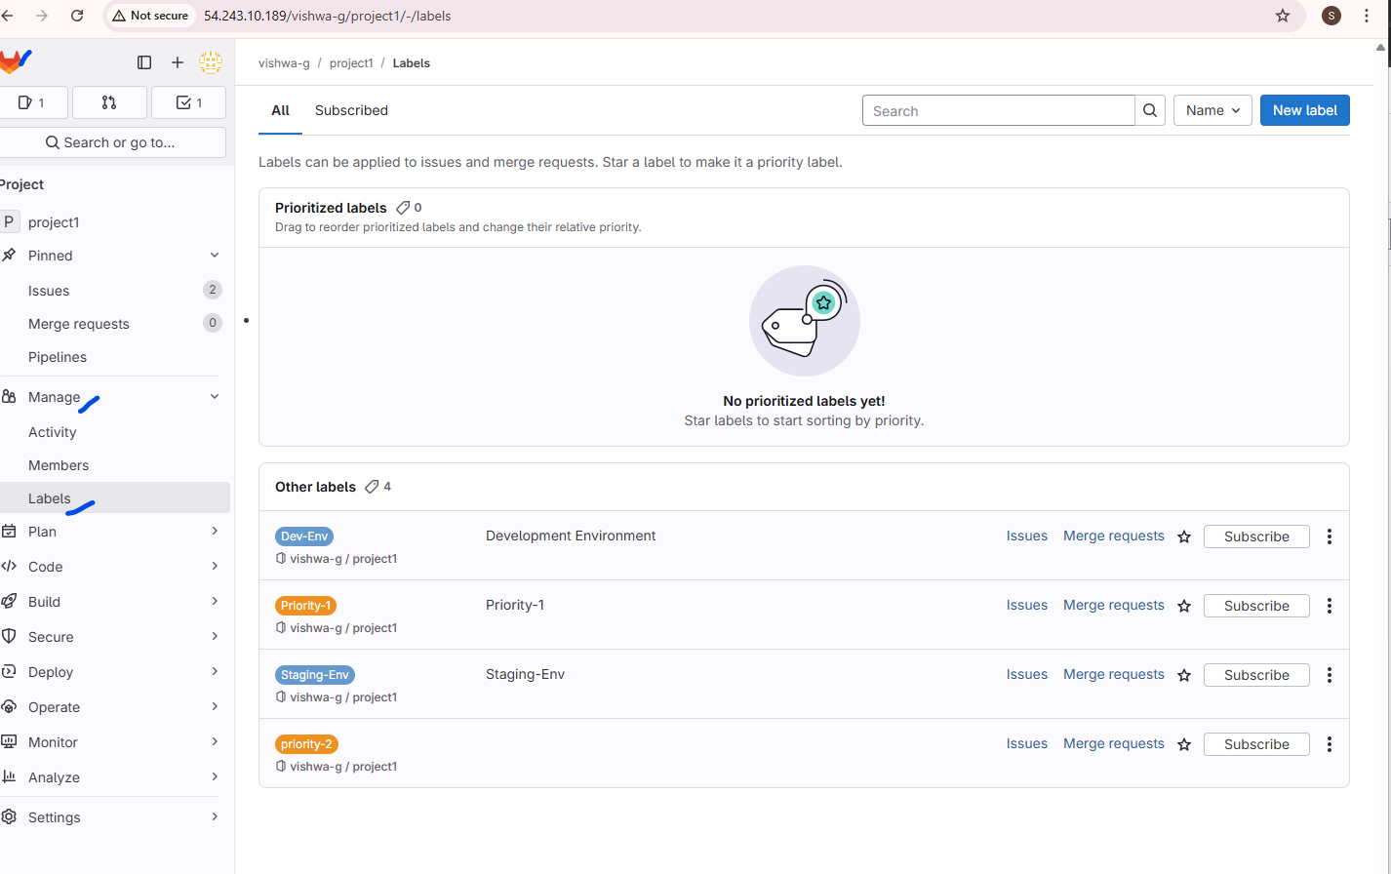

**Step2- Create a user**