**🔹 GitLab Use Case: Issue Visibility with Roles**

**Pre-requisites**

* GitLab instance (self-hosted or GitLab.com).
* One admin user (teacher/trainer).
* Lab students login as admin to create issues and users.

**Steps**

**1. Create Issues (as Admin)**

1. Login to GitLab as **Admin**.
2. Open a project → **Issues → New Issue**.
   * Create **Issue 1: Normal Issue** → *Title: “Normal Bug”* → Leave as default.
   * Create **Issue 2: Confidential Issue** → *Title: “Confidential Bug”* → Check ✅ **Confidential**.
3. Assign both issues to the **Admin user**.

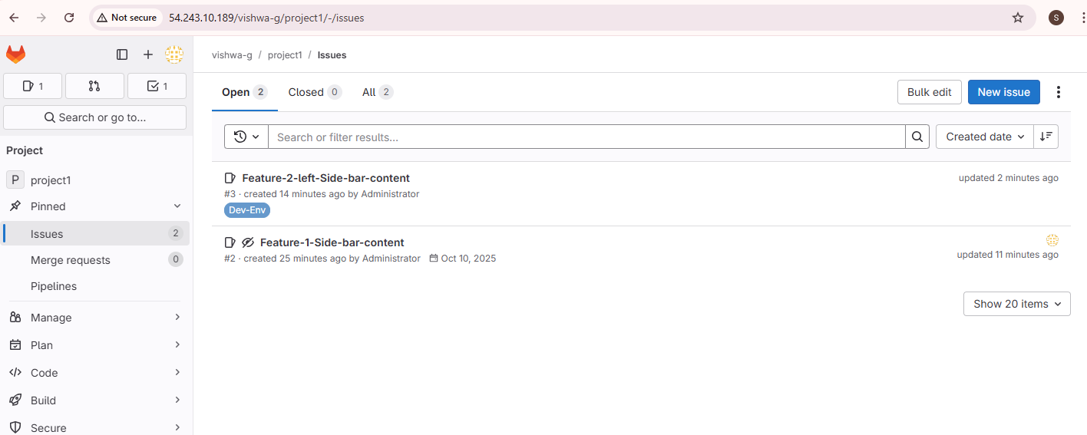

**2. Create a Guest User**

1. Go to **Admin Area → Users → New User**.
2. Create a new user, e.g.,
   * Username: guestuser
   * Email: guest@example.com
   * Password: set a temporary one (Password123@).
3. Go to **Group → Members → Invite Members**.
   * Add guestuser with **Role = Guest**.

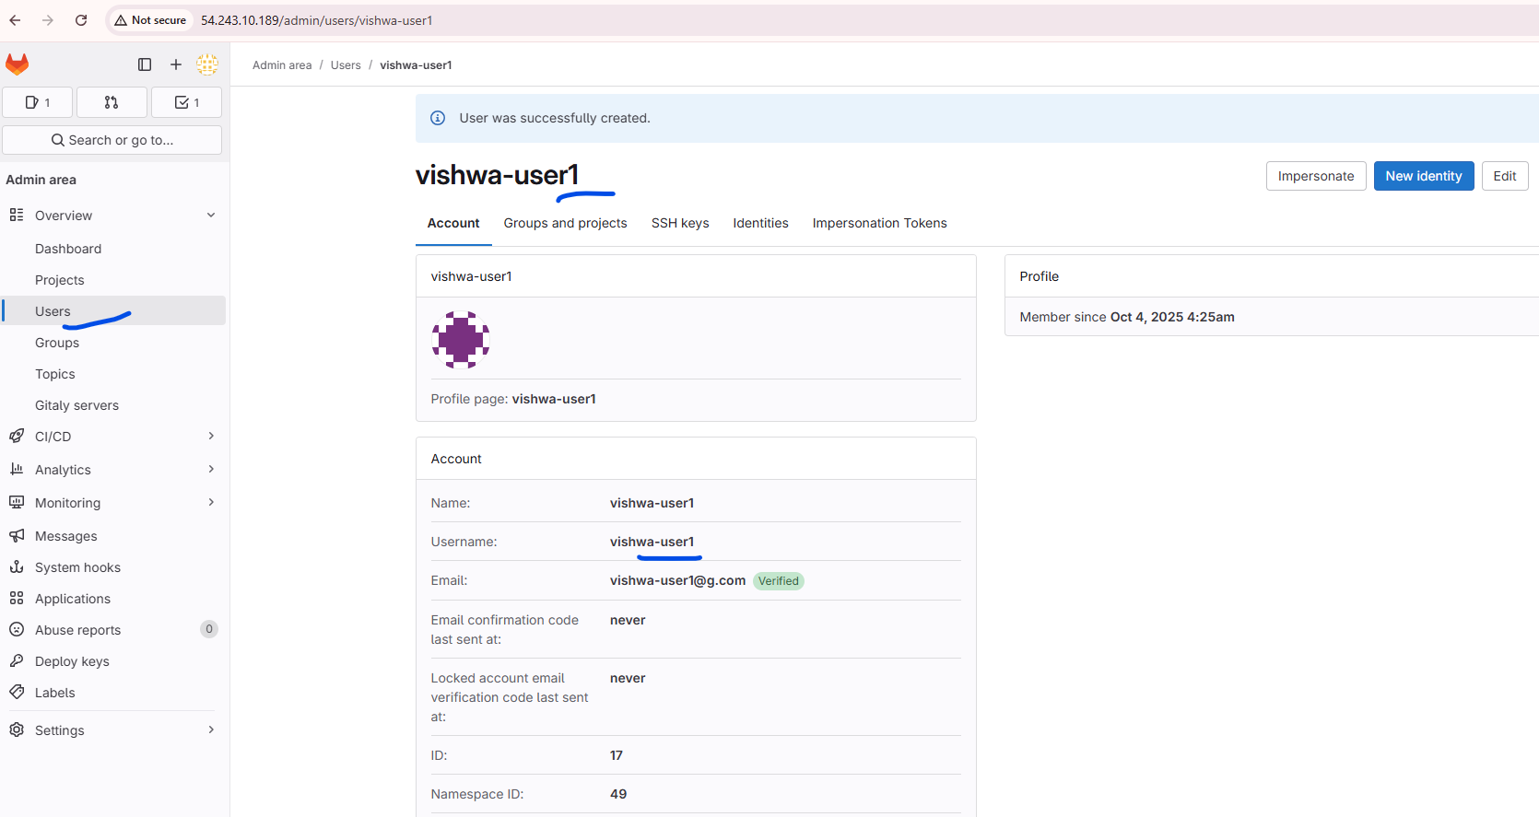

**3. Login as Guest User**

1. Logout from Admin.
2. Login with guestuser credentials.
3. Navigate to the same **Project → Issues**.
4. ✅ **Check visibility:**
   * Should **see only Normal Issue**.
   * ❌ **Confidential Issue should NOT be visible**.

**4. Change Role to Planner**

1. Login back as **Admin**.
2. Go to **Group → Members**.
3. Change guestuser role from **Guest → Planner**.

**5. Login again as Planner**

1. Logout and login as guestuser again.
2. Navigate to the same **Project → Issues**.
3. ✅ **Check visibility:**
   * Should now **see both issues** (Normal + Confidential).

**Outcome / Learning**

* **Guest role** → Limited visibility (cannot see confidential issues).
* **Planner role** → Designed for product/project managers → can see confidential issues.
* Students understand **role-based visibility** in GitLab issues.