Gitlab-SAAS-Account

1. Create an gitlab-saas account

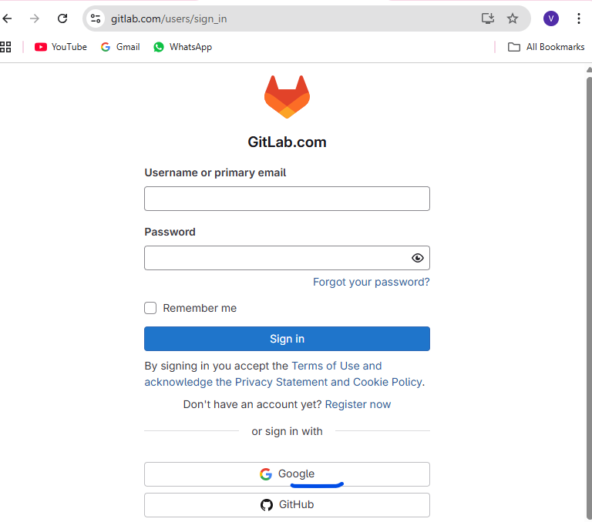

Login with the google account for the ease of login.

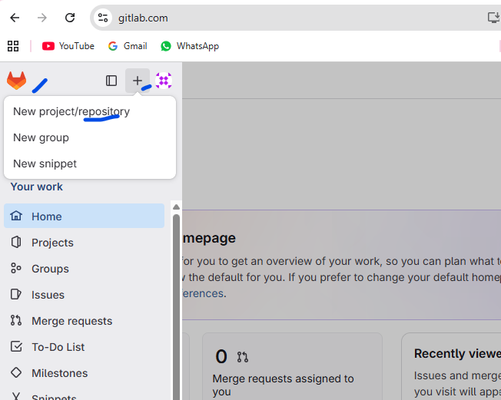

Click on new project

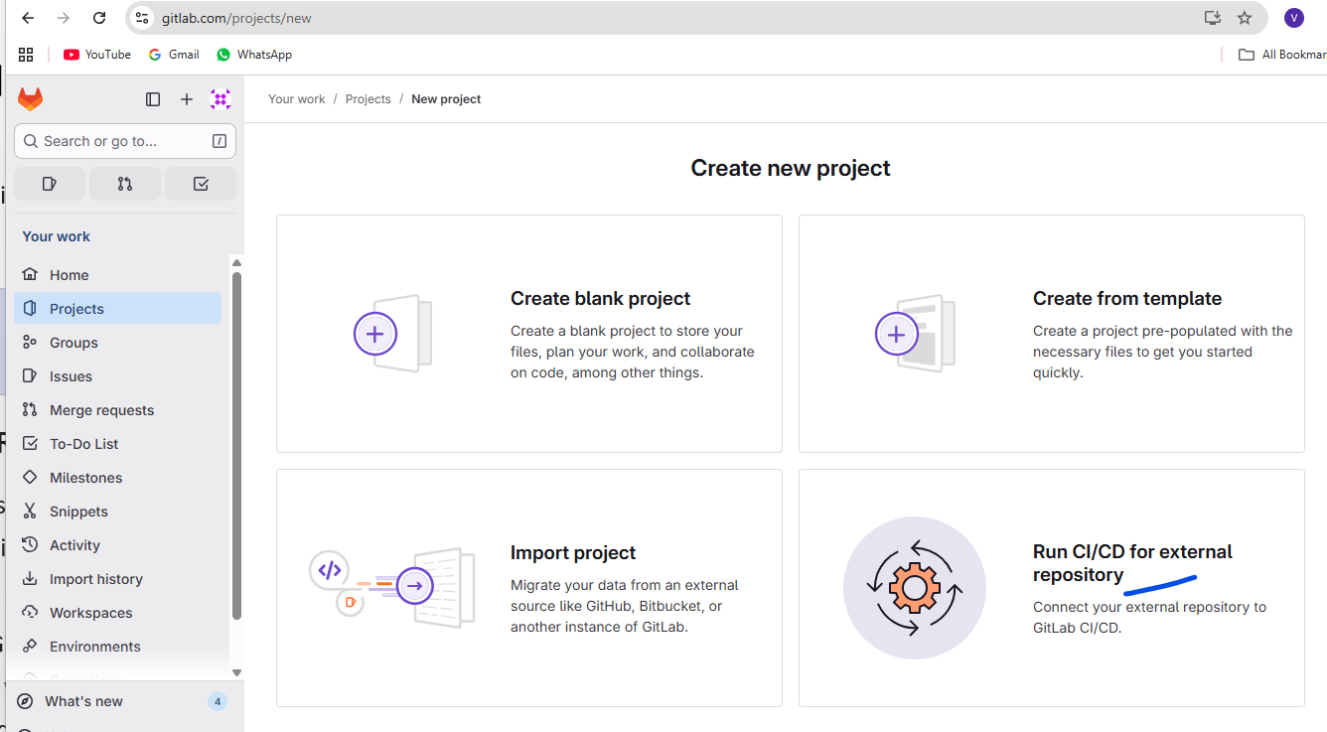

Select “Run CICD for external repository.

Note: -- we are doing this to test the default runners available on the gitlab cloud.

Also , remember to have the yaml file ready in the external repo, like below.

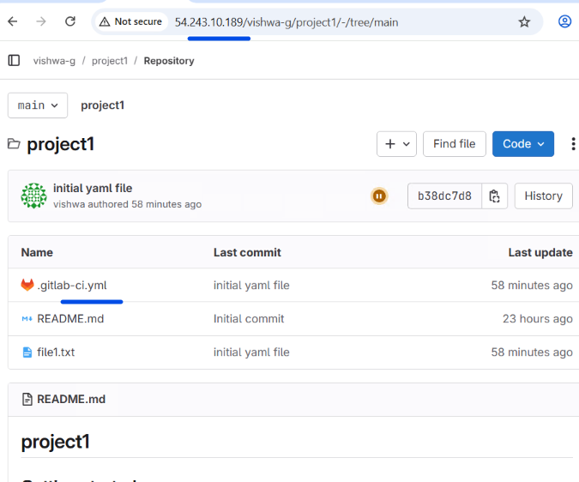

Step3:

Add all the detailed on the gitlab cloud to clone from the private repo as shown below.

And click on create project

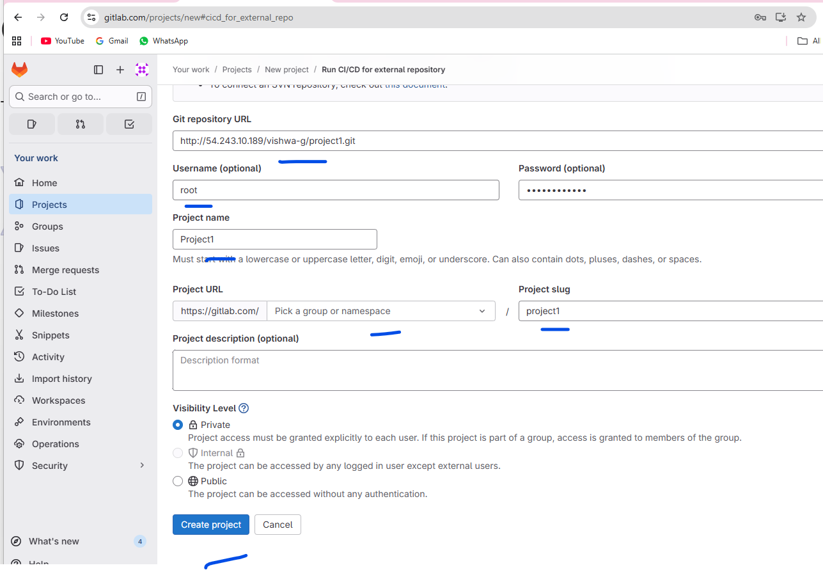

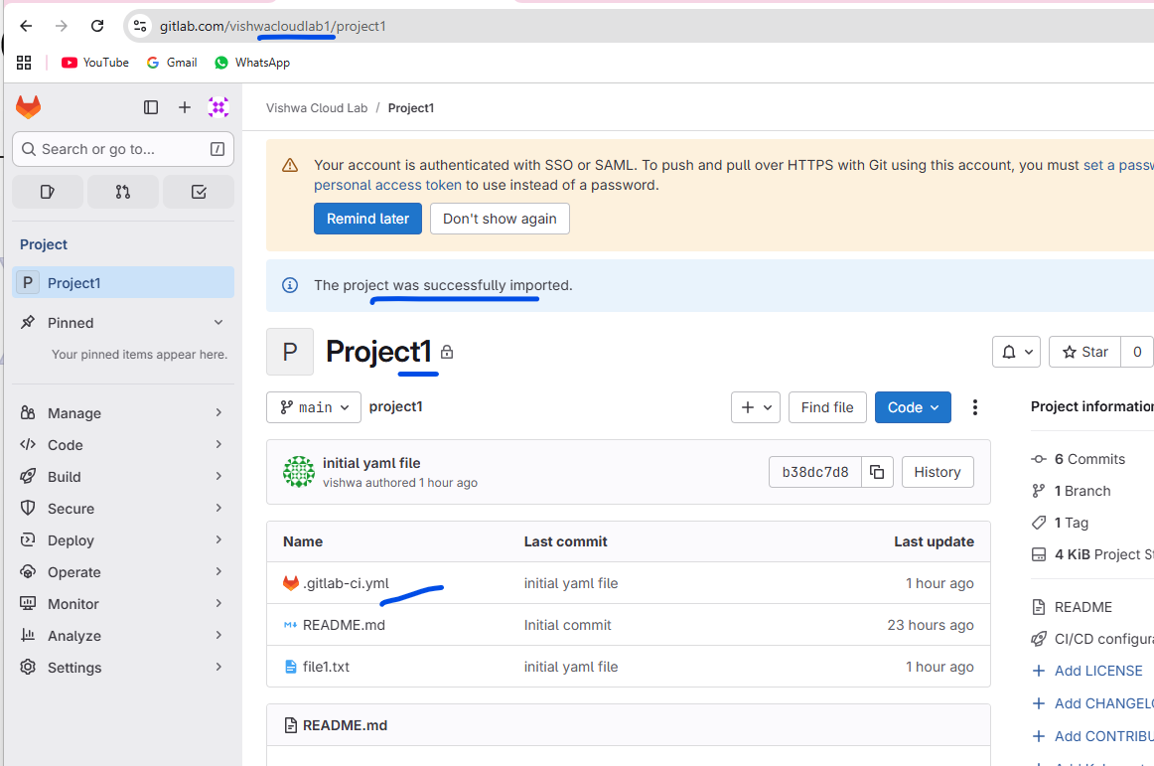

This project is cloned.

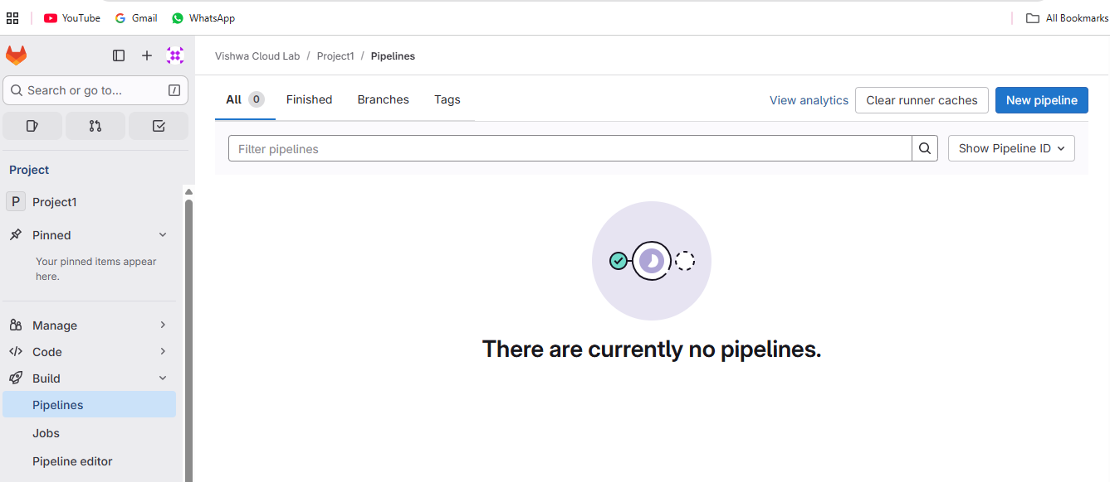

Currently there is no pipeline.

Click on create new pipeline.

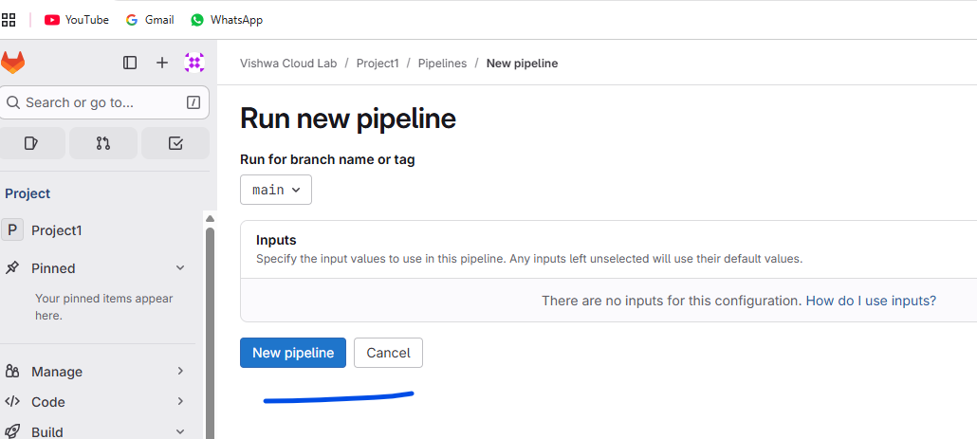

Click on “new pipeline”

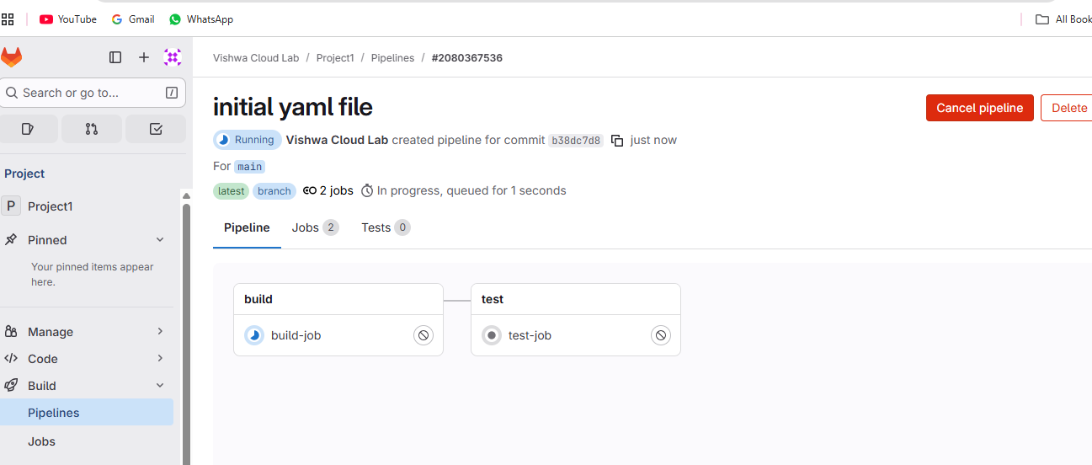

Click on the ‘build-job”.

