Steps

- Create new jenkinsfile
Named: jenkinsfile1 in the root folder
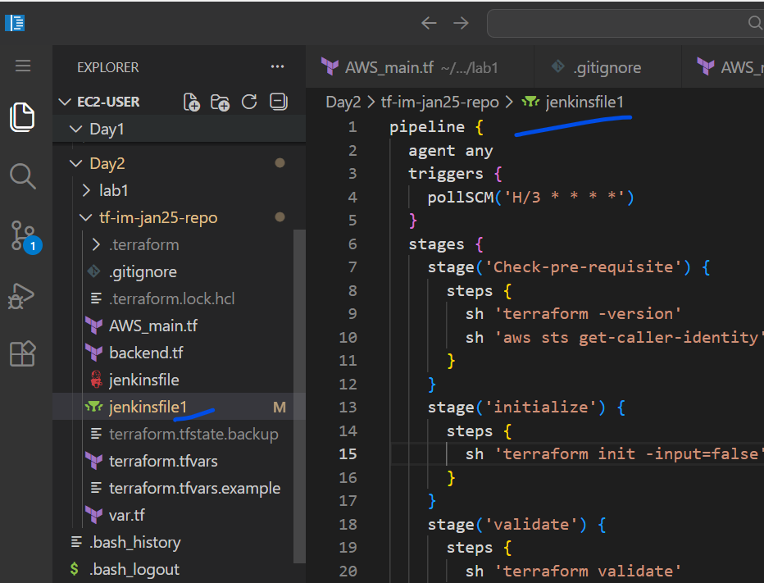
- Copy the content
- Create an another branch
git checkout -b b2
- Git commands
git add .
git commit -m “message”
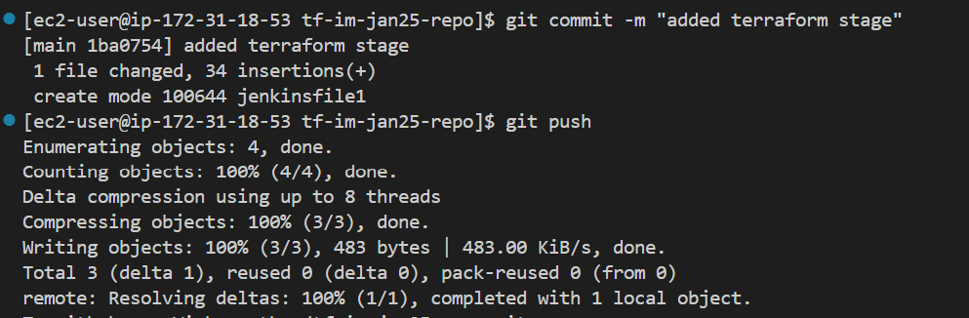

Git push
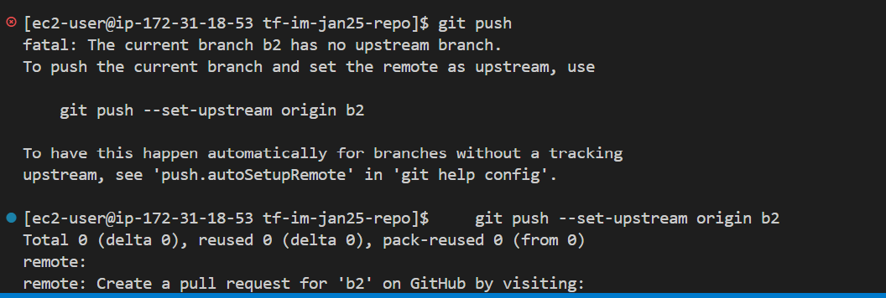
- Create a new job in Jenkins
Same configuration as job2 , but change the branch to “b2” and the Jenkins filename to the above one

