Steps
- Add the trigger to the jenkinsfiles
triggers {
pollSCM('H/3 * * * *')
}

- Push the code
git add .
git commit -m “message”
git push
- Run Jenkins job manually , this time only

- Now to test it , add some changes in the code like

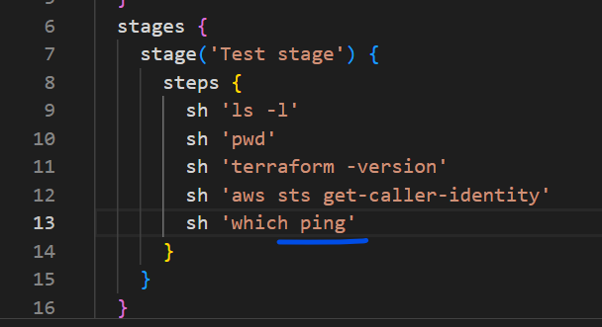

- Push the code
git add .
git commit -m “message”
git push

- Check on the Jenkins
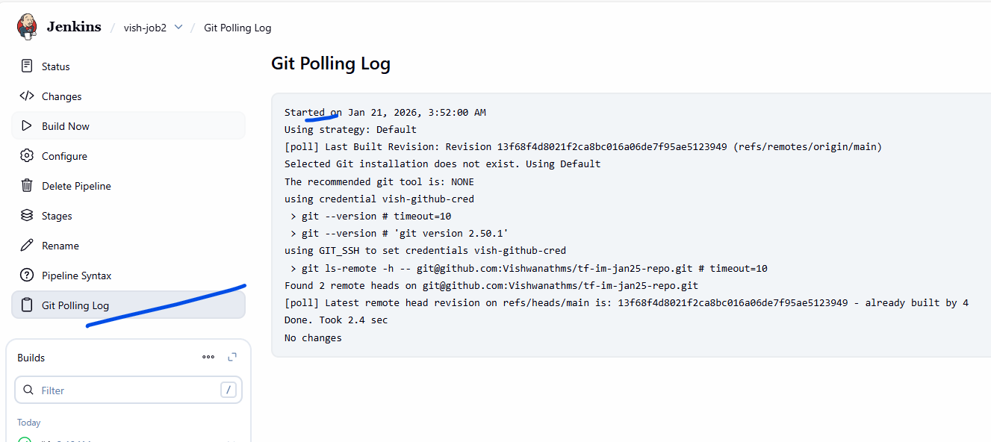

- Build should trigger automatically.
