Steps

- Create new jenkinsfile
Named: jenkinsfile1 in the root folder
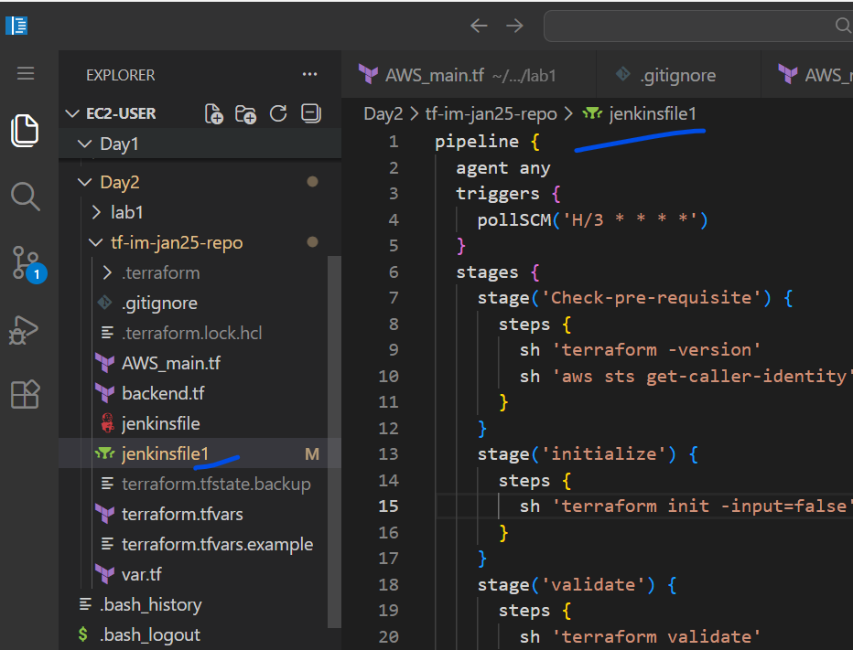
- Copy the content to jenkinsfile1
pipeline {
agent any
triggers {
pollSCM('H/3 * * * *')
}
stages {
stage('Check-pre-requisite') {
steps {
sh 'terraform -version'
sh 'aws sts get-caller-identity'
}
}
stage('initialize') {
steps {
sh 'terraform init -input=false'
}
}
stage('validate') {
steps {
sh 'terraform validate'
}
}
stage('Format') {
steps {
sh 'terraform fmt -check'
}
}
stage('plan') {
steps {
sh 'terraform plan -out=tfplan'
sh 'terraform show -json tfplan > tfplan.json'
}
}
}
}

- Create an another branch
git checkout -b b2
- Git commands
git add .
git commit -m “message”
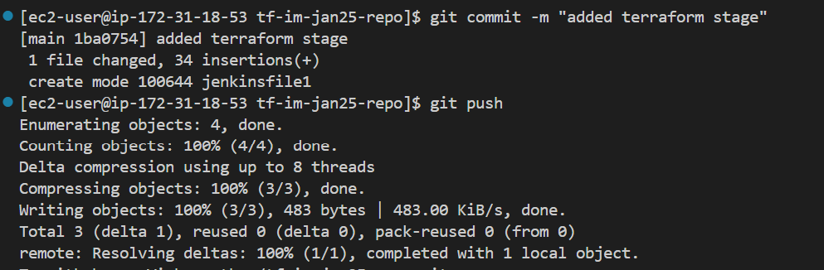

Git push
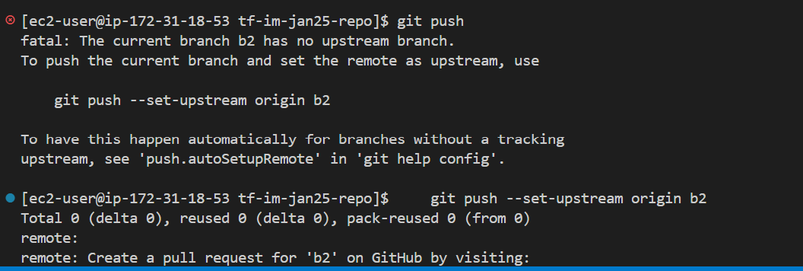
- Create a new job in Jenkins
Same configuration as job2 , but change the branch to “b2” and the Jenkins filename to the above one

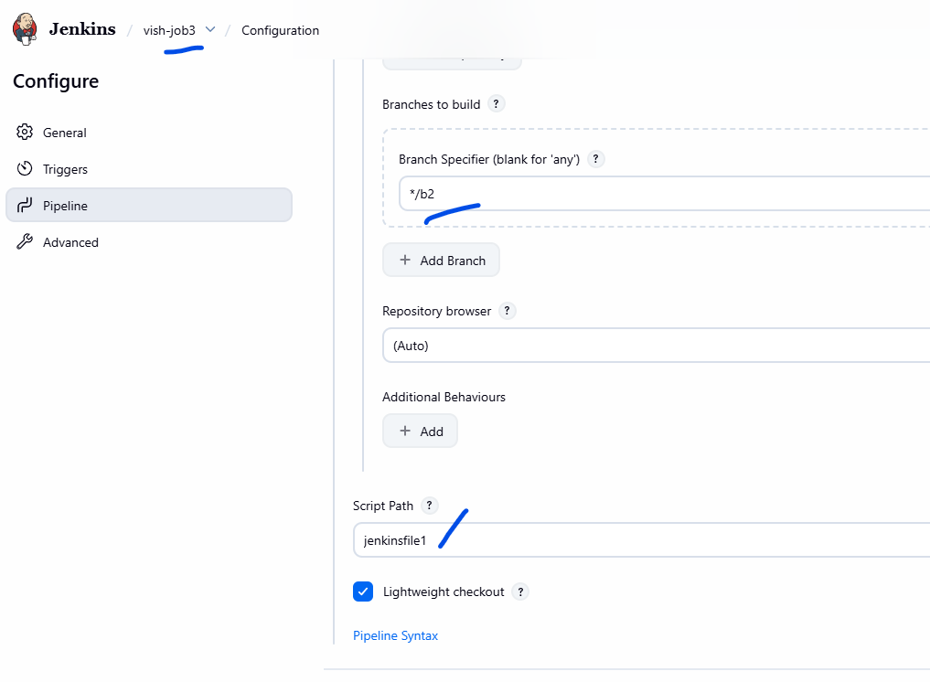
Build the job manually for the first time
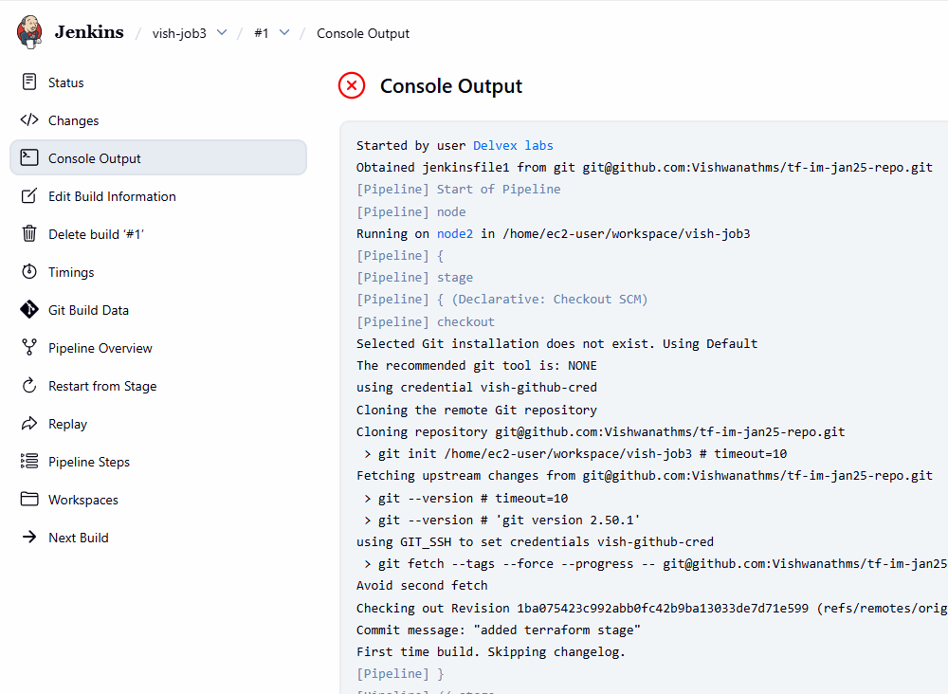
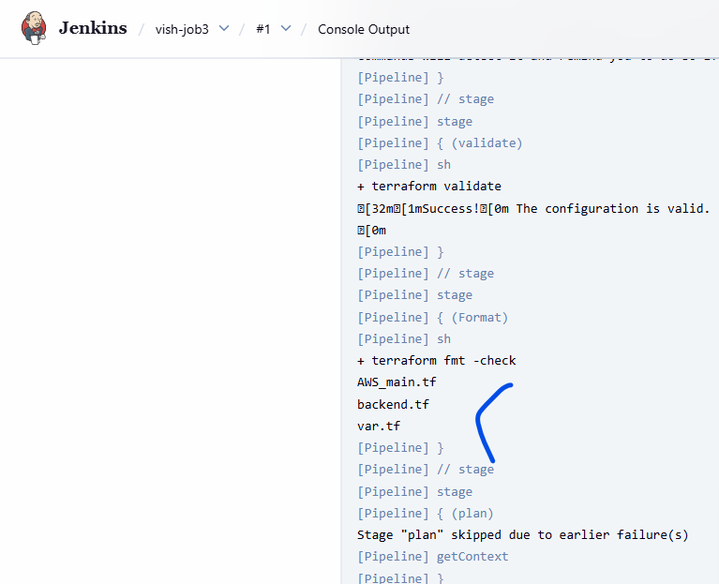
It failed silently on the terraform fmt

- To solve the problem
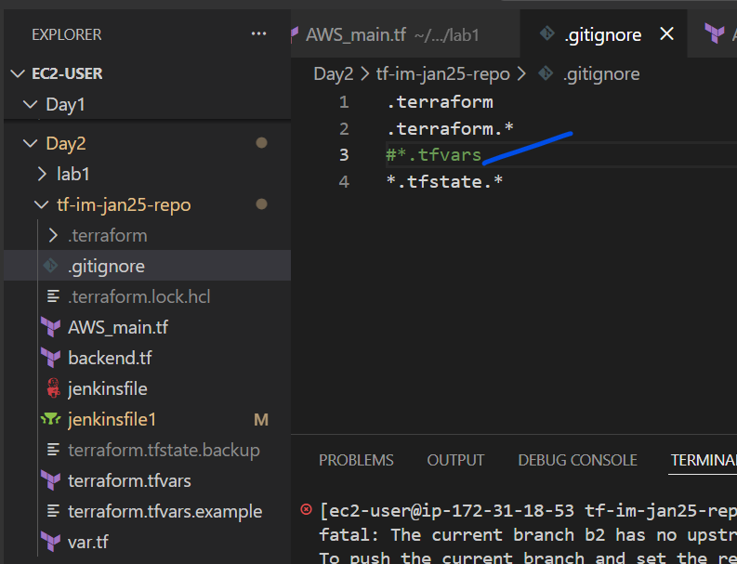
Comment the *.tfvars in the gitingore.
As the “Terraform fmt -check” needs it.

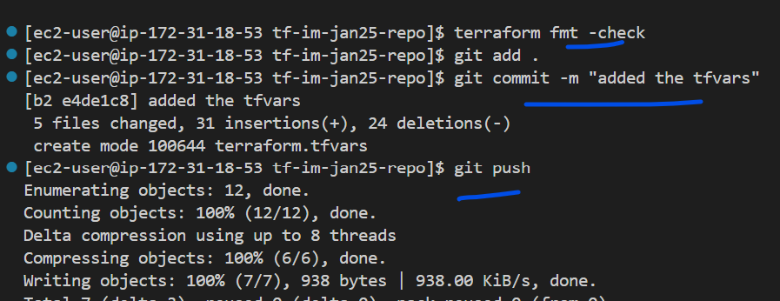

Output
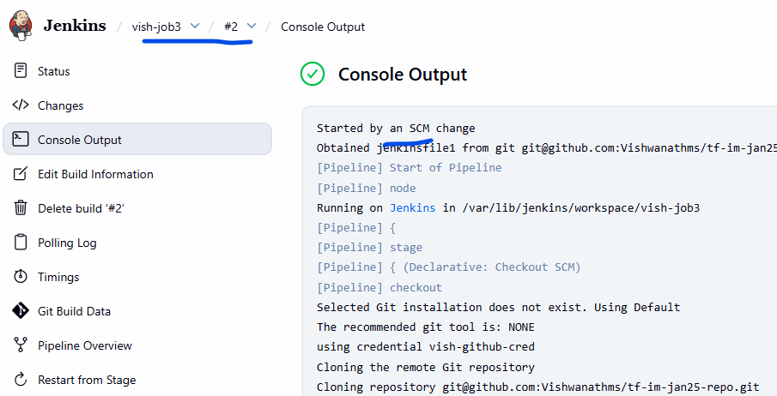
The job triggered automatically
