Steps
- Create Day3 and Lab1
- Create module folder inside Lab1
- And create “ec2-instance” folder inside “module”
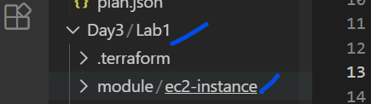
- Create file “ec2.tf” inside the “ed2-instance” folder.
Content of ec2.tf”
locals {
tag_Name = "Viswa-${var.env}"
}

resource "aws_instance" "main" {
ami = var.region_ami_map[var.region-1]
instance_type = var.instance_type
subnet_id = var.subnets[count.index]
count = var.num_of_vm
associate_public_ip_address = false

tags = {
"Name" = local.tag_Name
}
}
- Create “ec2_vars.tf” inside “ec2-instance folder
variable "region-1" {
default = "ap-south-1"
}
variable "env" {}
variable "num_of_vm" {
type = number
validation {
condition = var.num_of_vm >= 1 && var.num_of_vm <= 10
error_message = "Instance count must be between 1 and 10."
}
}

variable "instance_type" {
type = string
validation {
condition = contains(["t3.nano", "t3.micro"], var.instance_type)
error_message = "Only t3.nano or t3.micro are allowed."
}
}

variable "subnets" {
type = list
}

variable "region_ami_map" {
type = map(string)
default = {
"ap-south-1" = "ami-0ced6a024bb18ff2e"
"us-east-1" = "ami-12345"
}
}

- Create “ec2_output.tf”
output "vm_priv_pips" {
value = [for vm in aws_instance.main : vm.private_ip ]
}

- Finally create the main.tf for running the parents code.
The file has to be in the “lab1” folder.
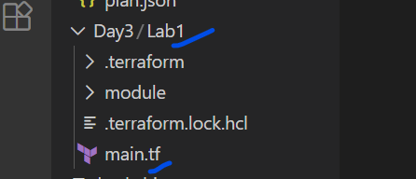
Main.tf content
provider "aws" {
region = "ap-south-1"
}

module "Vms_app1" {
source = "./module/ec2-instance"
region-1 = "ap-south-1"
instance_type = "t3.micro"
subnets = ["subnet-0a413d769fe98ba0b", "subnet-043f1f8151b681cca", "subnet-04f47a3252bdf06e6"]
num_of_vm = 1
env = "dev"
}

output "vm_private_ips01" {
value = module.Vms_app1.vm_priv_pips
}

