Steps

- Create an github a repo to store all the modules
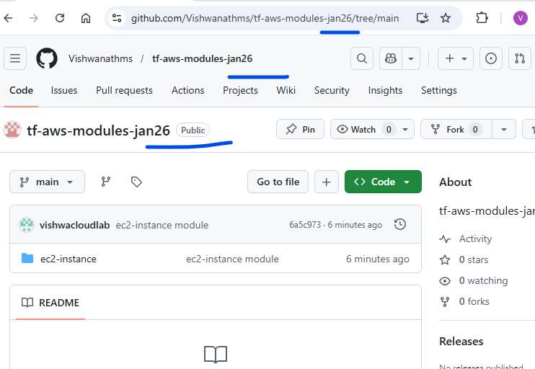

- Clone the repo
- Copy the “ec2-instance folder” to the new repo locally.
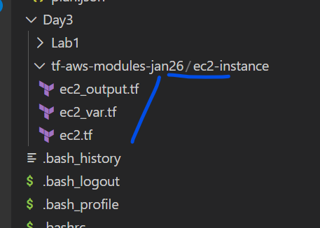
- Git commands
$ git add .
$ git commit -m “message”
$ git push
Check the file in the github
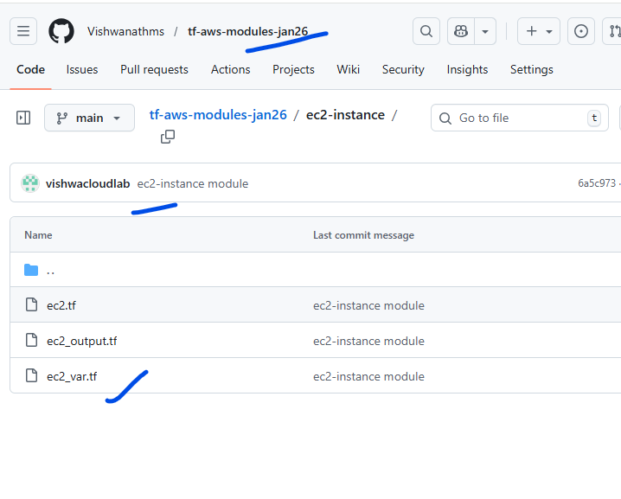

- Final stuff, change the source in the main.tf
source = "git::https://github.com/Vishwanathms/tf-aws-modules-jan26.git//ec2-instance?ref=main"

