This LM is to create sperate repo for capstone, and have basic file
Like .gitignore, main.tf and backend.tf

Steps:
- Create new github repo for capstone
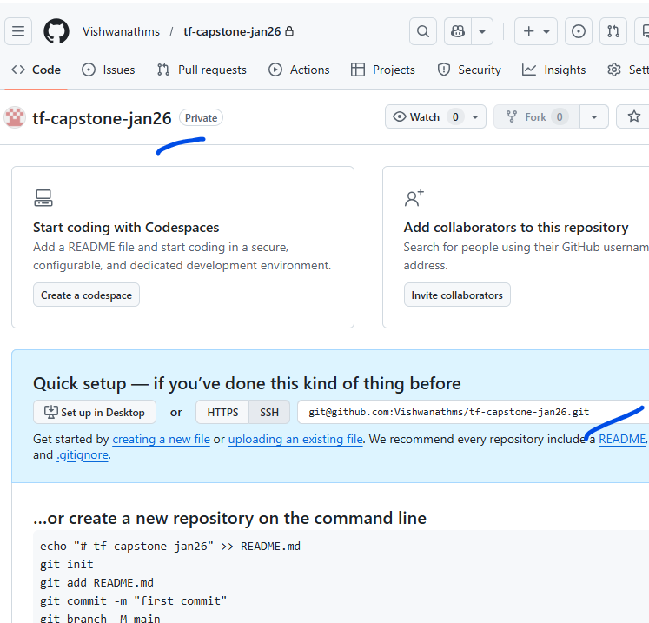
- Clone the repo to local VS code.
- Created 3 files.
.gitignore
Main.tf
Backend.tf
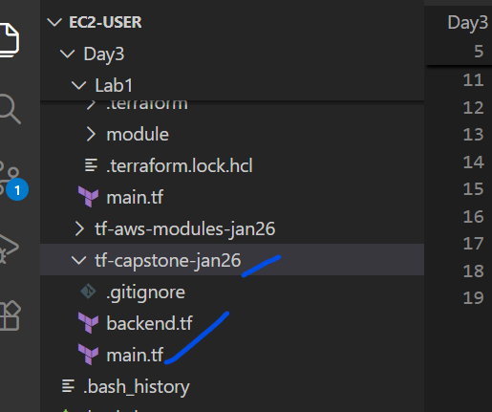

.gitignore
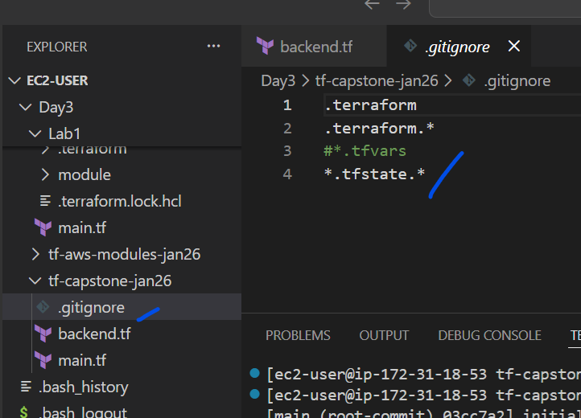
Content
.terraform
.terraform.*
#*.tfvars
*.tfstate.*

Filename: Backend.tf
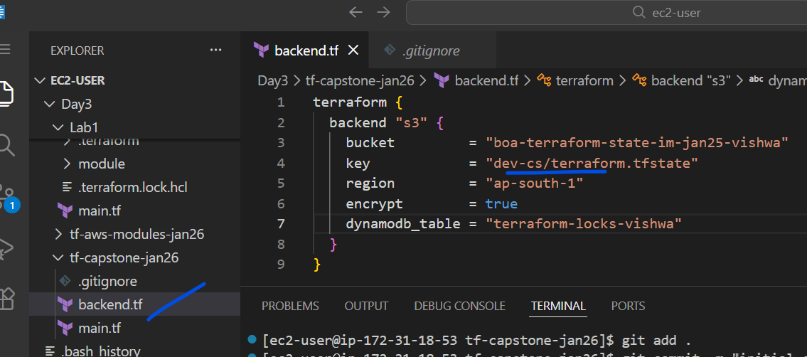
Content
terraform {
backend "s3" {
bucket = "boa-terraform-state-im-jan25-vishwa"
key = "dev-cs/terraform.tfstate"
region = "ap-south-1"
encrypt = true
dynamodb_table = "terraform-locks-vishwa"
}
}
Updating the folder name – “dev-cs”

Filename: main.tf
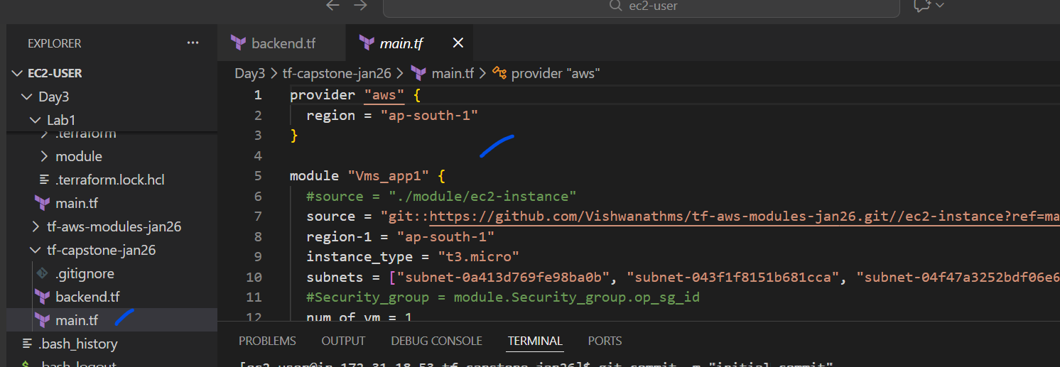
content
provider "aws" {
region = "ap-south-1"
}

module "Vms_app1" {
#source = "./module/ec2-instance"
source = "git::https://github.com/Vishwanathms/tf-aws-modules-jan26.git//ec2-instance?ref=main"
region-1 = "ap-south-1"
instance_type = "t3.micro"
subnets = ["subnet-0a413d769fe98ba0b", "subnet-043f1f8151b681cca", "subnet-04f47a3252bdf06e6"]
#Security_group = module.Security_group.op_sg_id
num_of_vm = 1
env = "dev"
}

output "vm_private_ips01" {
value = module.Vms_app1.vm_priv_pips
}

- Git commands to push to the github
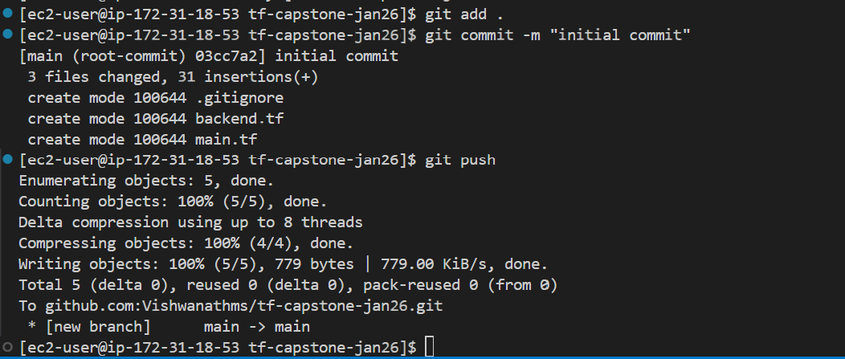
- Check the github repo
