This LM is to add security group module and use it in the parent main.tf

Steps

- Create the security group module
In the module github, create an “security groups” folder
Filename1: sg.tf

# Security Group - base security group (rules defined separately)
resource "aws_security_group" "web_sg" {
name = "lab9-web-sg-${var.project}"
description = "Security group for web server"
vpc_id = var.vpc_id

tags = {
Name = "lab9-web-sg-${var.project}"
}
}

# Security Group Rule - HTTP ingress
resource "aws_vpc_security_group_ingress_rule" "http" {
security_group_id = aws_security_group.web_sg.id
description = "HTTP"
from_port = 80
to_port = 80
ip_protocol = "tcp"
cidr_ipv4 = "0.0.0.0/0"

tags = {
Name = "lab9-http-rule-${var.project}"
}
}

# Security Group Rule - ssh ingress
resource "aws_vpc_security_group_ingress_rule" "ssh" {
security_group_id = aws_security_group.web_sg.id
description = "ssh"
from_port = 22
to_port = 22
ip_protocol = "tcp"
cidr_ipv4 = "0.0.0.0/0"

tags = {
Name = "lab9-http-rule-${var.project}"
}
}

# Security Group Rule - Allow all outbound
resource "aws_vpc_security_group_egress_rule" "all_outbound" {
security_group_id = aws_security_group.web_sg.id
description = "Allow all outbound"
ip_protocol = "-1"
cidr_ipv4 = "0.0.0.0/0"

tags = {
Name = "lab9-egress-rule-${var.project}"
}
}

Filename2: sg_var.tf
Filename3: sg_output.tf

- Add security group argument in the “ec2-instance” module
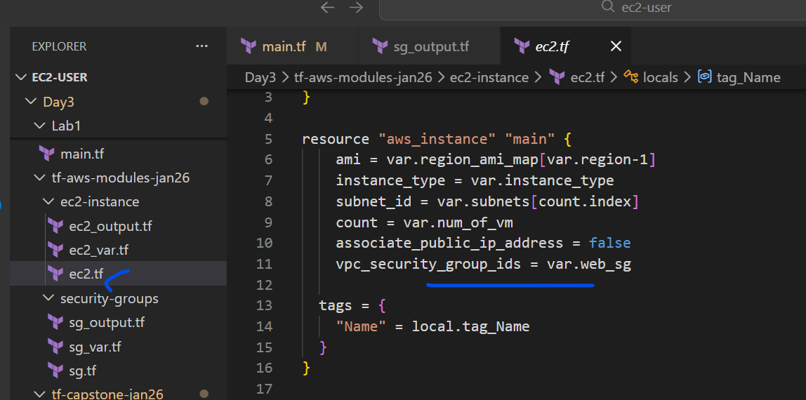
Add the below to the “ec2_var.tf file
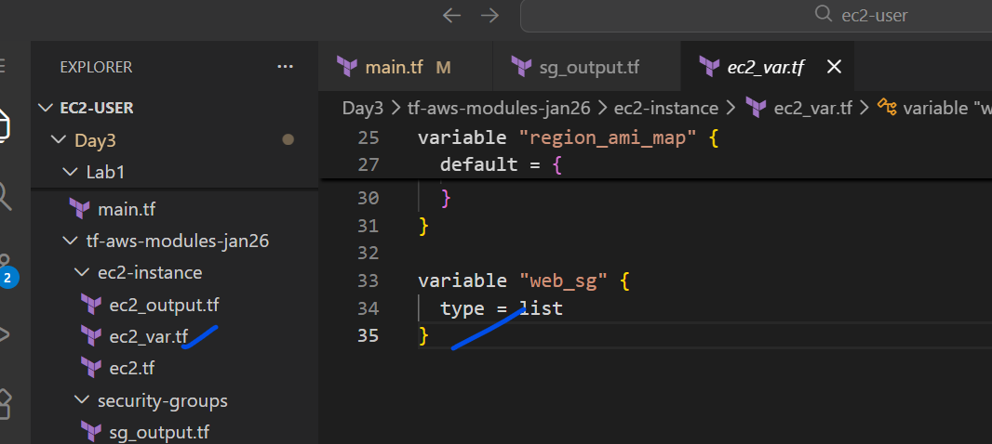
variable "web_sg" {
type = list
}

- Push the changes to the module github repo
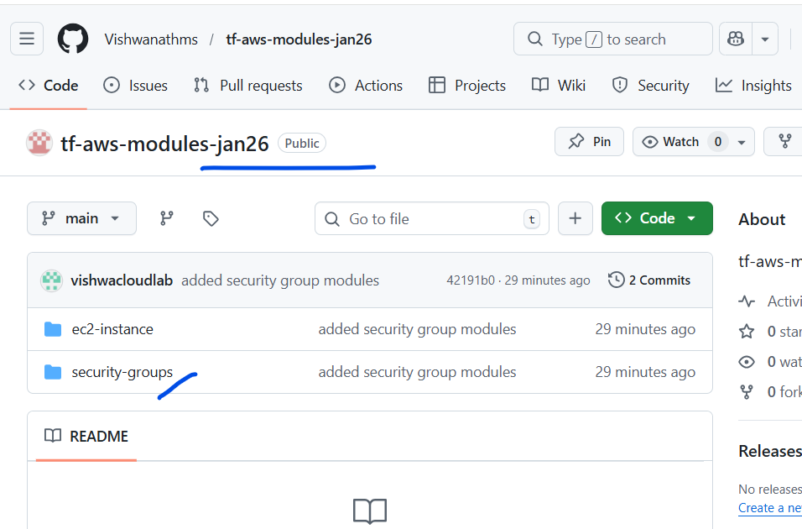

- Add the module to the main.tf
We are using the data to fetch the VPC ID automatically, instead of hard coding.
module "Web_SG01" {
source = "git::https://github.com/Vishwanathms/tf-aws-modules-jan26.git//security-groups?ref=main"
project = "vishwa"
vpc_id = data.aws_vpc.default.id
}

data "aws_vpc" "default" {
default = true
}

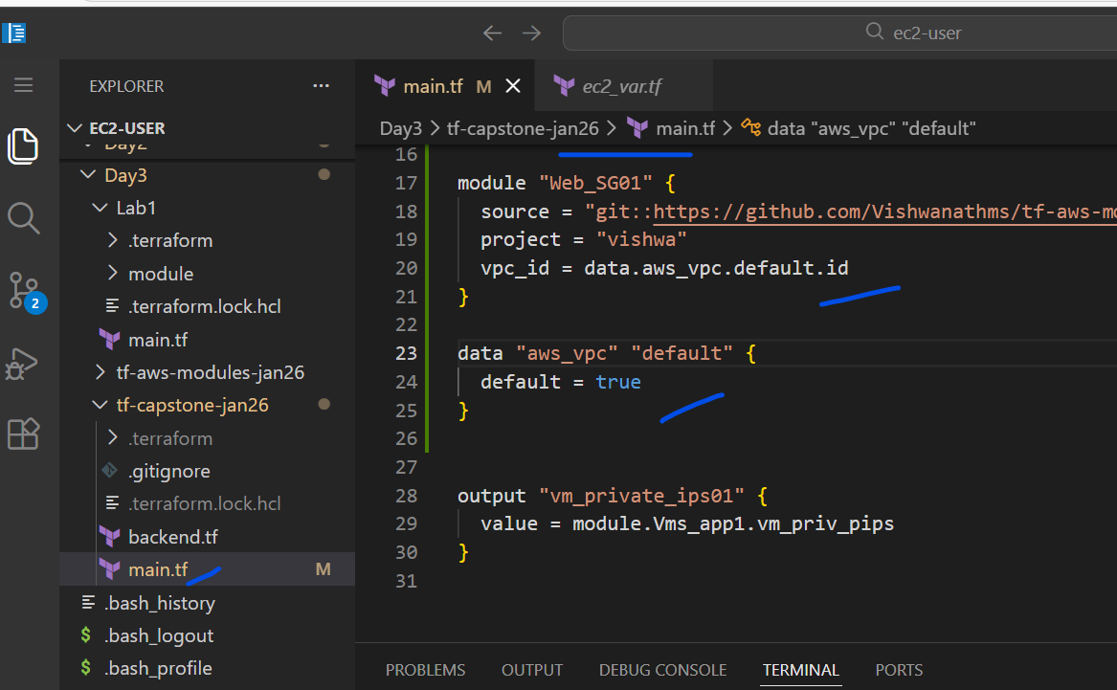

- Run terraform init and plan
We will get the below error
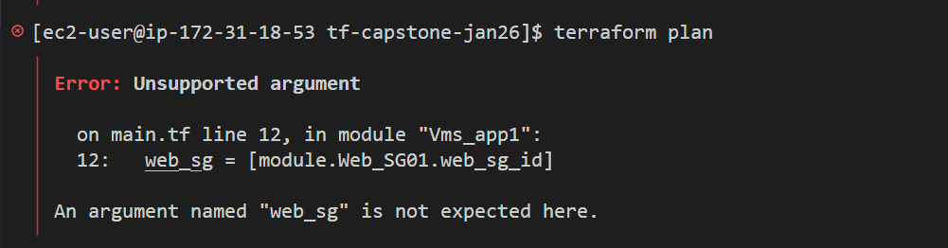
This is bcz the cached module folder in the .terraform in the capstone has the old module data for “Vms_app1”
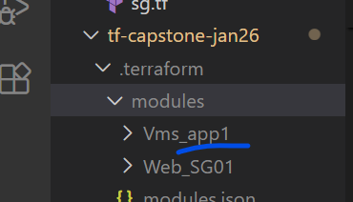
Delete that folder “Vms_app1” and run
Terraform init
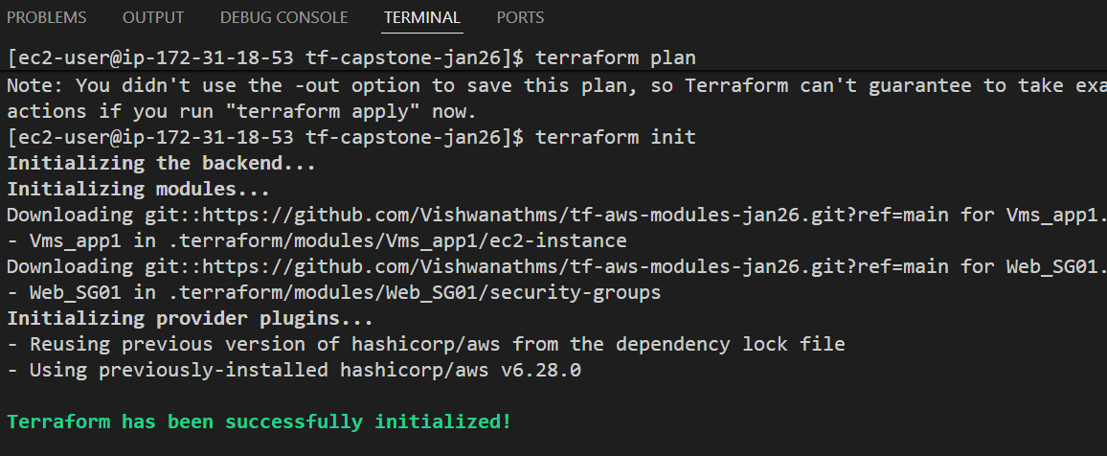
And then the terraform plan and apply will work

Output.
