This LM is to install the nginx on the ec2.

- Add userdata in the ec2-instance module
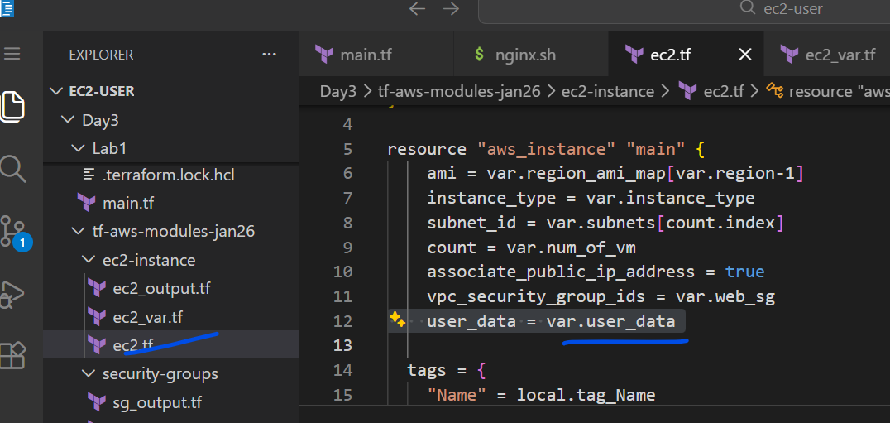
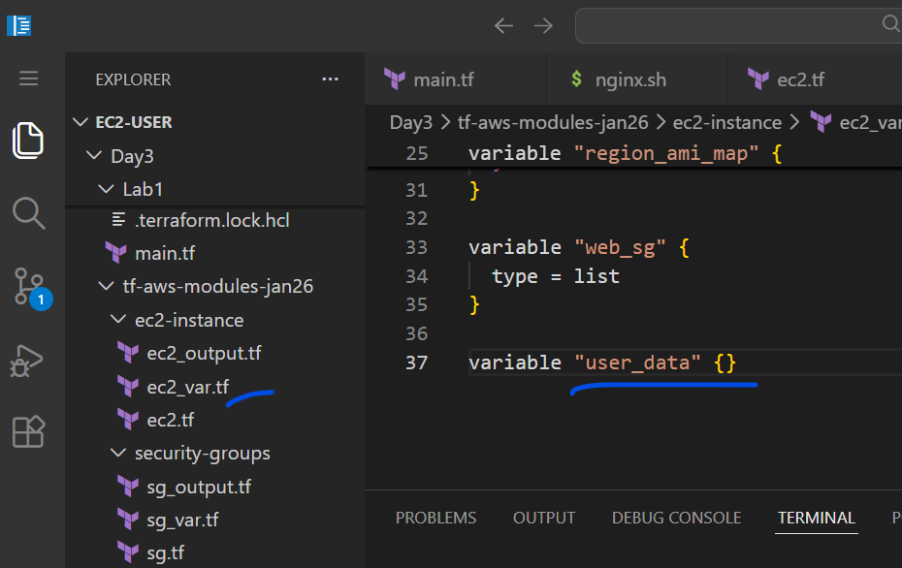
- Enabled public ip in the ec2-instance module
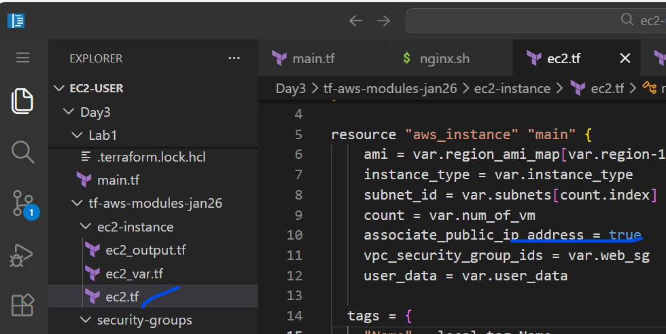
- Add userdata value in the main.tf
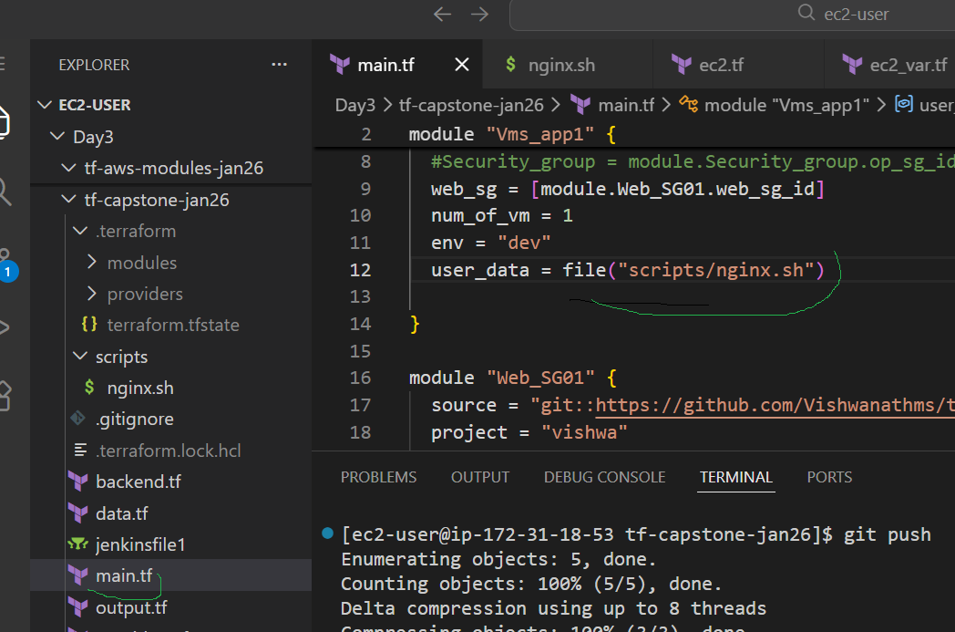

- Add the script
In the capstone project folder
Scripts/nginx.sh
#!/bin/bash
apt-get update -y
apt-get install -y nginx
systemctl enable nginx
systemctl start nginx

- Jenkinsfile data
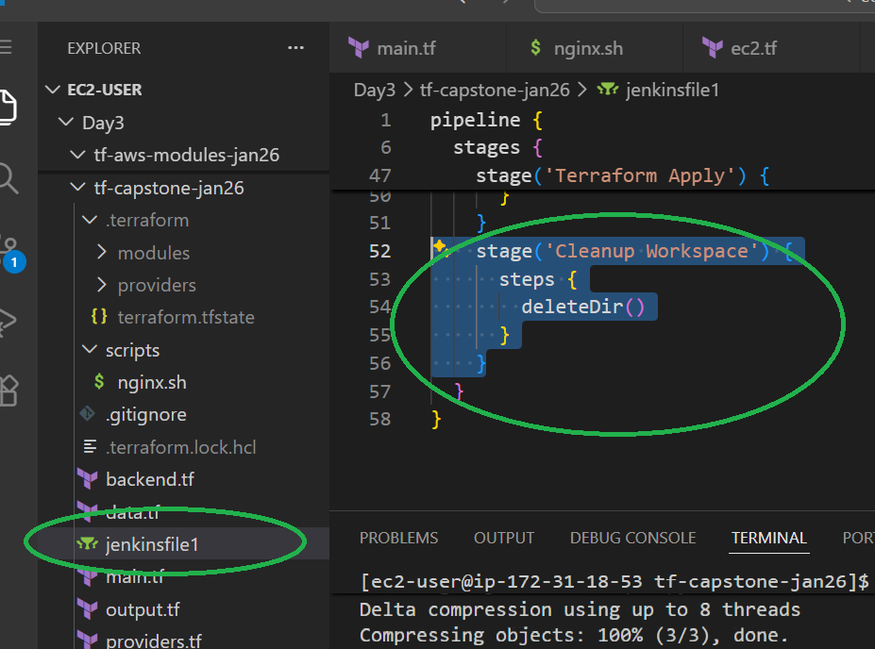
stage('Cleanup Workspace') {
steps {
deleteDir()
}
}

- Delete the .module in the .terraform in the capstone repo
- Terraform init
- Terraform destroy locallly
- Push the code , Jenkins to pick up automatically to apply

