🧪 Lab Manual: Terraform Workspaces (Dev & UAT)
1. Lab objective
In this lab, you will learn how to:
- Use Terraform workspaces to manage multiple environments
- Deploy the same Terraform code to:
  - dev
  - uat
- Maintain separate state files automatically
- Apply environment-specific configurations (instance type, tags, naming)

2. Why Terraform Workspaces?
Without workspaces:
- You must duplicate code for each environment
- Risk of overwriting state
- Hard to maintain consistency
With workspaces:
- One codebase
- Separate state per environment
- Cleaner CI/CD integration

3. Lab architecture
- AWS EC2 instance
- Amazon Linux 2023
- Same Terraform code
- Different values for dev and uat
Environment | Instance Type | Tag
dev | t3.micro | Environment=dev
uat | t3.small | Environment=uat

4. Folder structure
terraform-workspace-lab/
main.tf
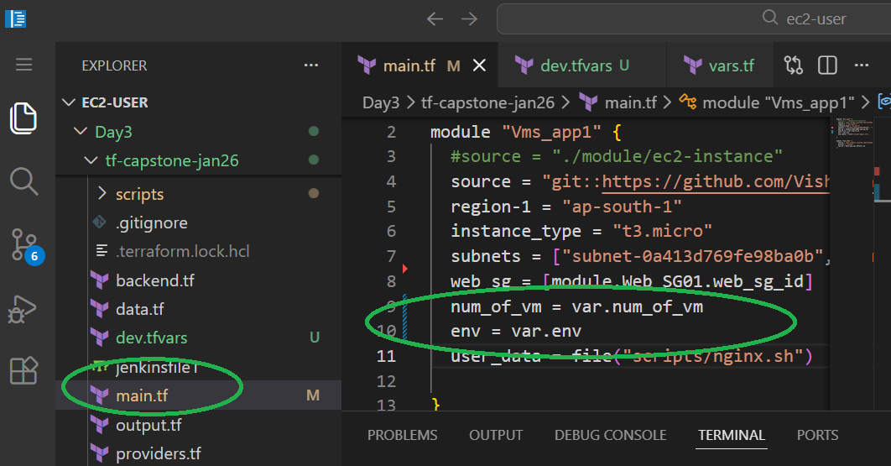
convering the below as variables
num_of_vm = var.num_of_vm
env = var.env

variables.tf
variable "env" {}
variable "num_of_vm" {
type = number
}

dev.tfvars
env = "dev"
num_of_vm = 1

uat.tfvars
env = "uat"
num_of_vm = 2

💡 Important: No separate folders for dev/uat. Workspaces handle isolation.

Problem
If I run
terraform apply -var-file=dev.tfvars ,
then
terraform apply -var-file=uat.tfvars this will override the current state file with UAT values.
THIS IS NOT EXPECTED

5. Lab execution steps
Step 1 — Initialize Terraform
terraform init

Step 2 — Check default workspace
terraform workspace list
Expected:
* default

Step 3 — Create dev workspace
terraform workspace new dev
terraform workspace select dev
Verify:
terraform workspace show
Output:
dev

Step 4 — Deploy DEV environment
terraform plan -var-file=”dev.tfvars”
terraform apply -var-file=”dev.tfvars”
✔ EC2 instance created with:
- Env: dev
- No of instance: 1
- State file: terraform.tfstate.d/dev/terraform.tfstate

Step 5 — Create uat workspace
terraform workspace new uat
terraform workspace select uat

Step 6 — Deploy UAT environment
terraform plan -var-file=”uat.tfvars”
terraform apply -var-file=”uat.tfvars”
✔ EC2 instance created with:
- Env: uat
- No of instance: 2
- Completely separate state

6. Verify state isolation
6.1 List state files
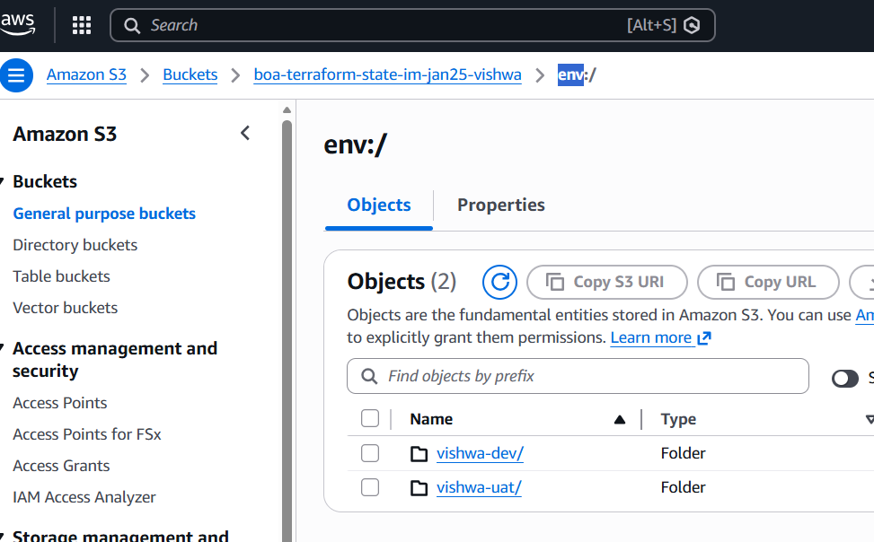
6.2 Check resources per workspace
terraform state list
- In dev: only dev EC2
- In uat: only uat EC2

7. Switching environments safely
terraform workspace select dev
terraform apply
Terraform only touches dev resources.

8. Destroy one environment without affecting the other
Destroy DEV only
terraform workspace select dev
terraform destroy
✔ UAT remains intact.

9. Common mistakes & best practices
❌ Mistakes
- Hardcoding environment names
- Using default workspace for real infra
- Sharing variables manually
✅ Best practices
- Always reference terraform.workspace
- Use maps for env-specific values
- Use workspaces mainly for small-to-medium setups
- Prefer separate state backends for large enterprises

10. Workspace vs Folder approach (exam + interview tip)
Feature | Workspaces | Separate folders
Code reuse | ✅ | ❌
Isolation | ⚠️ Partial | ✅ Strong
CI/CD friendly | ⚠️ | ✅
Enterprise scale | ❌ | ✅
💡 Rule of thumb:
- Use workspaces for learning, demos, small teams
- Use separate backends/folders for production-scale systems

11. Cleanup
terraform workspace select uat
terraform destroy
terraform workspace select dev
terraform destroy
(Optional)
terraform workspace delete dev
terraform workspace delete uat

