This Lab manual show cases the Jenkins pipeline for executing terraform commands stage wise

Steps
- Comment the .tfvars in the .gitignore.
- Add a new jenkinsfile named “jenkinsfile-tf” with the below stages
- Run git commands
- Verify the code in the github
- Create a new job , “vish-job4”
- Build now
- Add approval and apply stage
- Adding auto trigger SCM

- Comment the .tfvars in the .gitignore.
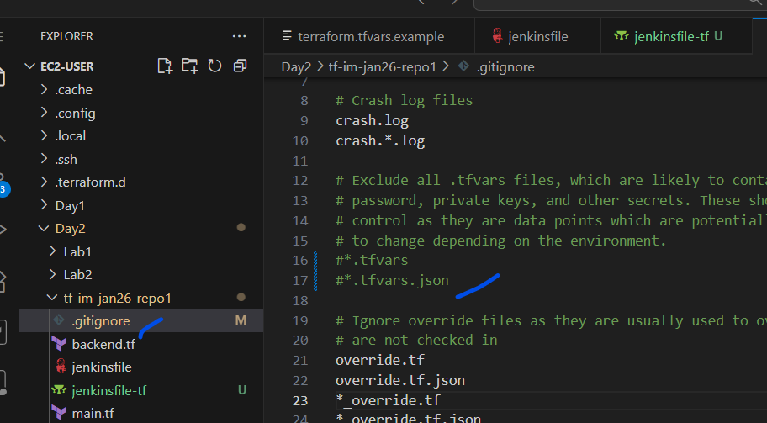

- Add a new jenkinsfile named “jenkinsfile-tf” with the below stages
pipeline {
agent any
stages {
stage('pre-requiste') {
steps {
sh '''
ls -l
pwd
terraform -version
git version
aws sts get-caller-identity
'''
}
}
stage('terraform init') {
steps {
sh "terraform init"
}
}
stage('terraform validate') {
steps {
sh "terraform validate"
}
}
stage('terraform plan') {
steps {
sh "terraform plan"
}
}
}
}

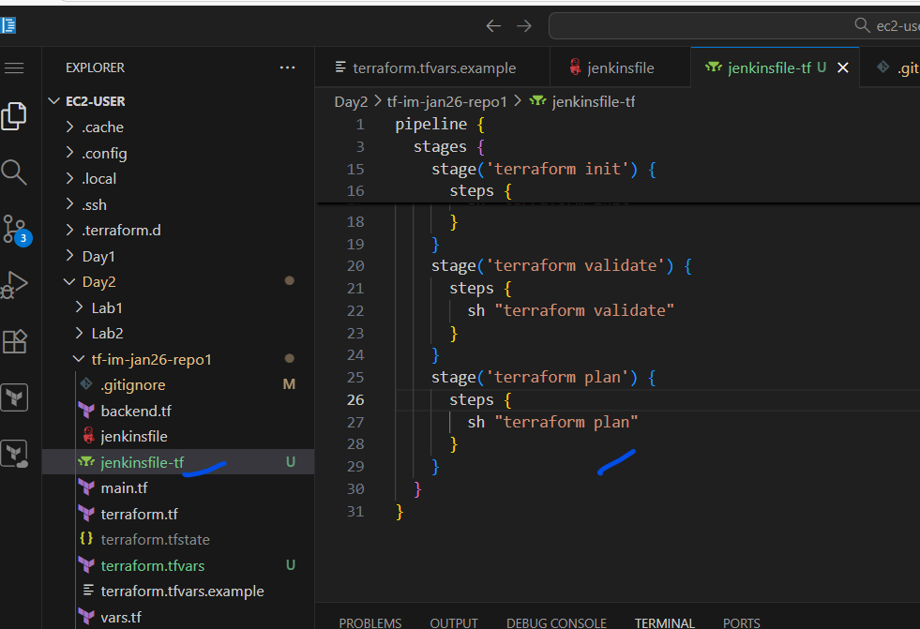
- Run git commands
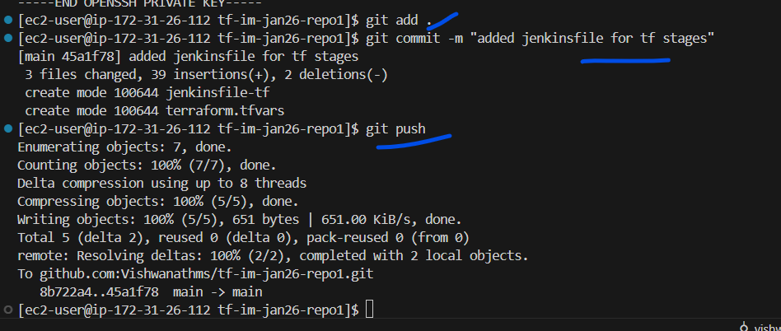

- Verify the code in the github
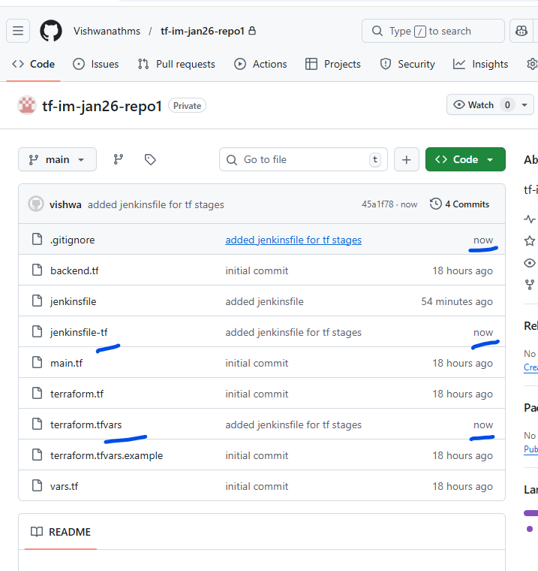

- Create a new job , “vish-job4”

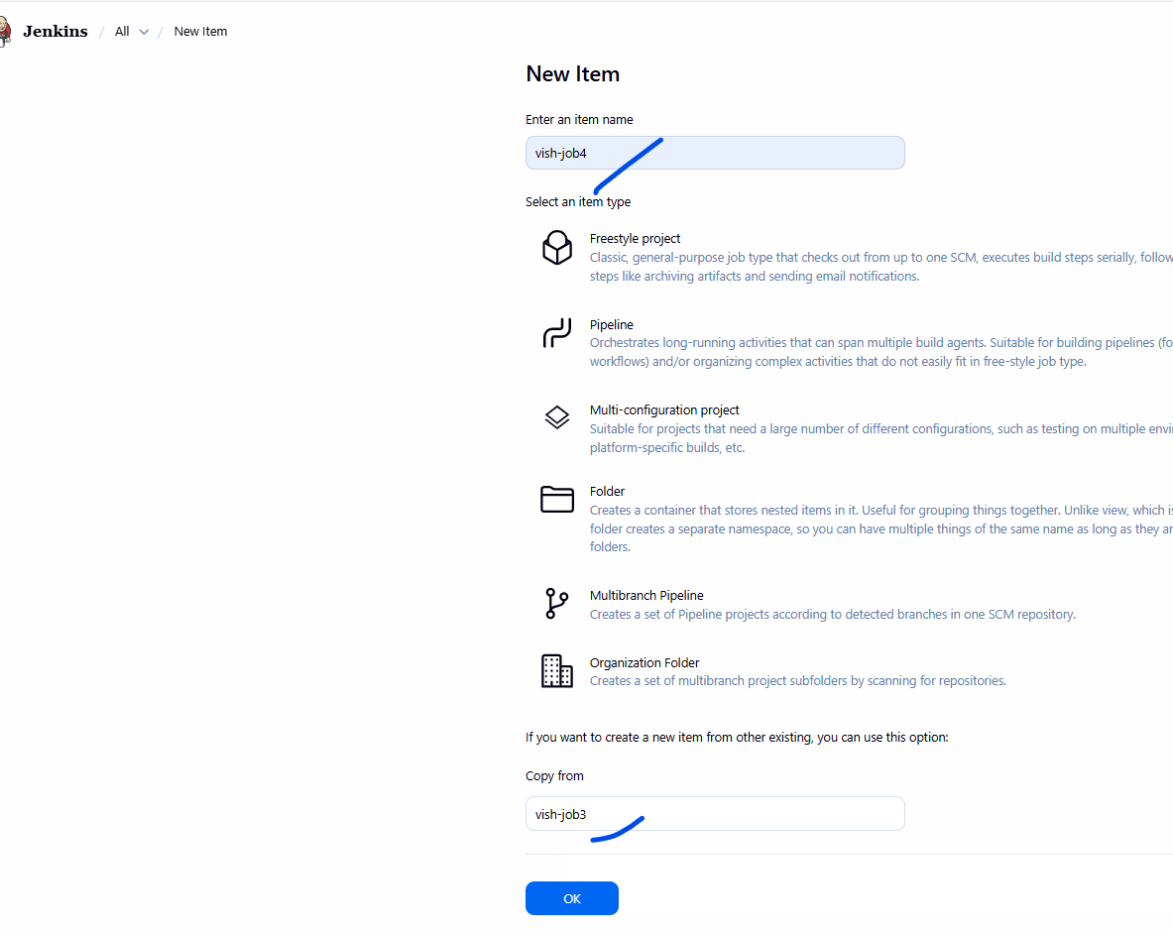
Let this be an copy from “vish-job3”
Click ok
The only value to be edited
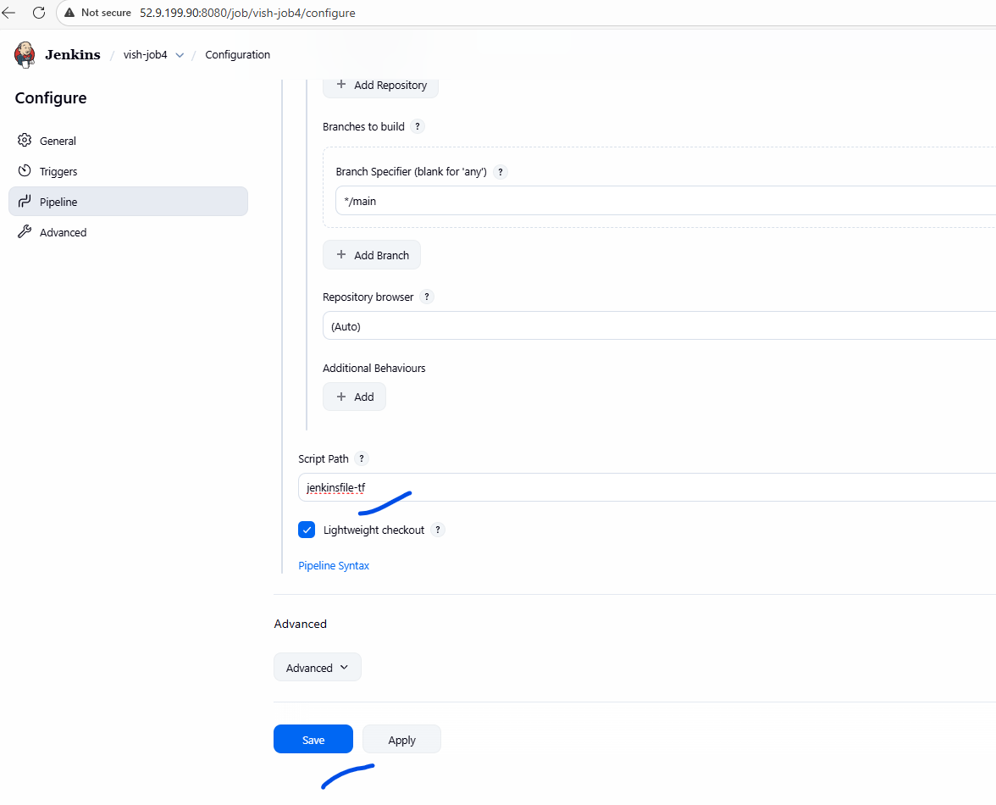

- Build now
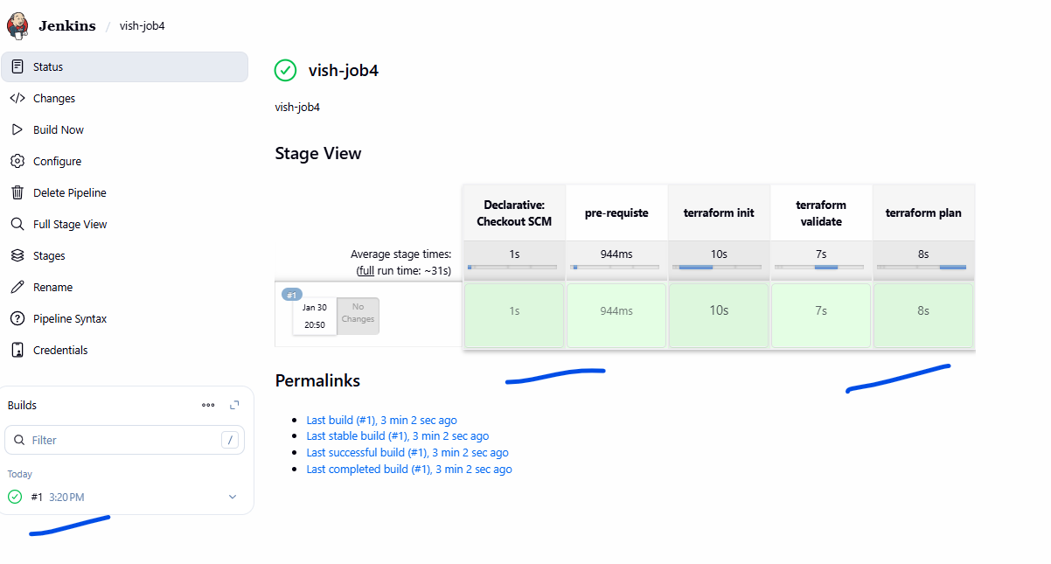

- Add approval and apply stage
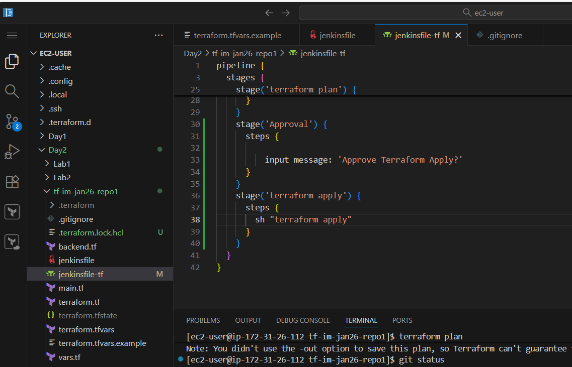
stage('Approval') {
steps {

input message: 'Approve Terraform Apply?'
}
}
stage('terraform apply') {
steps {
sh "terraform apply"
}
}

Run the git commands
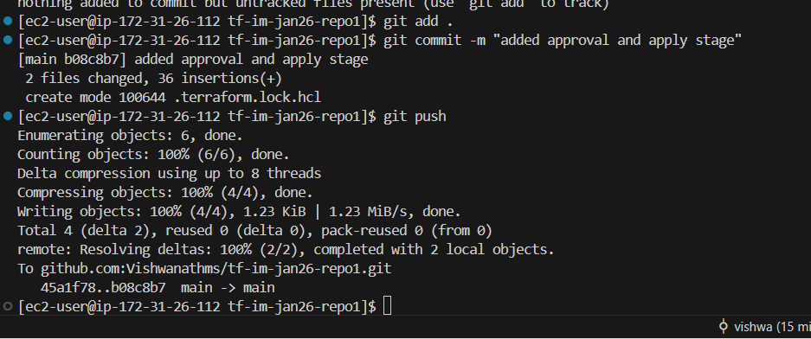

- Run the job again
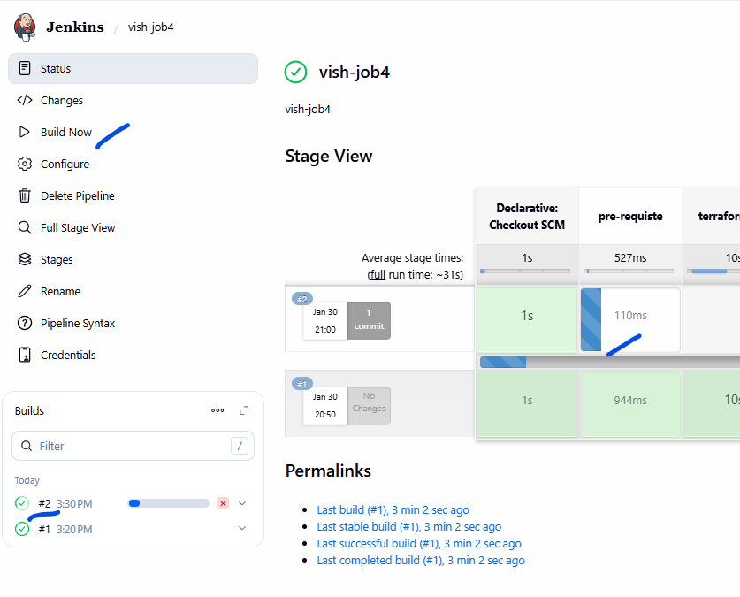
This would wait at approval
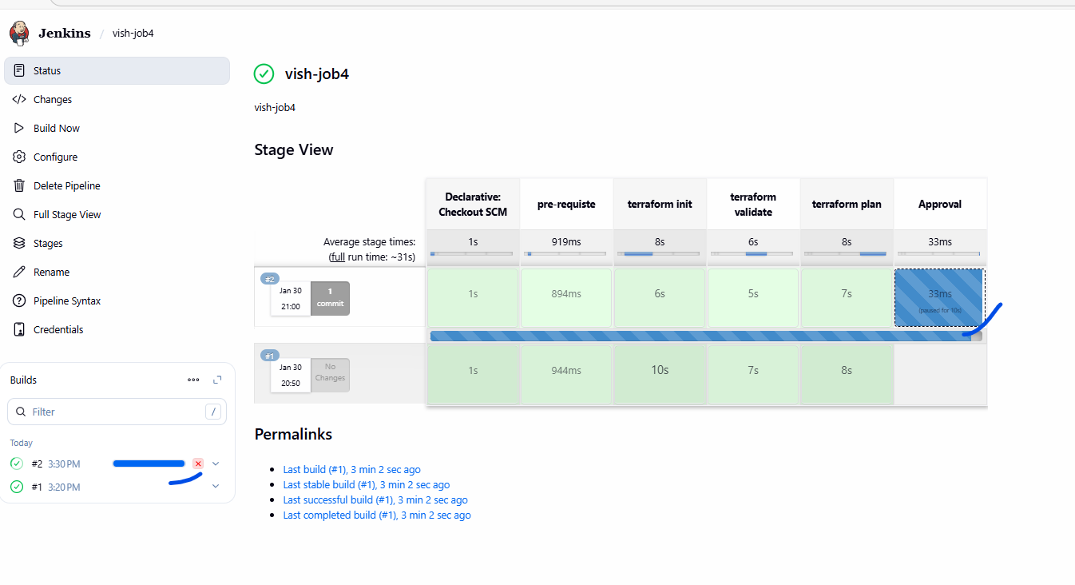

Option1: Click on “Abort”
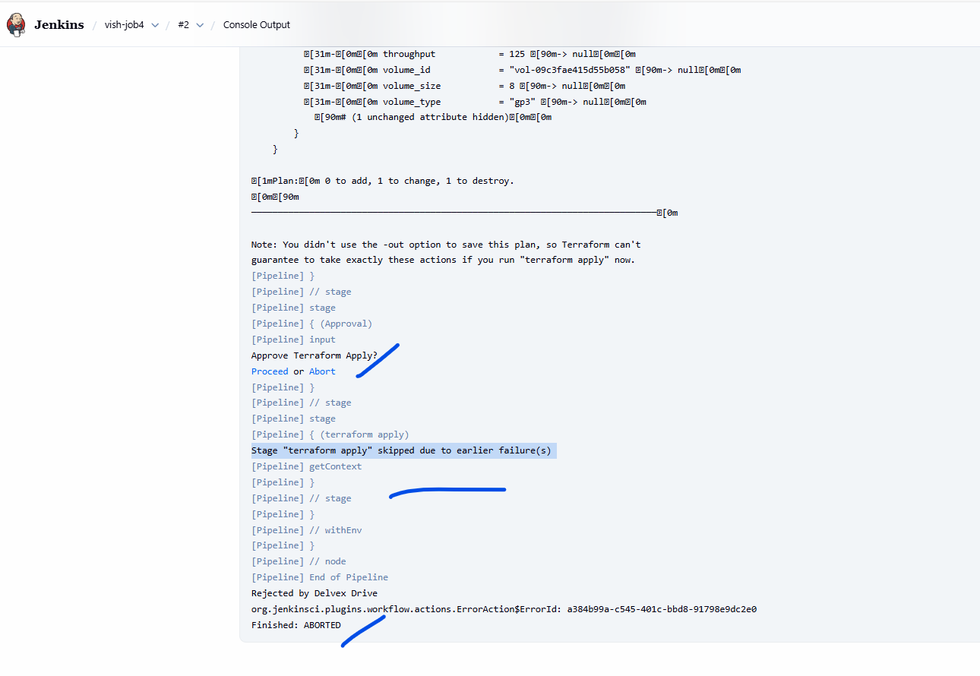

Option2: “Proceed”

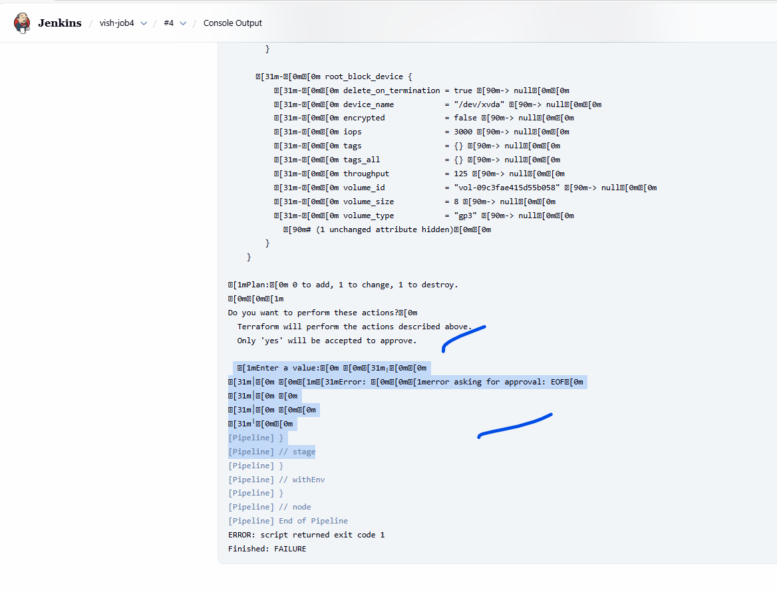
The above error is bcz terraform apply is waiting for “yes”
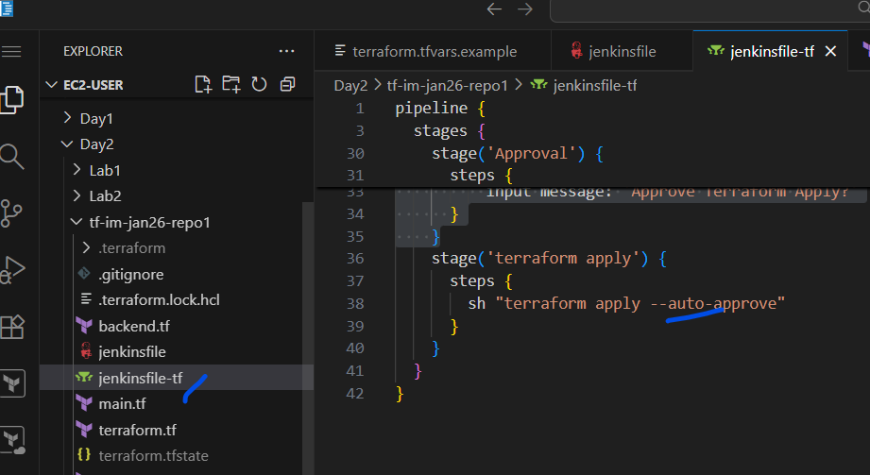

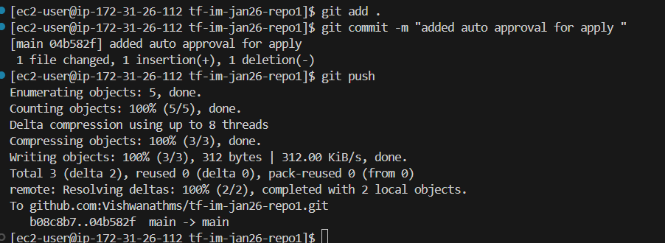

Running the job again

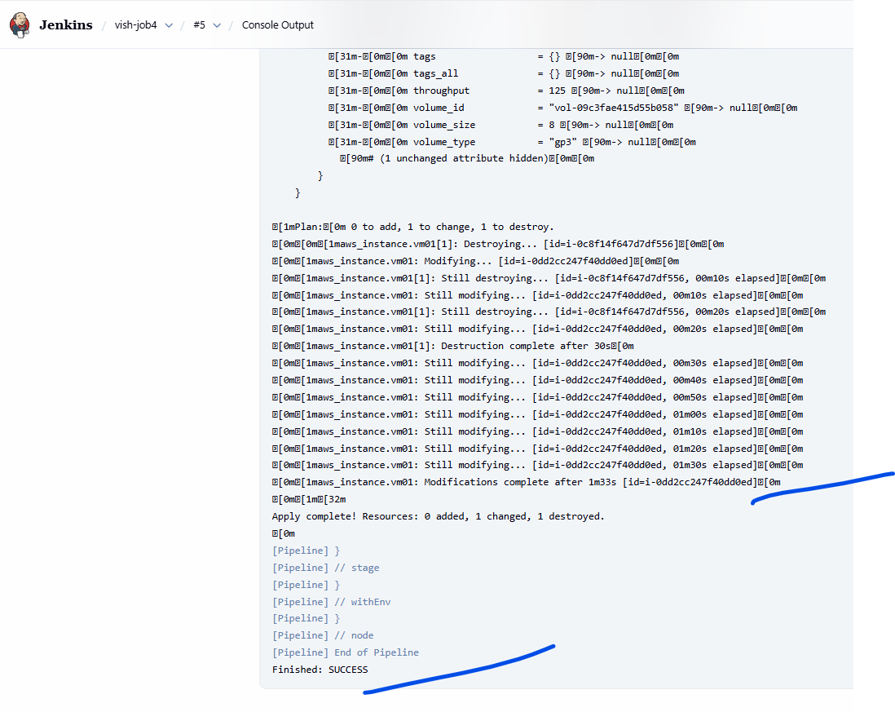
The job is successful

- Adding auto trigger SCM
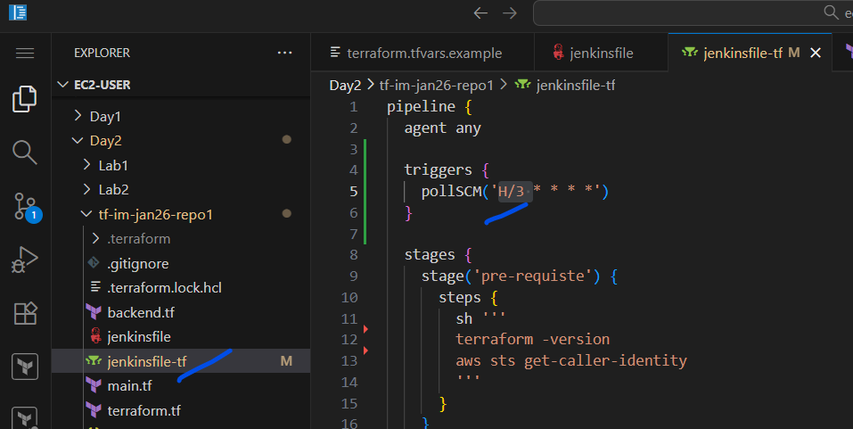
This will make sure Jenkins will keep checking if there is new commits every 3 min.

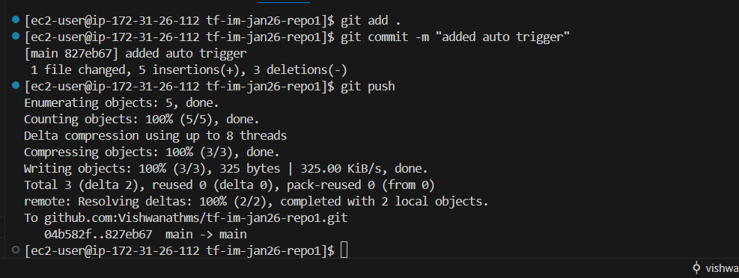

Now for one time we have to do a manual build
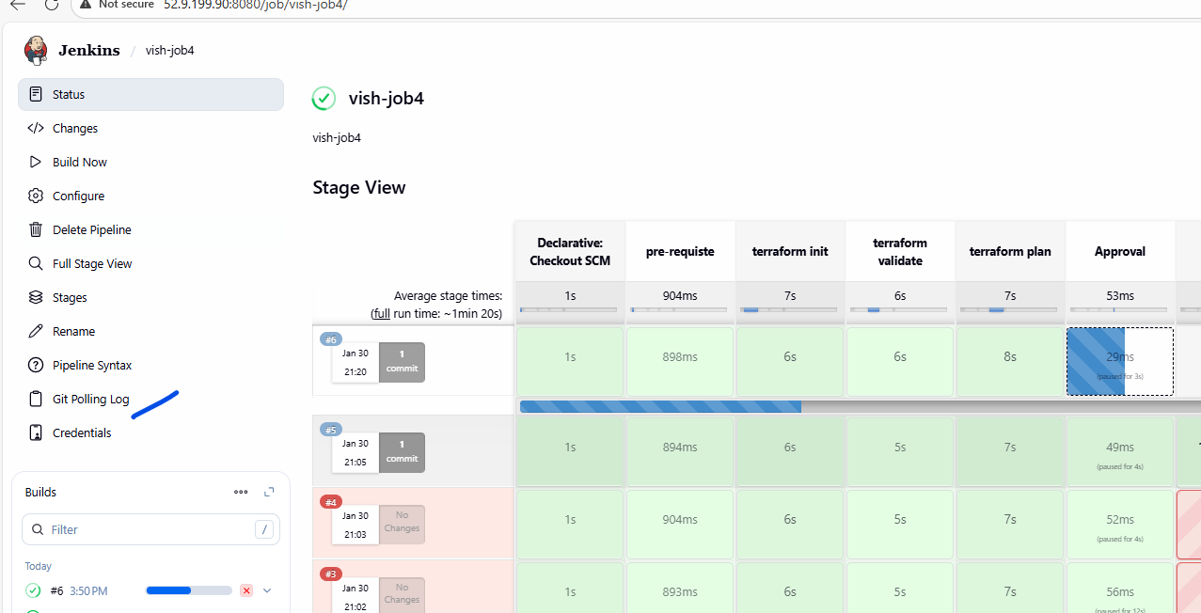
The “Git polling log” gets added.

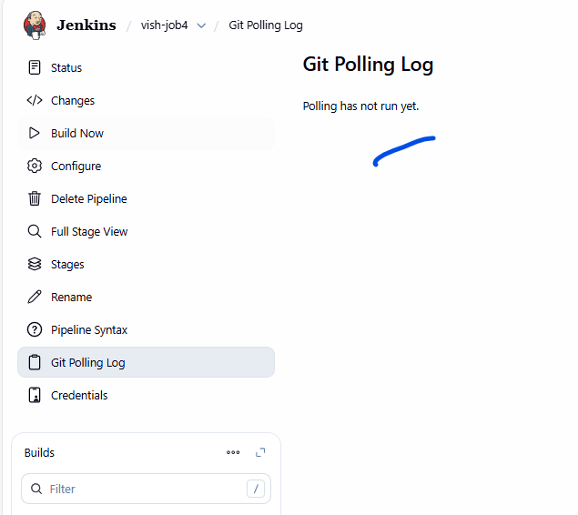
It would run for the first time after 3 min
