**Objective**

1. **Manifest file**
2. **Deploy app using Deployment option**
3. **Display and Validate Deployment**
4. **Expose it to the external world**
5. **Test – POD Failures**
6. **Test – Scale up**
7. **Test – Scale down**

Assumption:

* We are using ‘NodePort”

1. **Manifest file**
   1. **Deployment-file**
2. ---
3. apiVersion: apps/v1
4. kind: Deployment
5. metadata:
6. name: deploy1
7. spec:
8. replicas: 2
9. selector:
10. matchLabels:
11. app: vclapp
12. template:
13. metadata:
14. labels:
15. app: vclapp
16. spec:
17. containers:
18. - name: myapp
19. image: nginx
20. ports:
21. - containerPort: 80

Save the file as “deployment.yaml”

* 1. **service-port**

1. ---
2. apiVersion: v1
3. kind: Service
4. metadata:
5. name: node-port
6. spec:
7. type: NodePort
8. ports:
9. - port: 88
10. targetPort: 80
11. nodePort: 30303
12. selector:
13. app: vclapp

Save the file as “service.yaml”

1. **Folder structure looks like**

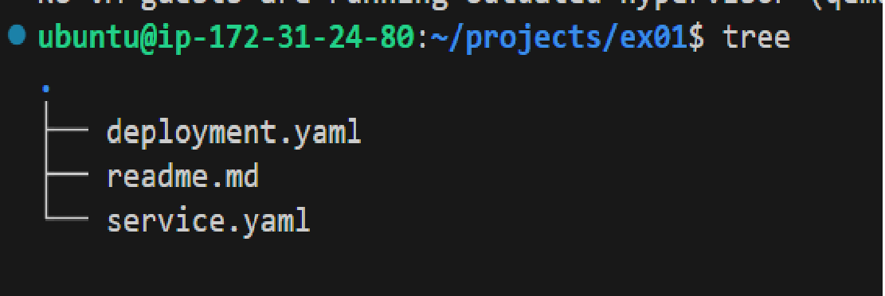

1. **Deploy app using Deployment**

**$ kubectl apply -f deployment.yaml**

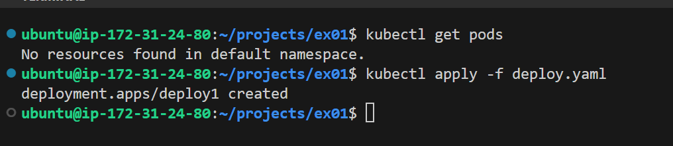

**$ kubectl get pods**

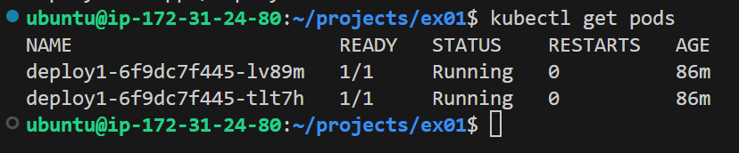

1. **Display and Validate deployment inside minikube**

Login to the minikube Vm, and run

projects/ex01**$ minikube ssh**

**$ docker ps | grep nginx**

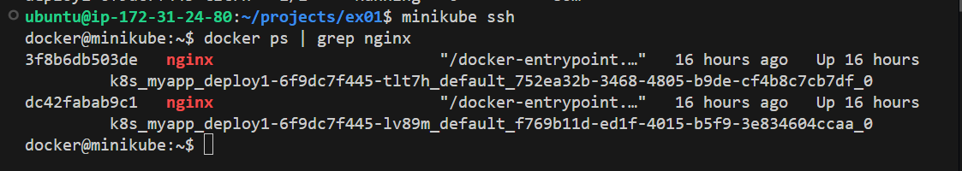

Check each PODS

**$ kubectl describe pods/deploy1-6f9dc7f445-lv89m**

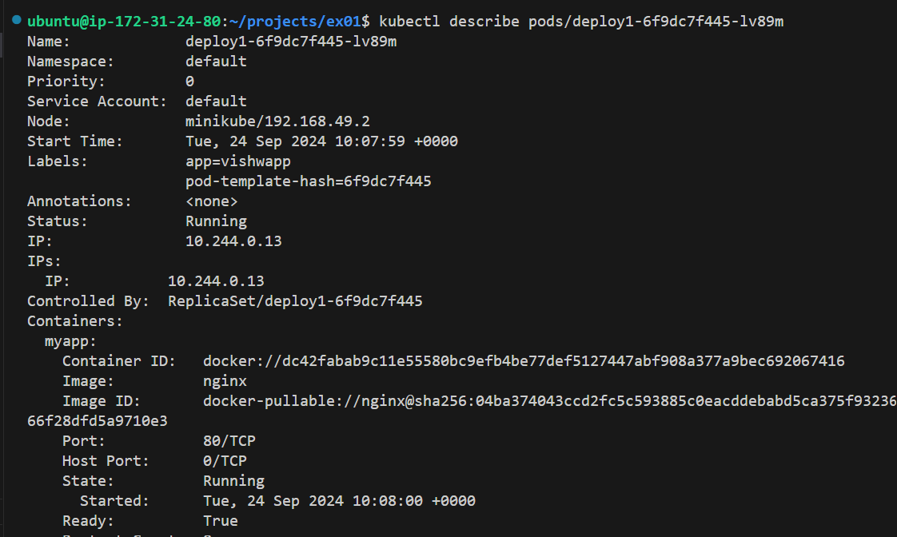

**$ kubectl describe pods/deploy1-6f9dc7f445-tlt7h**

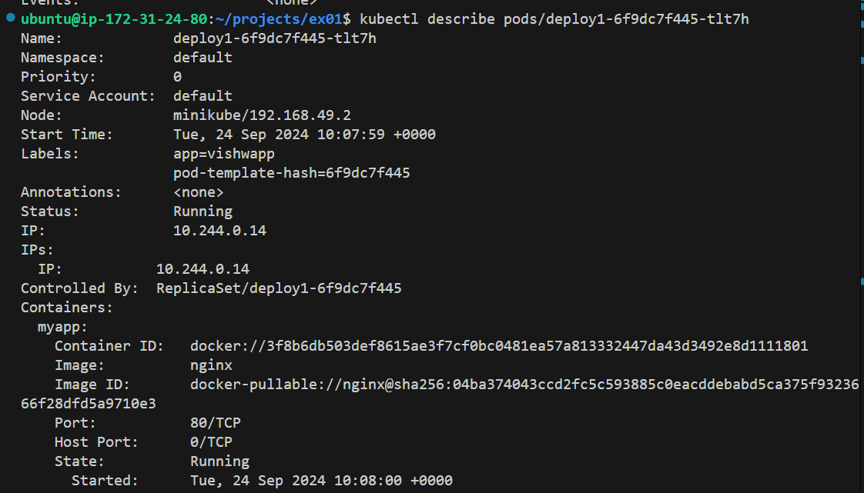

1. **Expose it to the external world ( Here the external world for the pod is minikube. Refe below diagram**

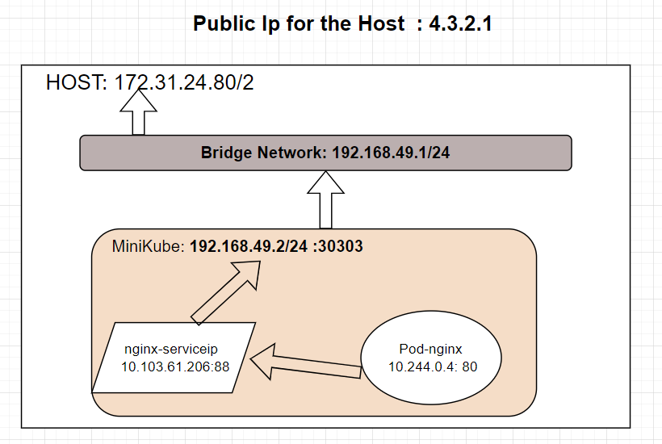

**$ kubectl apply -f service.yaml**

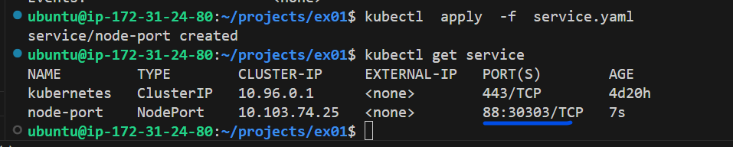

Here the pod is exposed to external world on port “30303”

**$ kubectl describe services/node-port**

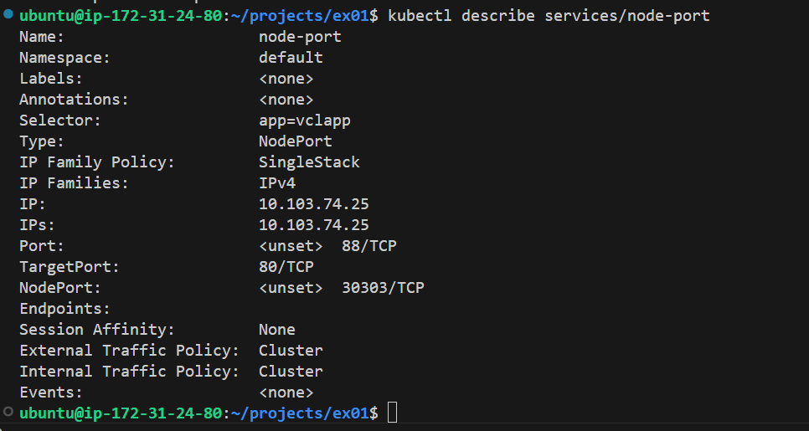

This clearly shows that the service has created the LOADBALANCER.

The endpoint points to all the 3 PODS and

The external port is working on “**32150**”

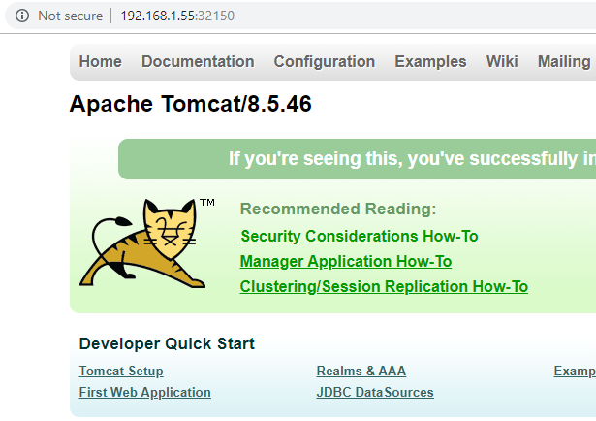

1. **Test – POD Failures**



We just removed a container.

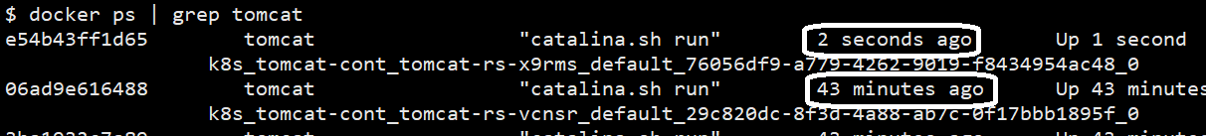

The container is back with no time.

This is the work of the Kubernetes.

1. **Test – Scale up**

**Change the replicas in the YAML file and save it.**

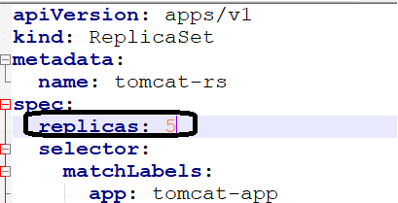



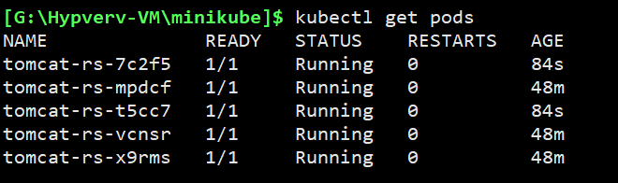

**$ kubectl describe services/replica-nodeport**

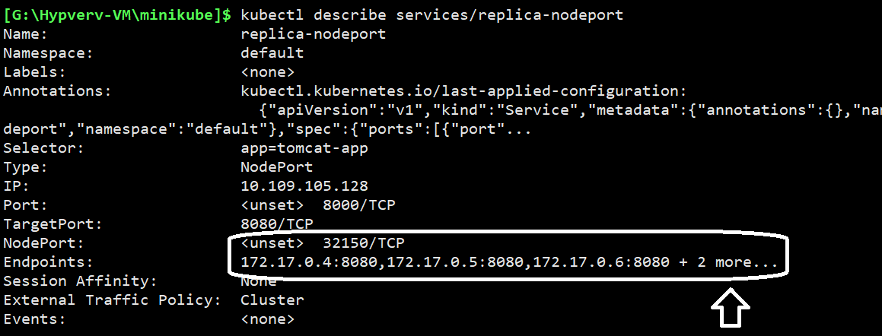

1. **Test – Scale down**

**Change the replicas in the YAML file and save it.**



