This project has 2 gitlab runner

Objective:
To deploy the spring boot 4 microservice application on the docker-desktop on windows.

Setup details
- Gitlab personal account
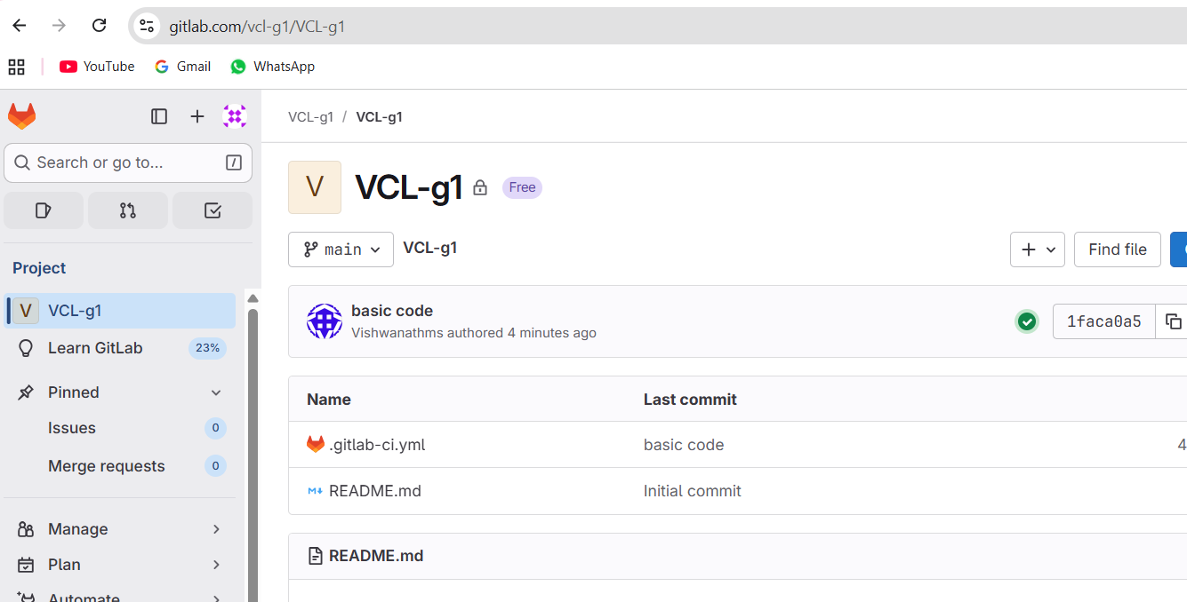
- Gitlab—runner as docker executor
- Gitlab—runner as shell executor
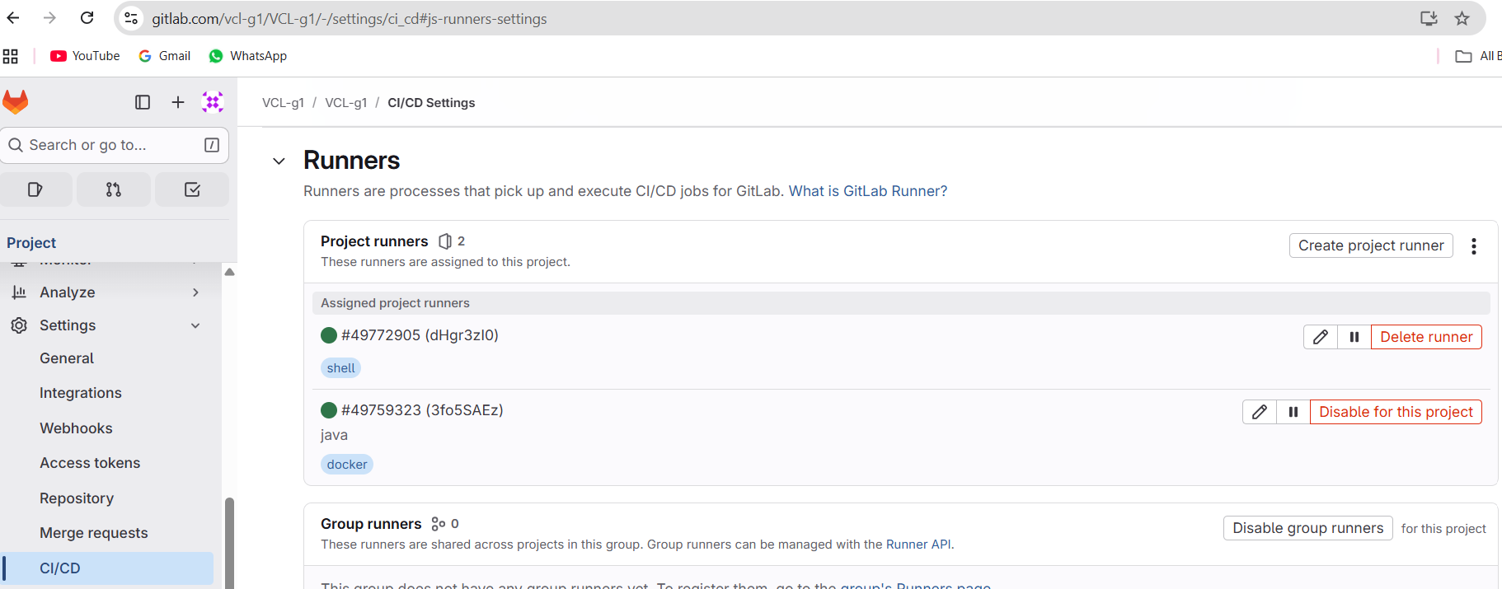

Coding-Steps
- Test the yaml file for checkout
- default:
- tags:
- - shell

- stages:
- - build

- build-job:
- stage: build
- script:
- - echo "Repo already cloned"
- - ls -la

2. Lets add

