Setting up a GitLab Runner for GitLab Running as Docker on Windows Docker Desktop

# Scenario

- You have GitLab CE/EE running in Docker on Windows via Docker Desktop.  
- You want to add a GitLab Runner (could be Shell, Docker, or Docker-in-Docker executor).

# 1. Prepare GitLab Server Info

- Ensure your GitLab instance is accessible from your Windows system, e.g., http://localhost.  
- Log in as an admin/maintainer to get the registration token:  
 - Navigate to: GitLab → Project → Settings → CI/CD → Runners section → Expand "Set up a specific Runner manually"  
 - Copy the URL (e.g., http://localhost/) and the Registration Token.

# 2. Install GitLab Runner

## Option 1: Use Docker (Recommended & Portable)

1. Open PowerShell or CMD.

2. Pull GitLab Runner image:  
 docker pull gitlab/gitlab-runner:latest

3. Create a directory for Runner config (optional but good for persistence):  
 mkdir C:\gitlab-runner

4. Run GitLab Runner container:  
 docker run -d --name gitlab-runner --restart always ^  
 -v C:\gitlab-runner:/etc/gitlab-runner ^  
 -v //var/run/docker.sock:/var/run/docker.sock ^  
 gitlab/gitlab-runner:latest

== Use the below for current setup of docker desktop

docker run -d --name gitlab-runner --restart always ^  
 -v C:\gitlab-runner:/etc/gitlab-runner ^  
 -e DOCKER_HOST=tcp://host.docker.internal:2375 ^  
 gitlab/gitlab-runner:latest

> Note: Replace C:\gitlab-runner with your preferred local folder.

# 3. Login to the runner on the cli

$ ***docker exec -it gitlab-runner bash***

# 

Root@1bb15ba:/# ***gitlab-runner register***

# 

# 4. Verify Runner Registration

- Go to GitLab → Project → Settings → CI/CD → Runners.  
- You should see your new runner listed as online.

# 5. Use the Runner in Your .gitlab-ci.yml

Example for a Docker runner:

stages:  
 - test  
  
job1:  
 stage: test  
 script:  
 - echo "GitLab Runner setup on Windows Docker Desktop!"

# Summary Table

|  |  |
| --- | --- |
| Step | Command/Action |
| Pull runner image | docker pull gitlab/gitlab-runner:latest |
| Start runner container | docker run -d --name gitlab-runner ... |
| Register runner | docker run --rm -it -v ... gitlab/gitlab-runner register |
| Verify | Check in GitLab CI/CD Settings → Runners |

# Troubleshooting Tips

- If you get errors like "Runner not connecting", make sure Docker can reach your GitLab container (especially if using custom networks or ports).  
- For Docker-in-Docker (DinD), you might need special configs (let me know if you want this setup).

Let me know if you need:  
- Shell executor details  
- Docker-in-Docker example  
- A complete .gitlab-ci.yml with stages!

Tips:

Make sure the hostname of the gitlab server is resolving on the gitlab runner.

“localhost” will not work , if configured as “external_url”

Or

Use the ipaddress of the Host machine (wndows) , tha tis the actual ip.

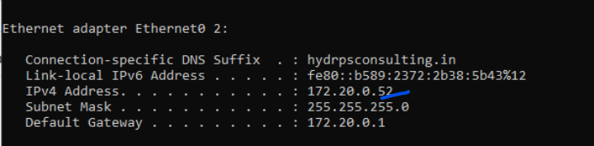

Check if it reachable from gitlab server and runner

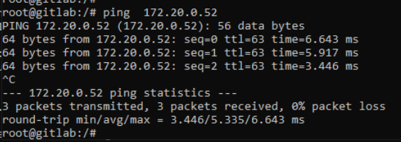

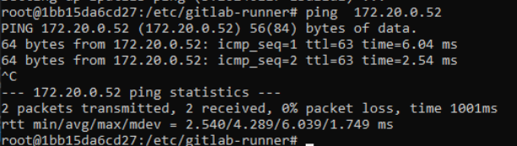

Make sure the gitlab.rb file is updated with the same

