**Objective**

1. **Manifest file**
2. **Deploy app using replicaset**
3. **Display and Validate ReplicaSet**
4. **Expose it to the external world**
5. **Test – POD Failures**
6. **Test – Scale up**
7. **Test – Scale down**
8. **Manifest file**
   1. **ReplicaSet-pod**

apiVersion: apps/v1

kind: ReplicaSet

metadata:

name: tomcat-rs

spec:

replicas: 3

selector:

matchLabels:

app: tomcat-app

matchExpressions:

- {key: tier, operator: In, values: [frontend]}

template:

metadata:

name: tomcat-pod

labels:

app: tomcat-app

tier: frontend

spec:

containers:

- name: tomcat-cont

image: tomcat

ports:

- containerPort: 8080

Save the file as “Replicaset-pod.yaml”

* 1. **ReplicaSet-node-port**

apiVersion: v1

kind: Service

metadata:

name: replica-nodeport

spec:

type: NodePort

ports:

- port: 8000

targetPort: 8080

selector:

app: tomcat-app

Save the file as “Replicaset-node-port.yaml”

1. **Deploy app using ReplicaSet**

**$ kubectl apply -f ReplicaSet-pod.yaml**



**$ kubectl get pods**

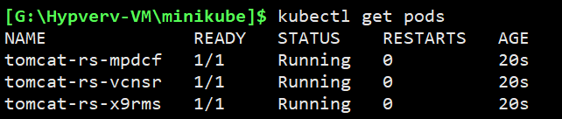

1. **Display and Validate ReplicaSet**

Login to the minikube Vm, and run

**$ docker ps | grep tomcat**

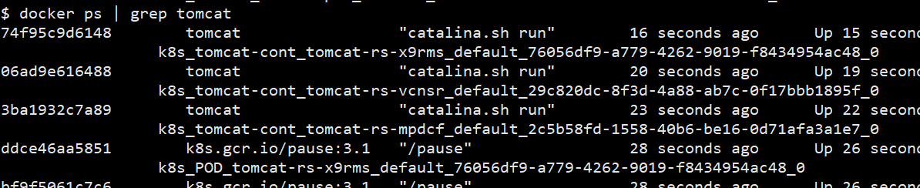

Check each PODS

**$ kubectl describe pods/tomcat-rs-mpdcf**

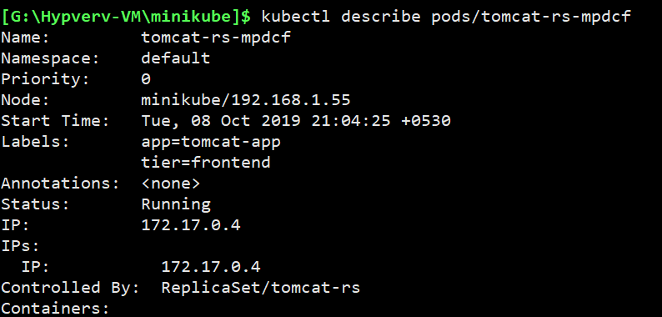

**$ kubectl describe pods/tomcat-rs-vcnsr**

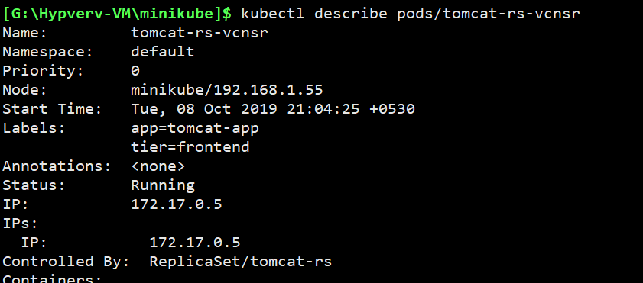

**$ kubectl describe pods/tomcat-rs-x9rms**

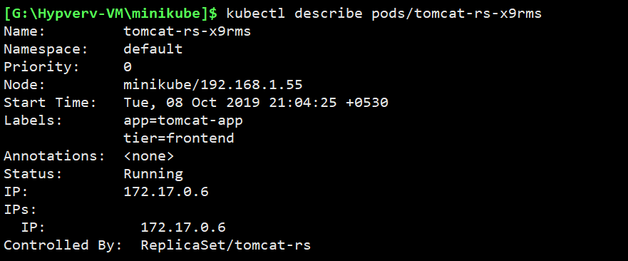

1. **Expose it to the external world**

**$ kubectl apply -f ReplicaSet-node-port.yaml**



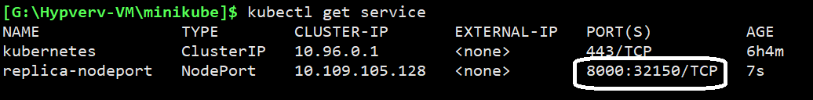

**$ kubectl describe services/replica-nodeport**

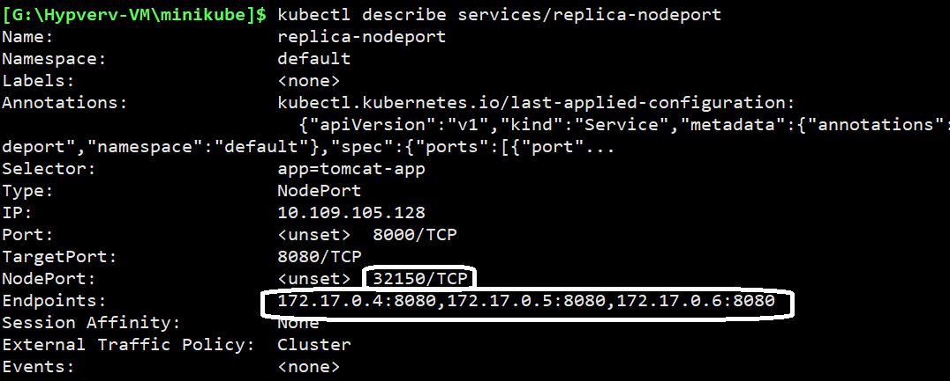

This clearly shows that the service has created the LOADBALANCER.

The endpoint points to all the 3 PODS and

The external port is working on “**32150**”

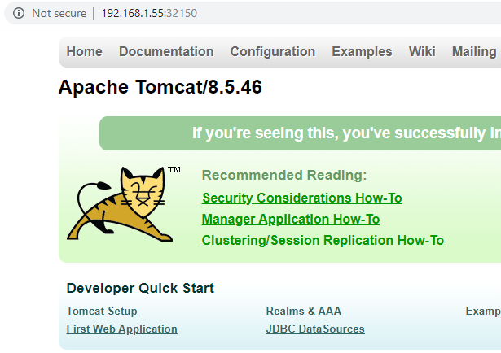

1. **Test – POD Failures**



We just removed a container.

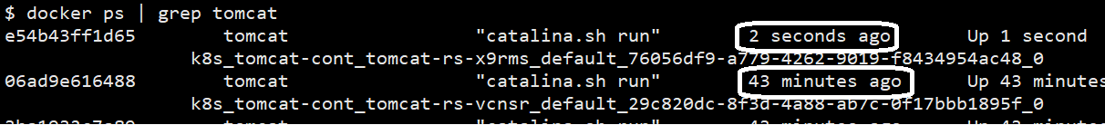

The container is back with no time.

This is the work of the Kubernetes.

1. **Test – Scale up**

**Change the replicas in the YAML file and save it.**

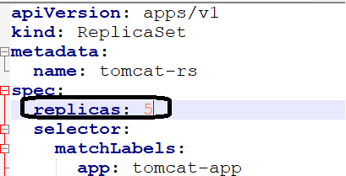



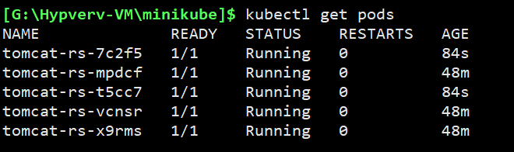

**$ kubectl describe services/replica-nodeport**

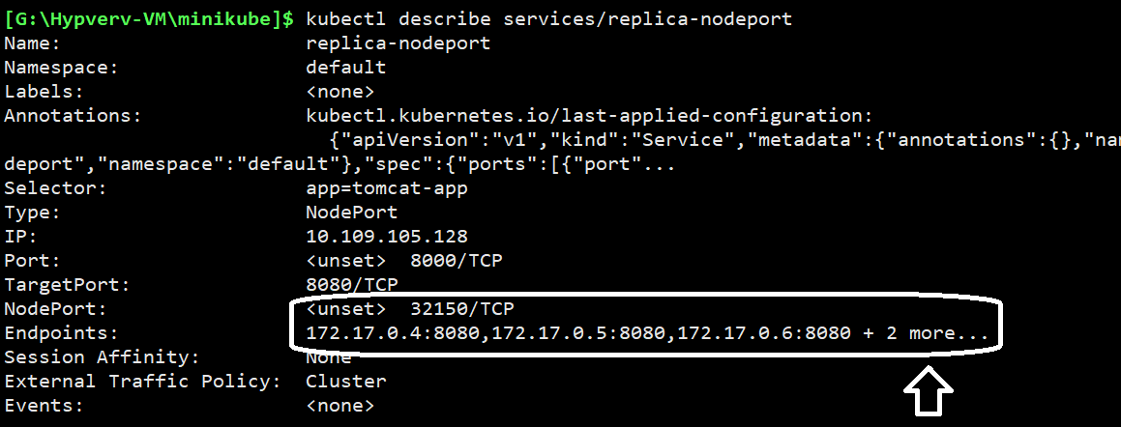

1. **Test – Scale down**

**Change the replicas in the YAML file and save it.**



