**RESUME**

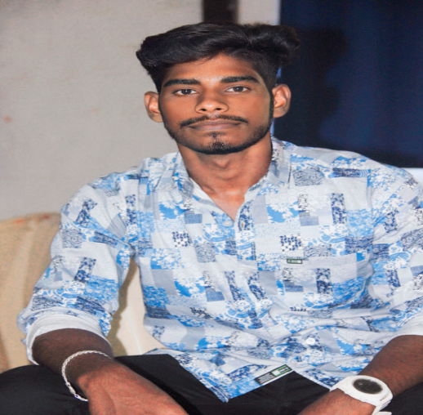

S.VISHWANATH

S/O V.SENTHILKUMAR

Address : 1/66,sowmiyanarayanapuram,

puthukattampur ,Thirupathur

Phone No: 9361338424

Sivagangai District – 630211.

Email ID: [vishwanath936133@gmail.com](mailto:vishwanath936133@gmail.com)

**ACADEMIC PERFORMANCE**

**EDUCATIONAL QUALIFICATION** **PERCENTAGE**

HSLC 91%

SSLC 93.5%

BSC.IT LAST YEAR OF GRADUATE

**SKILLS**

* I know basic computer knowledge
* MS office suite
* C programming language
* Java programming language
* PHP programming language
* Perl programming language
* Mysql
* Sql
* Oracle
* .NET framework programming language

**PERSONAL DETAILS**

NAME : VISHWANATH.S

DATE OF BIRTH : 22/04/2004

GENDER : MALE

AGE : 19

FATHER’S NAME : V.SENTHILKUMAR

MOTHERS’S NAME : S.KAVITHA

RELIGION : HINDU

NATIONALITY : INDIAN

LANGUAGES KNOWNS : TAMIL, ENGLISH

MARTIAL STATUS : UNMARRIED

**DECLARATION**

I hereby declare that the above given details are true to the best of my knowledge.

Yours Faithfully,

S.VISHWANATH