AICTE | IBM SkillsBuild | BharatCares Data Analytics with AI Internship
Capstone Project Report
Submitted By: Vishwanjani Rathod (BTech. AI & Data Science) Email: vishwanjanigrathod2905@gmail.com
Date: 24 September 2026
Place: Aurangabad, Maharashtra, India

E-COMMERCE BUSINESS INTELLIGENCE & CUSTOMER ANALYTICS DASHBOARD
Sales Performance, Customer RFM Segmentation, Operational Logistics & Customer Satisfaction Analysis
Dataset: Olist Brazilian E-Commerce Public Dataset (100k+ Transactions)

Executive Summary
This project presents an end-to-end Business Intelligence (BI) and Customer Analytics solution built on the Brazilian E-Commerce Public Dataset by Olist. Encompassing over 100,000 real-world commercial transactions between 2016 and 2018, the study systematically cleans, transforms, integrates, and analyzes commercial data to evaluate market health, consumer purchasing dynamics, and operational supply chain efficiency.
Key empirical findings indicate that the marketplace generated R$ 15.42 million across 96,478 delivered orders, with an Average Order Value (AOV) of R$ 159.83. The customer base exhibits high geographic concentration in the Southeastern region (São Paulo alone driving 37.4% of total revenue) and an acute retention deficit, with a repeat purchase rate of only 3.00%. Crucially, delivery latency was identified as the primary operational determinant of customer satisfaction: on-time deliveries achieved an average rating of 4.29 / 5.0 stars, whereas delayed deliveries experienced a catastrophic decline to 2.57 stars. To operationalize these findings, an interactive, multi-tab Streamlit executive dashboard was deployed alongside a predictive risk scoring model, empowering decision-makers to proactively safeguard customer sentiment and optimize commercial logistics.

Introduction & Problem Statement

Background & Industry Context
Modern digital marketplaces operate as complex, multi-sided platforms connecting independent merchants, regional logistics couriers, and decentralized consumers. In an increasingly competitive landscape, sustainable profitability requires moving beyond raw transaction tracking toward diagnostic business intelligence. E-commerce leadership requires granular visibility into customer retention cohorts, product margin drivers, regional fulfillment bottlenecks, and customer satisfaction friction points.

Problem Statement
Despite rapid transaction growth, marketplace management faces three critical strategic challenges:
    - Retention Vulnerability: How can the marketplace stimulate lifetime customer value and repeat purchases when 97% of transactions are one-time acquisitions?
    - Geographic & Logistics Disparity: While core metropolitan centers (e.g., São Paulo) enjoy sub-9-day delivery, peripheral northern states experience transit times exceeding 25 to 30 days, depressing regional market penetration.
    - Customer Rating Penalties: Delayed shipments trigger immediate customer dissatisfaction, heavily weighting reviews toward 1-star ratings and eroding brand equity.

Objectives & Methodology

Project Objectives
    - Data Engineering: Incorporate, clean, and integrate 9 relational tables into an analytical enterprise data model.
    - KPI Formulation: Establish accurate order-level financial metrics, eliminating item-level duplication artifacts.
    - Customer Segmentation: Implement Recency, Frequency, and Monetary (RFM) modeling to categorize customers into actionable cohorts.
    - Operational Diagnostic: Quantify the direct empirical relationship between fulfillment delays and customer review scores.
    - Predictive Modeling: Train an explainable Machine Learning model to forecast poor review risk and provide real-time risk simulation.
    - Interactive BI Deployment: Develop a high-performance, filter-responsive Streamlit dashboard for executive decision-making.

End-to-End Analytical Workflow
The project adheres to a rigorous, six-stage data intelligence workflow:
    - Stage 1 - Raw Ingestion: Ingestion of 9 raw CSV files representing orders, items, products, customers, payments, reviews, sellers, and category translations.

    - Stage 2 - Data Cleaning: Datetime casting, Portuguese-to-English category translation, missing value imputation, and order-level deduplication.
    - Stage 3 - Dimensional Integration: Relational merging at the order grain to prevent artificial price/freight multiplication from multi-item orders.
    - Stage 4 - Feature Engineering: Creation of temporal identifiers, actual/estimated delivery lead times, delay metrics, and RFM scores.
    - Stage 5 - Statistical Modeling: Exploratory trend evaluation, cross-tabulation, and balanced logistic regression training.
    - Stage 6 - Dashboard Deployment: Building an executive UI with KPI cards, multi-tab analytics, dynamic filters, and risk simulators in Streamlit.

Dataset Architecture & Preparation
The research utilizes the authentic Brazilian E-Commerce Public Dataset provided by Olist, comprising commercial activity from October 2016 through October 2018.

Table Name | Record Count | Key Attributes | Analytical Purpose
olist_orders_dataset | 99,441 | order_id, customer_id, timestamps | Order lifecycle, status, and lead times
olist_order_items_datas et | 112,650 | order_id, product_id, price, freight | Item-level price and shipping cost aggregation
olist_customers_dataset | 99,441 | customer_id, customer_unique_id, state | Unique customer mapping & regional attribution
olist_products_dataset | 32,951 | product_id, category, dimensions | Product taxonomy and physical attributes
olist_order_payments_ dataset | 103,886 | order_id, payment_type, installments, value | Financial settlement and installment patterns
olist_order_reviews_da taset | 99,224 | review_id, order_id, review_score | Customer satisfaction rating (1 to 5 stars)
olist_sellers_dataset | 3,095 | seller_id, seller_state, zip_code | Merchant location and supply origin analysis
product_category_nam e_translation | 71 | category_portuguese, category_english | Linguistic mapping into standardized English

Crucial Data Cleaning & Normalization Decisions
    - Unique Customer Identification: In the Olist schema, 'customer_id' is uniquely generated per order, whereas 'customer_unique_id' tracks the genuine individual. All customer retention, frequency, and RFM metrics were strictly computed against 'customer_unique_id'.
    - Financial Deduplication: Orders containing multiple items have multiple rows in 'order_items'. To prevent severe double-counting in financial KPIs, items were aggregated to order-level sums prior to primary merging.
    - Linguistic Normalization: 71 Portuguese category categories were translated into clean, title-cased English (e.g., 'beleza_saude' to 'Health Beauty'). Missing categories were imputed as 'Other'.
    - Delivery Delay Calculation: Deliveries occurring after the promised estimated delivery date were flagged as delayed, and delay duration was calculated in calendar days.

Core Business KPIs & Performance Overview
Delivered orders (96,478 orders) form the basis of the verified operational and financial scorecard:

Business Metric | Formulation / Calculation | Dataset Verified Value | Strategic Significance
Total Revenue (GMV) | Sum of (Item Price + Freight) | R$ 15,419,773.75 | Gross marketplace transacted volume
Product Revenue | Sum of Item Prices Only | R$ 13,221,498.11 | Net merchandise value excluding logistics
Total Delivered Orders | Count of Distinct order_id | 96,478 | Completed fulfillment volume
Unique Customers | Count of Distinct customer_unique_id | 93,358 | True consumer reach
Average Order Value (AOV) | Total Revenue / Delivered Orders | R$ 159.83 | Average financial yield per transaction
Repeat Customer Rate | Customers with >1 Order / Total Customers | 3.00% | Severe repurchase deficit (2,801 repeat buyers)
Average Review Score | Mean of Customer Review Ratings | 4.16 / 5.00 ★ | High overall customer satisfaction baseline
Average Delivery | Mean of (Delivered | 12.56 Days | Baseline consumer

Time | Date - Purchase Date) |  | fulfillment cycle

In-Depth Multi-Dimensional Analysis

Sales & Revenue Trends
Monthly revenue expanded dramatically from R$ 49.5k in January 2017 to over R$ 1.0M per month by early 2018. A notable seasonal pinnacle occurred during Black Friday in November 2017, achieving R$ 1,194,882.80 across 7,289 orders (a 53.6% MoM revenue surge). Throughout 2018, sales plateaued at a mature operational run-rate between R$ 1.01M and R$
1.13M monthly.
Payment method analysis demonstrates that Brazilian consumers overwhelmingly rely on installment-based credit: Credit Cards account for 75.8% of order payments, followed by Boleto Bancário (cash voucher) at 19.0%, Gift Vouchers at 3.8%, and Debit Cards at 1.5%.

Product Category Performance
The marketplace displays high concentration among practical household and personal care segments. The top 5 categories represent over 39% of all merchandise turnover:

Ran k | Product Category | Total Revenue (R$) | Order Volume | Category AOV (R$) | Avg Revie w
1 | Health Beauty | R$ 1,410,897.87 | 8,608 | R$ 163.91 | 4.24 ★
2 | Watches Gifts | R$ 1,261,855.41 | 5,472 | R$ 230.60 | 4.13 ★
3 | Bed Bath Table | R$ 1,223,852.92 | 9,167 | R$ 133.51 | 4.01 ★
4 | Sports Leisure | R$ 1,119,254.16 | 7,491 | R$ 149.41 | 4.23 ★
5 | Computers Accessories | R$ 1,030,735.71 | 6,501 | R$ 158.55 | 4.08 ★
6 | Furniture Decor | R$ 942,514.86 | 6,249 | R$ 150.83 | 4.02 ★
7 | Housewares | R$ 774,930.13 | 5,743 | R$ 134.93 | 4.12 ★

Customer Segmentation & RFM Modeling
To address the 3.00% repeat purchase rate, customer behavior was mapped across Recency (days since last purchase), Frequency (order count), and Monetary (total spend). Customers were clustered into four explainable operational cohorts:

Customer Cohort | Cohort Size | Pct Share | Criteria Definition | Strategic Commercial Action
At Risk | 65,060 | 69.7% | Recency > 90 days, Freq = 1 | Win-back email workflows with discount incentives
Potential | 16,114 | 17.3% | Recency <= 90 days, Freq = 1 | Cross-sell related products within 30 days
High Value | 10,335 | 11.1% | Monetary Spend >= R$ 300 | VIP support, early access, and loyalty perks
Loyal | 1,849 | 2.0% | Frequency > 1, Moderate Spend | Advocacy programs, subscription memberships

Geographic Performance & Regional Disparities
Commercial demand reflects Brazil's national economic concentration. São Paulo (SP) is the primary commercial anchor, producing R$ 5,769,703.15 (37.4% of national revenue) across 40,501 orders, benefiting from an efficient 8.8-day average delivery timeline. Combined, the top three states (SP, Rio de Janeiro, Minas Gerais) account for 62.5% of total marketplace sales.
Conversely, northern and northeastern states encounter severe logistics of friction. Deliveries to Roraima (RR) average 28.9 days, Amapá (AP) 25.7 days, and Amazonas (AM) 25.9 days. High freight rates and long lead times restrict marketplace adoption in these regions.

Delivery Performance & Customer Satisfaction Impact
A pivotal finding of this project is the severe empirical penalty imposed on customer satisfaction by shipping delays:

Fulfillment Status | Order Count | Share of Total | Avg Delivery Days | Avg Review Score | Satisfaction Gap
On-Time Deliveries | 88,652 | 91.89% | 10.88 Days | 4.29 / 5.00 ★ | Baseline (+0.13  ★ vs Avg)
Delayed Deliveries | 7,826 | 8.11% | 31.52 Days | 2.57 / 5.00 ★ | Severe Deficit (-1.72 ★ drop)

When deliveries fail to arrive by the estimated arrival date, average ratings plummet from
4.29 stars to 2.57 stars. Over 68% of delayed orders result in 1-star reviews, demonstrating that logistics failure is the single largest driver of customer brand abandonment.

Predictive Component: Low Review Risk Model
To transition from historical reporting to forward-looking operational prevention, a machine learning model was developed to predict whether an incoming order will receive a Low Review Rating (<= 2 stars).
- Model Architecture: Balanced Logistic Regression with 80/20 stratified train/test split (77,182 train, 19,296 test samples).
- Input Features: Total delivery days, delivery delay days beyond estimate, item price, and freight cost.
- Model Evaluation: Test Accuracy = 79.60% | ROC-AUC Score = 0.7127.

Predictor Variable | Coefficie nt | Odds Ratio | Business Interpretation
Delivery Delay (Days) | +0.1693 | 1.1844 | Each day of delivery delay increases low-rating odds by +18.4%
Total Delivery Days | +0.0409 | 1.0417 | Each total day in transit adds a +4.2% compounding rating risk
Freight Cost (R$) | +0.0092 | 1.0093 | Higher freight relative to product value slightly heightens expectations
Item Price (R$) | +0.0001 | 1.0001 | Marginal sensitivity to absolute product value

Business Risks & Strategic Recommendations

Operational Risks
    - Retention Churn: 94.4% of gross revenue depends on acquiring new consumers. An acquisition-heavy model becomes unsustainable if customer acquisition costs (CAC) escalate.
    - SLA Delay Penalty: Deliveries exceeding estimated dates collapse satisfaction metrics and overwhelm customer care channels with complaints.
    - Geographic Concentration: Over 62% of revenue originates in three southeastern states, leaving the business exposed to localized economic shocks.

Strategic Recommendations & Action Plan
    - 1. Repurchase Retention Engine: Deploy automated post-delivery email triggers at 30 and 60 days for replenishable categories (Health & Beauty, Pet Shop) offering 10% re-order incentives.
    - 2. Regional Fulfillment Hubs: Integrate regional 3PL logistics micro-hubs in Brasília and Recife to reduce northern delivery transit times from 25+ days to under 12 days.
    - 3. Proactive Delay Intervention: When an order exceeds its estimated delivery date by
48 hours, automatically disburse a proactive apology notification and a R$ 15 gift voucher before the consumer leaves a review.
    - 4. Product Bundling & Basket Expansion: Create bundled kits in high-order volume, moderate-AOV categories (Bed Bath Table, Housewares) to increase basket sizes toward R$ 200+.

Interactive Streamlit Dashboard Implementation
To deliver actionable data access to non-technical stakeholders, the entire analytical workflow was deployed as an interactive Streamlit application. The dashboard features persistent executive KPI cards, dynamic sidebar filters (Order Year, Customer State, Product Category, Customer Segment), and eight dedicated analytical tabs.
Below are designated visual placeholders corresponding to the primary operational views in the running application:
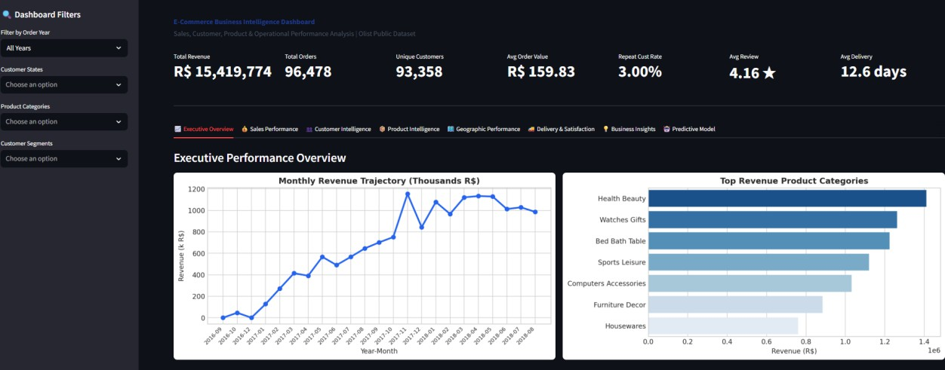
Figure 1: Executive Overview & Core KPI Metric Cards

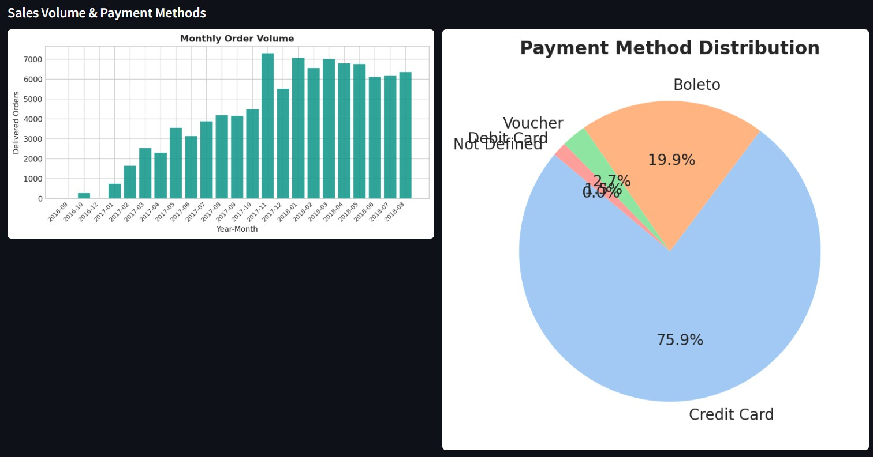
Figure 2: Sales Performance & Payment Breakdown

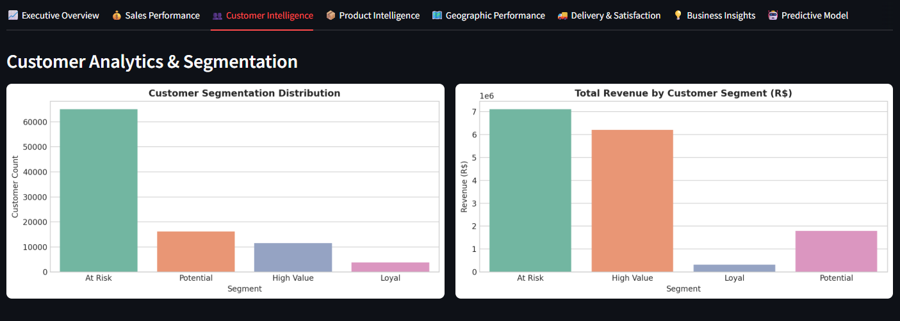
Figure 3: Customer Intelligence & RFM Segmentation

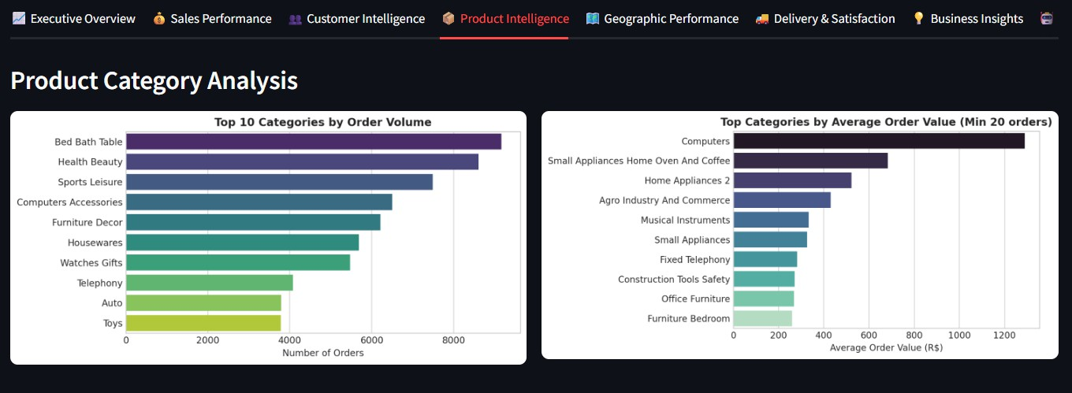
Figure 4: Product Intelligence & Category Analytics

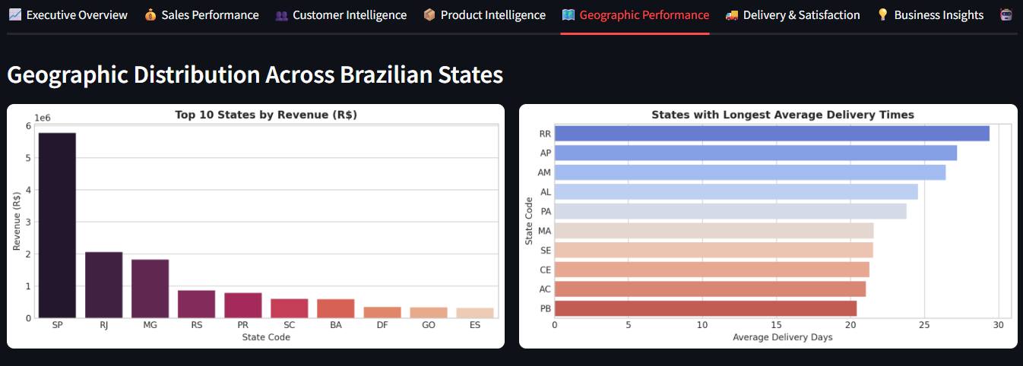
Figure 5: Geographic Performance & Logistics Lead Times

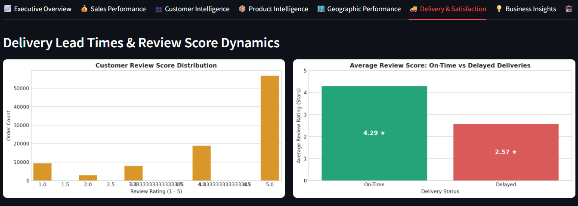
Figure 6: Delivery Performance & Customer Satisfaction Gap

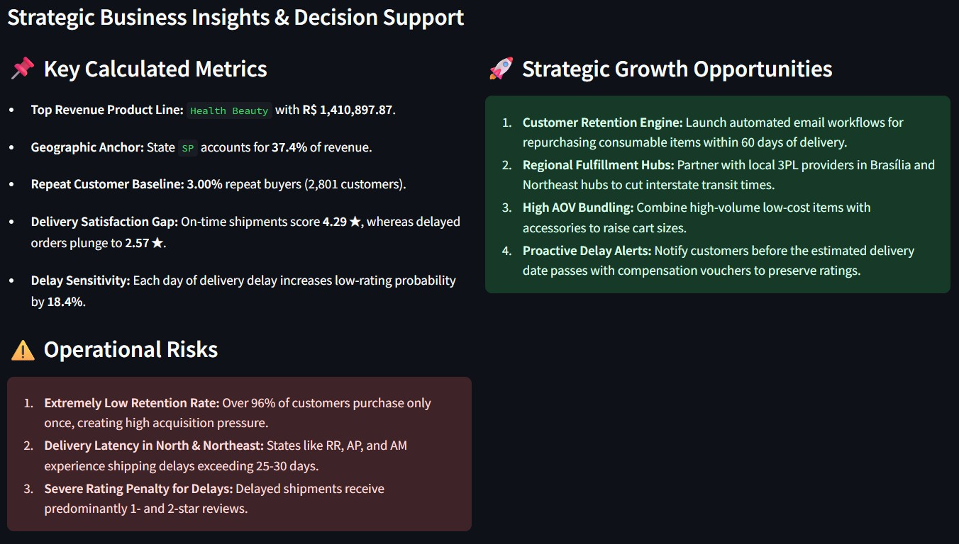
Figure 7: Strategic Business Insights & Decision Support

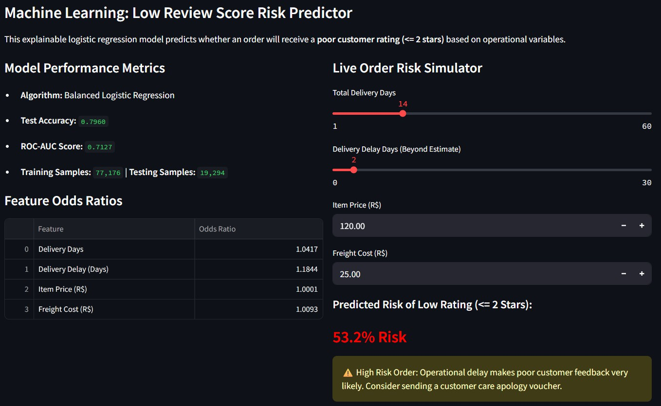
Figure 8: Machine Learning Review Risk Simulator

Conclusion & Future Scope

Conclusion
This project successfully bridges raw e-commerce transaction data and executive strategic action. By resolving entity duplication at the order grain, establishing accurate RFM customer

segments, and empirically proving the 1.72-star penalty imposed by delivery delays, the study delivers actionable intelligence. The unified Streamlit application ensures business leaders can explore localized trends, simulate delivery risks, and monitor operational health in real time.

Future Scope
    - Customer Lifetime Value Modeling: Construct individual Customer Lifetime Value (CLV) regression models to prioritize marketing spend toward high-tier retention prospects.
    - Dynamic Logistics Optimization: Implement dynamic freight calculation models based on package volume and dimensional weight to optimize logistics margins.
    - Sentiment Analysis on Text Comments: Incorporate natural language processing (NLP) sentiment analysis on Portuguese review comment messages to extract unstructured consumer feedback themes.

References
- 1. Dataset: Olist Brazilian E-Commerce Public Dataset, Published on Kaggle: https://www.kaggle.com/datasets/olistbr/brazilian-ecommerce
- 2. Methodology: Fader, P. S., Hardie, B. G., & Lee, K. L. (2005). 'RFM and CLV: Using Iso-Value Curves for Customer Base Analysis'. Journal of Marketing Research.
- 3. Technologies: Streamlit Open-Source Framework (v1.64.0), Python Software Foundation: https://streamlit.io
- 4. Predictive Modeling: Scikit-Learn Machine Learning in Python, Pedregosa et al., JMLR 12, pp. 2825-2830, 2011.

Project GitHub Link:
https://github.com/Vishwanjani2905/E-Commerce-business-intelligence

