**NAME: VISHWANTH P**

**REGNO: 21MIS1117**

CAT – 1 Solution

Question – 1

def generate_temp_data

  temps = {}

  (1..365).each do |day|

    temps[day] = rand(15..35)

  end

  temps

end

def calc_avg_temp(temps)

  total_temp = temps.values.sum

  total_temp.to_f / temps.size

end

def find_temp_extremes(temps)

  hot_day, hot_temp = temps.max_by { |_day, temp| temp }

  cold_day, cold_temp = temps.min_by { |_day, temp| temp }

  { hot_day: hot_day, hot_temp: hot_temp, cold_day: cold_day, cold_temp: cold_temp }

end

def calc_monthly_avg(temps)

  days_in_month = [31, 28, 31, 30, 31, 30, 31, 31, 30, 31, 30, 31]

  monthly_avg = {}

  day = 1

  days_in_month.each_with_index do |days, idx|

    month_temps = temps.slice(day, days).values

    monthly_avg[idx + 1] = month_temps.sum.to_f / days

    day += days

  end

  monthly_avg

end

def find_long_heatwave(temps)

  heatwave = 0

  max_wave = 0

  temps.each_value do |temp|

    if temp > 30

      heatwave += 1

    else

      max_wave = [max_wave, heatwave].max

      heatwave = 0

    end

  end

  max_wave

end

def find_long_cold_spell(temps)

  cold_spell = 0

  max_spell = 0

  temps.each_value do |temp|

    if temp < 20

      cold_spell += 1

    else

      max_spell = [max_spell, cold_spell].max

      cold_spell = 0

    end

  end

  max_spell

end

def find_hot_month(monthly_avg)

  monthly_avg.max_by { |_month, avg_temp| avg_temp }.first

end

temps = generate_temp_data

avg_temp = calc_avg_temp(temps)

extremes = find_temp_extremes(temps)

monthly_avg = calc_monthly_avg(temps)

long_heatwave = find_long_heatwave(temps)

long_cold_spell = find_long_cold_spell(temps)

hot_month = find_hot_month(monthly_avg)

puts "Average Temp: #{avg_temp}"

puts "Hottest Day: #{extremes[:hot_day]} (#{extremes[:hot_temp]}°C)"

puts "Coldest Day: #{extremes[:cold_day]} (#{extremes[:cold_temp]}°C)"

puts "Monthly Averages: #{monthly_avg}"

puts "Longest Heatwave: #{long_heatwave} days"

puts "Longest Cold Spell: #{long_cold_spell} days"

puts "Hottest Month: #{hot_month}"

Output

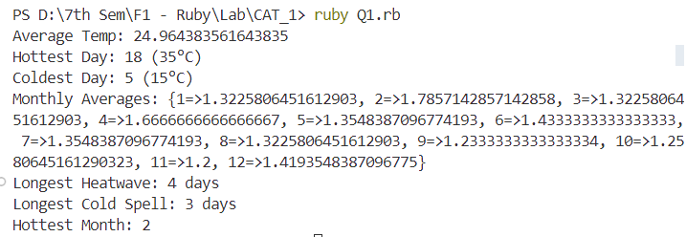

Question – 2

class NumAnalyzer

  def find_heads(nums, n)

    puts "Head numbers: "

    (1...n - 1).each do |i|

      if nums[i] > nums[i - 1] && nums[i] > nums[i + 1]

        puts nums[i]

      end

    end

  end

  def find_max_pair(nums, n)

    max_pair = [nums[0], nums[1]]

    max_sum = nums[0] + nums[1]

    (0...n - 1).each do |i|

      (i + 1...n).each do |j|

        cur_sum = nums[i] + nums[j]

        if cur_sum > max_sum

          max_sum = cur_sum

          max_pair = [nums[i], nums[j]]

        end

      end

    end

    max_pair

  end

end

puts "Enter number of elements: "

n = gets.chomp.to_i

nums = []

puts "Enter elements: "

n.times do

  nums << gets.chomp.to_i

end

analyzer = NumAnalyzer.new

analyzer.find_heads(nums, n)

max_pair = analyzer.find_max_pair(nums, n)

puts "Max Pair: #{max_pair}"

Output

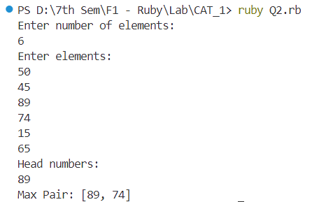

Question – 3

class DynamicDispatcher

  def method_missing(method_name, *args)

    if method_name.to_s.start_with?("calculate")

      operation = method_name.to_s.split("calculate")[1]

      perform_calculation(operation, args)

    else

      super

    end

  end

  def respond_to_missing?(method_name, include_private = false)

    method_name.to_s.start_with?("calculate") || super

  end

  private

  def perform_calculation(operation, args)

    case operation

    when "Factorial"

      puts factorial(args[0])

    when "Square"

      puts square(args[0])

    else

      puts "Unsupported operation: #{operation}"

    end

  end

  def factorial(n)

    return 1 if n == 0

    n * factorial(n - 1)

  end

  def square(n)

    n * n

  end

end

dispatcher = DynamicDispatcher.new

dispatcher.calculateFactorial(5)

dispatcher.calculateSquare(4)

Output

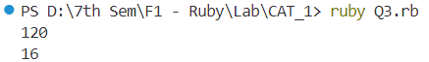

Question – 4

class BracketChecker

  def balanced_parentheses(str)

    pairs = { '(' => ')', '{' => '}', '[' => ']', '<' => '>' }

    stack = []

    str.each_char.with_index do |char, idx|

      if pairs.key?(char)

        stack.push([char, idx])

      elsif pairs.value?(char)

        return "Unbalanced at position: #{idx + 1}" if stack.empty? || pairs[stack.last[0]] != char

        stack.pop

      end

    end

    stack.empty? ? true : "Unbalanced at position: #{stack.last[1] + 1}"

  end

  def evaluate_expression(str)

    return balanced_parentheses(str) unless balanced_parentheses(str) == true

    exprs = str.scan(/\([^)]+\)/)

    exprs.each do |expr|

      result = eval(expr[1..-2])

      str.sub!(expr, result.to_s)

    end

    str

  end

end

checker = BracketChecker.new

puts checker.balanced_parentheses("(11)")

puts checker.balanced_parentheses("|(|)])")

puts checker.balanced_parentheses("<(1+2) (3+4)>")

puts checker.evaluate_expression("(1+2) (3+4)")

Output

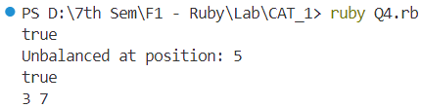

Question – 5

require 'fileutils'

class WordCounter

  def initialize(filename)

    @filename = filename

    @word_counts = {}

  end

  def analyze_word_usage

    read_file

    count_words

    output_results

  end

  private

  def read_file

    File.open(@filename, 'r') do |file|

      @text = file.read

    end

  end

  def count_words

    words = @text.downcase.gsub(/[^a-z\s]/, '').split

    words.each do |word|

      @word_counts[word] ||= 0

      @word_counts[word] += 1

    end

  end

  def output_results

    sorted_words = @word_counts.sort_by { |_word, count| -count }

    puts "Top 10 Most Frequent Words:"

    sorted_words[0..9].each do |word, count|

      puts "#{word}: #{count}"

    end

  end

end

# Example usage

filename = 'sample.txt'

word_counter = WordCounter.new(filename)

word_counter.analyze_word_usage

sample.txt

Mahendra Singh Dhoni (born 7 July 1981) is an Indian professional cricketer who plays as a right-handed batter and a wicket-keeper. Widely regarded as one of the most prolific wicket-keeper batsmen and captains, he represented the Indian cricket team and was the captain of the side in limited overs formats from 2007 to 2017 and in test cricket from 2008 to 2014.

Output

