**RUBY LAB -3**

**Name: Vishwanth P**

**Register No: 21MIS1117**

**Assessment 3**

1. **Write a ruby code using the following keywords yield, lambda and procs.**

def greet

  puts "Hi!"

  yield if block_given?

  puts "Bye!"

end

greet { puts "Hello, Vishwanth!" }

say_hello = ->(name) { puts "Hi, #{name}!" }

say_hello.call("Vishwanth")

multiply = ->(a, b) { a * b }

puts multiply.call(2, 3)

def example(proc_obj, lambda_obj)

  puts proc_obj.call(1, 2)

  lambda_obj.call("Vishwanth")

  yield if block_given?

end

my_proc = ->(x, y) { x + y }

my_lambda = ->(name) { puts "Goodbye, #{name}!" }

example(my_proc, my_lambda) { puts "This is a block!" }

**Output**

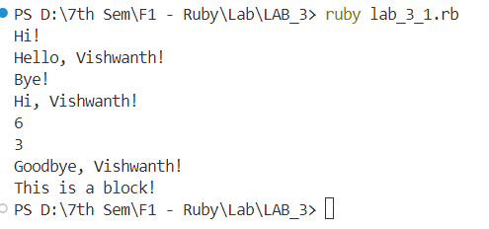

1. **Write a ruby programming using Modules concept.**

module Vehicle

  def speed

    raise "Speed method not implemented"

  end

  def fuel

    raise "Fuel method not implemented"

  end

  def display_info

    puts "Speed: #{speed} km/h"

    puts "Fuel: #{fuel} liters"

  end

end

class Car

  include Vehicle

  def initialize(speed, fuel)

    @speed = speed

    @fuel = fuel

  end

  def speed

    @speed

  end

  def fuel

    @fuel

  end

end

class Bike

  include Vehicle

  def initialize(speed, fuel)

    @speed = speed

    @fuel = fuel

  end

  def speed

    @speed

  end

  def fuel

    @fuel

  end

end

car = Car.new(120, 50)

puts "Car:"

car.display_info

bike = Bike.new(80, 10)

puts "\nBike:"

bike.display_info

**Output**

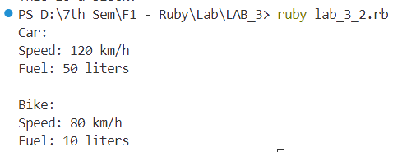

1. **Write a ruby programming using Mixins concept**

module Readable

  def read

    puts "#{title} is being read."

  end

end

module Borrowable

  def borrow

    puts "#{title} has been borrowed."

  end

end

class Book

  include Readable

  include Borrowable

  attr_accessor :title

  def initialize(title)

    @title = title

  end

end

class Magazine

  include Readable

  include Borrowable

  attr_accessor :title

  def initialize(title)

    @title = title

  end

end

book = Book.new("The Great Gatsby")

magazine = Magazine.new("National Geographic")

book.read

book.borrow

magazine.read

magazine.borrow

**Output**

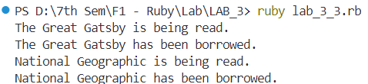

1. **Write a ruby programming using Reflection concept.**

class Person

    attr_accessor :name, :age

    def initialize(name, age)

      @name = name

      @age = age

    end

    def greet

      puts "Hello, my name is #{@name} and I am #{@age} years old."

    end

  end

  person = Person.new("Vishwanth", 18)

  puts "Calling greet method:"

  person.send(:greet)

  puts "\nModifying using reflection:"

  person.instance_variable_set(:@age, 20)

  puts "Updated age: #{person.instance_variable_get(:@age)}"

**Output**

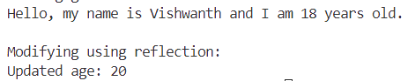

1. **Write a ruby programming using Meta-programming concept.**

class DynamicMethods

  def self.create_method(name, &block)

    define_method(name, &block)

  end

end

class Vehicle < DynamicMethods

end

vehicle = Vehicle.new

Vehicle.create_method(:drive) do

  puts "The vehicle is driving."

end

Vehicle.create_method(:fuel_up) do |amount|

  puts "Fueled up with #{amount} liters."

end

vehicle.drive

vehicle.fuel_up(20)

**Output**

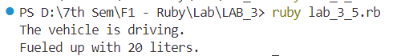

1. **Create an array a=[1,2,3,4,5,6], and perform the following:**
   1. **Different ways to access the array elements**
   2. **Five different methods associated with array.**
   3. **Different ways to add and delete an element of an array.**
   4. **Introduce two new arrays and perform intersection, concatenation, difference.**
   5. **Perform a binary search using array a.**

def get_numbers_from_user

  puts "Enter numbers separated by spaces:"

  gets.chomp.split.map(&:to_i)

end

numbers = get_numbers_from_user

puts "You entered: #{numbers}"

puts "\nArray basics:"

puts "First element: #{numbers[0]}"

puts "Last element: #{numbers[-1]}"

puts "Slice (2..4): #{numbers[2..4]}"

puts "First two elements: #{numbers.first(2)}"

puts "Last element removed: #{numbers.pop}"

puts "\nArray methods:"

puts "Length: #{numbers.length}"

puts "Reversed: #{numbers.reverse}"

puts "Sorted: #{numbers.sort}"

puts "Adding 5: #{numbers.push(5)}"

puts "\nAdding and removing elements:"

numbers.push(6)

numbers.insert(1, 7)

puts "After additions: #{numbers}"

numbers.delete(5)

puts "After deletion: #{numbers}"

new_array = [10, 20, 30]

puts "\nArray operations with new array:"

puts "Concatenated: #{numbers + new_array}"

puts "Difference: #{numbers - new_array}"

def linear_search(array, target)

  array.index(target) || "Not found"

end

target = 6

index = linear_search(numbers, target)

puts "\nLinear search for #{target}:"

puts "Element #{target} found at index #{index}." if index.is_a?(Integer)

**Output**

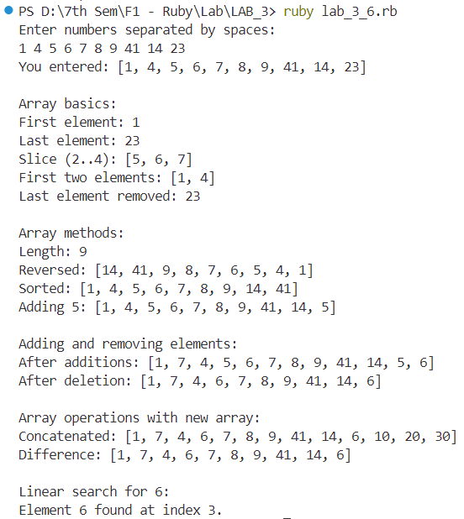

**Assessment 3.1**

1. Scenario: Managing a Library Catalog Question: You are building a library catalog system in Ruby. Each book has multiple attributes such as title, author, genre, and publication year. Design a hash structure to store information about multiple books and implement a method to search for books published after a specific year.

class LibraryManagement

  def initialize

    @books = []

  end

  def add_book

    print "Title: "

    title = gets.chomp

    print "Author: "

    author = gets.chomp

    print "Genre: "

    genre = gets.chomp

    print "Publication Year: "

    pub_yr = gets.chomp

    @books << { title: title, author: author, genre: genre, pub_yr: pub_yr }

    puts "Book Added"

  end

  def display_books

    if @books.empty?

      puts "No books available."

    else

      @books.each_with_index do |book, index|

        puts "Book #{index + 1}: #{book[:title]} by #{book[:author]}, Genre: #{book[:genre]}, Year: #{book[:pub_yr]}"

      end

    end

  end

  def search_book

    print "Publication Year: "

    year = gets.chomp

    result = @books.select { |book| book[:pub_yr] == year }

    if result.empty?

      puts "No books from #{year}."

    else

      result.each_with_index do |book, index|

        puts "Book #{index + 1}: #{book[:title]} by #{book[:author]}, Genre: #{book[:genre]}, Year: #{book[:pub_yr]}"

      end

    end

  end

end

library = LibraryManagement.new

loop do

  puts "\nMenu:"

  puts "1. Add Book"

  puts "2. Display Books"

  puts "3. Search Books"

  puts "4. Exit"

  print "Choice: "

  choice = gets.chomp.to_i

  case choice

  when 1 then library.add_book

  when 2 then library.display_books

  when 3 then library.search_book

  when 4 then break

  else puts "Invalid choice."

  end

end

**Output**

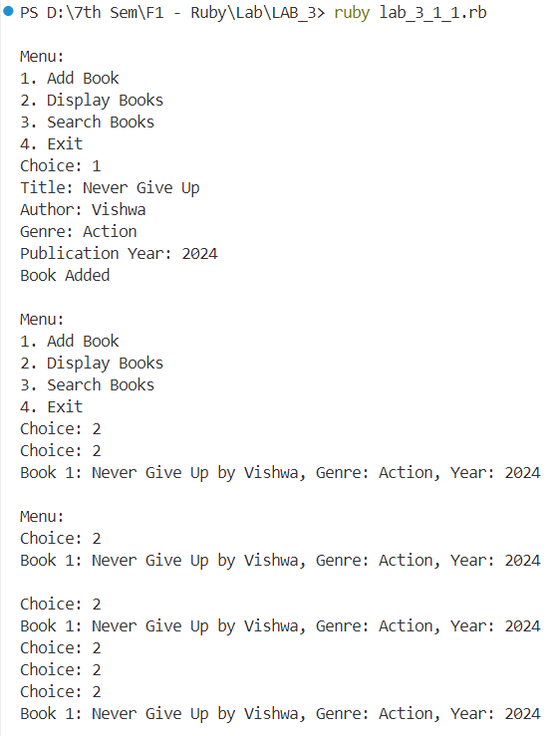

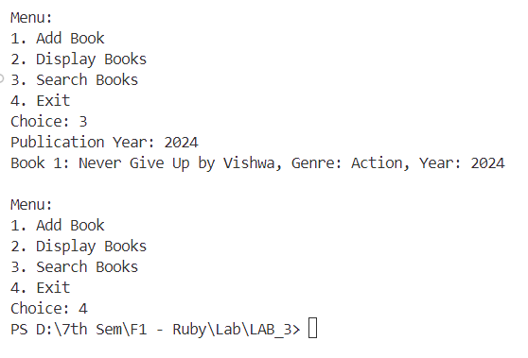

1. Scenario: Employee Database Question: You are developing an employee management system. Design a hash structure to store information about employees, including their names, departments, and salaries. Implement a method to find the highest-paid employee and display their details.

class EmployeeManagement

  def initialize

    @employees = []

  end

  def add_emp

    print "Name: "

    name = gets.chomp

    print "Department: "

    dept = gets.chomp

    print "Salary: "

    sal = gets.chomp.to_i

    @employees << { name: name, dept: dept, sal: sal }

    puts "Employee Added"

  end

  def display_emp

    if @employees.empty?

      puts "No employees found."

    else

      @employees.each_with_index do |emp, index|

        puts "\nEmployee #{index + 1}: #{emp[:name]}, #{emp[:dept]}, Salary: #{emp[:sal]}"

      end

    end

  end

  def high_paid

    highest = @employees.max_by { |emp| emp[:sal] }

    if highest

      puts "Highest Paid Employee: #{highest[:name]}, #{highest[:dept]}, Salary: #{highest[:sal]}"

    else

      puts "No records found."

    end

  end

end

employee_mgmt = EmployeeManagement.new

loop do

  puts "\n1. Add Employee"

  puts "2. Display Employees"

  puts "3. Find Highest Paid Employee"

  puts "4. Exit"

  print "Choice: "

  choice = gets.chomp.to_i

  case choice

  when 1 then employee_mgmt.add_emp

  when 2 then employee_mgmt.display_emp

  when 3 then employee_mgmt.high_paid

  when 4 then break

  else puts "Invalid choice."

  end

end

**Output**

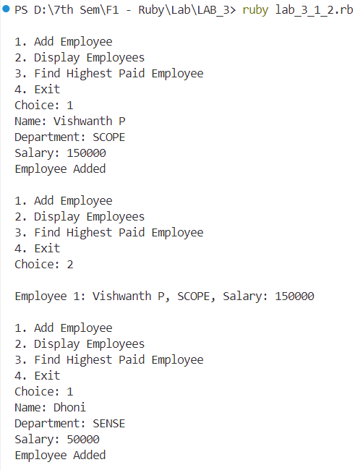

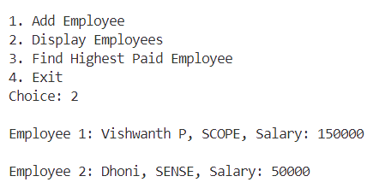

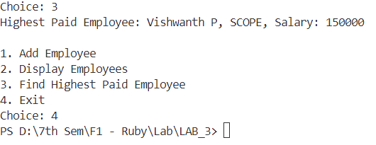

1. Scenario: Online Marketplace Question: You are creating an online marketplace where sellers can list their products. Design a hash structure to store information about products, including their names, prices, and quantities. Implement a method to calculate the total value of all products in the marketplace.

class MarketPlace

  def initialize

    @products = []

  end

  def add_product

    print "Name: "

    name = gets.chomp

    print "Price: "

    price = gets.chomp.to_i

    print "Quantity: "

    qty = gets.chomp.to_i

    @products << { name: name, price: price, qty: qty }

    puts "Product Added"

  end

  def display_product

    if @products.empty?

      puts "No products available."

    else

      @products.each_with_index do |prd, index|

        puts "\nProduct #{index + 1}: #{prd[:name]}, Price: #{prd[:price]}, Quantity: #{prd[:qty]}"

      end

    end

  end

  def tot_value

    @products.each_with_index do |prd, index|

      puts "Total Value of Product #{index + 1} (#{prd[:name]}): Rs.#{prd[:price] * prd[:qty]}"

    end

  end

end

marketplace = MarketPlace.new

loop do

  puts "\n1. Add Product"

  puts "2. Display Products"

  puts "3. Product Values"

  puts "4. Exit"

  print "Choice: "

  choice = gets.chomp.to_i

  case choice

  when 1 then marketplace.add_product

  when 2 then marketplace.display_product

  when 3 then marketplace.tot_value

  when 4 then break

  else puts "Invalid choice."

  end

end

**Output**

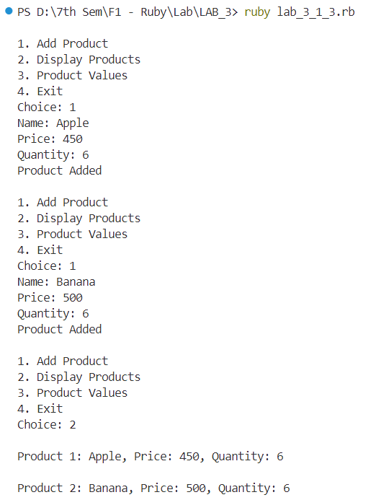

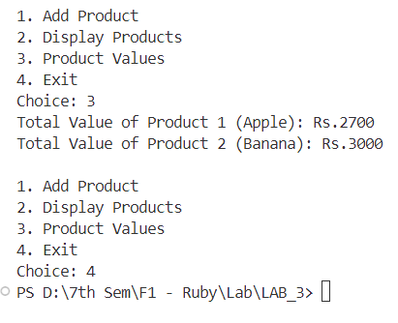

1. Scenario: Student Grades Question: You are building a system to manage student grades. Design a hash structure to store information about multiple students, including their names and an array of grades for different subjects. Implement a method to calculate the average grade for each student and display the results.

class GradeManagement

  def initialize

    @students = {}

  end

  def add_student

    print "Student Name: "

    name = gets.chomp

    subjects = []

    grades = []

    print "Number of Subjects: "

    num_subjects = gets.chomp.to_i

    num_subjects.times do |i|

      print "Subject ##{i + 1}: "

      subjects << gets.chomp

      print "Grade: "

      grades << gets.chomp.to_i

    end

    @students[name] = { subjects: subjects, grades: grades }

    puts "Student Added"

  end

  def calculate_averages

    if @students.empty?

      puts "No records found."

    else

      @students.each do |name, details|

        avg = details[:grades].sum.to_f / details[:grades].size

        puts "#{name}'s Average: #{avg.round(2)}"

      end

    end

  end

end

grade_management = GradeManagement.new

loop do

  puts "\n1. Add Student"

  puts "2. Calculate Averages"

  puts "3. Exit"

  print "Choice: "

  choice = gets.chomp.to_i

  case choice

  when 1 then grade_management.add_student

  when 2 then grade_management.calculate_averages

  when 3 then break

  else puts "Invalid choice."

  end

end

**Output**

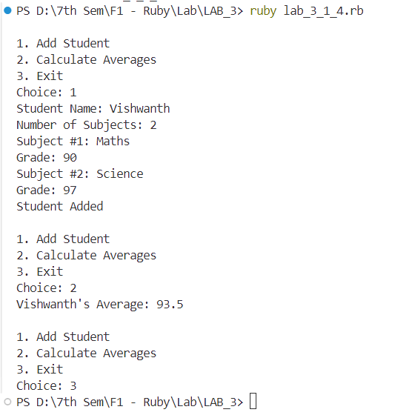

1. Scenario: Music Playlist Question: You are developing a music playlist application. Design a hash structure to store information about songs, including their titles, artists, and genres. Implement a method to shuffle the playlist randomly and play the songs in a random order.

class PlaylistManagement

  def initialize

    @playlist = []

    @shuffled_playlist = []

  end

  def add_song

    print "Title: "

    title = gets.chomp

    print "Artist: "

    artist = gets.chomp

    print "Genre: "

    genre = gets.chomp

    @playlist << { title: title, artist: artist, genre: genre }

    @shuffled_playlist.clear

    puts "Song added."

  end

  def shuffle_and_play

    if @playlist.empty?

      puts "The playlist is empty."

    else

      @shuffled_playlist = @playlist.shuffle if @shuffled_playlist.empty?

      song = @shuffled_playlist.shift

      puts "Playing: #{song[:title]} by #{song[:artist]} (Genre: #{song[:genre]})"

    end

  end

end

playlist_manager = PlaylistManagement.new

loop do

  puts "\n1. Add Song"

  puts "2. Shuffle and Play"

  puts "3. Exit"

  print "Choice: "

  choice = gets.chomp.to_i

  case choice

  when 1 then playlist_manager.add_song

  when 2 then playlist_manager.shuffle_and_play

  when 3 then break

  else puts "Invalid choice."

  end

end

**Output**

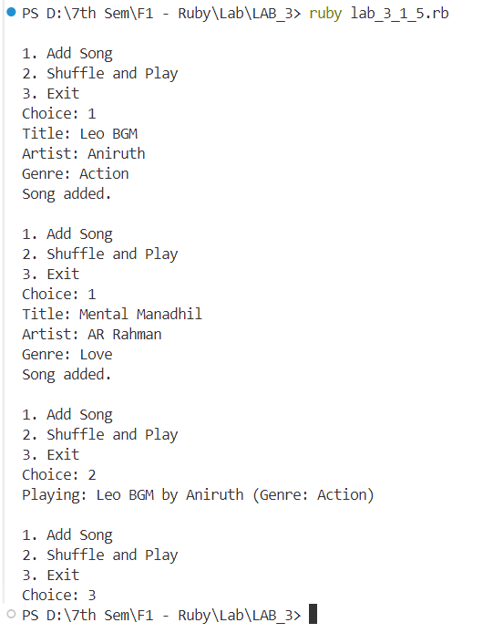

**3.2 CAT – 1 Solution**

**Question – 1**

def generate_temp_data

  temps = {}

  (1..365).each do |day|

    temps[day] = rand(15..35)

  end

  temps

end

def calc_avg_temp(temps)

  total_temp = temps.values.sum

  total_temp.to_f / temps.size

end

def find_temp_extremes(temps)

  hot_day, hot_temp = temps.max_by { |_day, temp| temp }

  cold_day, cold_temp = temps.min_by { |_day, temp| temp }

  { hot_day: hot_day, hot_temp: hot_temp, cold_day: cold_day, cold_temp: cold_temp }

end

def calc_monthly_avg(temps)

  days_in_month = [31, 28, 31, 30, 31, 30, 31, 31, 30, 31, 30, 31]

  monthly_avg = {}

  day = 1

  days_in_month.each_with_index do |days, idx|

    month_temps = temps.slice(day, days).values

    monthly_avg[idx + 1] = month_temps.sum.to_f / days

    day += days

  end

  monthly_avg

end

def find_long_heatwave(temps)

  heatwave = 0

  max_wave = 0

  temps.each_value do |temp|

    if temp > 30

      heatwave += 1

    else

      max_wave = [max_wave, heatwave].max

      heatwave = 0

    end

  end

  max_wave

end

def find_long_cold_spell(temps)

  cold_spell = 0

  max_spell = 0

  temps.each_value do |temp|

    if temp < 20

      cold_spell += 1

    else

      max_spell = [max_spell, cold_spell].max

      cold_spell = 0

    end

  end

  max_spell

end

def find_hot_month(monthly_avg)

  monthly_avg.max_by { |_month, avg_temp| avg_temp }.first

end

temps = generate_temp_data

avg_temp = calc_avg_temp(temps)

extremes = find_temp_extremes(temps)

monthly_avg = calc_monthly_avg(temps)

long_heatwave = find_long_heatwave(temps)

long_cold_spell = find_long_cold_spell(temps)

hot_month = find_hot_month(monthly_avg)

puts "Average Temp: #{avg_temp}"

puts "Hottest Day: #{extremes[:hot_day]} (#{extremes[:hot_temp]}°C)"

puts "Coldest Day: #{extremes[:cold_day]} (#{extremes[:cold_temp]}°C)"

puts "Monthly Averages: #{monthly_avg}"

puts "Longest Heatwave: #{long_heatwave} days"

puts "Longest Cold Spell: #{long_cold_spell} days"

puts "Hottest Month: #{hot_month}"

Output

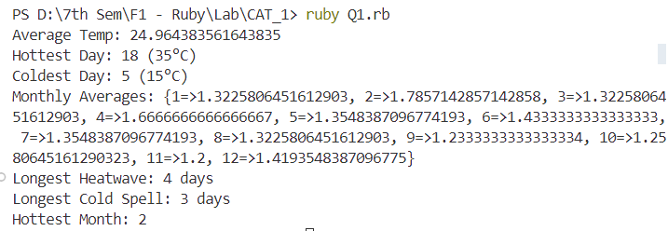

**Question – 2**

class NumAnalyzer

  def find_heads(nums, n)

    puts "Head numbers: "

    (1...n - 1).each do |i|

      if nums[i] > nums[i - 1] && nums[i] > nums[i + 1]

        puts nums[i]

      end

    end

  end

  def find_max_pair(nums, n)

    max_pair = [nums[0], nums[1]]

    max_sum = nums[0] + nums[1]

    (0...n - 1).each do |i|

      (i + 1...n).each do |j|

        cur_sum = nums[i] + nums[j]

        if cur_sum > max_sum

          max_sum = cur_sum

          max_pair = [nums[i], nums[j]]

        end

      end

    end

    max_pair

  end

end

puts "Enter number of elements: "

n = gets.chomp.to_i

nums = []

puts "Enter elements: "

n.times do

  nums << gets.chomp.to_i

end

analyzer = NumAnalyzer.new

analyzer.find_heads(nums, n)

max_pair = analyzer.find_max_pair(nums, n)

puts "Max Pair: #{max_pair}"

Output

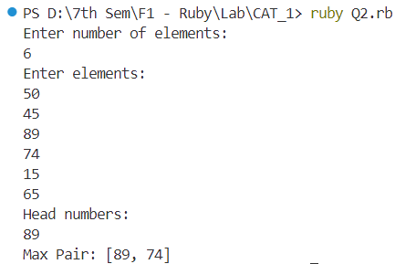

**Question – 3**

class DynamicDispatcher

  def method_missing(method_name, *args)

    if method_name.to_s.start_with?("calculate")

      operation = method_name.to_s.split("calculate")[1]

      perform_calculation(operation, args)

    else

      super

    end

  end

  def respond_to_missing?(method_name, include_private = false)

    method_name.to_s.start_with?("calculate") || super

  end

  private

  def perform_calculation(operation, args)

    case operation

    when "Factorial"

      puts factorial(args[0])

    when "Square"

      puts square(args[0])

    else

      puts "Unsupported operation: #{operation}"

    end

  end

  def factorial(n)

    return 1 if n == 0

    n * factorial(n - 1)

  end

  def square(n)

    n * n

  end

end

dispatcher = DynamicDispatcher.new

dispatcher.calculateFactorial(5)

dispatcher.calculateSquare(4)

Output

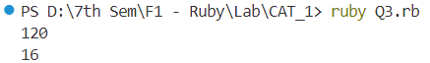

**Question – 4**

class BracketChecker

  def balanced_parentheses(str)

    pairs = { '(' => ')', '{' => '}', '[' => ']', '<' => '>' }

    stack = []

    str.each_char.with_index do |char, idx|

      if pairs.key?(char)

        stack.push([char, idx])

      elsif pairs.value?(char)

        return "Unbalanced at position: #{idx + 1}" if stack.empty? || pairs[stack.last[0]] != char

        stack.pop

      end

    end

    stack.empty? ? true : "Unbalanced at position: #{stack.last[1] + 1}"

  end

  def evaluate_expression(str)

    return balanced_parentheses(str) unless balanced_parentheses(str) == true

    exprs = str.scan(/\([^)]+\)/)

    exprs.each do |expr|

      result = eval(expr[1..-2])

      str.sub!(expr, result.to_s)

    end

    str

  end

end

checker = BracketChecker.new

puts checker.balanced_parentheses("(11)")

puts checker.balanced_parentheses("|(|)])")

puts checker.balanced_parentheses("<(1+2) (3+4)>")

puts checker.evaluate_expression("(1+2) (3+4)")

Output

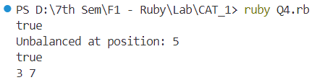

**Question – 5**

require 'fileutils'

class WordCounter

  def initialize(filename)

    @filename = filename

    @word_counts = {}

  end

  def analyze_word_usage

    read_file

    count_words

    output_results

  end

  private

  def read_file

    File.open(@filename, 'r') do |file|

      @text = file.read

    end

  end

  def count_words

    words = @text.downcase.gsub(/[^a-z\s]/, '').split

    words.each do |word|

      @word_counts[word] ||= 0

      @word_counts[word] += 1

    end

  end

  def output_results

    sorted_words = @word_counts.sort_by { |_word, count| -count }

    puts "Top 10 Most Frequent Words:"

    sorted_words[0..9].each do |word, count|

      puts "#{word}: #{count}"

    end

  end

end

filename = 'sample.txt'

word_counter = WordCounter.new(filename)

word_counter.analyze_word_usage

sample.txt

Mahendra Singh Dhoni (born 7 July 1981) is an Indian professional cricketer who plays as a right-handed batter and a wicket-keeper. Widely regarded as one of the most prolific wicket-keeper batsmen and captains, he represented the Indian cricket team and was the captain of the side in limited overs formats from 2007 to 2017 and in test cricket from 2008 to 2014.

Output

