**RUBY LAB -4**

**Name: Vishwanth P**

**Register No: 21MIS1117**

**Assessment 4**

1. **Create a directory in Ruby**

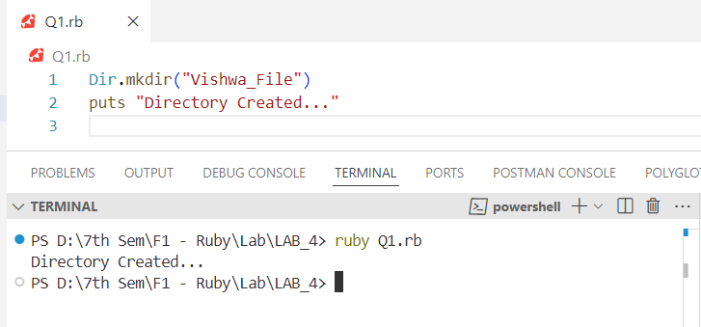

1. **Check if a directory exists in Ruby**

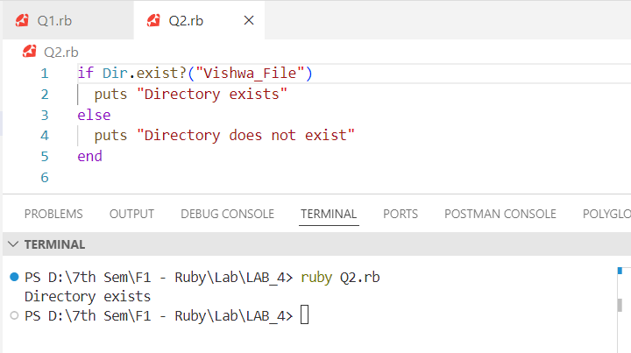

1. **List files in a directory using Ruby**

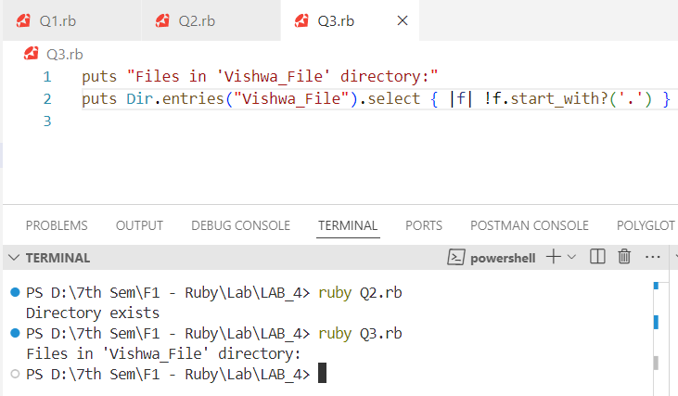

**4. Create a file in Ruby**

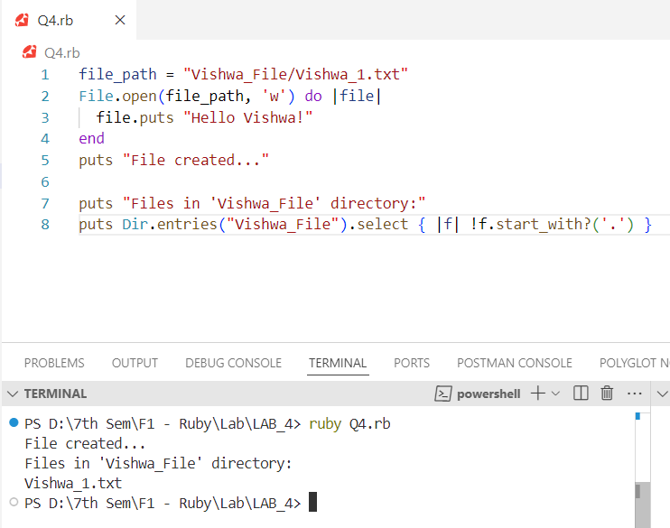

1. **Write to a file in Ruby and use various methods like seek ( ), lineno( ), eof( ), size( )**

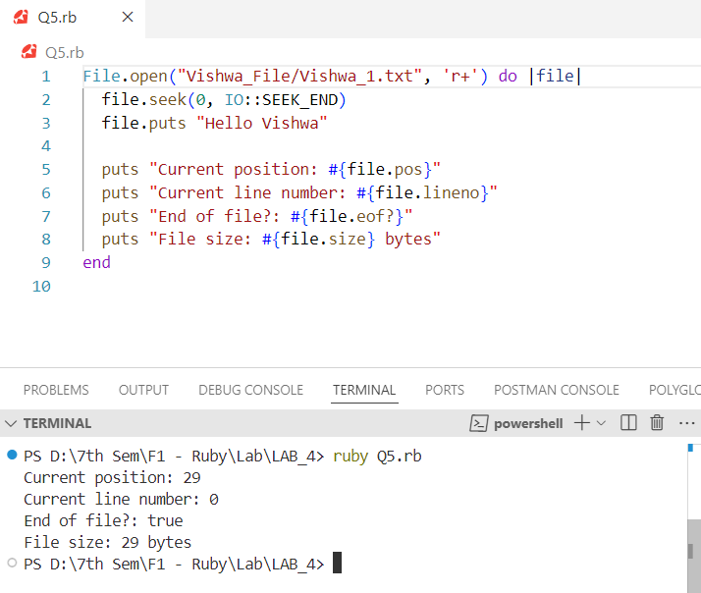

**Vishwa_1.txt**

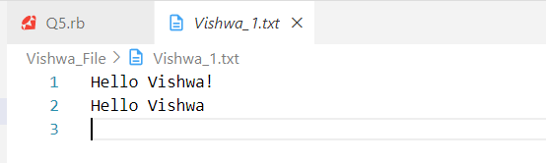

**6. Read from a file in Ruby**

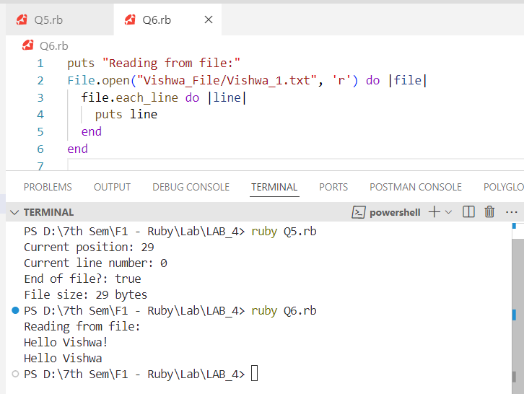

**7. Delete a file in Ruby**

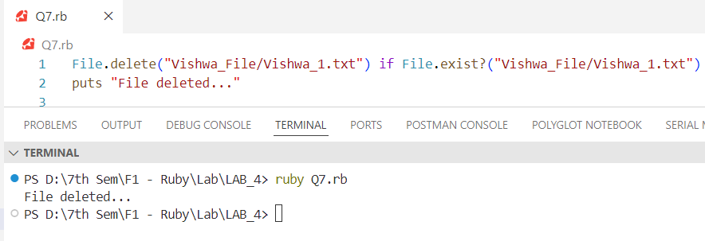

**8. Rename a file in Ruby**

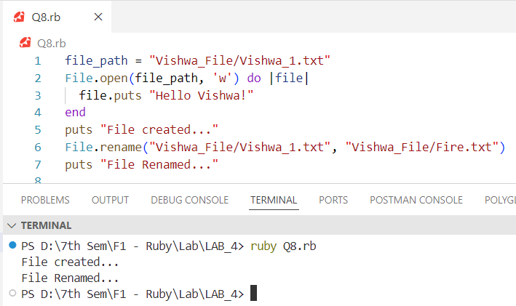

**9. Read a CSV and print specific rows and columns**

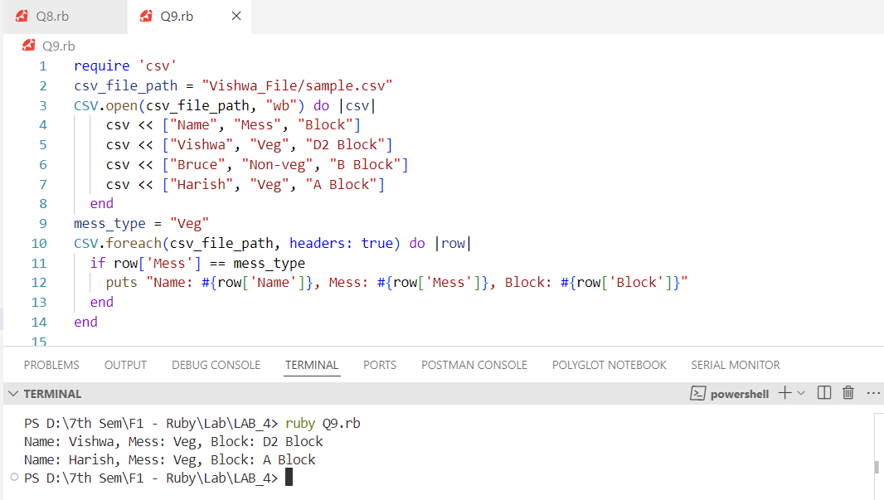

**10. File Splitting and Joining: Imagine you have a large file, such as a video or a database backup, that you need to transfer or store on multiple devices. However, transferring or storing the entire file at once may not be feasible due to limitations in file size or storage capacity. In this scenario, you can use a program that splits the large file into smaller parts and joins them back together when needed. How can you implement such a program using Ruby?**

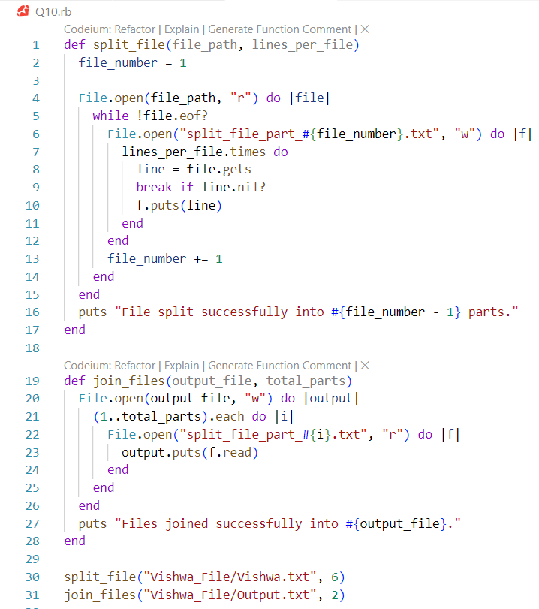

**Vishwa.txt**

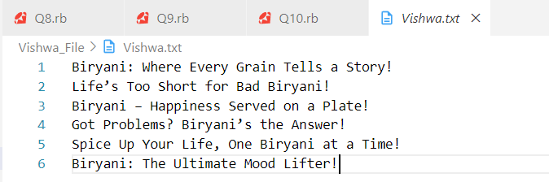

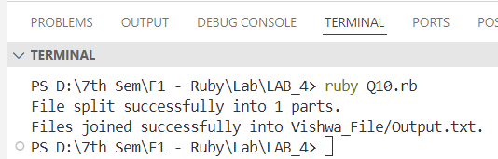

**Output.txt**

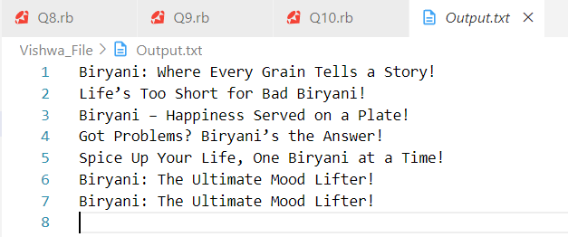

**11. File Backup and Restore: Imagine you have important files or directories on your computer that you want to protect against data loss due to hardware failure, malware, or accidental deletion. In this scenario, you can use a program that creates a backup of the files or directories and restores them later if needed. How can you implement such a program using Ruby?**

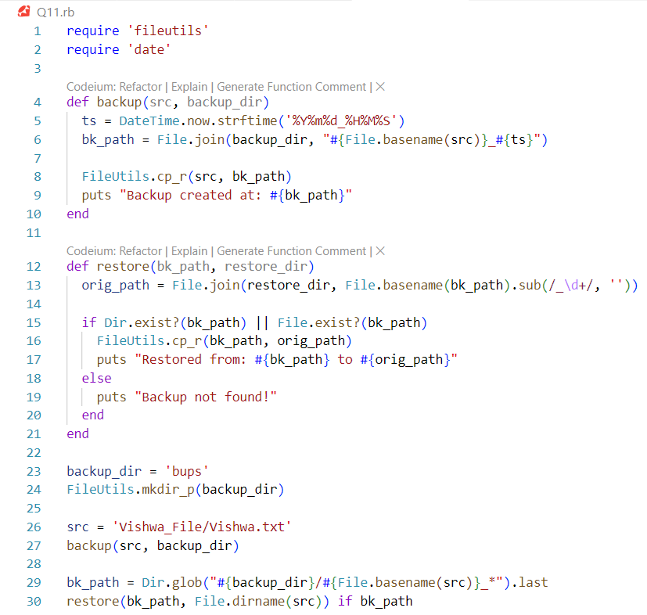

**Backup File (Vishwa.txt_20240930_200043)**

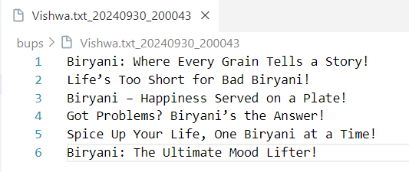

**Restored File (Vishwa.txt_200043)**

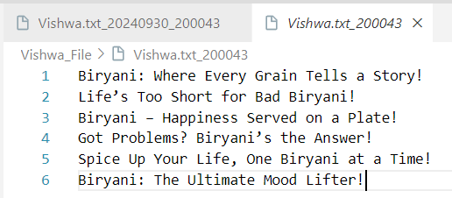

**12. File Renaming and Copying: Imagine you have a file that you want to rename or copy to a different location, optionally with a new name. In this scenario, you can use a program that allows you to perform these operations easily and efficiently. How can you implement such a program using Ruby?**

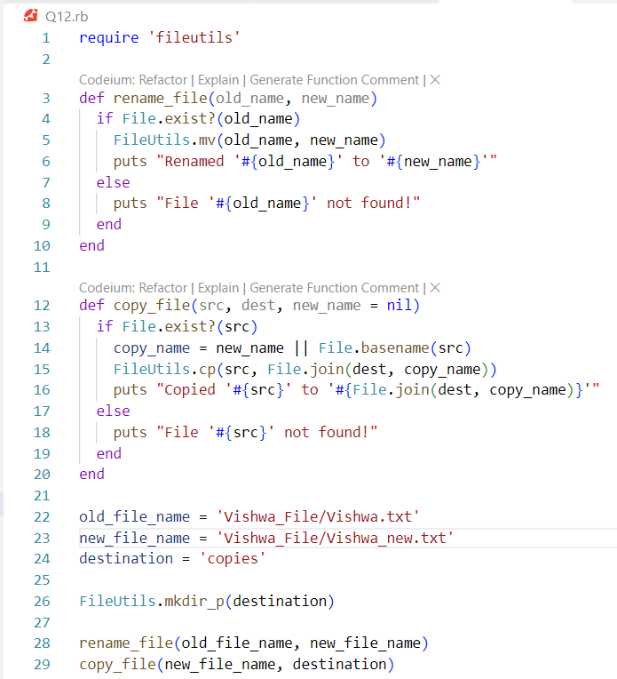

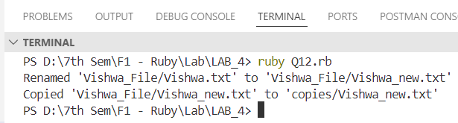

**13. File Searching and Filtering: Imagine you have a large collection of files on your computer and you want to find specific files based on their name, extension, size, or other criteria. In this scenario, you can use a program that searches for files matching a pattern or filters files based on certain criteria. How can you implement such a program using Ruby?**

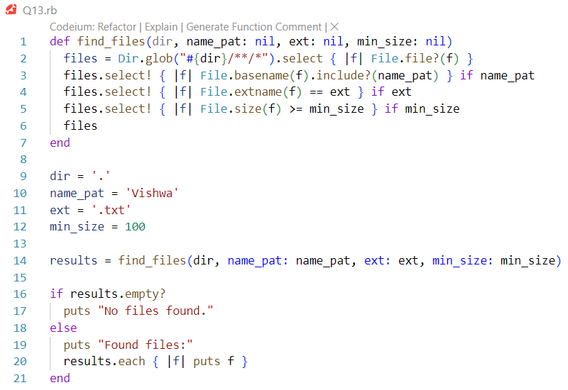

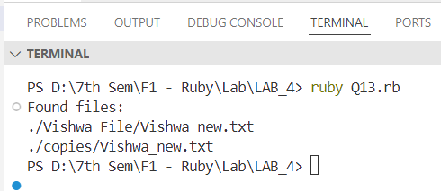

**14. File Sorting and Merging: Imagine you have multiple files that contain data that needs to be combined into a single file, such as log files from different servers or reports from multiple departments. In this scenario, you can use a program that sorts the files based on certain criteria and merges them into a single file. How can you implement such a program using Ruby?**

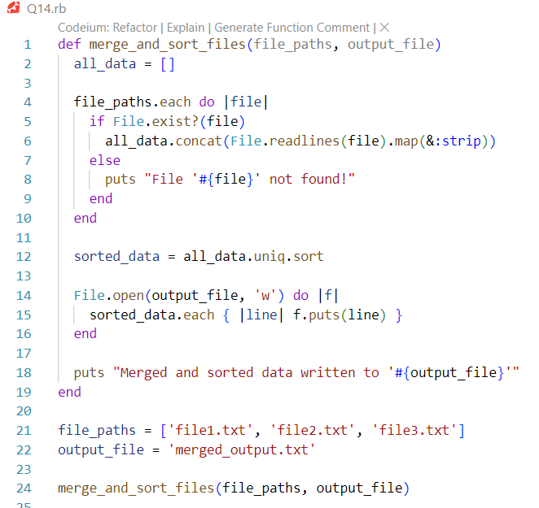

**Output**

