

**SWE2034 – Ruby Programming**

Guided By – **Dr Yogesh C**

Slot – **L5+L6**

NAME: **VISHWANTH P**

REGISTER.NO: **21MIS1117**

**Lab Assessment - 5**

1. **Write a separate program using the following functions:**

**Fiber – yield and resume**

**Fiber – transfer**

**Fiber – raise**

Code

fiber1 = Fiber.new do

  puts "Fiber1 is running"

  Fiber.yield

  puts "Fiber1 is resumed"

end

fiber1.resume

puts "back to Main"

fiber1.resume

fiber2 = Fiber.new do

  puts "Fiber2 is running"

end

fiber3 = Fiber.new do

  puts "Fiber3 is running"

  fiber2.transfer

end

fiber3.resume

fiber4 = Fiber.new do

  begin

    Fiber.yield

  rescue => e

    puts "Caught an exception: #{e.message}"

  end

end

fiber4.resume

fiber4.raise "An error occurred in Fiber4"

Output:

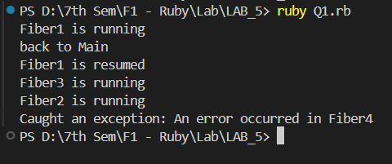

1. **Create 10 threads, each of which sleep for a random amount of time and then prints a message.**

Code

require 'thread'

threads = []

10.times do |i|

    threads << Thread.new do

        sleep_time = rand(1..5)

        sleep(sleep_time)

        puts "Thread #{i+1} woke up later #{sleep_time} seconds."

    end

end

threads.each(&:join)

Output

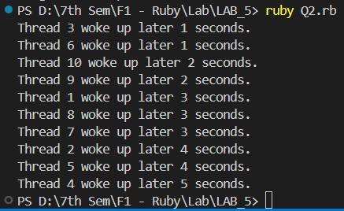

1. **Create a local variable for a main thread, additional threads and fiber and prints the value of it.**

Code

Main_var = "Main thread variable"

Fiber_var = "Fiber variable"

Thread_var = "Thread variable"

fiber = Fiber.new do

    puts " inside fiber : #{Fiber_var}"

end

thread = Thread.new do

    puts " inside thread :  #{Thread_var}"

end

puts " in main thread : #{Main_var}"

fiber.resume

thread.join

Output

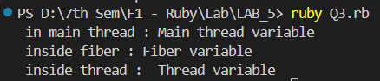

1. **Local variable values in Nested Thread within a Fiber.**

Code

fiber = Fiber.new do

    local_fiber_var = "Fiber variable"

    Thread.new do

        thread_var = "Thread variable"

        puts thread_var

        puts local_fiber_var

    end.join

end

fiber.resume

Output

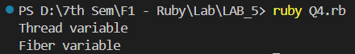

1. **Local variable values in Nested Fiber within a Thread.**

Code

Thread.new do

    thread_var = "Thread variable"

    fiber=Fiber.new do

        local_fiber_var = "fiber variable"

        puts local_fiber_var

        puts thread_var

    end

    fiber.resume

end.join

Output

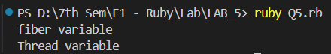

1. **Multi Thread sharing same variable address space.**

Code

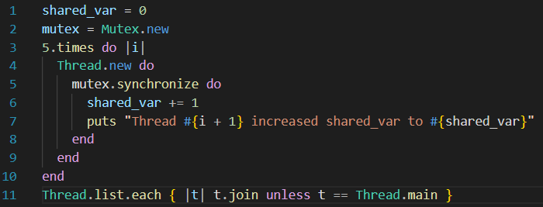

Output

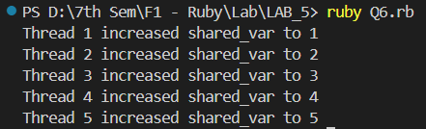

1. **Write a separate program using the following functions:** 
   1. **Thread – Stop and Run**

**Code**

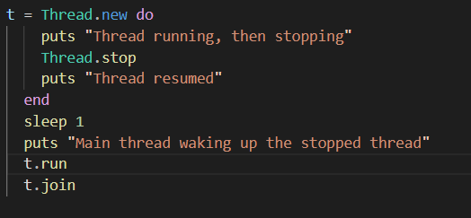

**Output**

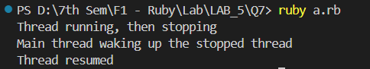

* 1. **Thread – Wakeup**

**Code**

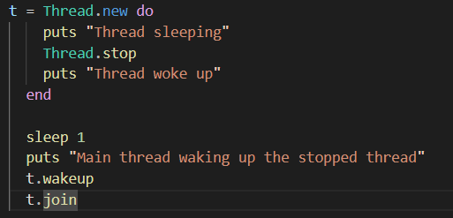

**Output**

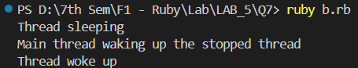

* 1. **Thread – Value**

**Code**

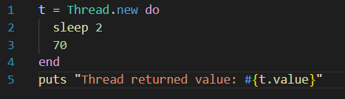

**Output**



* 1. **Thread – Pass**

**Code**

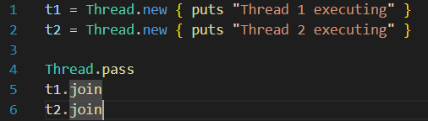

**Output**

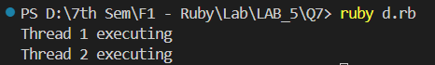

* 1. **Thread –Priority**

**Code**

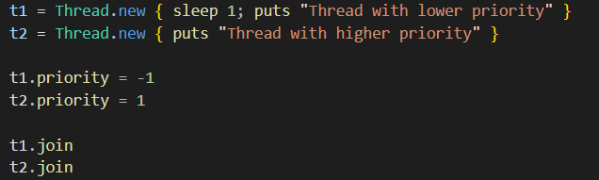

**Output**

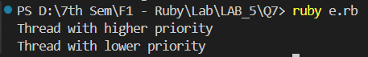

* 1. **Thread – Mutex**

**Code**

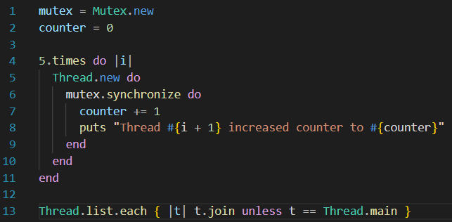

**Output**

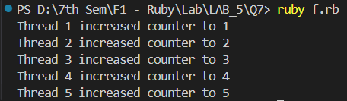

* 1. **Thread – Fork**

**Code**

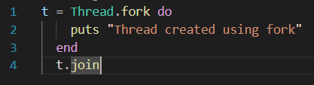

**Output**

