

**SWE2034 – Ruby Programming**

Guided By – **Dr Yogesh C**

Slot – **L5+L6**

NAME: **VISHWANTH P**

REGISTER.NO: **21MIS1117**

**Lab Assessment - 1**

1. **Introduction**
   1. **Variables and Methods**
      1. **Different Types of Variables and Scope**

**Local Variable**

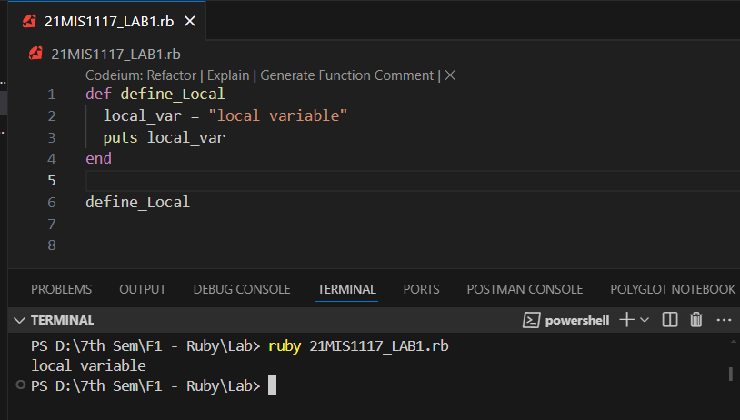

**Instance Variable**

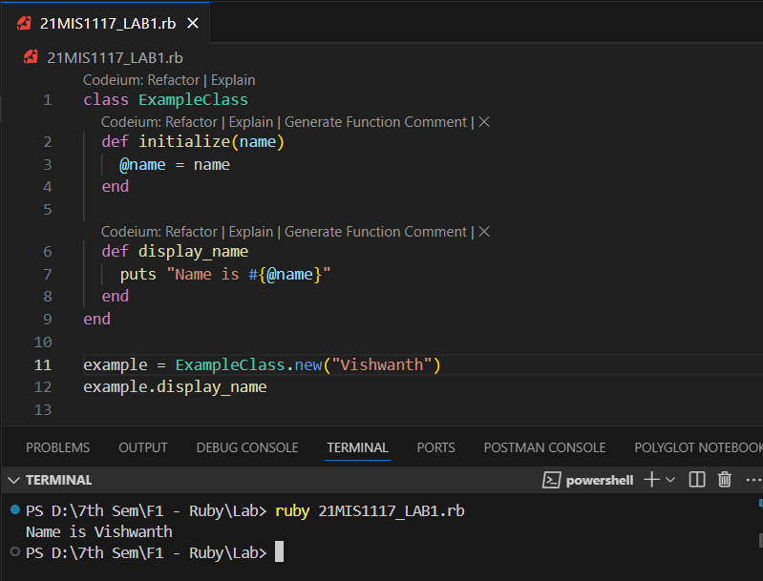

**Class Variable**

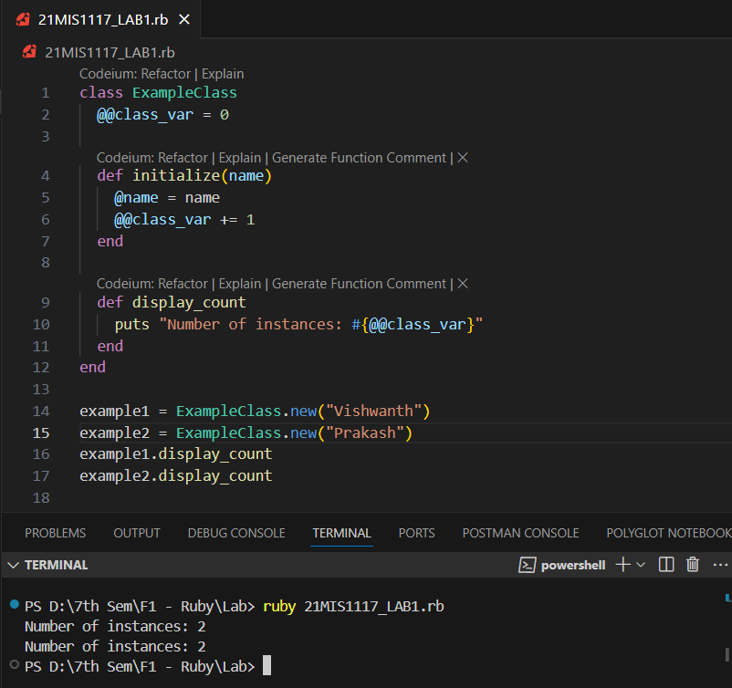

**Global Variables**

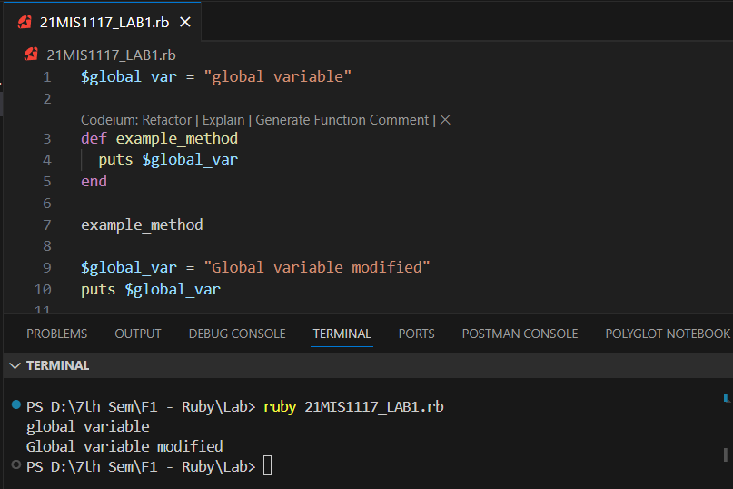

**Constants**

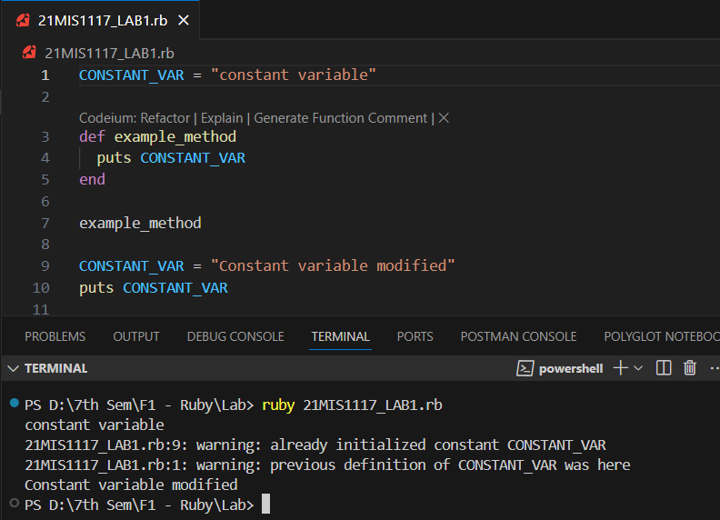

* + 1. **Arithmetic, Relation, Logical and Boolean operators (Each 2 Programs)**

**Arithmetic Operators**

**Program 1: Basic Arithmetic Operations**

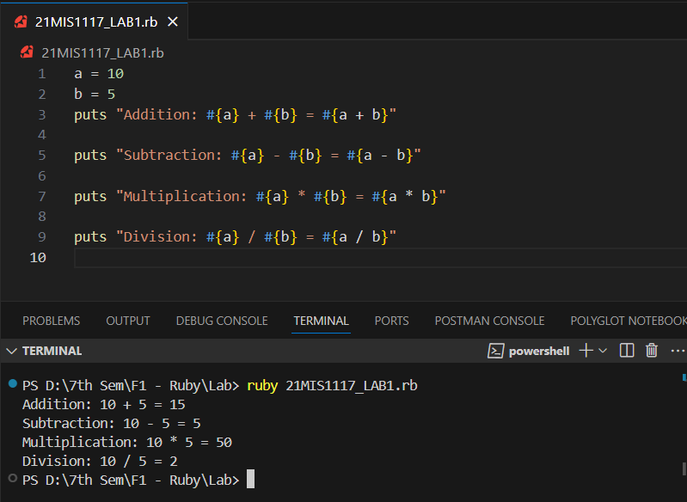

**Program 2: Modulus and Exponentiation**

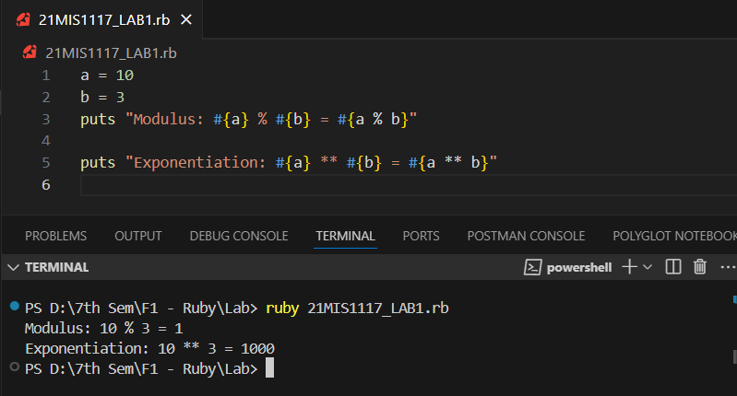

**Relational Operators**

**Program 1: Basic Comparisons**

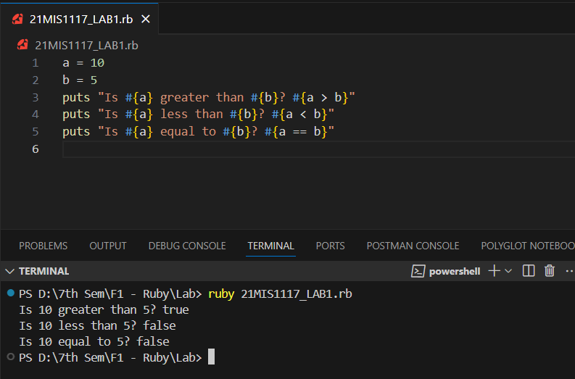

**Program 2: Complex Comparisons**

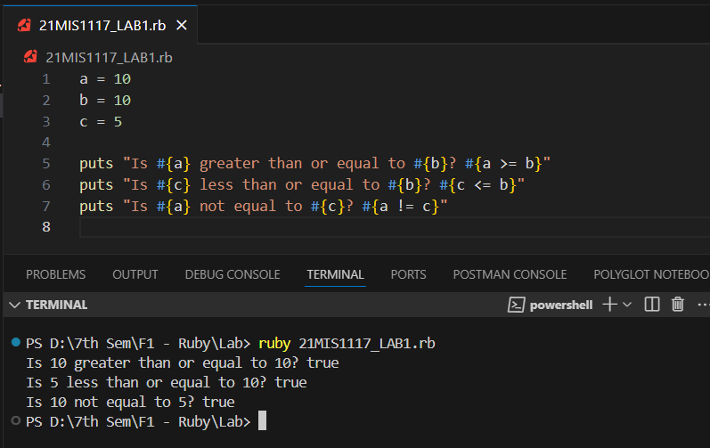

**Logical Operators**

**Program 1: Logical AND and OR**

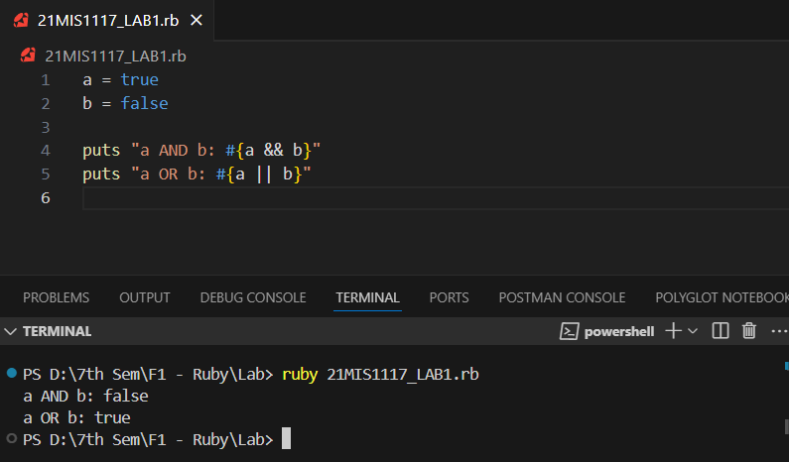

**Program 2: Logical NOT**

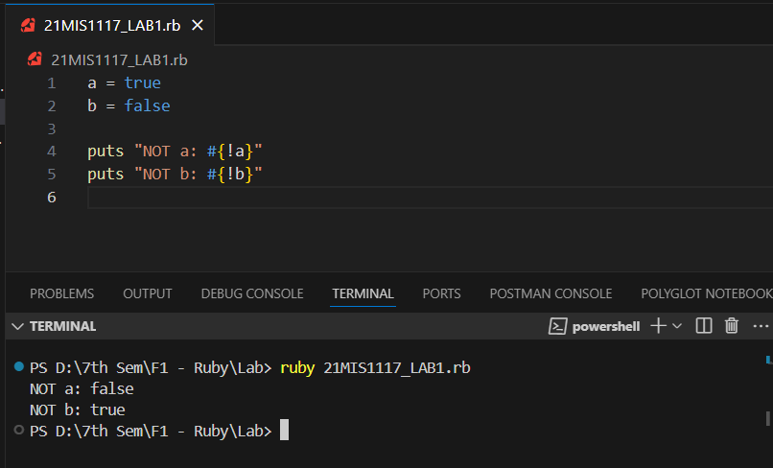

**Boolean Operators**

**Program 1: Combining Conditions**

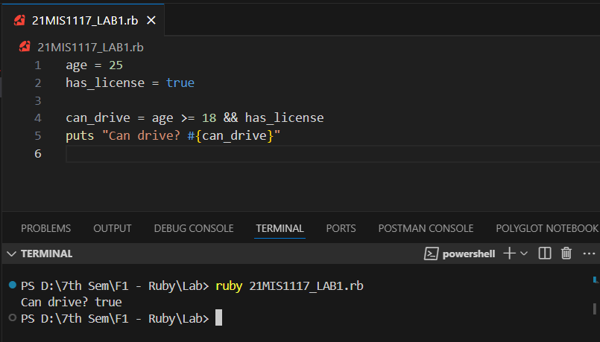

**Program 2: Using OR to Provide Alternatives**

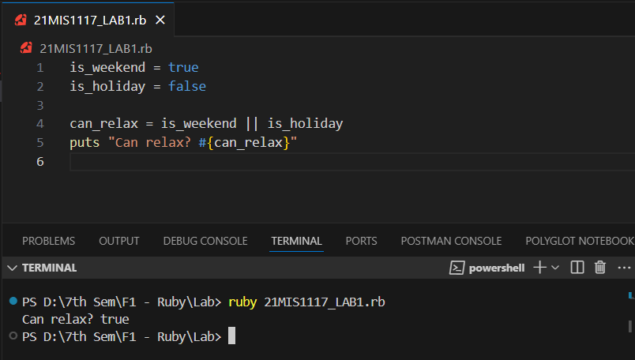

* 1. **Conversion of Variables**

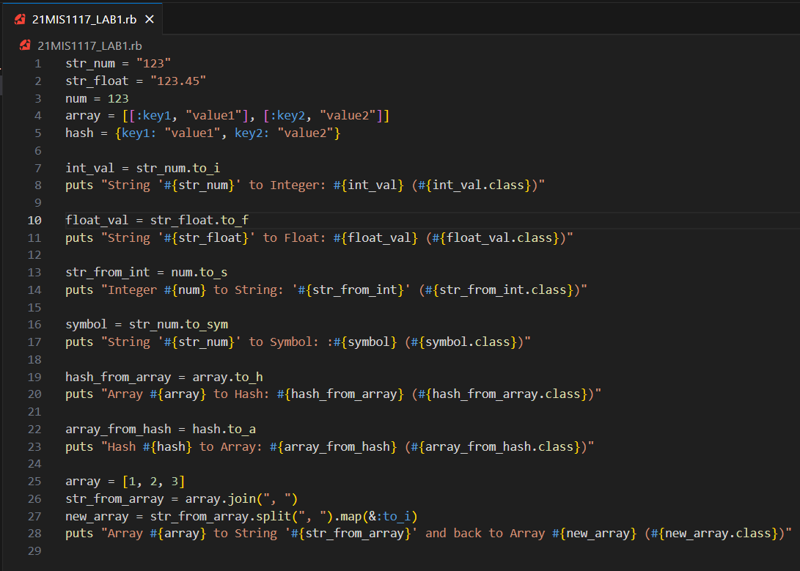

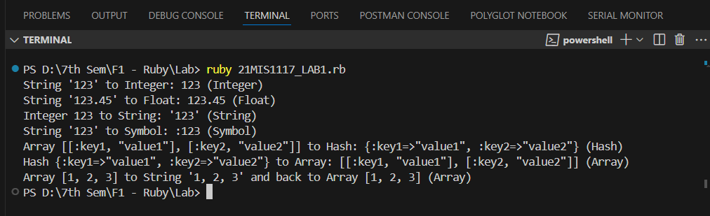

* 1. **Inclusive and Non-Inclusive Ranges**

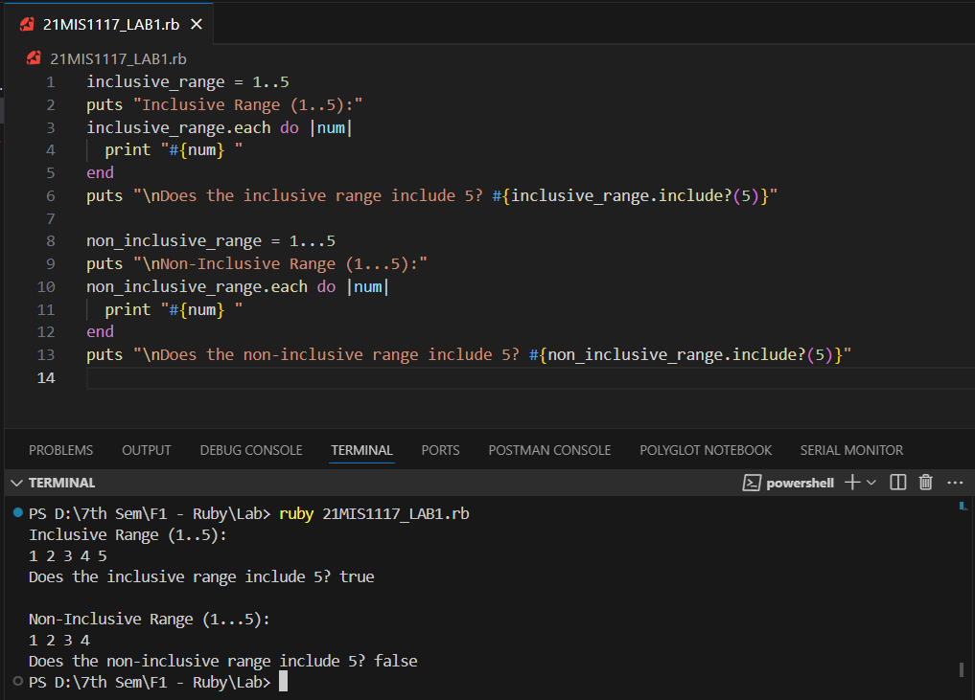

* 1. **Redo Program**

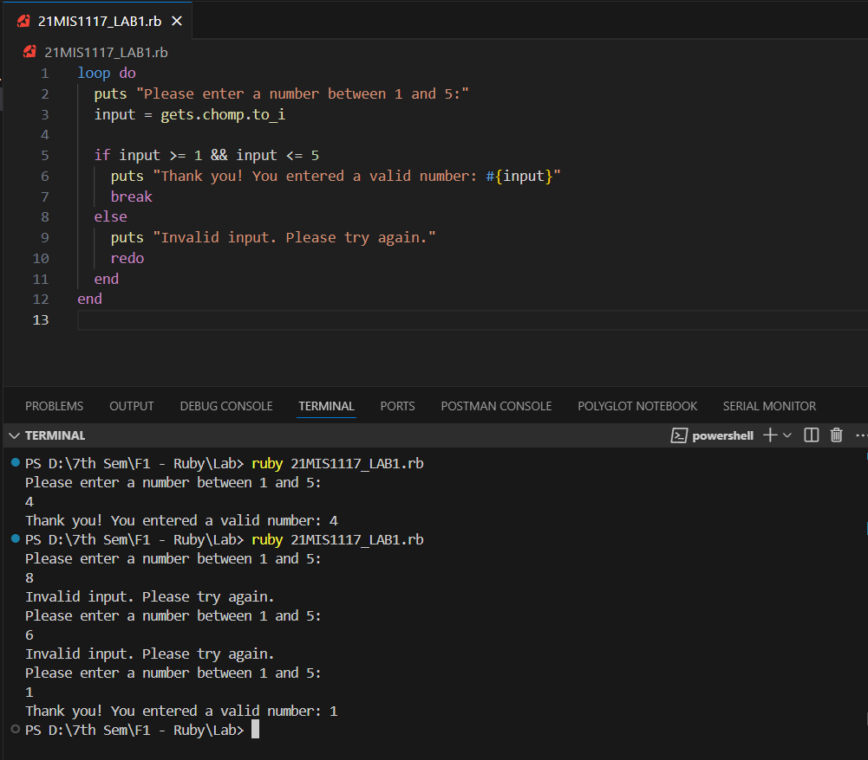

* 1. **Break Program**

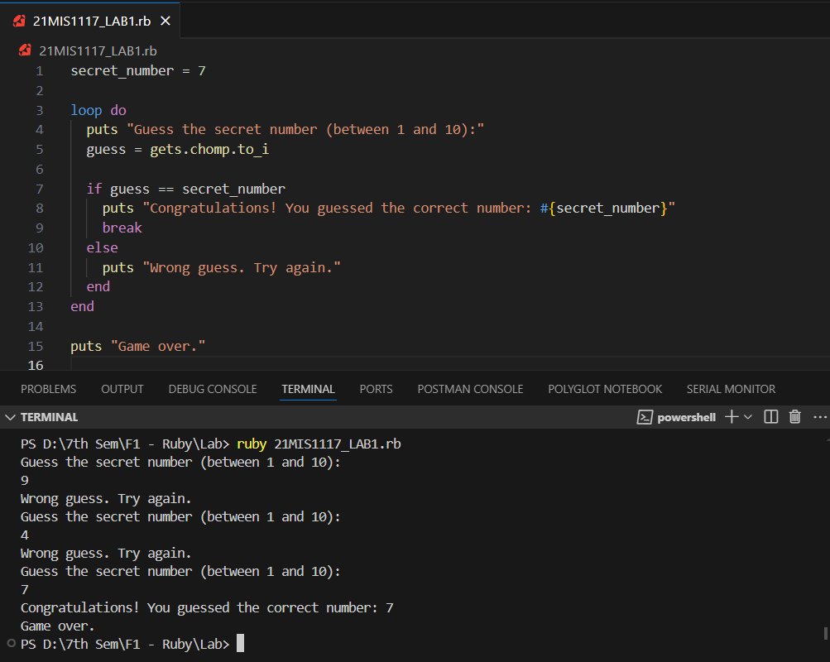

1. **A program that prints out the first 10 even numbers**

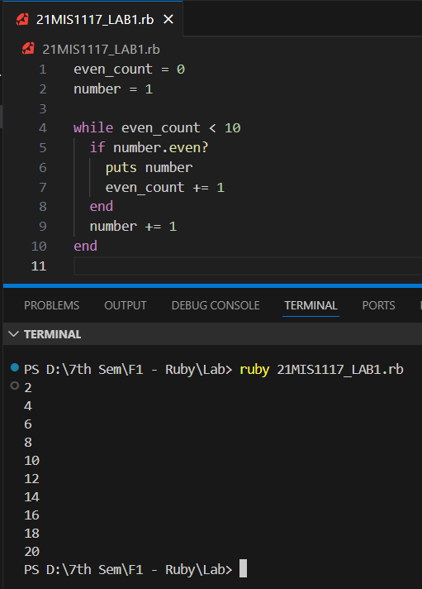

1. **A program that calculates the factorial of a number using a while loop**

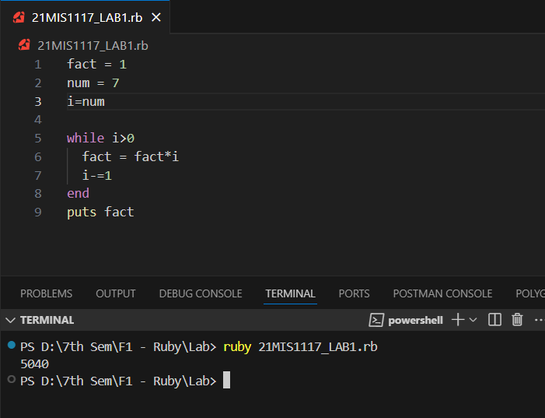

1. **A program that prints out the sum of all numbers from 1 to 100 using a for loop S.**

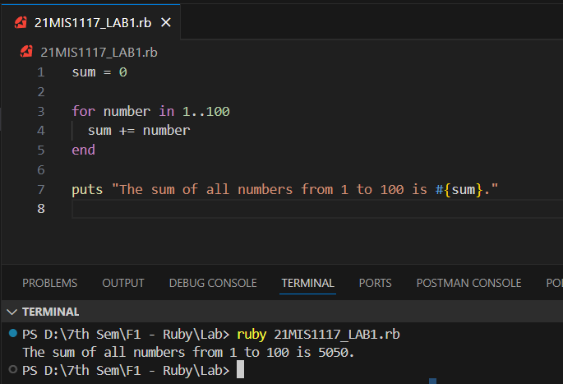

1. **A program that prints out the multiplication table of a number**

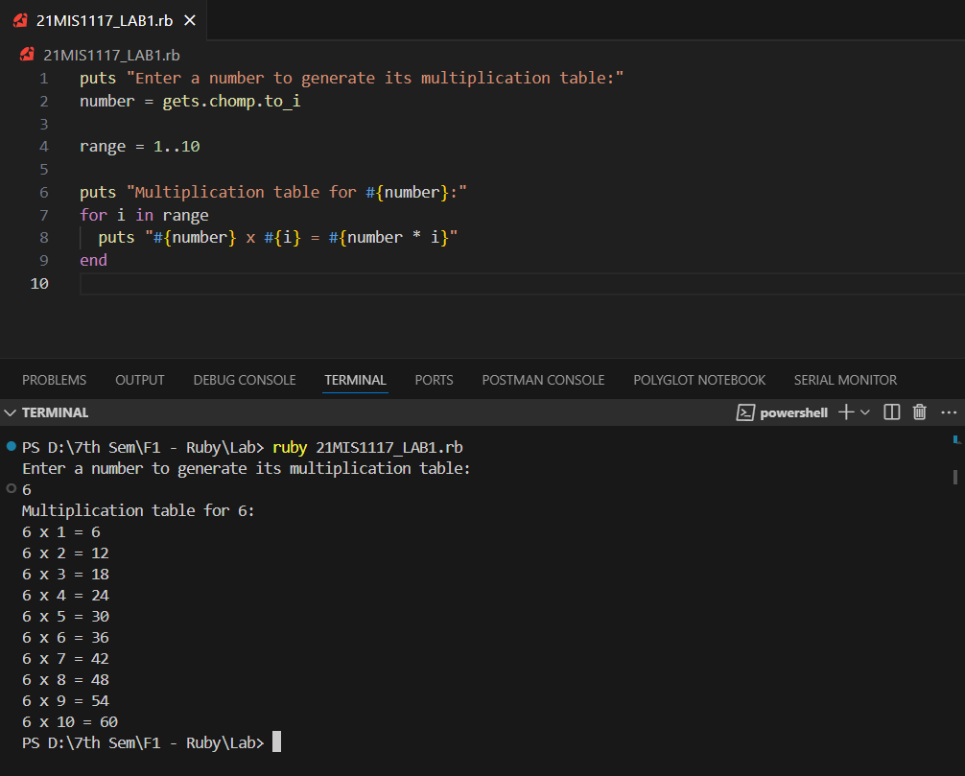

1. **A program that checks if a number is prime or not**

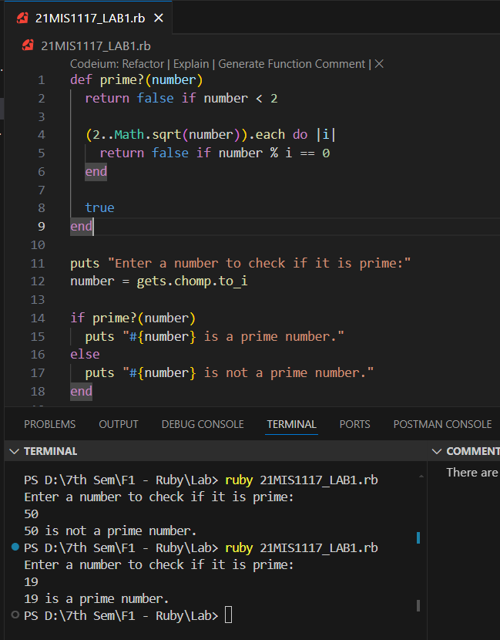

1. **A program that prints out the Fibonacci sequence up to a certain number**

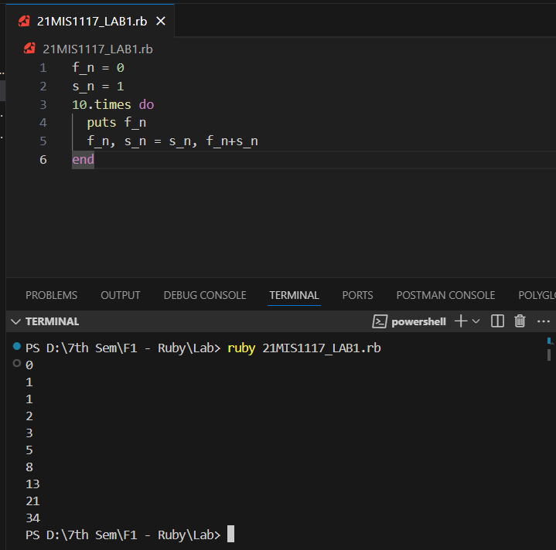

1. **A program that prints out a triangle of stars**

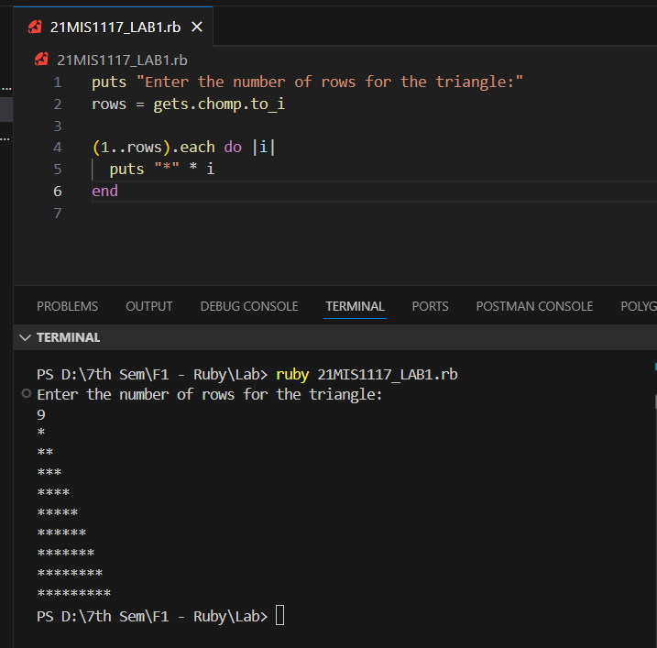

1. **A program that reverses a string using a while loop**

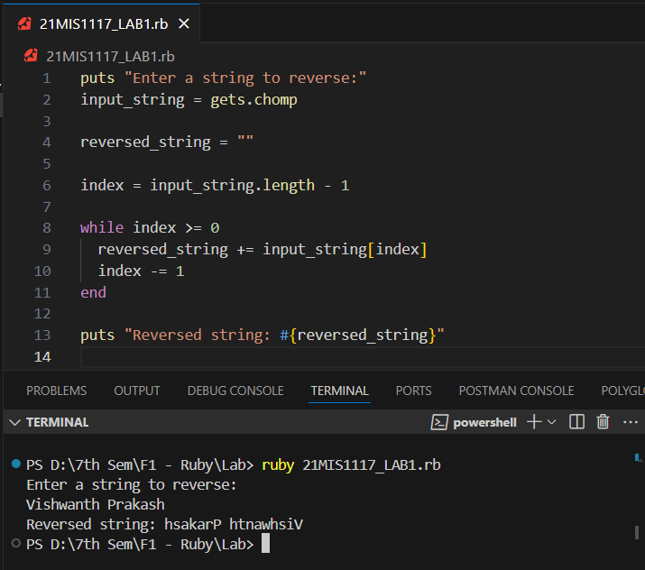

1. **A program that prints out the comm-elements between two arrays**

