**Machine Learning-Project Submission 2**

1.**Title: Driver Fatigue Detection using Convolutional Neural Networks**

**2.Datasets:** **We are using facial data from UMass Amherst open eye face data and Nanjing University closed eye face data.**

3**.Steps of Data Pre-processing:**

* Installing the dependencies. The following dependencies are required to pre-process the datasets. Refer Fig 1:
  + 1.CMAKE: required for face recognition
  + 2.DLIB: required for face recognition
  + 3.FACE_RECOGNITION: required for recognizing eye coordinates in a face.

Fig 1

* Calling the respective functions: As we are using two different datasets, we require to different functions to pre-process the data. Although the internal code has same logic, the only difference is how we iterate through the files in their respective folders.

* Each image is retrieved from their folders and the coordinates are found using this snippet.

* After recognizing the coordinates, let us create a list to store their values for each eye. If the library fails to recognize the face, we skip the pre-processing step.

* For each eye let us find the boundaries such that we can crop the eye from the face. To make sure that full eye is captured, we are adding a cushion to the range.

* Now, we use the crop functionality of the PIL image library to crop out the eye from the face.

* Let us resize the image now such that all the images sent into the neural network will be having same uniform sizes.

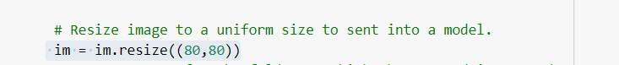

* We, now create a folder and store it in a folder for sending it to training and then save it.



* **Above all steps are same for the closed_eye_data.**

**4.Input:**

* Open eye dataset

* Closed eye dataset

**4.Output:**

* Open eye dataset

* Closed eye dataset

